CANON
XJ100x, XJ86xII, XJ75x, XJ72x
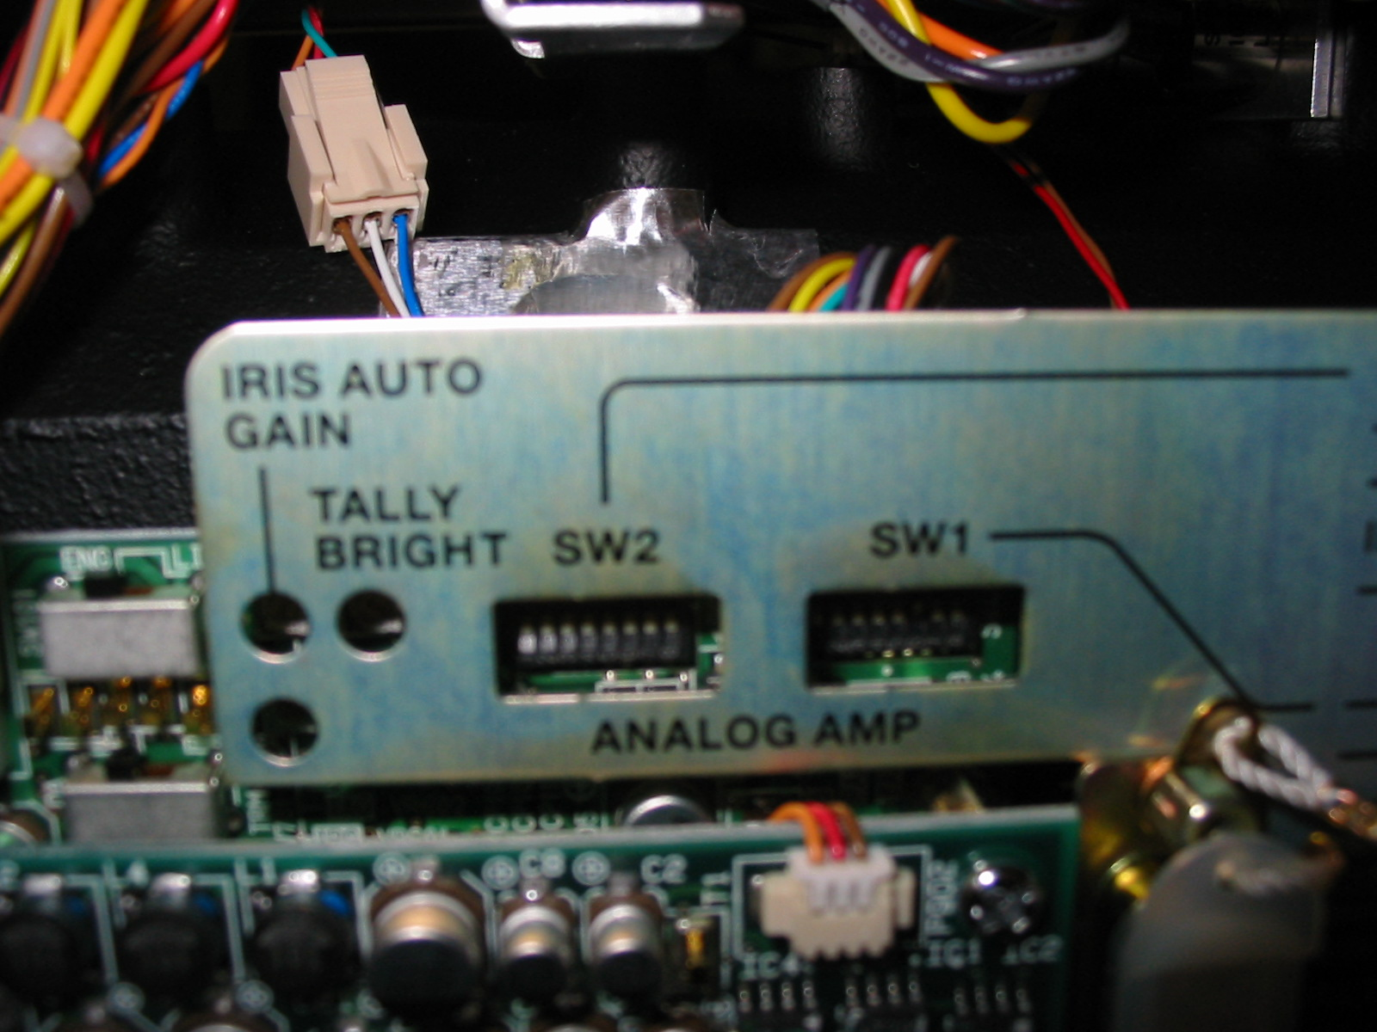

SW2:No.6 ON→LDK Lens + SONY Camera (BTA Camera)
SW2:No.6 OFF→LDK Lens + LDK Camera

LDK TO BVP

At the lens 36 pin connector, remove 2 screws

Pin 22 remove blue wire & shrink tube end
Pin 16 remove grey wire & move to pin 22 position
Pin 30 remove yellow wire & move to pin 16 position
Replace connector and screws

