 | Chyron Lyric® 6.14 and the  Lyric® PRO Option  Release Notes  July 13, 2007 | 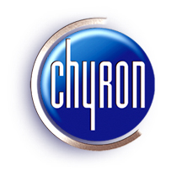

Welcome to the brilliant graphics of Lyric® and the Lyric® PRO option. Lyric is Chyron’s powerful, award-winning graphics application, featuring HD/SD, 2D/3D animation creation and real-time playout, especially suited to live broadcast. The Lyric PRO option adds a host of advanced features, including persistent objects, continuous rendering, Interactive Messages, hierarchical animations, multiple timelines and much more. Lyric is supported by Chyron’s CG/graphics system line, and is supplied standard with those systems. The Lyric PRO option is supported on HyperX, LEX, HX200 and MicroX systems and is pre-installed when ordered with new systems of these types. For offline creation capability, Lyric Offline and Lyric Offline with the Lyric PRO option can run on a PC.
Lyric 6.14 and the Lyric PRO option require the presence of a Chyron-supplied dongle in the system in order to run.
- To upgrade a system without a dongle to Lyric 6.14, please contact Customer Service at 631 - 845 - 2132 to arrange for shipment of a dongle kit. Note that a valid Lyric SMA must be in force in order to upgrade to Lyric 6.14.
- If Lyric PRO is purchased for a Chyron system that already has a Lyric dongle, it will require reprogramming in order to run the Lyric PRO option. Note that a valid Lyric SMA must be in force in order to purchase the Lyric PRO option. Please contact Customer Service for details.
- If the Lyric PRO option is purchased for a Chyron system that does not have a Lyric dongle, a dongle kit will be shipped. DO NOT LOSE THIS DEVICE. Note that a valid Lyric SMA must be in force in order to purchase the Lyric PRO option.
- Lyric 6.14 Offline and Lyric 6.14 Offline plus the Lyric PRO option include a dongle kit; no reprogramming is necessary unless upgrading from an earlier version. Please see additional information specific to Lyric Offline and Lyric Offline with the Lyric PRO option later in this document.
Please contact Customer Service about any questions regarding dongles.
User documentation for Lyric and the Lyric PRO option can be accessed by clicking the Help icon in the Lyric toolbar. Context-sensitive help can be accessed by pressing the F1 key or by clicking the button in the Windows® toolbar in Lyric. Downloadable updates to Lyric Help and to the Release Notes can be accessed from http://www.chyron.com/support/downloads/manuals.aspx.
Downloadable updates to Lyric software and drivers are available at http://www.chyron.com/support/downloads/software.aspx. Do not change the dropdown menu (which reads ‘All Products’ at the top of the page. Locate System Drivers on the page and click the Related Files link.

Note that to access download links to manuals and software, you must be a current Lyric SMA customer and be a registered user on the Chyron web site.

About the Trial Version of Lyric
A 30-day trial of Lyric Offline plus the Lyric PRO option is available by installing Lyric 6.14 on a Chyron system or a PC that does not have a dongle. The trial version also enables optional software features, including 3D Objects, Advanced Image Effects, Advanced Text Effects/Animate Elements, Clip Control Panel, DB Link, Intelligent Interface®, Macros and Movie Objects. Messages (pages) can be created and saved, but frame buffer operations are not enabled, hence there is no output.
Once the 30-day trial has expired, Lyric 6.14 Offline/Lyric PRO requires the presence of a Chyron-supplied dongle in order to run. The following choices are available:
- Lyric 6.14 Offline can be purchased. The software options listed above are provided standard with the application.
- Lyric 6.14 Offline plus the Lyric PRO option can be purchased. The software options listed above are also provided standard with the application. Please refer to About Lyric 6.14 Offline and Lyric PRO Offline, later in this document, for additional information regarding Lyric PRO offline operations.
- A current Lyric SMA customer can request a dongle kit from Chyron for Lyric, or Lyric plus the Lyric PRO option. Lyric PRO requires purchase.
- An expired SMA may be renewed, enabling the online version of Lyric 6.14, which runs on Chyron systems and controls frame buffer output for on-air and production use. If the system does not have a dongle, a dongle kit will be shipped.

About Lyric, Lyric PRO, Driver and Plugin Installation

Overview
New systems are delivered with Lyric or Lyric PRO installed. An upgrade to Lyric or Lyric PRO, or newly-purchased Lyric PRO, must be installed. Before installation of Lyric, Lyric PRO, or a plugin, close any open instance of Lyric, and then wait for thirty seconds. If, after the Lyric or Lyric PRO or plugin installation, an error message appears, indicating the presence of a duplicate LEIFLet, the system must be rebooted.
Visit the Chyron web site periodically for product-specific information. Updated Lyric, Lyric PRO, plugins and drivers are posted at http://www.chyron.com/support/downloads/software.aspx.

Lyric/Lyric PRO
To install Lyric or Lyric PRO:
- Insert the Lyric or Lyric PRO disk into the CD drive of the system. A page with links to the Lyric install program, documentation and utilities should automatically open. If it does not open, then use Windows®® Explorer view the files on the CD, and then click on Setup.html.
- Under the Lyric heading in the left navigation, click the Install link, and then click Open to start the installation. Follow the instructions to complete Lyric or Lyric PRO installation.
- The following drivers must be installed for online Lyric or Lyric PRO operation on a Chyron graphics system.
  - eFX Plugin: Necessary for systems with eFX frame buffer(s) and/or eFX clip player(s).
  - nVidia Driver: Necessary for all systems.
  - CMix Plugin: Necessary only for systems using a CMix SD Mixer.
Please refer to the information in the following sections for information on installing the plugins and drivers.

eFX Plugin
A system with an eFX frame buffer(s) and/or an eFX clip player option(s) must have eFX Plugin Version 1.7, Build 174 installed.
If you have an older system with eFX boards, do not uninstall the existing driver; allow the new driver to install over it.
The current eFX plugin can be found in the DuetUtilities\eFX folder on the installation disk, or at:
http://www.chyron.com/support/downloads/software.aspx
eFX driver installation defaults to Custom, which leaves the eFX Driver checkbox cleared (unchecked). Be sure to click (select) this checkbox for a full installation. During eFX plugin installation, Matrox codecs will also install. These are necessary for the Matrox-to-LTV file conversion utility.
When installing the eFX drivers, a prompt is displayed with the following message:
Answer No to the question “Install Audio Drivers” to prevent Frame Buffer reversal in Lyric
Click OK. A prompt will be displayed is following request:
Do you want to install audio driver?
Click No. This prevents the enumeration of eFX boards from being reversed in Lyric. Note that the intentional omission of these audio drivers does NOT have a negative effect on Lyric and system operation, and in fact, prevents Windows® system sounds from accidental output via the eFX board(s).

nVidia® Drivers
On HyperX2 systems, nVidia Forceware release 158, version 158.22 should be installed. This is the nVidia driver tested and approved by Chyron at the time of this writing.
For all other systems, nVidia Forceware Release 90, version 94.24 should be installed. On an existing Chyron system, the GPU driver should be updated to this version.
The drivers can be found in the Utilities\VGA Drivers\nVIDIA folder on the installation disk, or at:
http://www.chyron.com/support/downloads/software.aspx

CMix Plugin (SD Only)
Where a Chyron CMix is in use with the system, a CMix Plugin must be installed. The current plugin is CMIX build 123, and may be found in the CMix folder on the installation disk or at:
http://www.chyron.com/support/downloads/software.aspx

About Lyric 6.14 and the Lyric PRO Option
Lyric 6.14 is an upgrade from the Lyric 5 series. It is available to customers who have valid, current Software Maintenance Agreements (SMAs). The Lyric PRO is an option to Lyric 6.14, and provides an advanced set of Lyric features:
- interFuse™ continuous graphics rendering technology delivers smooth transitions on and off screen of multiple objects, independently and at any point during an animation.
- Interactive Messages trigger events within themselves and other messages for dramatic transition effects that are easy to create.
- Persistent objects and scenes, such as score bugs, remain on-screen through multiple message reads.
- Multiple timelines gives each message object a variety of “in”, “out” and “update” effects that can be triggered at any time.
- Hierarchical animations combined with enhanced lighting and multiple animated textures provide startling realism to your 2D and 3D objects.
- Compose and Playout Modes provide greater control over the creation of graphics while simplifying playout. Compose Mode provides a complete set of creation tools and access to all elements in a message. Playout Mode allows modification only to selected elements and permits access only to a subset of playout controls.
- Live particle effects including fire, smoke, snow, sparks, frost, glitter, magic trails, edge rays, metallic paint, glow, and refraction all render in real time.
- 3D primitive library provided for building 3D scenes.
- Powerful, real-time 2D/3D animation.
- Advanced Text and Image Effects.

New Features in Lyric 6.14/Lyric PRO

Transitions and Events; Event Nodes (Lyric PRO only)
In previous versions of Lyric, multiple events could not be sustained by a single Transition. With a given Transition (and the events it contained) running, triggering a new Transition would replace the events in the first Transition, effectively canceling it. This limitation extended to manual triggering of a new Transition, as well as Transitions triggering subsequent Transitions.
With Lyric version 6.14, event nodes are no longer limited to one Transition. Therefore, a Transition currently running can continue undisturbed when a second (or third or fourth, etc.) Transition is triggered, either manually or by a keyframe Activation. All of a message's Transitions can thus run simultaneously. The number of Transitions that can run is theoretically infinite, but compositions using this feature should be carefully previewed.
Nodes common to multiple transitions will only execute within a single transition, however. A node cannot simultaneously execute multiple transitions. The interface change is seen on the Events Properties page, where new events may be added to the Event Nodes list box.

Clone Canvas Window
The Lyric Canvas as it appears on the Windows desktop can now be “cloned” and displayed on an analog TV monitor, creating an extra Preview of activity on the current Canvas. This feature is configured via a new option on the Config > Preferences menu, “Windows” tab in Lyric.
Important settings must also be made in the NVIDIA Control Panel Advanced Settings. Click on 3D Settings followed by Manage 3D settings and set "Multi-display/mixed-GPU acceleration" to "Compatability performance mode"

Continued on next page.

Other Changes/Enhancements to Lyric
Changes, Bug Fixes and Known Issues apply to both Lyric PRO and Lyric Standard, unless otherwise specified.
- Online Help regarding Lyric's Video Capture function has been updated
- Lyric PRO only: The Transition Properties page now includes a checkbox option allowing the user to add a node at the current frame in the animation.
- Lyric PRO only: An operator working in Playout Mode may now enable or disable Visibility of Groups on the Timeline. Refer to the topic “Playout/Compose Mode” which may be found in the Index of Lyric’s Online Help facility.
- In Lyric Versions 6.14 and PRO, Lyric’s sole Full-Screen Antialiasing control has been relocated to the Canvas Resolution menu (Config > Canvas Resolution). Antialiasing control over individual objects remains in the Rendering Properties menu. This change facilitates the application of Antialiasing on a per-Frame Buffer basis.
- On the Preferences > Windows tab, options have been added for treating the Scene Tree and Macros as Basic Windows.
- On Playlists, the Speed column is now unlabelled. Effect “Speed” functionality is unaffected, and is set by other means, as explained in Lyric’s Online Help.
- In the Timeline, Scene Graph and Keyframe Graph, as well as Message Properties menus, Undo and Redo functions have been improved. Moving, deleting and inserting keyframes can now be accomplished without unwanted changes to other attributes of the message.
- On the Surface Properties menu, the Blur slider is now a spin-edit control.
- On the 3D Object Template dialog, a Browse button has been added for use with the 3D object’s Filename field. This allows the Lyric user to replace the current 3D object with a new one at a given keyframe, retaining the original object’s keyframes and other attributes.
- Users may now decide whether to include ALL Transitions or only the currently selected Transition when exporting to an .lno (Lyric Node Object) file. This choice is available via a checkbox on the CG Preferences tab of the Config > Preferences panel.
- The familiar Global Keyframe Adjustment now affects all the Transitions in a given message.
- An option has been added to the eFX Video Mix panel providing a choice between setting values for CCIR601 or Full Range Key.
- In previous versions of Lyric, Quicktime (.mov) files with Alpha information did not export correctly. Checkboxes allowing the user to invert Alpha information have been added to the Save As and Import Movie dialogs.
- On the Preferences > Windows menu, an option has been added for disabling mouse position/Canvas coordinates updates to the Status Bar.
- In Playlists, an automatic “Apply” is now carried out if a column within multiple selected rows is changed. For example, if a user selects the “FB” column in each entry, and changes the entry to “1”, the Frame Buffer designations in all of the selected rows will change to that value.
- GPI assignments and trigger events are now logged.
- Commands sent to CODI hardware are now logged.
- Log entries regarding Frame Buffer hardware now indicate whether the last animation was completed or Escaped.
- In the Scene Graph, a lock symbol has been added for any object that is marked with "Position Lock" in the right click menu.

Bug Fixes
- Problems associated with synchronizing animations with eFX Objects (e.g. Clips, audio, video mix, etc.) on the Lyric timeline have been corrected. Also, messages including an eFX clip were subject to a delay in the clip clearing from Output when a new message was called up. (Requires eFX 1.7 Build 174)
- Image Quality and aligment issues related to full screen graphics being added to the scene background have been corrected.
- Previous problems with the Playlist window’s size and appearance on the Lyric interface have been corrected.
- In previous versions of Lyric, the use of Macros to replace audio clips in a composition occasionally resulted in erratic audio playout. This problem has been corrected.
- Previous problems associated with Clocks and Timers not starting on static pages (i.e. pages without keyframes) have been corrected.
- In previous versions of Lyric, effects originating from the PCI-Squeezeback board could not be triggered via Intelligent Interface. This problem has been corrected.
- In previous versions of Lyric, deletion of 7 or more messages from the Browser occasionally resulted in the application crashing. This problem has been corrected.
- In previous versions of Lyric, MOS running orders were subject to problems wherein the Effect-in failed to update the graphic if Lyric’s Default Effect settings were “Effect In: None / Effect Out: None”. This problem has been corrected.
- In previous versions of Lyric, playing a message on the Canvas occasionally caused unwanted changes to the currently active Transition. This problem has been corrected.
- Previous versions of Lyric had occasional problems involving Template Data Messages using the V \ 5 \ 3 Intelligent Interface command. These problems have been corrected.
- Previous problems clearing a selected field in Template Data Messages, using Ctrl-Record have been resolved.
- Lyric PRO only: In previous versions, objects could not be moved on the Canvas when an animation was playing to Output. Therefore, objects could be reoriented on the Canvas only after playout on Output was complete. This problem has been corrected.
- Lyric PRO only: In previous versions, changing a message’s Scene Priority or name would make an unwanted change of the active Transition with no indication on the interface. This problem has been corrected.
- Lyric Standard only: Previous problems clearing the output of Frame Buffer 2 have been resolved. The problem may occur in Lyric Pro in certain situations.
- Previously, eFX clips with a Pause set at Frame 0 did not play until the Pause was released. This problem has been corrected.
- In previous versions of Lyric, the Properties menu remained on the Lyric interface after a given Canvas was closed. Accessing some of the various Properties tabs would cause Lyric to crash. This problem has been corrected.
- In previous versions of Lyric, unwanted vertical lines appeared during dissolve and swap operations executed on eFX frame buffers and on some LEX systems containing CODI-type frame buffers. This problem has been corrected.
- Previous versions of Lyric Standard occasionally failed to accept the user’s initial entry in a Playlist. This also resulted in occasional crashes. This has been corrected.
- In previous versions of Lyric 6.x Standard, Clocks Transferred to output did not run after execution of a Default Effect. This problem has been corrected.
- Previous problems with the release of GPI Pauses have been corrected.
- In previous versions of Lyric, Effects configured through the Playlist did not work correctly, occasionally causing message playout to freeze. This problem has been corrected.
- Previous problems with the Center Last pause option for a Crawl have been resolved.
- In previous versions of Lyric, 2D- and 3D text did not appear in the first attempt at play-to-output after Lyric was launched. This problem has been corrected.
- Previous versions of Lyric were subject to crashing after the playlist executed a ‘Take’ followed by use of the Erase function. This problem has been corrected.
- The amount of script that can be entered for a Macro has been increased.
- In previous versions of Lyric, import of multiple nodes from an .lno (Lyric Node Object) were added to the wrong transition. This problem has been corrected.
- Some earlier versions of Lyric did not play imported .WAV audio files. This problem has been corrected with Lyric 6.1 and subsequent releases.
- Earlier problems with slow message-recall times have been resolved.
- In previous standard versions of Lyric, a scene “Xfer”-ed (Transferred) off of Output occasionally appeared again and executed an unwanted Effect-Out following the use of Alt-Erase (Ctrl + Alt + Q). This problem has been corrected.
- Previous versions of Lyric failed to apply Full Scene Antialiasing after a User Profile was loaded. This problem has been corrected.
- Wavefront object (.obj file format) import has been improved.
- In previous versions of Lyric, changing the Alpha value for one surface of a 3D object mapped with a bitmap image caused the desired texture to disappear. This problem has been corrected.
- In previous versions of Lyric, Intelligent Interface prematurely transmitted the V\6 command’s acknowledgment of ‘animation playout complete’. This problem has been corrected.
- Earlier problems with incomplete execution of Default Effects have been corrected.
- Previously, invalid Channel designations in Playlists could not be corrected, re- saved and later recalled successfully. This problem has been corrected.
- Previous problems with the appearance and scrolling behavior of the Surface Properties window have been corrected.
- In previous versions of Lyric, adding a node to a Transition caused the animation to rewind; this unwanted result was not readily apparent on the Lyric interface. This problem has been corrected.
- In previous versions of Lyric, applying an image to the surfaces of a 3D object occasionally failed to affect all of the object’s surfaces. This problem has been corrected.
- If you Shift Enter to insert a CR into an existing multi row 2D text box, the text moved onto the second line is not spaced correctly next to the existing first character. This problem has been corrected.

Macros/LEIF Bug Fixes
- Previous versions of Lyric were unable to enable the “Use 1:1 Pixel Aspect for Graphics Import” setting using LEIF-created Macros. This problem has been corrected. (On the Lyric interface, the Use 1:1 Pixel Aspect for Graphics Import option is found on the Canvas Resolution menu.)
- When certain plugins issued a call to RestoreCanvas (from scene proxy), an unwanted change in Lyric Canvas resolution occurred. This problem has been corrected.
- Previous problems with the center values in Transitions when including a Group within another Group have been resolved.

Known Issues
- In configurations where Lyric’s eFX Plugin 163 is installed on a system using the Leitch 97 driver, attention should be paid to the Transcoding setting on the Advanced “Setup HyperX eFX Config” menu. Do NOT select the Quality checkbox. (Config > Hardware > Setup Board Configuration > Advanced > Setup HyperX eFX Config.)
- Lyric writes and stores files with the .reg extension when a Lyric User Profile is created. Outside of Lyric, Windows regards these as ordinary Windows Registry files. DO NOT open Lyric User Profile .reg files outside of Lyric (for instance by double-clicking them in Windows Explorer). This type of action may have an adverse effect on your system’s hardware. Lyric User Profile files should only be opened with the “Load User Profile” selection near the bottom of the Config menu.
- Recalling a Lyric message containing an unembedded 3D object that has been moved from its source location causes reproduction of the entire message to fail. Not only does retrieval of the object fail, as would be expected, but the message cannot be called up successfully even though its other assets are undisturbed. Note that embedding a 3D object in a message DOES WORK as always, since the data comprising the 3D object is included in the stored Lyric message.
- Priority assignments that are set on the Transition Properties page may not be applied correctly if all of the messages on Output are not saved with the same Rendering mode (as set in messages’ Internal Properties, accessed via the Set Message Properties selection on the Tools menu).
- Continuous update of a template will operate only if there is an animation on the scene.

Suggestions/Workarounds
- If a faint line is observed at the top of a Mask, the problem may be remedied by setting the Rendering Mode to Fast on the message’s Internal Properties menu. This is available via the “Set Message Properties” selection on the Tools menu.
- In the Surface Properties menu’s “Minify” dropdown, Bilinear or Trilinear filtering is recommended for images and textures that have been scaled down.
- Full Screen Antialiasing should be enabled when 3D characters or objects are present in a Lyric composition.

Lyric 6.14’s Clone Canvas Window Function
HyperX2 graphics cards can deliver a duplicate of the Lyric Canvas to an analog TV monitor for preview use. This signal is derived from the picture displayed on your system’s VGA or digital PC monitor, so changes to the video card driver’s settings are required.
This document supersedes the “Graphics Card Preview Output” configuration procedure for earlier graphics cards. Setting up the Clone Canvas Window function involves configuration of your system’s graphics card driver and a new Preferences option in Lyric. The driver configuration described here is based on setup of an EVGA Corp.
e-GeForce 8800 GTS card, which is the video card supplied with HyperX2 systems at the time of this writing.
Remember that this entire function and its settings are completely independent of the Air/Production outputs from the Chyron system’s eFX, CODI or PCI Squeezeback boards. The sole purpose here is creating an extra output for monitoring the activity on the Lyric Canvas currently selected for editing.

- Turn off your Chyron system.
- Connect an analog TV monitor, NTSC or PAL, to the S-video-type connector on your system’s video card. Use the supplied RGB-type cable pictured below.
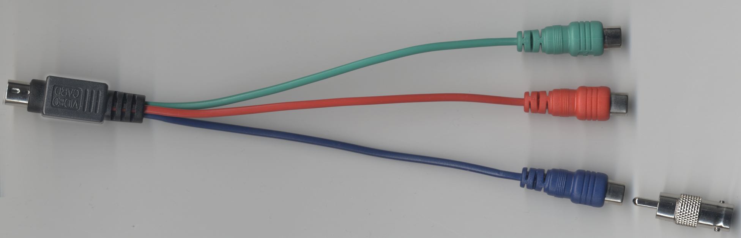
Select one of these RCA-type plugs for connection to the TV monitor. Use the RCA-to-BNC adapter for attachment to an appropriate coax cable. Any of the three RCA-type plugs may be used for this purpose, but Chyron suggests settling on one of them in situations where multiple systems are using this type of setup.
- After connection is complete, restart your system. The new connection is detected and the graphics card automatically outputs composite video. However, new settings are necessary in your graphics card’s NVIDIA control panel.
- Access the NVIDIA Control Panel through Windows Control Panel or by right-clicking the desktop. 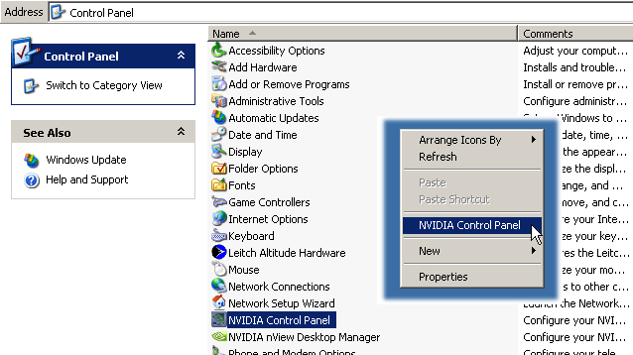
- The graphics card’s default output at the S-video connector is NTSC. To use a PAL monitor, first select “Change the signal or HD format” under “Video & Television”, as seen in the following illustration. Again, the connection of the TV monitor will have been detected by this point.

If you’ll be using an NTSC monitor, skip to Step #6.
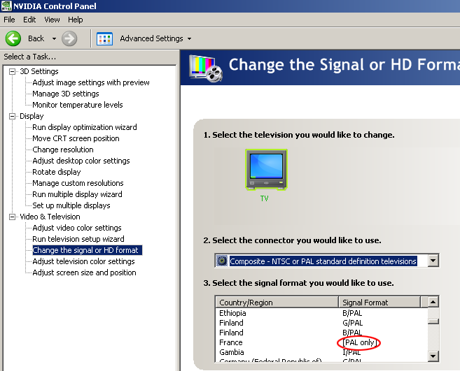
In the Task pane on the left, select Set Up Multiple Displays. Note that a sample monitor is identified here. Your graphics card should already be configured for, and “aware of” your VGA or digital PC monitor. 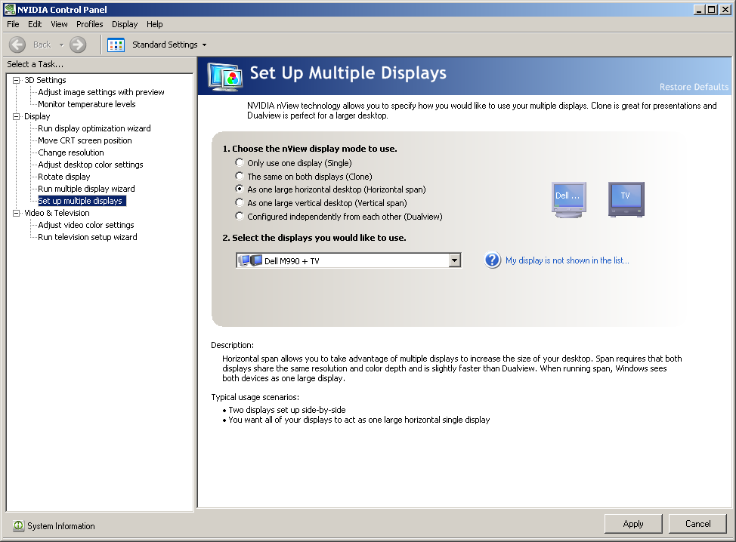
- In this part of the process, first be sure to select “As one large horizontal desktop (Horizontal span)”. Click Apply. The item you’ll select in the next step may not appear until you take this action.
- Next, select “Configured independently from each other (Dualview)”. Click Apply. An extension of your system’s desktop will appear on the TV monitor. It may be empty, displaying only the color of your desktop. You may wish to verify that you’ve effectively created a larger desktop by dragging a desktop item onto the area shown in the TV monitor.
NOTES
At some point during Steps 7 & 8, the display settings for your VGA or digital PC monitor may change. You may have to adjust the “Change Resolution” options under “Display” in the Task pane to restore them.
Important settings must also be made in the NVIDIA Control Panel Advanced Settings. Click on 3D Settings followed by Manage 3D settings and set"Multi-display/mixed-GPU acceleration" to "Compatability performance mode". Refer to the NVIDIA Control Panel’s Help.
- Close the NVIDIA Control Panel.
- Start Lyric.
- Under the Config menu, select Preferences.
- In the Preferences menu, select the Windows tab.
- On the Windows tab, select the Clone Canvas Window checkbox and click OK.

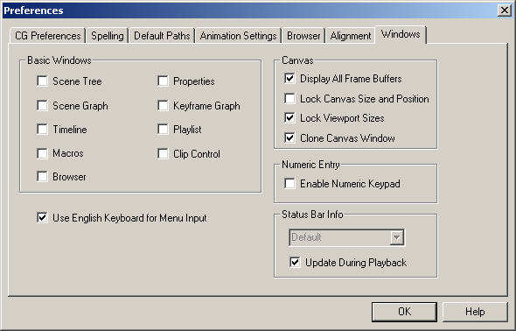

The Canvas portion (only) of the Lyric interface appears on the TV monitor.

© 2007 Chyron Corporation, 5 Hub Drive, Melville, NY 11747
631 - 845 - 2132
sales@chyron.com
www.chyron.com

