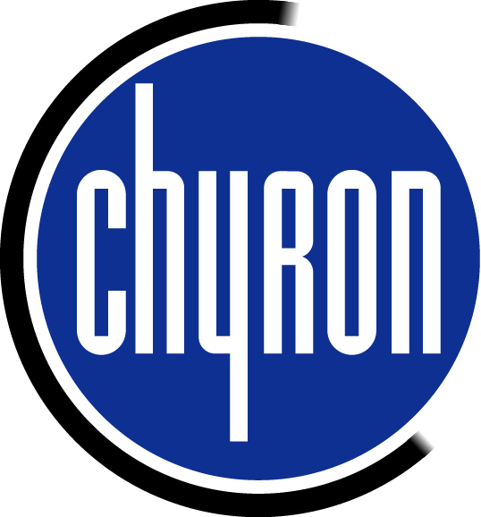

Graphic and Canvas Aspects

for the Chyron DUET

Chyron has added a new feature in Lyric 3.5 software to handle 4 x 3 to 16 x 9 aspect changes. Let’s assume a page is created in Lyric with the canvas set to D1 525 (4 x 3 - 720 x 486). Then the canvas resolution is changed to 16 x 9 525, the pixels remain the same at 720 x 486. If the same page were read to this canvas the end result would look like this.
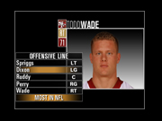
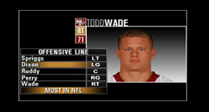

The added software feature in 3.5 Lyric has a setting to enable auto conversion standards. The end result would then look like this when read to the 16 x 9 canvas.
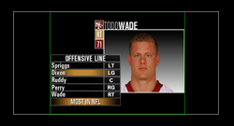

The result is that all messages created in Standard Def will read with correct looking aspect in the 16 x 9 canvas. Nothing has to be done with the graphics. When the canvas is set to 16 x 9 High Definition the same result will happen. All graphics will be expanded both in X and Y size to fill the center of the screen. If the message is made in the 16 x 9 canvas and then read to the 4 x 3 canvas the opposite will happen. The left and right edge of the canvas will be cut off. Therefore if graphics are made to fit the white safe title area in 16 x 9 will be clipped when reading into the 4 x 3 canvas. The only area to be careful with is the background clips that will get stretched to fill the whole screen when converting to 16 x 9 from 4 x 3.

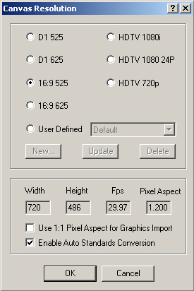
To enable this setting from within Lyric, click on the Config menu and select Canvas Resolution. If messages were created in D1 525 and the playback is for 16:9 525 or HDTV settings, check to Enable Auto Standards Conversion box. All messages will be displayed correctly inside a 4 x 3 safe title area as seen above. If the canvas is set to 16:9 and a graphic that was created for 4:3 mode has to be added to the scene, the canvas must be set back to D1 525 before adding it. Images that are created for 16:9 can be added in this case with correct aspect changes.

OTHER SETTINGS FOR LYRIC’S CANVAS
Lyric’s canvas can be set for many different resolutions. Some graphic programs produce graphics in a square pixel format and some in a rectangular pixel format. Lyric’s canvas can be set to accept either format. The following explanation describes what pixel aspects to follow to ensure that the graphics will be displayed properly on a DUET.

 | Aspect Ratio | Aspect Pixels for Output of DUET | Graphic Creation for Square Pixels  Or 1:1 checked | Graphic Change For Rectangular Pixels Or 1:1 not checked
D1 525 | .9 | 720 x 486 | 720 x 540 | 720 x 486
D1 625 | 1.067 | 720 x 576 | 768 x 576 | 720 x 576
16:9 525 | 1.2 | 720 x 486 | 864 x 486 | 720 x 486
16:9 626 | 1.4 | 720 x 576 | 1024 x 576 | 720 x 576
 | Aspect Ratio | Aspect Pixels for Output of DUET |  | Graphic Creation and Graphic Import with 1:1 not checked
HDTV 1080i | 1.0 | 1920 x 1080 |  | 1920 x 1080
HDTV 24p | 1.0 | 1920 x 1080 |  | 1920 x 1080
HDTV 720p | 1.0 | 1280 x 720 |  | 1280 x 720

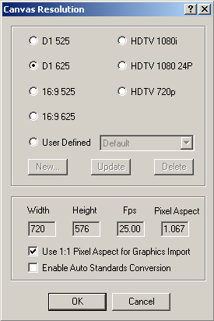
For example, if you wish to create a graphic in a Square Pixel program like Photoshop and have it display properly on the DUET, 2 methods can be used.
- D1 625 – Create a full screen graphic 768 x 578. Go to Lyric’s Config Menu and select Canvas Resolution. If the check box is checked as in the graphic to the left for (Use 1:1 Pixel Aspect for Graphics Import), the graphic will come in and be displayed properly.
- D1 625 – If the same graphic is created in a Program that creates rectangular pixels, the Canvas Resolution should be 720 x 576 and the Use 1:1 should not be checked.

If the graphic was produced in Photoshop at 768 x 576, the image could be scaled down to 720 x 576 upon completion and then brought into Lyric’s Canvas with the 1:1 not checked.

Graphics for 16:9
The 16:9 Canvas Resolution for NTSC or PAL (Not HDTV) is another area that can be confusing. Please follow this format for creating graphics.

NTSC – The pixel amount does not change fro 4:3. It is still 720 x 486. Therefore the graphics actually get stretched. If graphics are to be created to fit the full screen and be displayed properly, the canvas in the Graphics program should be set to 864 x 486. If the 1:1 box is checked, a graphic can be imported to Lyric’s 16:9 canvas with correct results. If the 1:1 box is not checked, the graphic has to be resized to 720 x 486 or squashing it in the X value before bringing it into Lyric’s canvas.

PAL – The same procedure has to be done for PAL except the values are 1024 x 576 for Square Pixel or resize it down to 720 x 576 for rectangular pixels.

The chart above explains all the formatting changes.

With HDTV, the pixel aspect is 1:1 automatically. So follow the aspects in the chart above and when importing them into Lyric, make sure the 1:1 is not checked, or an additional aspect change will occur.

