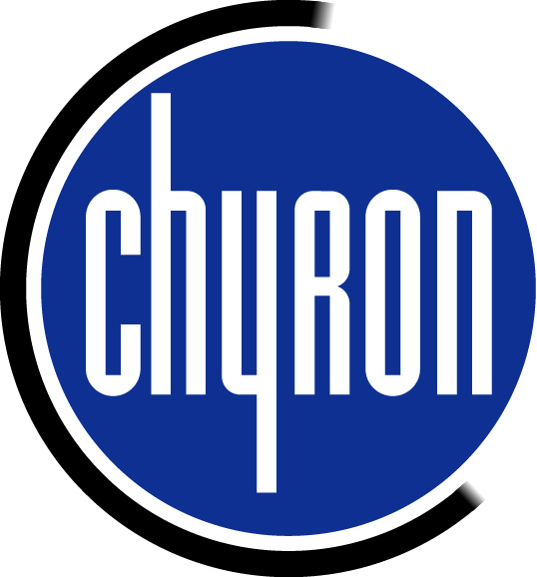

Audio and Preview Hookups

for the LEX and HyperX DUET’s

Computer Audio Hookups
A stereo wav file can be added to Lyric’s timeline for sound effects associated with animations. An audio (Match Box) which converts unbalanced audio to balanced audio must be used. The audio output of the computer sound card uses a stereo mini plug. This plugs into the Match Box. An XLR cable then comes out of the Match Box for hookups into the audio console.

VGA Preview from the DUET to NTSC monitor
The Duet uses the Nvidia VGA graphics card. This card has an S-video output as well as the VGA output.
- There is an S-video to NTSC adapter that has to be plugged in to VGA card.
- Go to Display properties by right clicking on your computer desktop and select Properties. Select Settings from the tabs along the top. Click advanced and select the GeForce tab along the top. Click Troubleshooting on the left and check My connected TV is not being detected and reboot computer.
- When Computer is rebooted go into display properties again. From the GeForce tab select nView Display mode. In the nView Modes select Clone from the pull down menu. From the Display pair select Analog Display + TV from the pull down.
- You should now see 1a and 1b in the window. Click 1b which is the TV, select Device settings in lower right and select Change resolution. Set the resolution to 640 x 480.
- Position the Nvidia window in place exactly over Lyric’s canvas.
- Click on Lyric to bring it to the foreground. Using the mouse pan the canvas around by moving the mouse to the outer edges. You should see the canvas panning in the NTSC monitor. When it is positioned correctly, press Alt Tab to switch to Nvidia panel. Click on Device settings and check Lock Pan Position.

