LINKING EXCEL DOCUMENTS TO CG PAGES

There are 3 separate sections we will cover:

Section 1
Creating the Excel Document.

This section will cover how to make the Excel so that it can work with the Chyron system.

Section 2
Making Excel Document Accessible in Lyric.

The Graphics Department will do this section first before the linking of the CG pages.

Section 3
Linking Excel Document fields with CG Template fields.

This section will cover how to link the fields from Excel to CG page template fields.

S E C T I O N 1 - Creating the Excel Document

- Preparation

The designer of the Excel document needs to conceptualize the end use of the product completely before creation. Here are things you must know ahead of time:

- What CG model do you want to use?

- How many entries (Template Fields) are on the model.

- Decide how you will label fields.

- How many pages will be made that will link to Excel?

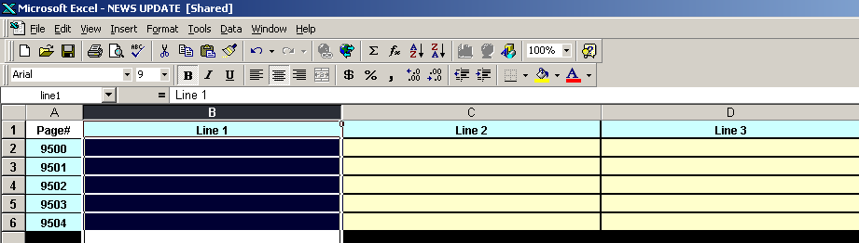

- Excel

Microsoft Excel is a spreadsheet program. You will be creating the Excel document that will feed information to CG pages.

- Select the first row.

- Make a header for each column on this row. These will be the field in Section 3.
- Page #, in cell A1
- Name, in cell B1
- Title 1, in cell C1
- Title 2, in cell D1

- Label each column for linking. This is the Table in Section 3.
- Select the entire column. By clicking on the letters A, B or C, etc…
- Click inside the box on the upper left, below the first name.
- Type the title of the column. Use one word entry only. Make sure you hit ENTER when done labeling. If you must do two words separate them with an underscore. Example: Top_Line

- Squeeze or expand the column width to fit information.

- Give Document Character.
- Select a field of many fields.
- Right Click on selected fields.
- Select Format Cells…
- Make borders on fields.
- Change Background Color if needed.

F. Share Document. If you do not share document it will not work. Follow these steps.
- On the toolbar select Tools
- Select Share Workbook.
- Click on the little box that says Allow changes by more than one user.
- You will be asked to save the document at this time. Give it a name and save it.

S E C T I O N 2 - Linking DUETs to Read Excel Documents

- Preparation.
Any Duet or Lyric off-line version that you want to be able to call up pages that are linked to an Excel Document HAS TO HAVE the following steps done.

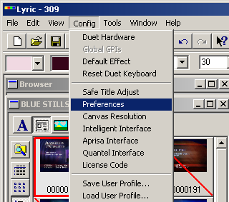

- Linking Pages. (for A & B see image above)

- In LYRIC Software, click on CONFIG on the top left tool bar.

- Select PREFERENCES

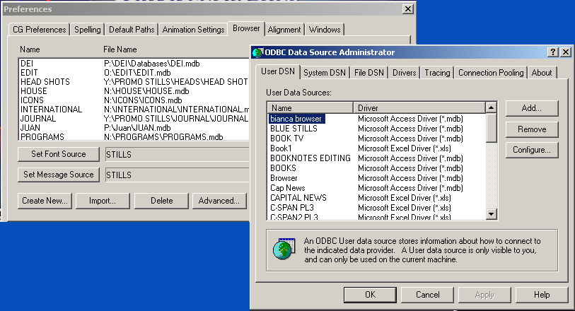
(See last image on previous page for steps C through G)
- Click on the BROWSER tab.

- Click on the ADVANCED button on the lower right.

- ODBC Data Source Administration Box comes up.

- Make sure the USER DSN tab, furthest left is highlighted.

- Click on ADD

- Box shown below will appear.

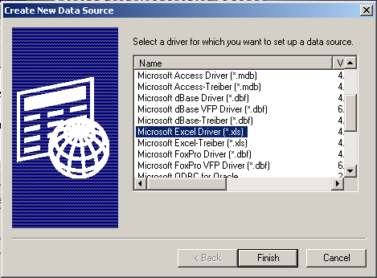

- Scroll down and select Microsoft Excel Driver (.xls).

- Then Click Finish

- ODBC Microsoft Excel Setup Box will appear (see following page for screen image). Click on the “Select Workbook…” button.

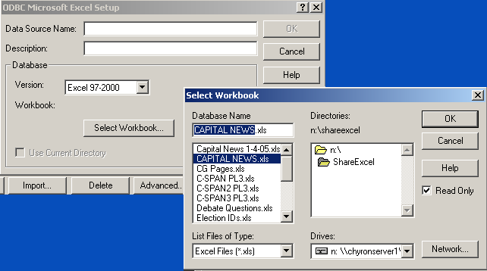

- The Select Workbook box will appear.

- Select the Drive letter on the Drives drop down.

- Find the path to the Excel file.

- Now select the (.xls) file you want to link.

- Once selected it will populate the Database Name field.

- Highlight, then right click and copy only the name of the file. Omit the .xls portion.

- Click OK. Select Workbook box will disappear, leaving you with the ODBC Microsoft Excel Setup box only.

- On the top field labeled Data Source Name, right click and paste. This will paste the name copied earlier. This step insures that you will not miss label Source.

- Click on OK.

- You will be left with the ODBC Data Source Administrator Box only.

- Make sure the SYSTEM DSN tab, directly to the right of the USER DSN is selected.

- Now follow steps F through S again.

- After linking Excel document on both USER and SYSTEM DSN. Click on OK on the ODBC Data Source Administrator Box.

- Then Click on OK on the PREFERENCES / Browser Box.

- Now your machine should read Excel linked pages.

S E C T I O N 3
Linking Excel Document fields with CG Template fields

Design the Lyric page, including the templates. Make sure all templates have the desired names, justification, and values selected in Template Properties.

- In the Scene Graph select the 2D text layer that you made your templates.

- Right clock on the canvas.

- Select Template Properties.

- Inside the 2D Text Template window click on Prev/Next to move from template to template. Green triangles inside the template box Hill show you what template you have active.

- Check the box to the left of the DB Link button.

- This will open the DB Link window.

- On the drop down Data Source, select the name we assigned the Excel document in ODBC.

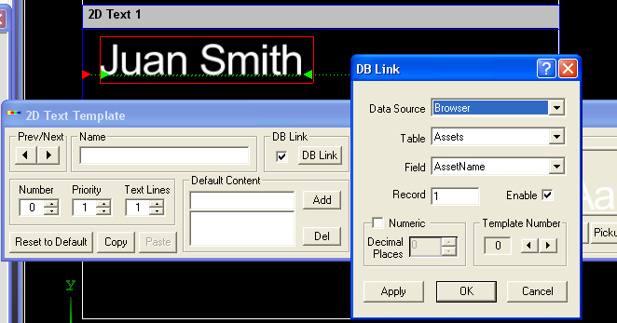

- On the drop down Table, select the name of the column you named in Excel you wish to link. See Section 1, II, C.

- On the drop down Field, you should see the title you typed in excel. See Section 1, II, B.

VERY IMPORTNANT!!! The number inside the record box has to be the number of rows below the field in the Excel document, For Example:
Record 1 is row 2 in the Excel Document.
Record 2 is row 3. Record 3 is row 4.
Record 4 is row 5. Record 10 is row11.
Record 50 is row 51. Record 100 is row 101.

- Make sure the enable box is checked.

- If your information is a numeric value only, then select Numeric, this will also allow you to assign the number of decimal places on your template.

- Once you’re done with the selection in the DB link window you must click on the Apply button before moving on to another template.

- Alter clocking on Apply you do not have to leave this window, there is a left and right arrow on the right side of the DB Link window, this is a way to navigate to other templates on the same page without exiting the menu.

- Once you are done with all templates on the page click on OK.

O. Exit the Template Properties window.

R. Save your page, by assigning it a page number on the number keypad then hit the Record key.

S. The next time you call up the page (page number then Read key) it will have the information in the Excel document displayed in the templates.

