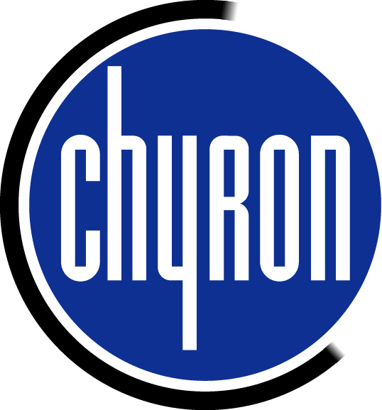

After Effects Settings to Save a Matrox Digiserver File or Matrox MJPEG File

for the DUET Clip Player

- Make sure you have the Matrox Windows Codec installed on the computer. These can be found on the Chyron ftp site at:
ftp://ftp.chyron.com//pub/software/Lyric/MatroxDrivers/codecs.exe

Build the animation with an alpha. From the After Effects tool bar press the Composition button and Make Movie.
Make sure the file size is 720 x 486 for NTSC and 720 x 576 for PAL on systems with the Digisuite Board.
Make sure the file size is 720 x 480 for NTSC and 720 x 576 for PAL on systems with the Digiserver Board
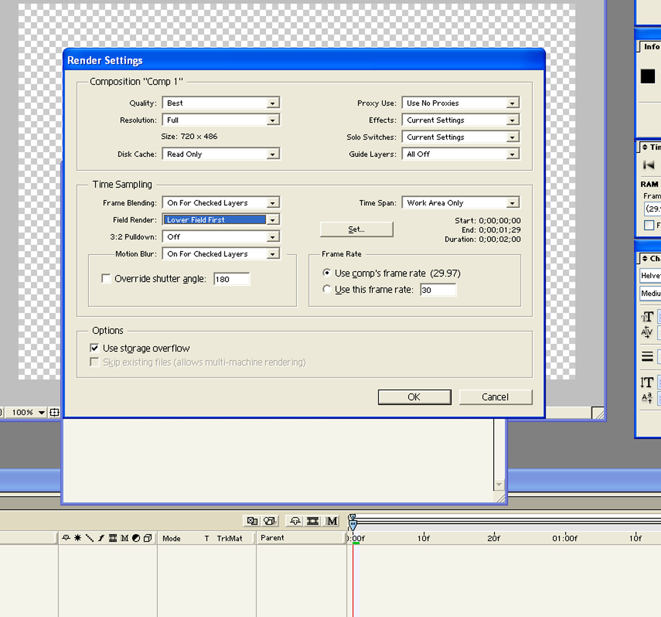

- The Render Queue menu appears on screen. On the Render Settings, press the Best Settings words that are blue and this menu will appear on the screen. The only setting that is critical is the Field Render. Make this Lower Field First for NTSC or Upper Field First for PAL and click OK.

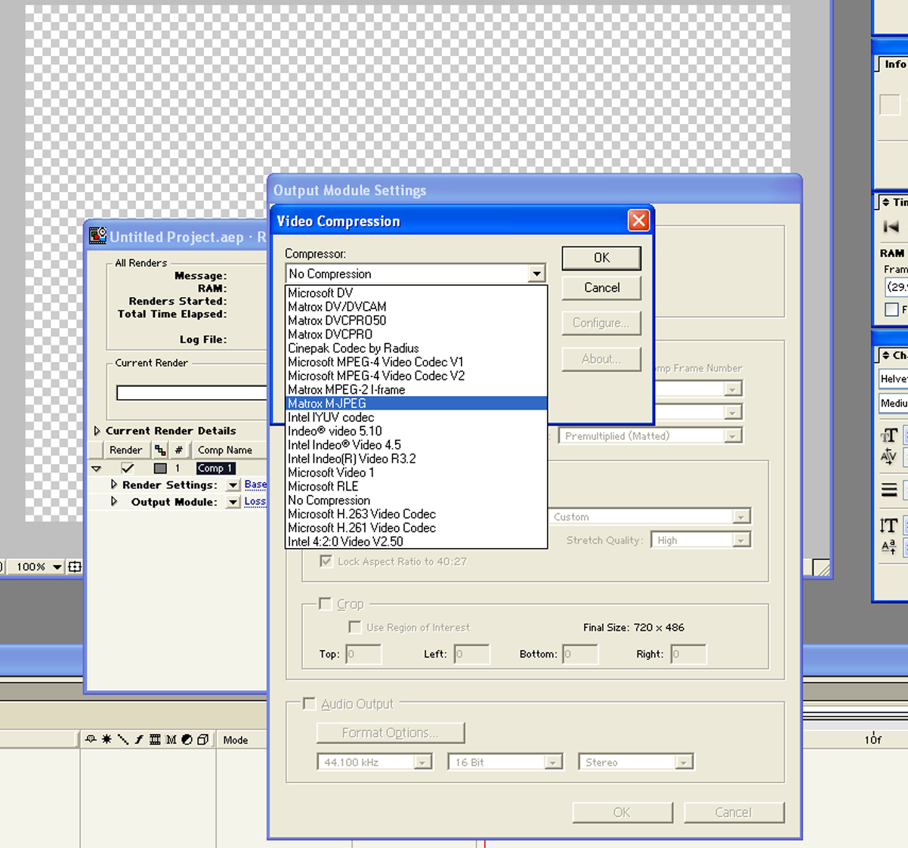
- Click on the Output Module “Lossless” words and the Output Module Settings menu will appear. The format should be set to Video for Windows in the top menu box. Then click the Format Options button to the left and select Matrox M-JPEG as the compressor if you are making the clips for the Matrox Digisuite LE clip player. If for the Digiserver board (see number 7 below.)

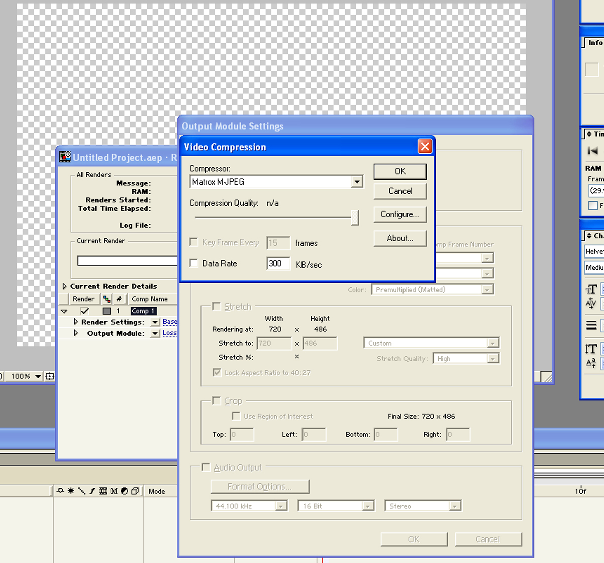

- Make sure the Data Rate 300 KB/sec box is not checked.

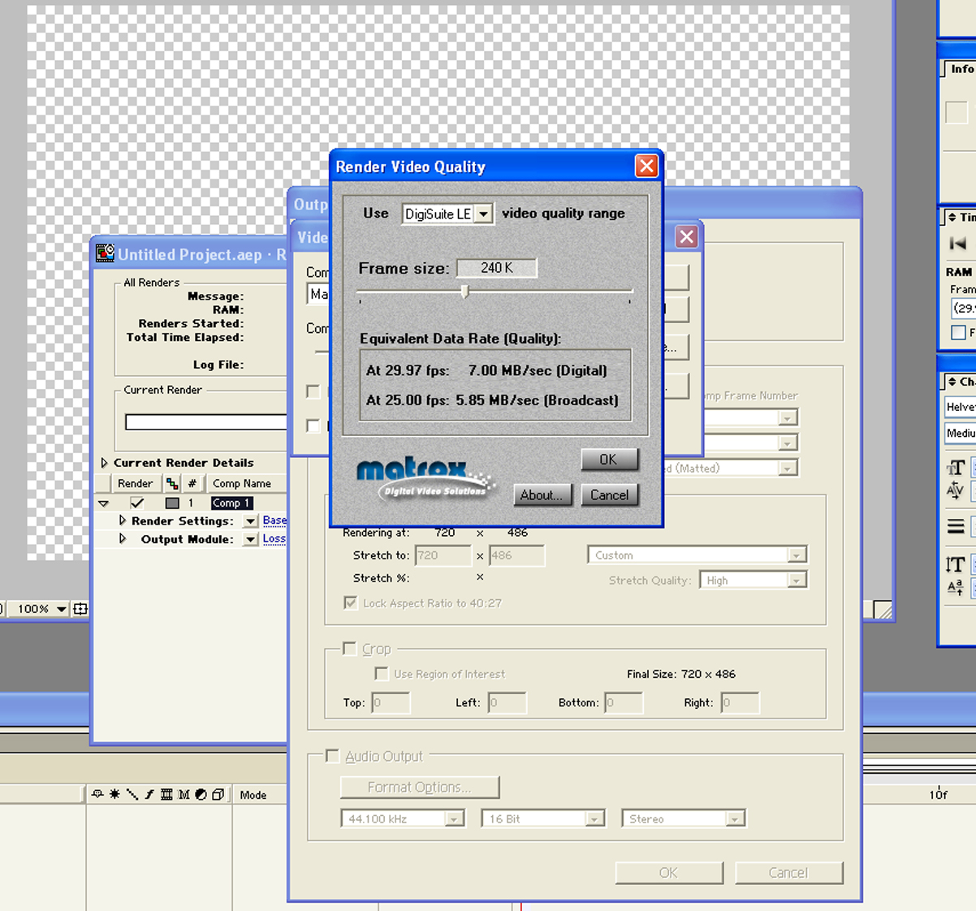

- Click on the Configure button and the Matrox Render Video Quality window will appear. Change to slider to make the Quality 7.00 MB/sec (Digital).

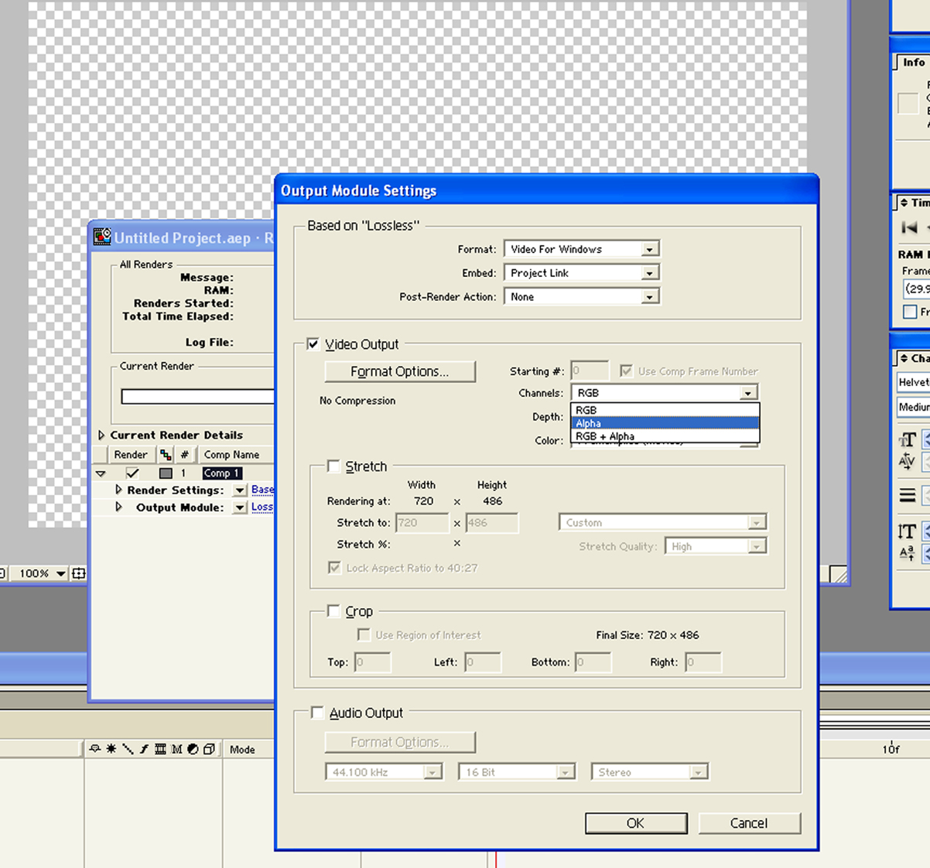

- There needs to be 2 renders done if there is to be an alpha channel associated with the video channel. The first pass should be set for RGB for the Video Output Channels. The second pass should be set for Alpha in the Output Channels pull down box.

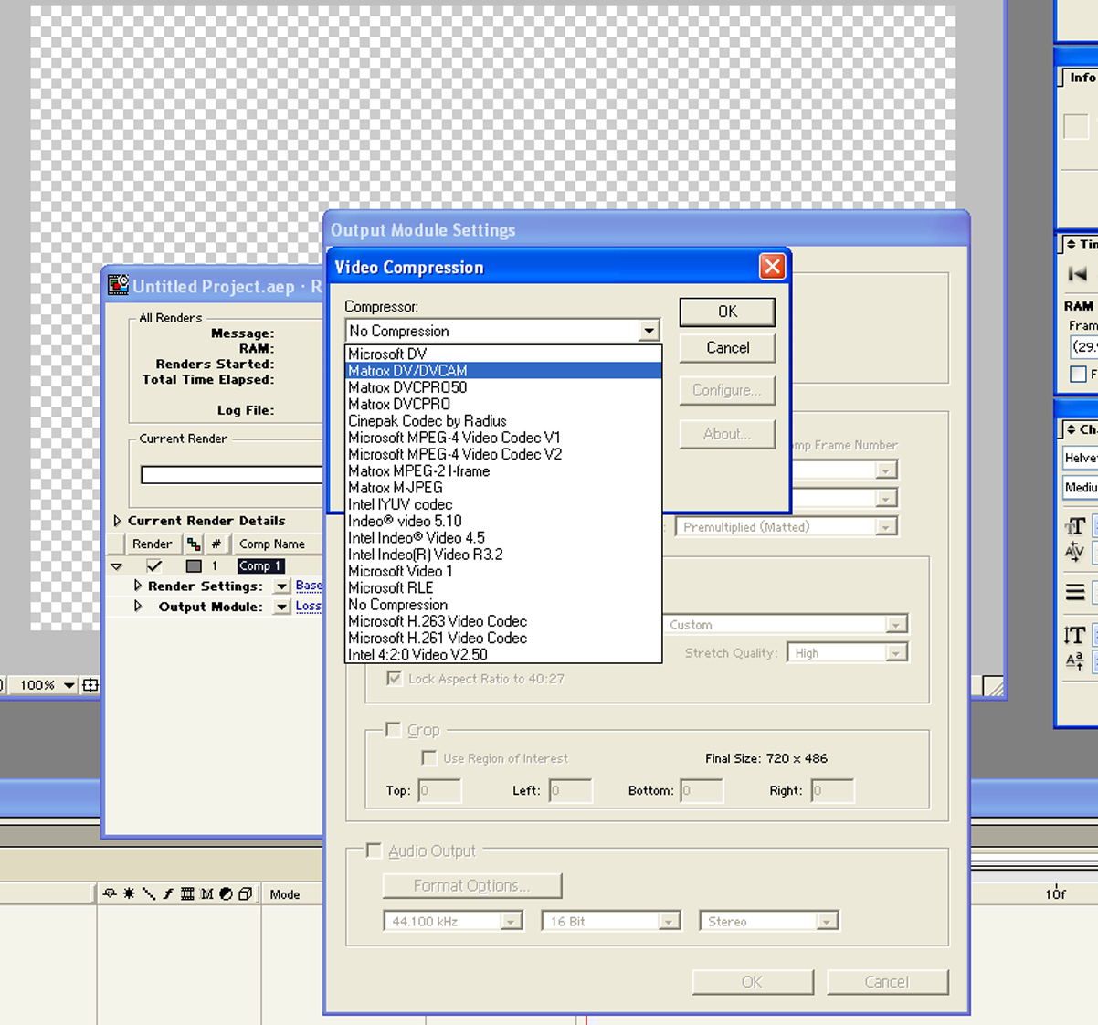
- This is the setting if making a clip for use in the Matrox Digiserver Clip Player in the DUET. Click on the Output Module “Lossless” words and the Output Module Settings menu will appear. The format should be set to Video for Windows in the top menu box. Then click the Format Options button to the left and select Matrox DV/DVCAM as the compressor. The 2 passes still have to be done for Video and Key as described in number 6 above.

- If you are making targa sequences in After Effects, you only have to make one pass for the render. The output module should be set to RGB+Alpha. The targa sequences can then be imported into the Clip Player by using the DigiUtils software that resides on the DUET for the Matrox Digisuite LE Clip Player or by using the Chyron TGA to AVI Converter software for the Matrox Digiserver Clip Player. The software will automatically make the 2 Matrox clips needed for video and key.

- There are 2 free software utilities from Chyron’s ftp site.
  - TGA to AVI converter – This utility converts targa files to be used in the Digiserver board. *MAKE SURE the files are 720 x 480 for NTSC and
720 x 576 for PAL.

  - Matrox Video Converter – This software converts digisuite files into digiserver files.

These files can be downloaded from Chyron’s ftp site at
ftp://ftp.chyron.com/pub/software/Lyric/Test/ Chyron TGA to AVI Converter11092004.ZIP

ftp://ftp.chyron.com/pub/software/Lyric/CurrentRelease/ MatroxVideoConverter.zip

