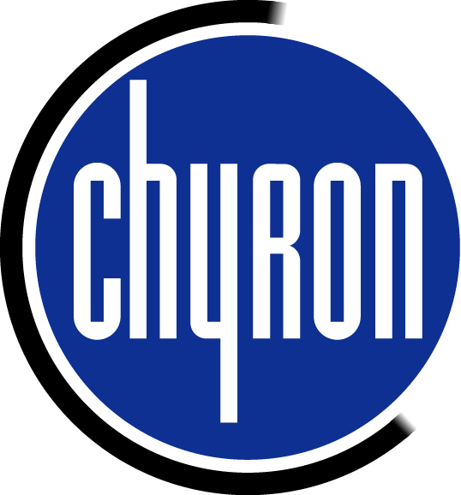

After Effects Settings to Save a Windows AVI File with Alpha for Lyric

- Build the animation with an alpha. From the After Effects tool bar press the Composition button and Make Movie.

- The Render Queue menu appears on screen. On the Render Settings, press the Best Settings words that are blue and this menu will appear on the screen. The only setting that is critical is the Field Render. Make this Lower Field First and click OK.
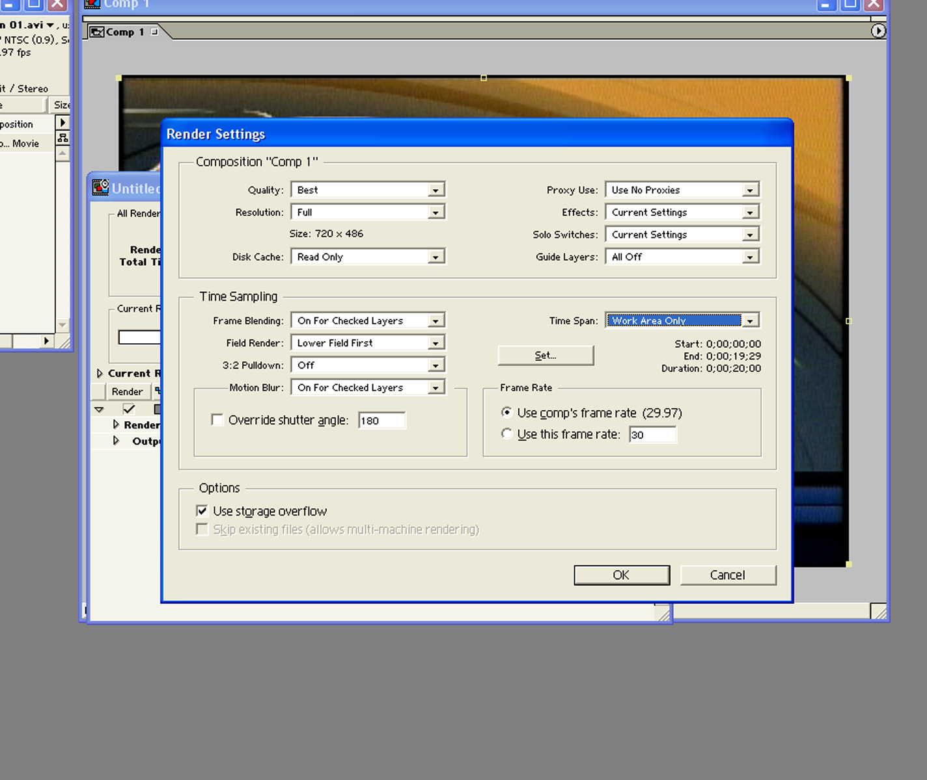

- Click on the Output Module Lossless words and the Output Module Settings menu will appear. The format should be set to Video for Windows in the top menu box. Then click the Format Options button to the left and select No Compression as in this picture.
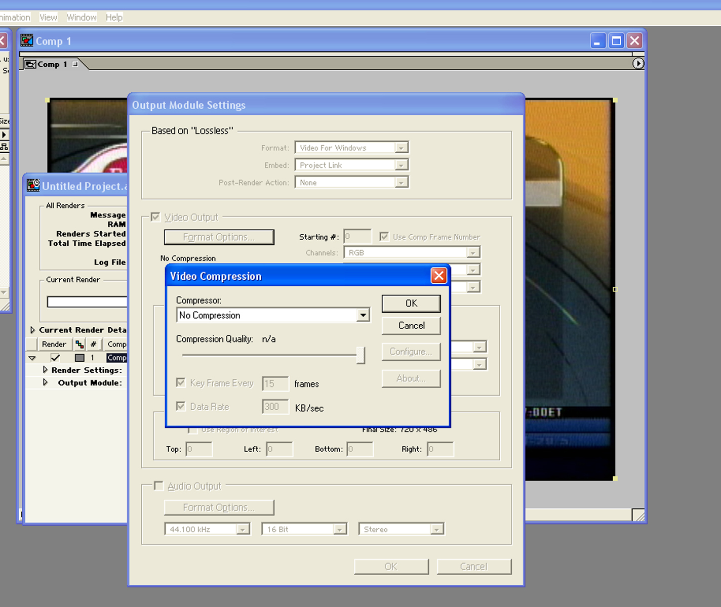

- Press on the arrow down for the Channels setting. Select RGB+Alpha setting and press OK as in this diagram.

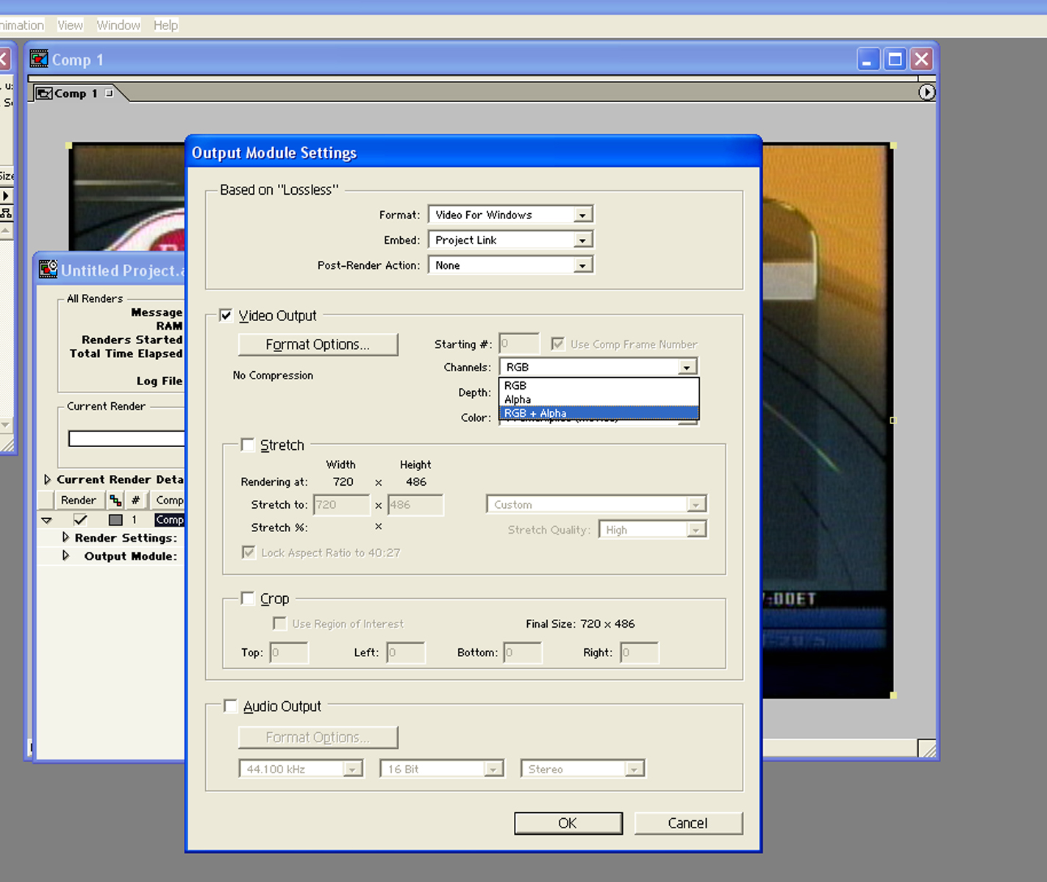

- Save the file to a message. This should import as a movie object into Lyric including the alpha channel. The same description will work for saving a Quicktime movie. Be sure to have Quicktime installed on the DUET for this to work.

- Windows AVI files use the texture memory of the DUET. If the movie object is not full frame then it is a good choice to crop the movie or reduce the movie in size to the biggest size needed. If the movie object is to loop, it should be designed as a 10 – 15 second movie. Anything longer will increase the preload time, thus making the recall time slower. A good number to work with is to NOT exceed a total of 700mb for all movie files used for a single message page.

