G/HQW200 in multi-view applications
Up to 40 channels of 3Gb/s, HD or SD-SDI on 3Gb/s SDI or DVI up to 1920x1200
A Synapse® Application Note

Copyright ©2007 AXON DIGITAL DESIGN BV

ALL RIGHTS RESERVED

NO PART OF THIS DOCUMENT MAY BE REPRODUCED IN ANY FORM WITHOUT THE PERMISSION OF AXON DIGITAL DESIGN BV.

Introduction

The GQW200 and HQW200 quad-split cards can be used to build a very flexible multi-view system. There are no additional costs involved other then the addition of one G/HQW200 per 4 inputs.
With the GQW200 you can build a system compatible with SD, HD (1.5Gb/s) and 3Gb/s SDI, The HQW200 can be used for SD and HD SDI, but allows for future upgrading to 3Gb/s.

Some of the key advantages of the G/HQW200 in multi-view applications are:

- Compatibility up to 3Gb/s
- Linear expansion
  - Start with 4 inputs, grow to 40 inputs when needed
- Extreme low latency of the whole system
  - 20ms for 50Hz video
  - 17ms for 60Hz video
- The system can be combined with a choice of over 130 other infrastructure and conversion product out of the extensive Synapse range in the same frame
- Output choice of DVI up to 1920x1200 and 3Gb/s SDI for 1080p
- 16 channel in 1RU with the SFR04 Synapse frame
- 32 channel in 2RU with the SFR08 Synapse frame
- 40 channel in 4RU with the SFR18 Synapse frame (maximum power for that frame)
- Preset based storage of all graphical settings
  - One mouse click or ACP command can re-organize the multi-view graphical settings

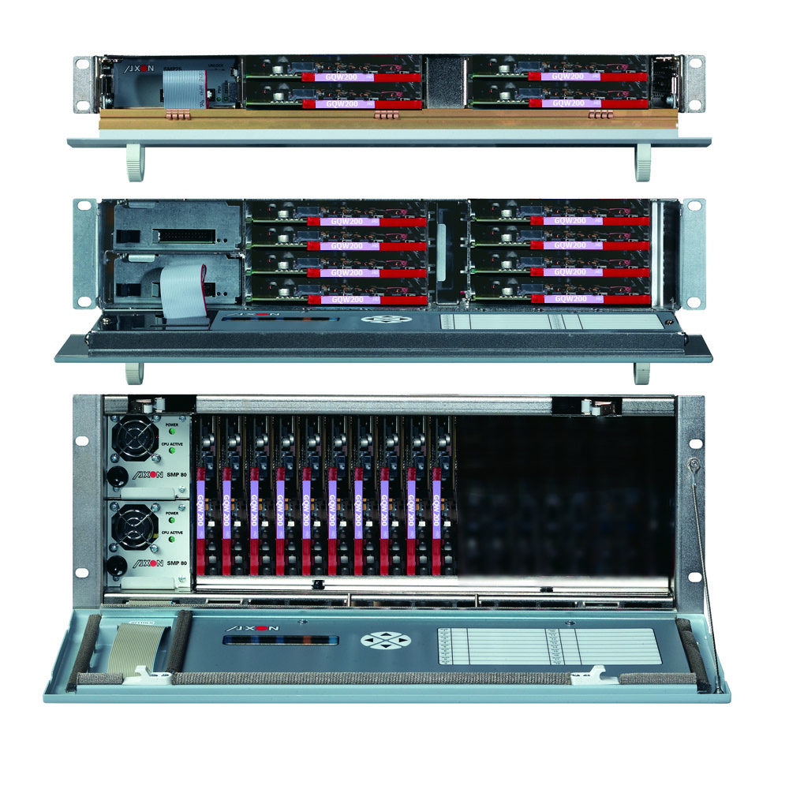
SFR04 with 4x QWW200 = 16 Channel multi-view

SFR08 with 8x QWW200 = 32 Channel multi-view

SFR18 with 10x QWW200 = 40 Channel multi-view

The GQW200 and HQW200 can be the ideal building blocks for high density multi-view applications
Card Features and applications

The GQW200 is a high-quality 4x 3Gb/s or HD or SD-SDI (in any combination) to QWXGA converter on DVI or 3Gb/s HD SDI out. The unit supports resolutions up to 1920x1200. A Tally and UMD OSD is included. This will enable a very compact monitor solution with the UMD and Tally as part of the set. High-quality in-house developed de-interlacing and scaling algorithms ensure crisp picture quality. The GQW200 si triple rate (3Gb/s, HD and SD) and the HQW200 is HD and SD, upgradeable to handle 3Gb/s.

- Quad-split function or full-screen mode for each input
- Low latency (20 mS for 50Hz, 17 mS for 59.94Hz)
- UP to 1920x1200 resolution on DVI (BPH15)
- Up to 1920x1080p on 3Gb/s SDI output (BPH16)
- Full variable scaling and positioning for all individual inputs
- All inputs compatible with (mixing is allowed within equal framerates):
  - 1080p 50 an 59.94
  - 1080i and 720p 50 and 59.94 Hz
  - 1080p (sf) and 720p 29.97/25/24
  - 1035i 60
  - SD 625 and 525
- 15-pole sub-D connector for serial UMD, Tally protocols (TSL and ASCII) and GPI triggers
- 8 and 16 character UMD capability
- Lock to input, reference or free running
- Color corrector
- UMD colors:
  - White
  - Green
  - Red
  - Amber
- Border, UMD and tally brightness adjustment
- Safe area:
  - Action
  - Graphics
  - Action + Graphics
  - Shoot and protect 4:3
  - Shoot and protect Action
  - Shoot and protect Graphics
  - Shoot and protect Action + Graphics
- Automatic 4:3 and 16:9 modes through VI or WSS triggers (SD-SDI inputs)
- GPI control for:
  - Aspect ratio (4:3 or 16:9)
  - Full screen or quad mode
  - Tally
- Full control and status monitoring through the front panel of the SFR04/18 frame and the Ethernet port (ACP)

Applications

- High resolution monitor walls
- Truck preview monitoring, registration walls and shading areas
- All life multi-view applications that require low latency
- Monitoring areas where flexibility and expansion is requierd

The use of the Synapse bus for multi-view applications

At the introduction of Synapse as a system the internal ‘Daisy Chain’ bus was developed for embedding and de-embedding applications. The popular ADD-ON functions were mainly used for Digital audio, Dolby E and Dolby Digital (plus) injection or extraction out of a Master-Card.
The beauty of the Synapse ADD-ON daisy chain buss is that it isn’t a real bus. It consists of a mere 13 traces running from card slot to card slot via the dedicated connecter found on every Synapse card. These 13 –non intelligent- traces are therefore very reliable as they are completely passive.
These traces are however impedance controlled and guarantee a safe transport of in this case 1920x1200 pixel DVI based information as standard twisted pair groups.

So how does this work?

If you take a look at the block schematic in the next paragraph you can see that the output of the G/HQW200 is not only fed to the physical output connector on the connector panel, but also to what we describe as the Synapse buss.
Just prior to the output sits a DVI mux, or better explained a summing device. This summing device takes DVI information (a full scale picture at end resolution) from the N-1 slot and sums that with its local picture to output the summed picture to the local DVI or SDI output and via the Synapse bus to the N+1 slot.

This method allows for a cascading of multiple quad-splits to form a multi-view device. It is linear in its expansion, very reliable and maintenance easy as every active building block is a hot swappable Synapse card, running a very stable Linux operating system that allows for very powerful vector based graphics to support the live images with Tally, UMD and other visual information features like audio bar graphs, Input integrity information or even displaying future metadata information.

These functions are enabled by just putting 2 or more GQW200 or HQW200 cards next to each other. No dip switches, no extra cables, no external DVI looping.

Block Schematic & Connector panel

BPH15 BPH16
3Gb/s, HD, SD SDI INPUT 1
3Gb/s, HD, SD SDI INPUT 2
3Gb/s, HD, SD SDI INPUT 3
3Gb/s, HD, SD SDI INPUT 4
TALLY UMD and GPI
DVI OUTPUT (BPH15) SDI OUT (BPH16)
Cascading quad-split cards

Some guides for building a multi view application:
- Every quad-split outputs the same resolution (up to 1920x1200)
- Any input can be positioned anywhere in the end resolution
- The individual images should not overlap as they will be mixed
- Only the card in the highest slot number will have the end picture
- The output can be DVI or 3Gb/s, HD or SD SDI

Because the individual outputs of each quad-split card are summed (over black in the DVI domain in very little time of a few clock samples) the total latency is still a field (or ‘p’ frame).

Set-up Software

Here are some screenshots of the setup program:

Ordering Information

Module:
- GQW200: 3Gb/s, HD, SD SDI quad split to QWXGA converter on DVI or (3Gb/s-HD) SDI
- HQW200: HD/SD-SDI quad split) to QWXGA converter on DVI or HD SDI. (upgradeable to handle 3Gb/s)

Standard I/O:
- BPH15_GQW200: I/O-panel for GQW200 with DVI output
- BPH15_HQW200: I/O-panel for HQW200 with DVI output
- BPH16_GQW200: I/O-panel for GQW200 with SDI output
- BPH16_HQW200: I/O-panel for HQW200 with SDI output

Specifications

HD/SD Serial Video Input
Standard | 625/50 or 525/59.94 SMPTE 259M-C (270Mb/s) with SMPTE 272M embedded audio
Standard | SMPTE 292M (1.5Gb/s), SMPTE 260M, SMPTE 274M, SMPTE 296M, SMPTE 349M, SMPTE424
Standard | 1080i/59.94, 1080i/50, 720p/59.94, 720p/50  1080p/50 and 1080p/59.94
Equalization | Automatic to 130m @ 1.5Gb/s with Belden 1694A or equivalent cable.  Automatic to 100m @ 3Gb/s with Belden 1694A or equivalent cable.
Return Loss | > 15dB up to 1.5GHz
Number of Inputs | 4
Reference Video Input
Standard | PAL (ITU624-4), NTSC (SMPTE 170M)
Number of Inputs | 2 on SFR18, 2 on SFR08, 1 on SFR04
Connector | BNC
Signal Level | 1V nominal
Impedance | High impedance, with loop for termination
Return Loss | > 25dB to 10MHz
DVI output
Standard | DVI digital single link 1920 x 1200
Number of Outputs | 1
Cable driver | Up to 10 meter of high quality DVI cable (Gefen)
SDI output
Standard | SMPTE 292M (1.5Gb/s), SMPTE 260M, SMPTE 274M, SMPTE 296M, SMPTE 349M, SMPTE424A
Number of Outputs | 2 (optional Dual link)
Miscellaneous
Weight | aprox 250g
Operating Temperature | 0° C to +50° C
Dimensions | 137 x 296 x 20 mm (HxWxD)
Electrical
Voltage | +24V to +30V
Power | <16 Watts

