**Cascade VIPs**

In order to setup a cascaded VIP system you will need to do the following:   
  
1. Connect the DVI-OUT from the first VIP to the DVI-IN of the second VIP in your cascade.  
  
2. In VistaLINK, on the VIP that is using its DVI-IN, right click and select view configuration. Make sure the Graphics Input Control - Mode is set to Scaled.

3. In Maestro, create a new system of type VIP. Set the VIP Type to "VIPCascade".  
  
4. Add the IP address and Hardware Type of each VIP involved in the cascade, and click OK.

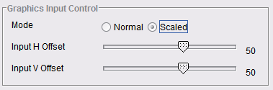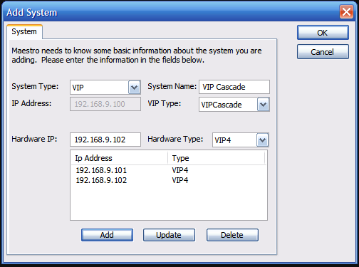

5. When you open the system in Maestro, you will see a "Unified Monitor". This will give you access to all inputs across the VIP modules.

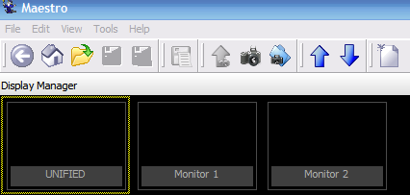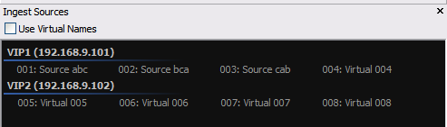

**For cascading VIP’s running newer firmware the procedure it’s different**

"For cascading VIP's you need to take the AUX output of one board and feed that into the AUX input of the other board

The Cascade has to be enabled on the board receiving the signal only

For VIPA-DUO (running onboard server) you have to enable Cascade through the serial menu, cannot be done through Web Interface

Cascade Configuration (Enter)

1) Enable Cascade (Enter)

Then y (Enter)

Then press s (Enter) to save and exit

After doing this it will be enabled (no re-boot required)

When you enable the Cascade serially your DVI 1 Output (Display 1) of that board will become the signal coming from the other VIP (it will be in the background if you have a full screen layout already, you may not see it)

The signal coming from the AUX output is DVI 1 Output (Display 1) of that VIP

You will not be able to Cascade to DVI 2, only #1”

To avoid conflicts make sure the frame rates and resolutions match on the cascaded VIP’s