1. How to configure Magnum to allow DAKtronics to fire a Salvo 2
1.1. Create a Salvo in Magnum 2
1.2. Open a Quartz port in Magnum 2
1.3. Confirm the Salvo number 2
1.4. Formulate the correct Quartz command 3
1.5. Verify the Salvo has been fired 3

Introduction
Daktronics is often used to control stadium video boards of many varieties. Stadiums are often required to have emergency messaging displayed on these boards in case of an emergency at the stadium. When triggered there are often routes that need to be executed to get the emergency messages to the stadium boards. Daktronics has the ability to fire a pre-configured salvo in magnum. The process below will describe how that can be configured.

How to configure Magnum to allow DAKtronics to fire a Salvo

Create a Salvo in Magnum
Open the Magnum Web interface. Navigate to Controls->Salvos. Create a new salvo, give the salvo a unique name, select the required destinations and relevant sources. Save the salvo and commit the changes to Magnum.

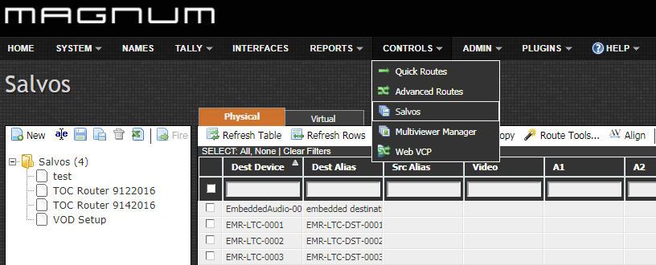

Open a Quartz port in Magnum
Navigate to Interfaces->Quartz. Open a port for Daktronics to connect on. Because you’re only firing salvos there’s no need to makes sources or destinations available.

Confirm the Salvo number
Once you’ve created the salvo, you will need to determine the salvo preset number. SSH into the Magnum server and login using the following credentials:

etservice//magnumhdtv

Once you’ve logged in execute the following command to readout the preset mapping file (salvo mapping):

cat /opt/eqx-server/config.d/presetmapping.map

Lookup the salvo name and the number to its left will be the salvo number you will use.
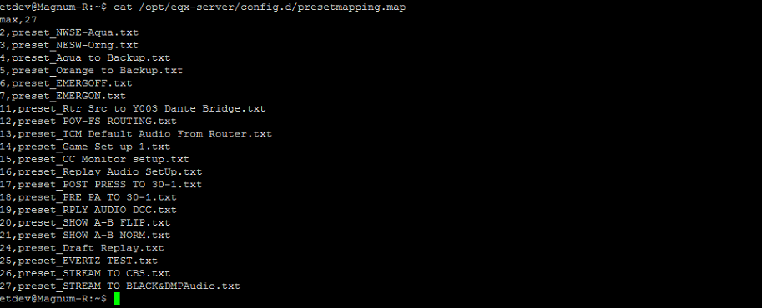

Formulate the correct Quartz command

From the quartz protocol document:

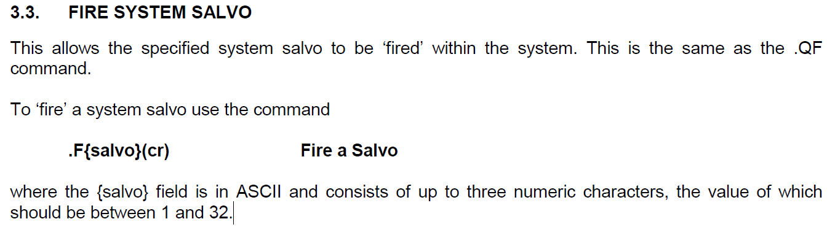

If we use the salvos from the example above, if we wanted to fire the EMERGON salvo our command would look like this.

.F7<cr>

Verify the Salvo has been fired
Using the same credentials mentioned in step 1.3, ssh into Magnum. This time run the command below to follow the triton logs:

tail –f /var/log/triton*.log

In these logs, after you execute the salvo you should see the salvo being fired as well as the IP that is was fired from (in this case it would be the IP of the Daktronics control system).
