This document contains instruction on how to determine a Kaleido-X RAM and CF card capacity from the system snapshot.

Steps:

- Take a system snapshot
  - Go to the IP address of the MultiViewer from a browser and click the “XAdmin” button
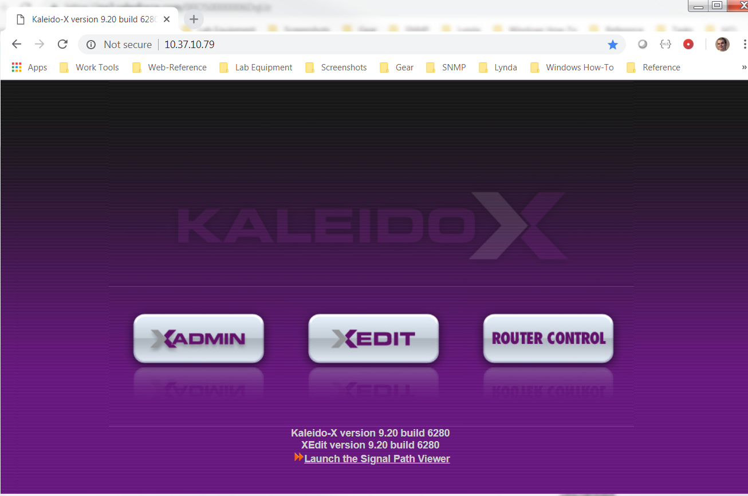
- Click on the “Help & support” tab on the left, then the “system snapshot” URL. This will download a .zip file to your PC’s web download location. This is the system snapshot we need.
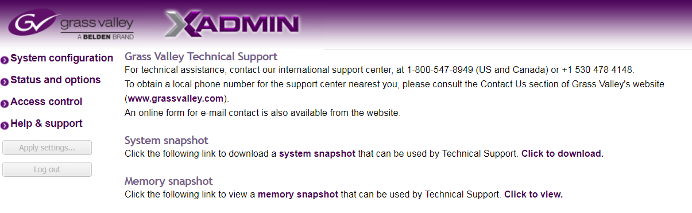
- Anatomy of a system snapshot
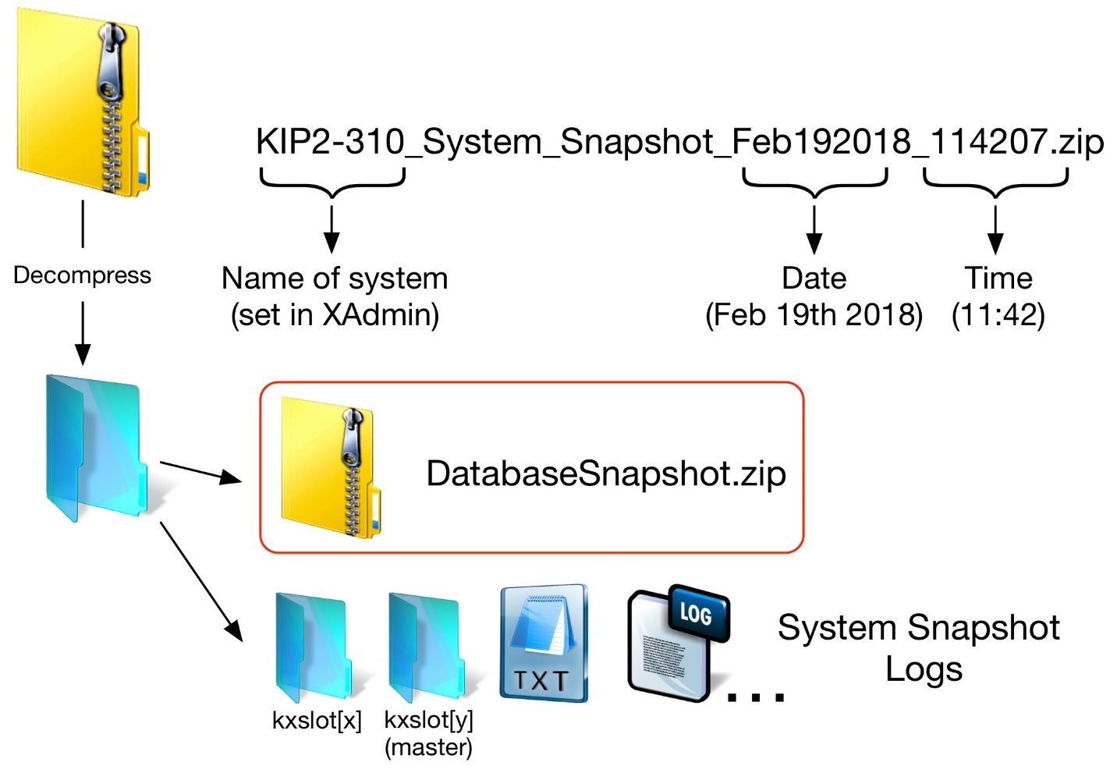
- The kxslot folders are for each output card, and they are the ones we need to drill into
  - Each folder will contain a dmesg file, this is the file we need to look at. This file is created by the embedded Linux OS, and will contain entries regarding the booting of the card.
  - Look for the value HIGHMEM and LOWMEM, add them together. If the total is around 2000, you have 2GB RAM, if the total is around 1000, you have 1GB RAM
Example for a card with 2GB
1142MB HIGHMEM available.
896MB LOWMEM available.
  - Look for the size of the detected storage, this can be detected as HDA or SDA depending on the card or Flash card, and will be shown in MB or GB
Examples for a card with 4GB flash card
hda: 7847280 sectors (4017 MB) w/1KiB Cache, CHS=7785/255/63, UDMA(66)
sd 4:0:0:0: [sda] 7847280 512-byte logical blocks: (4.01 GB/3.74 GiB)

