NUCLEUS Centrio Quickstart Guide

- Before You Start ( Hierarchy, Connectivity and IP Settings)
- Discovering Devices
- Transferring To The Configuration Folder
- Creating A Centrio Panel

- Before You Start (Hierarchy, Connectivity and IP Settings)

For sake of simplicity, this quickstart guide will assume that the devices to be configured are 1 – CENTRIO and 1 – NUCLEUS panel.

The first step in configuring NUCLEUS panels is to insure all the devices you wish to configure are connected to a common network switch and are all on the same IP subnet.
If you don’t understand this statement it’s time to ask for help from your IT person.

NOTE: This guide will also assume that all devices are connected to the same switch.
It also assumes that a Router database has already been configured.

- Discovering Devices

1. Start the Navigator software application

2. On start up, the application should look similar to the image below.

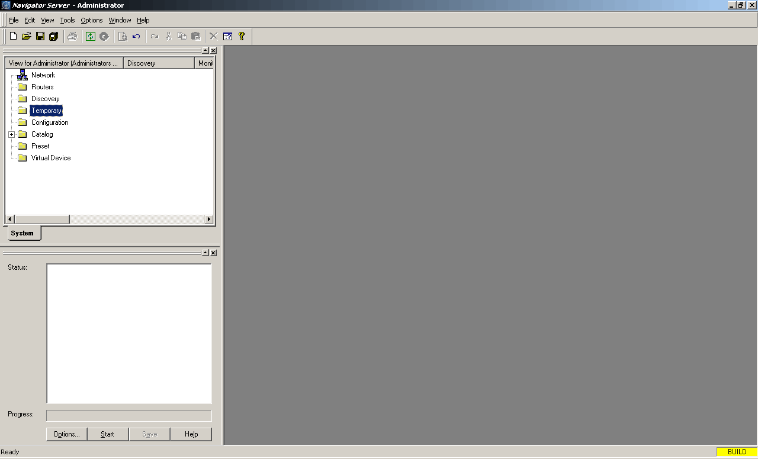

3. However, if the Navigation and Discovery screens to the left are not open, click on the Tools menu at the top of the screen to open them.

4. Click the Options button in the Discovery window.
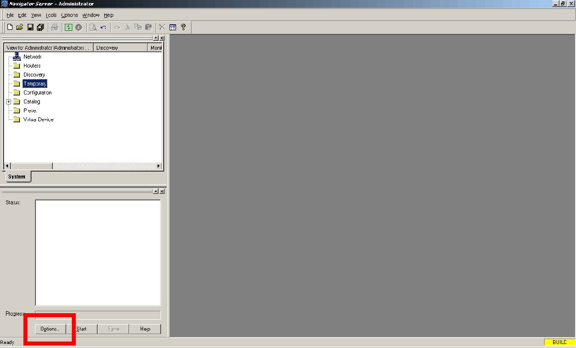

5. The Discovery Options window opens
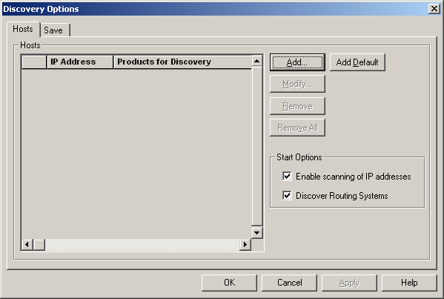

6. Click the Add button

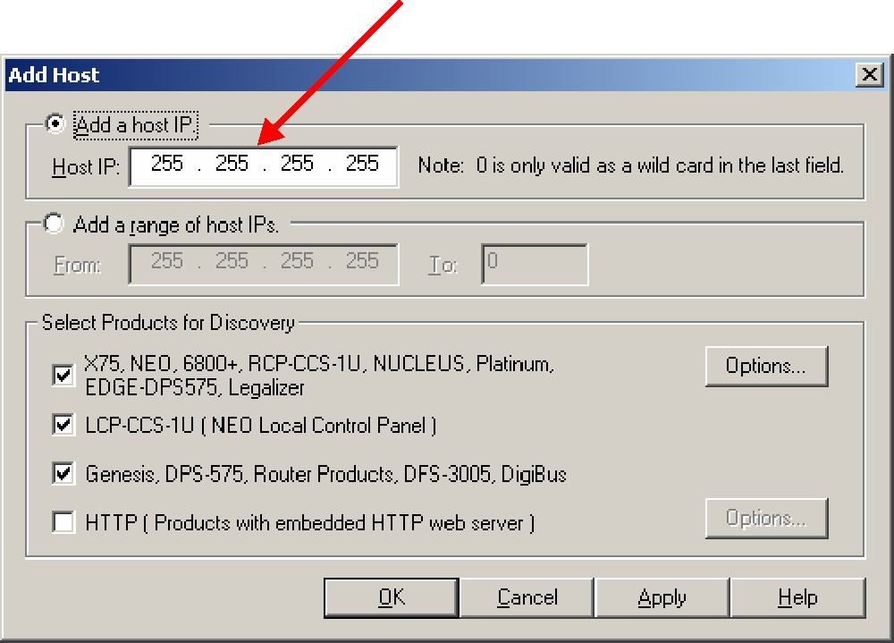
If you want to discover only a single device, type its IP address in the Host IP field.

7. For multiple device discovery, type in a range of IP addresses by using the Add a range of host IP’s fields

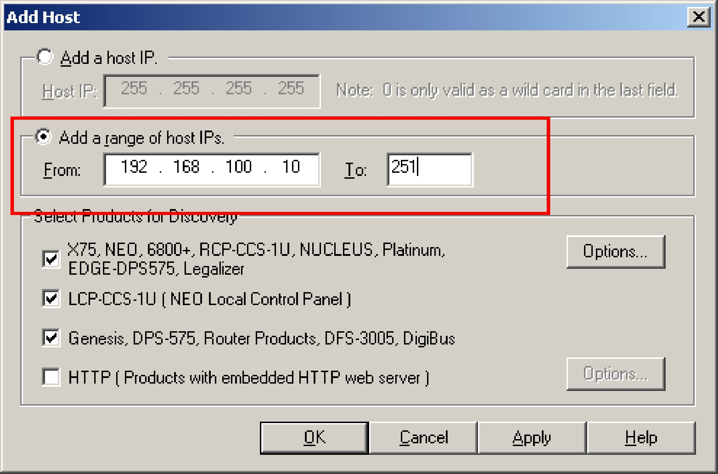

8. The IP addresses you added are displayed under IP Addresses

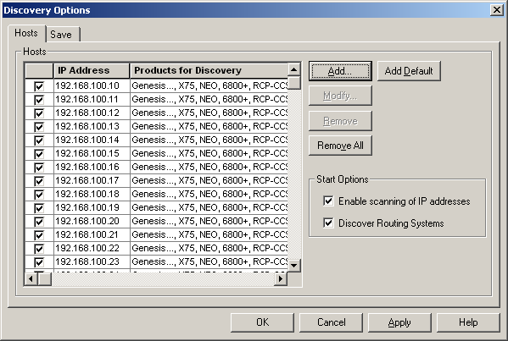

9. Click on OK

10. Click the Start button in the Discovery window

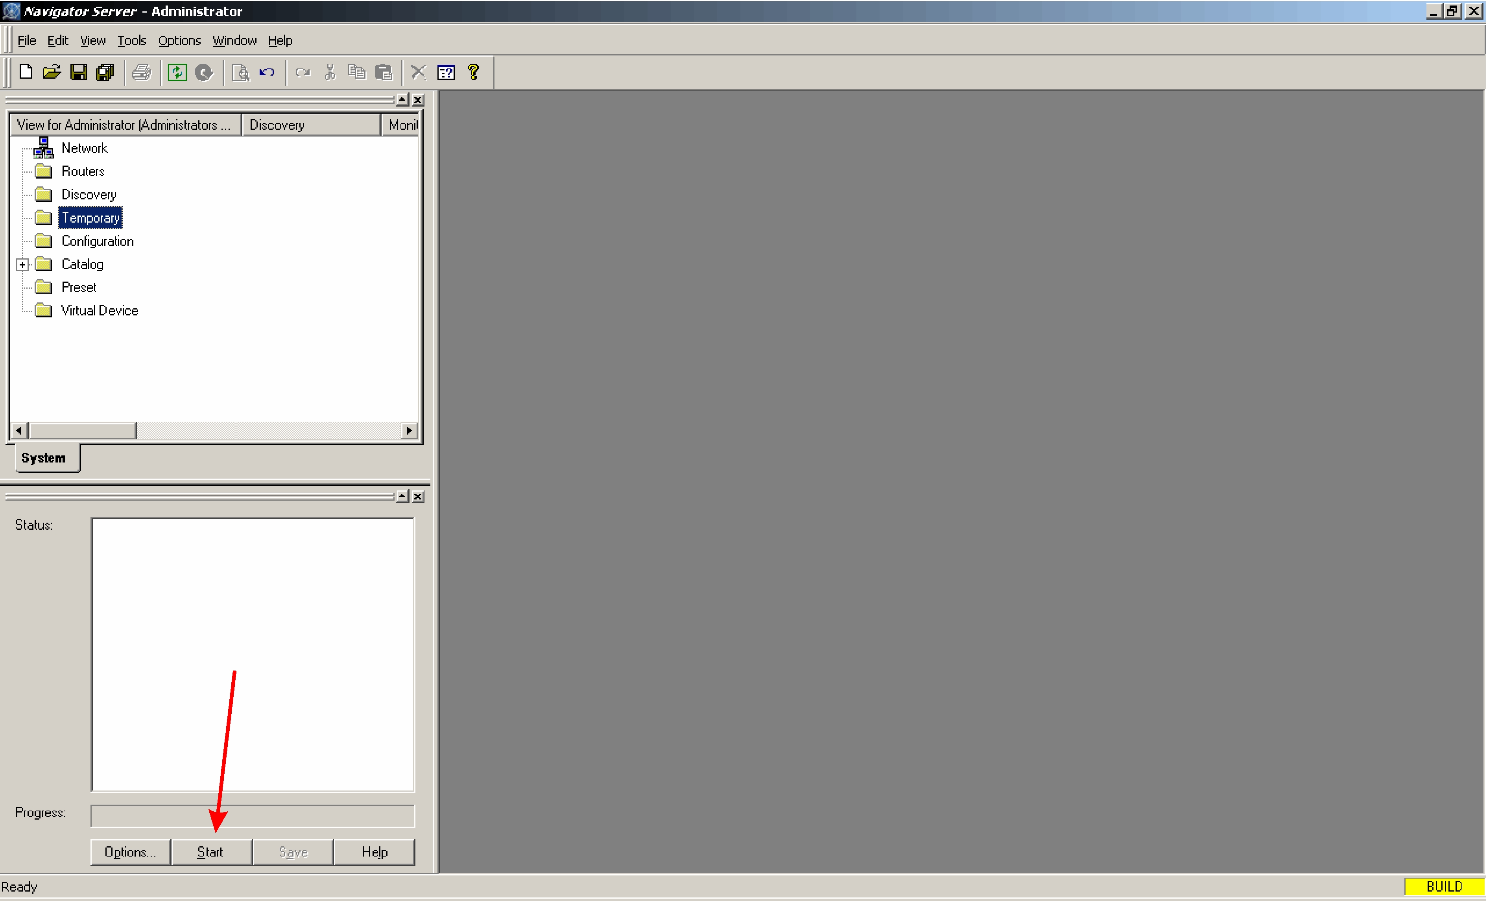

11. When the discovery process is complete, click Save in the Discovery window. Click Yes when the conformation window appeals.

12. Close the Discovery window by clicking on the x in the upper right corner of the window. This allows for more useable screen area.

- Transferring To The Configuration Folder

Before starting a configuration, the NUCLEUS panel to be configured and the devices it will control must be copied and transferred to the configuration folder.
There are two methods for doing this. The first is to “Click and Drag”.
To do this, first select a NUCLEUS panel from the Discovery folder. Hold down the left mouse button and drag the NUCLEUS icon into the Configuration folder.

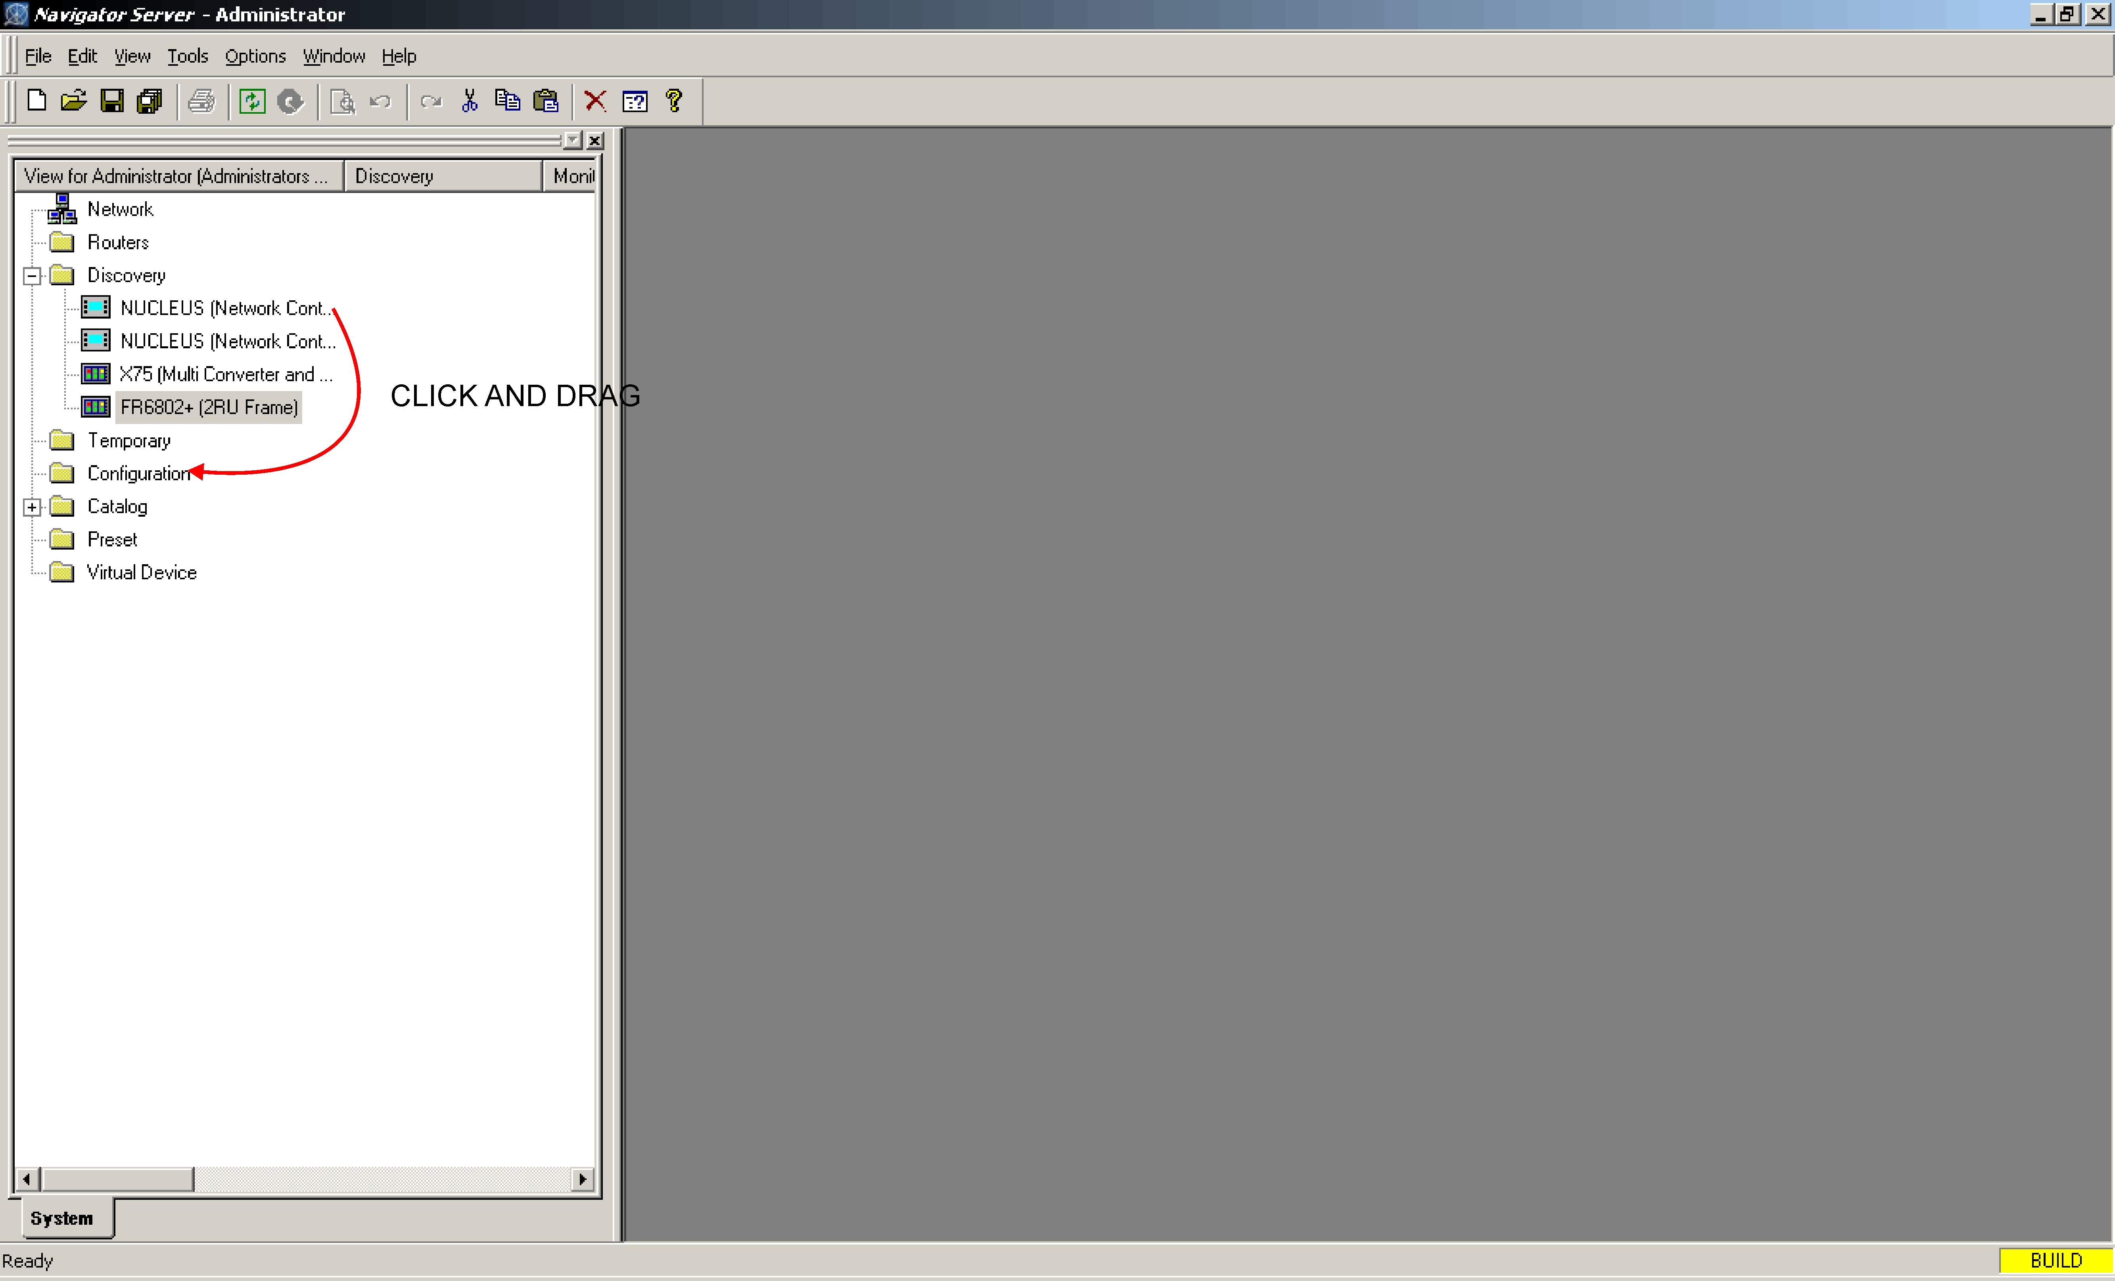

The second method is to copy a device from the Discovery folder and paste it into the Configuration folder. The fastest way to do this is to highlight the desired device in the Discovery folder, then hold down the “Ctrl” key on the keyboard and press “c”.
Next, click on the Configuration folder, hold down the “Ctrl” key and press “v”.

After the NUCLEUS panel is in the Configuration folder, expand it to reveal the following sub folders: Router/Centrio Views, Devices and Configurations.
Expand the Centrio icon to expose the Centrio System icon then transfer it to the Router/Centrio Views folder under the NUCLEUS panel.

- Creating A Centrio Panel
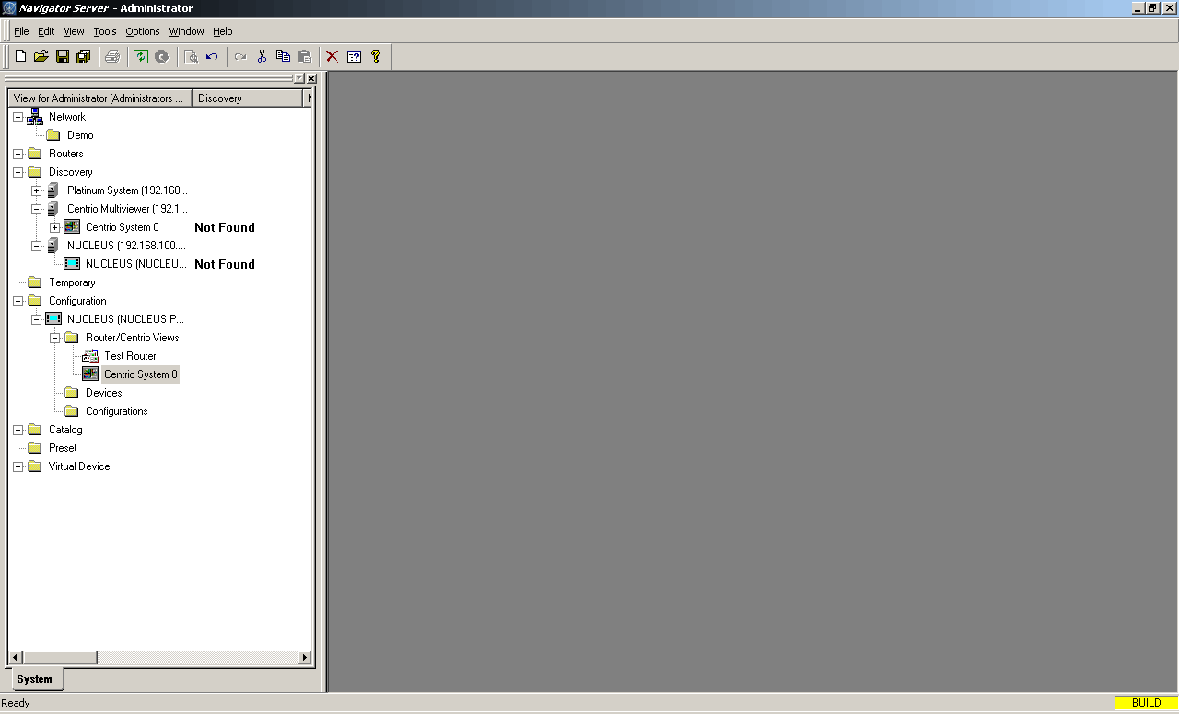

Expand the NUCLEUS in the configuration folder to reveal the Router / Centrio Views subfolder.
Expand the Router / Centrio subfolder and right click on the Centrio System icon,
Click Create and Routing Panel

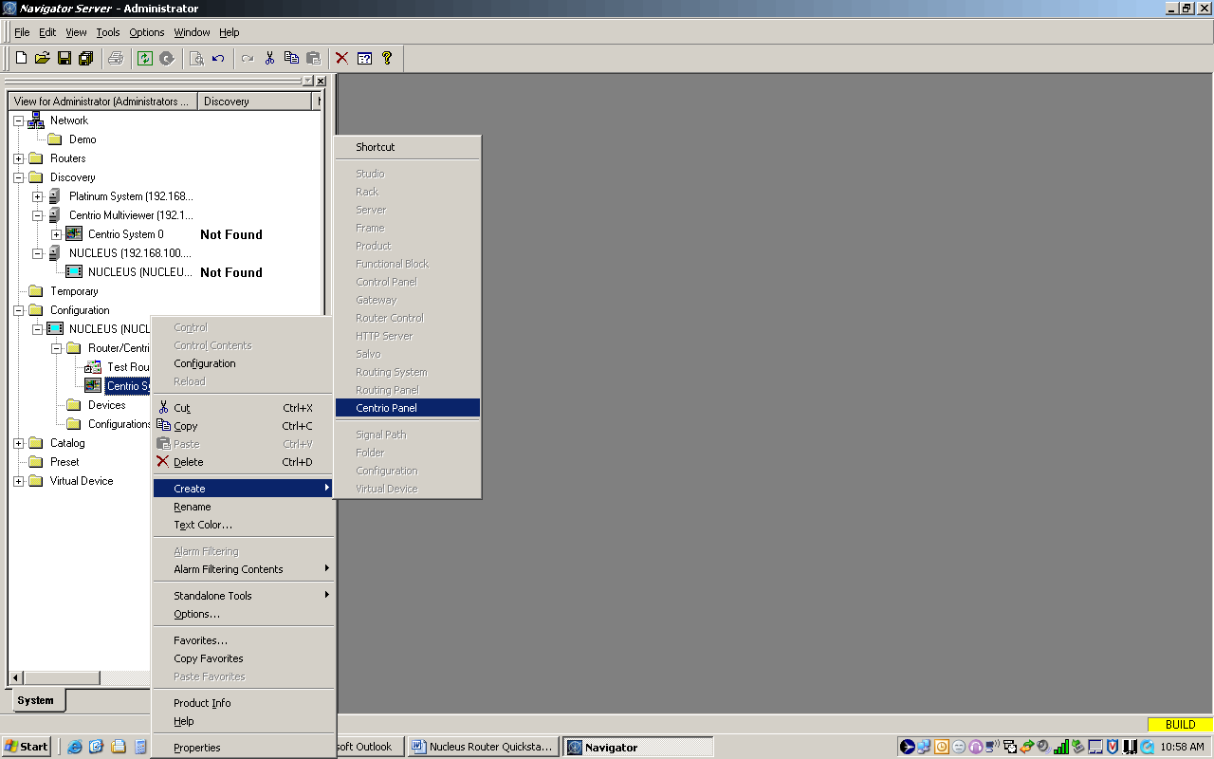

The Centrio Panel Configuration window opens.

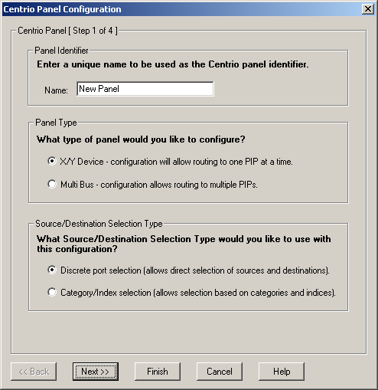

Under Panel Identifier enter a name for this Panel.
Under Panel Type select either XY or Multibuss.
Under Source / Destination Selection Type select either Discreet Port Selection or Category / Index Selection.

Click Next

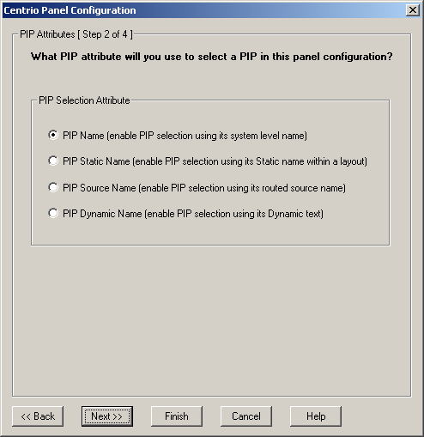

This window lets you select how PIPs will be identified
Select the option which best fits your application

Click Next

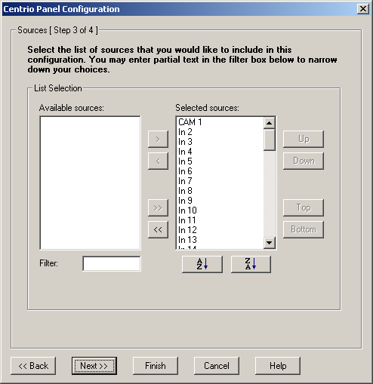

In this step you can select which of the sources in the router database will be available to this panel
NOTE: The default is all sources selected. To remove sources move them to the Available Sources pane using the <, >, << and >> keys

Click Next

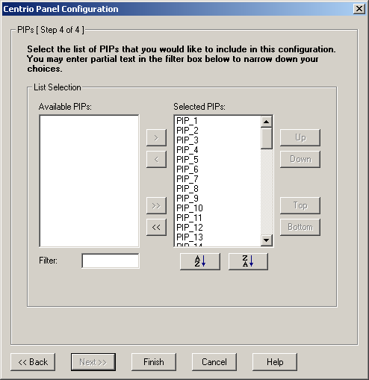

This step is identical to the two previous one except here you can select which PIPS you want.

Click Finish

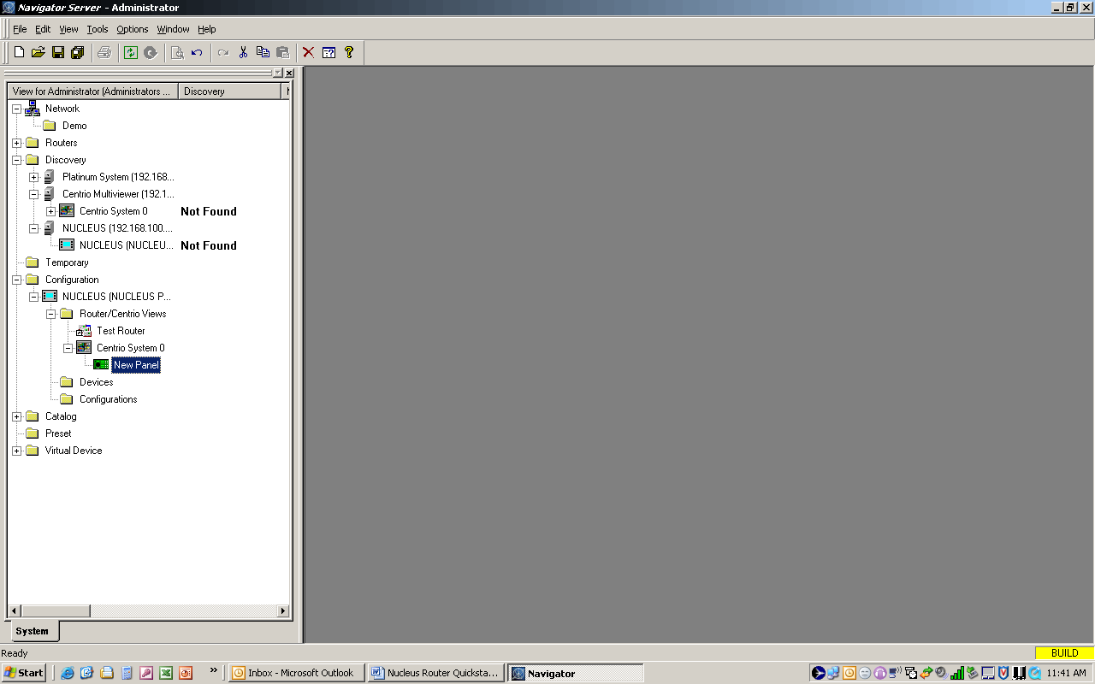

There will now be a new panel icon under the Centrio System icon in the Router / Centrio view folder of the NUCLEUS panel.

The new Centrio panel can now be transferred to the NUCLEUS panel.
For information on this procedure please refer to the NUCLEUS Quickstart Guide

