Nucleus Quickstart Guide

- Before You Start ( Hierarchy, Connectivity and IP Settings)
- Discovering Devices
- Transferring devices to the Configuration folder
- Setting Favorites and Alias Names
- Making a First Configuration
- Transferring Configurations to the Nucleus Panel

- Before You Start (Hierarchy, Connectivity and IP Settings)

For sake of simplicity, this quickstart guide will assume that the devices to be configured are 1 – X75 frame sync and 1 – NUCLEUS panel.

The first step in configuring Nucleus panels is to insure all the devices you wish to configure are connected to a common network switch and are all on the same IP subnet.
If you don’t understand this statement it’s time to ask for help from your IT person.

Once again, for sake of simplicity, this guide will assume the following IP addresses:

Nucleus – 192.168.100.50
X75 – 192.168.100.70

NOTE: This guide will also assume that all devices are connected to the same switch.

- Discovering Devices

1. Start the Navigator software application

2. On start up, the application should look similar to the image below.

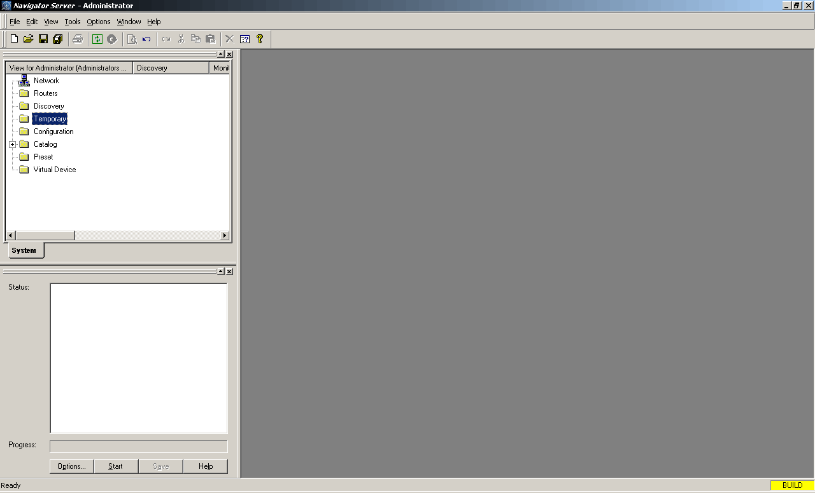

3. However, if the Navigation and Discovery screens to the left are not open, click on the Tools menu at the top of the screen to open them.

4. Click the Options button in the Discovery window.
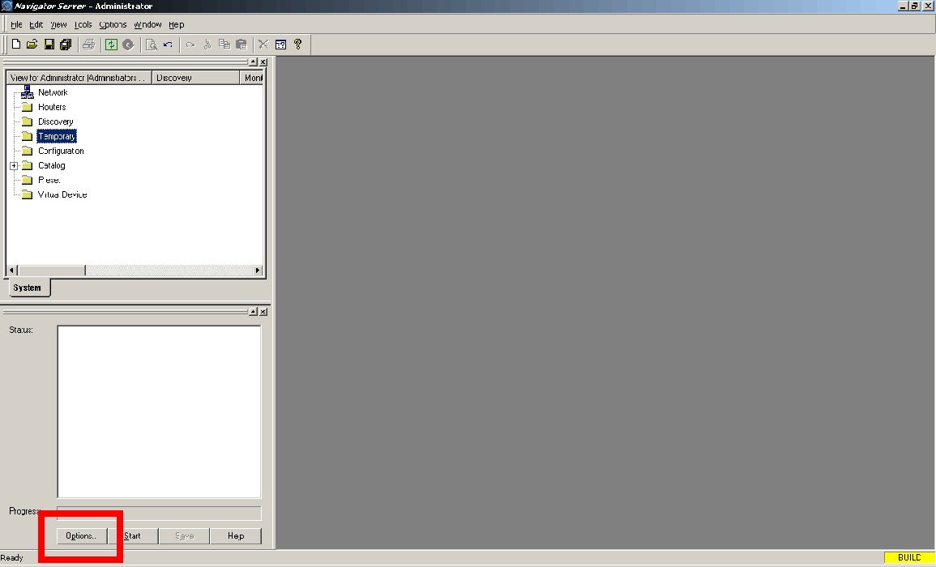

5. The Discovery Options window opens
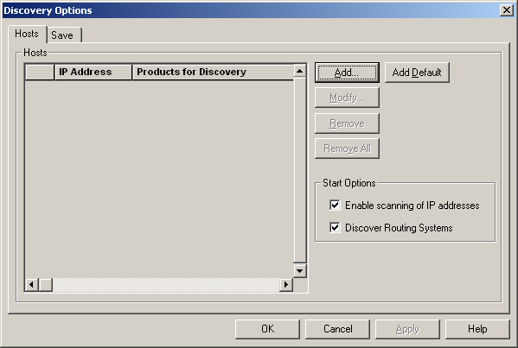

6. Click the Add button

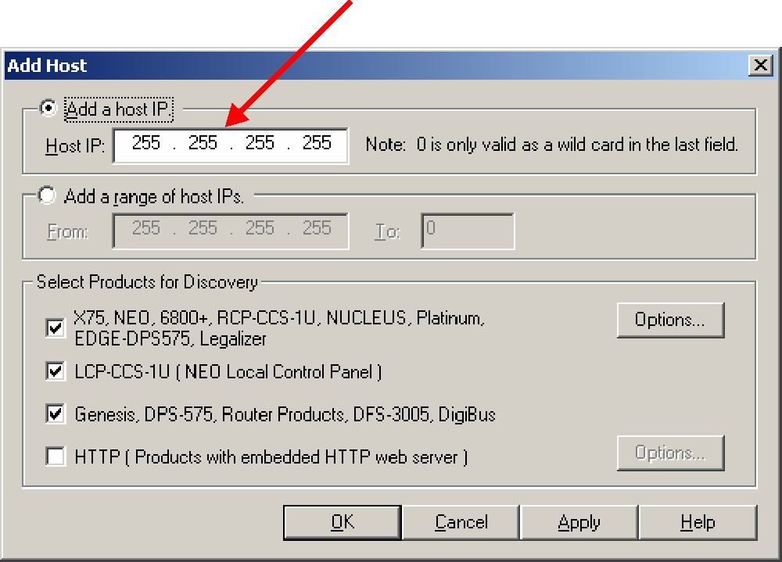
If you want to discover only a single device, type its IP address in the Host IP field.

7. For multiple device discovery, type in a range of IP addresses by using the Add a range of host IP’s fields

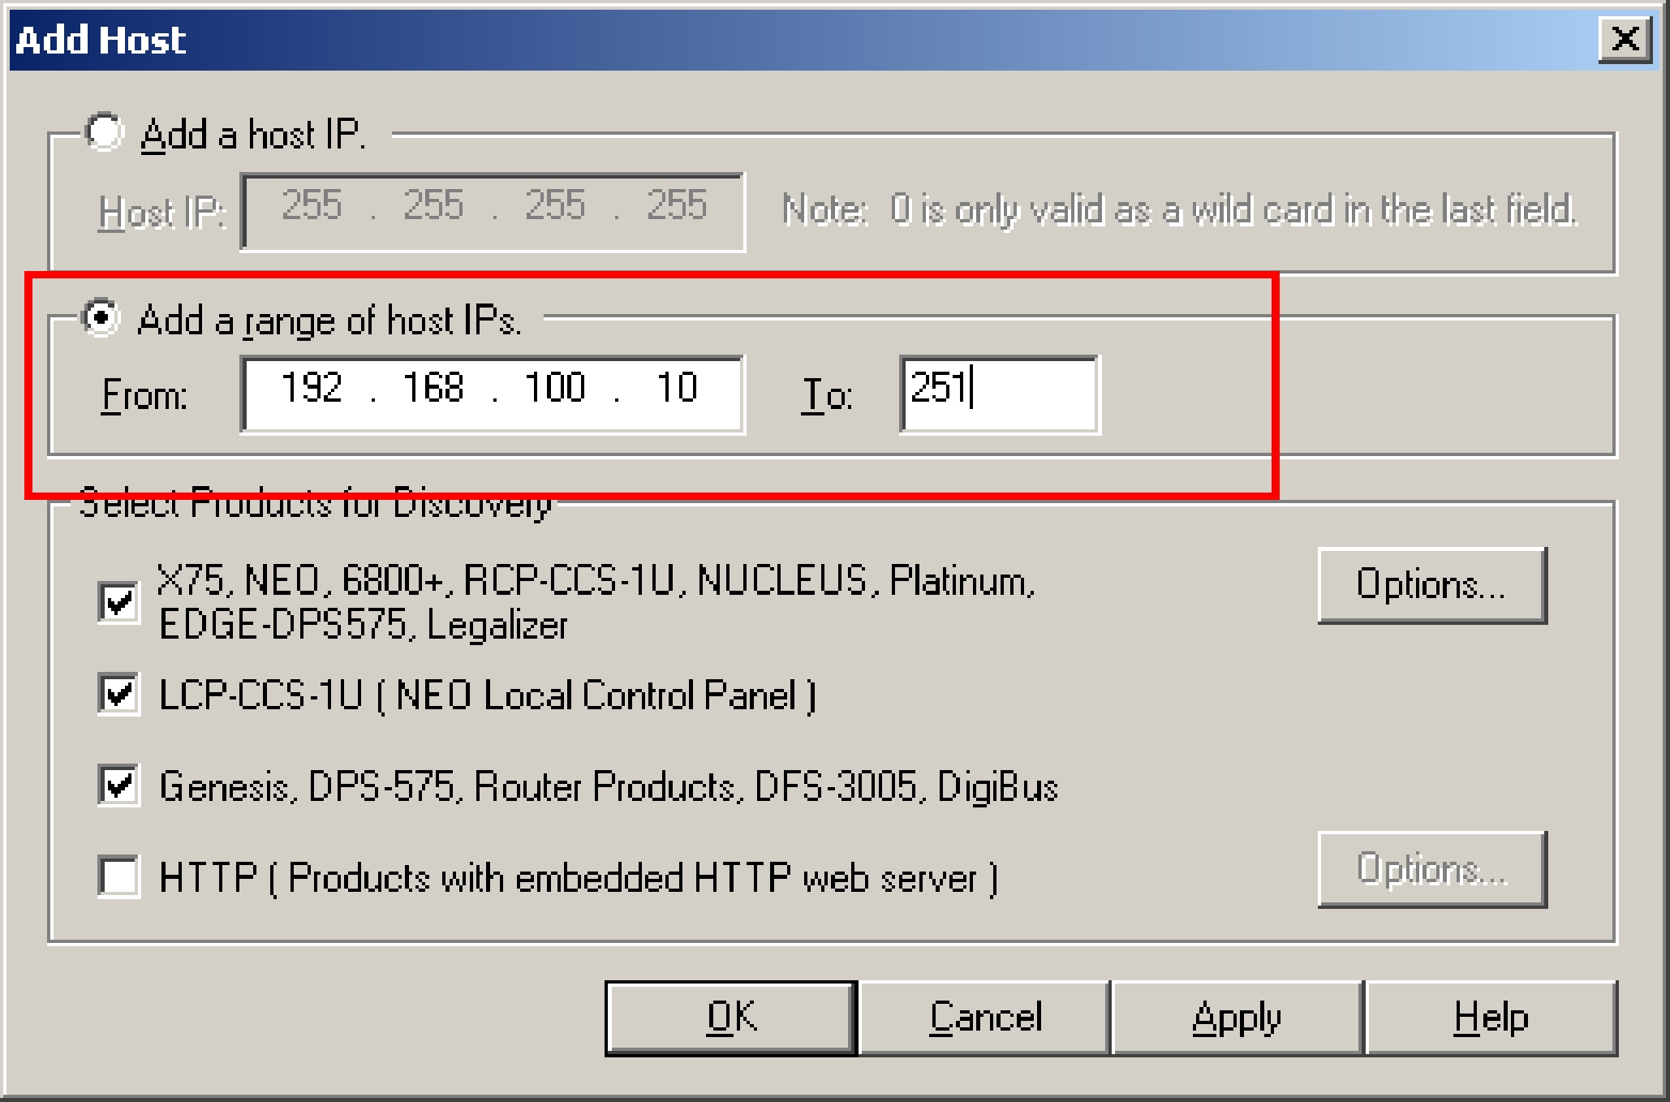

8. The IP addresses you added are displayed under IP Addresses

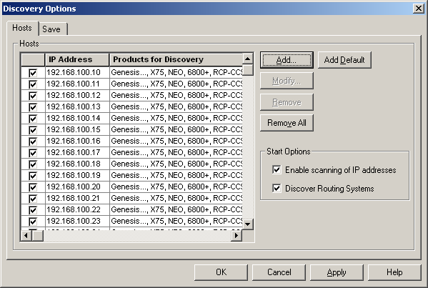

9. Click on OK

10. Click the Start button in the Discovery window

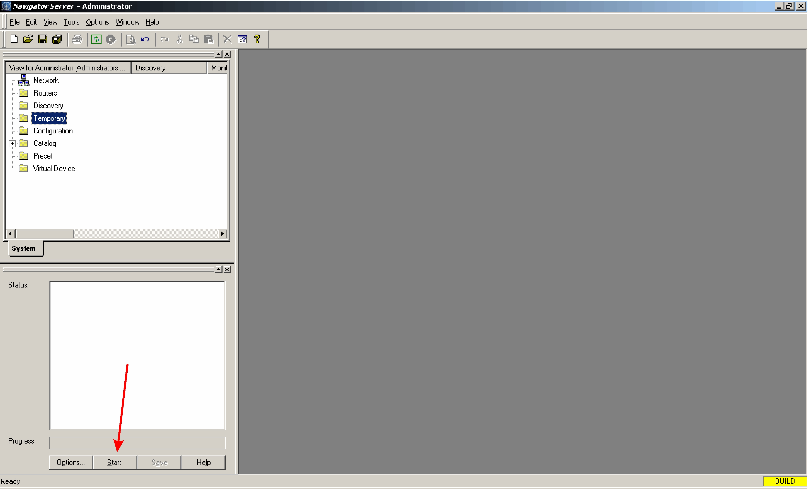

11. When the discovery process is complete, click Save in the Discovery window. Click Yes when the conformation window appeals.

12. Close the Discovery window by clicking on the x in the upper right corner of the window. This allows for more useable screen area.

- Adding Devices to the Configuration Folder

Before starting a configuration, the NUCLEUS panel to be configured and the devices it will control must be copied and transferred to the configuration folder.
There are two methods for doing this. The first is to “Click and Drag”.
To do this, first select a NUCLEUS panel from the Discovery folder. Hold down the left mouse button and drag the NUCLEUS icon into the Configuration folder.

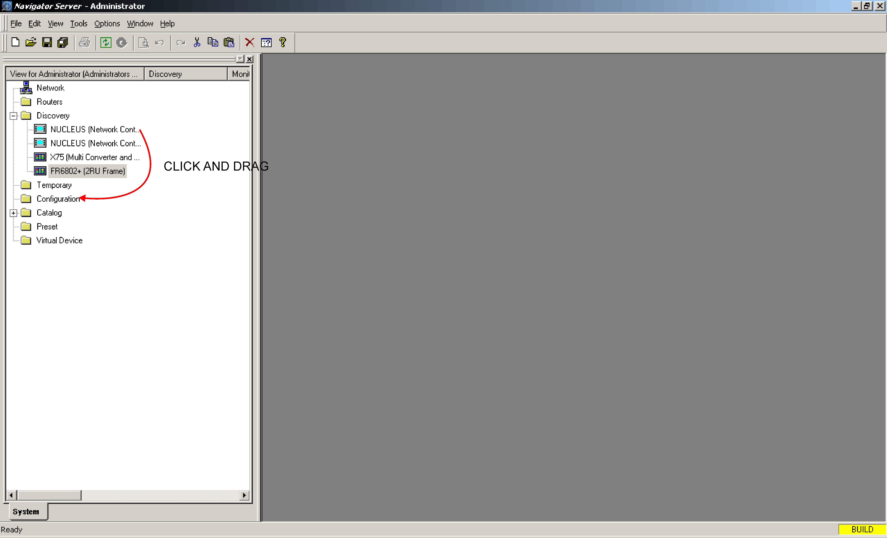

The second method is to copy a device from the Discovery folder and paste it into the Configuration folder. The fastest way to do this is to highlight the desired device in the Discovery folder, then hold down the “Ctrl” key on the keyboard and press “c”.
Next, click on the Configuration folder, hold down the “Ctrl” key and press “v”.

After the NUCLEUS panel is in the Configuration folder, click on it to reveal the following sub folders: Router, Devices and Configurations.
Using either the drag and drop or copy paste methods described above, transfer a device from the Discovery menu to the Devices sub-menu of the NUCLEUS panel in the Configuration folder.

- Setting Favorites and Alias Names

When configuring the NUCLEUS panel to control a device, it is extremely rare that all of the available parameters on any device actually need to be adjusted on a regular basis. Particularly on complex devices, such as an X75, having all the devices parameters available on the Nucleus panel would be complex, inefficient and unnecessary.
Therefore, it makes sense to configure the NUCLEUS panel only with parameters that are adjusted frequently. The method Navigator uses to select commonly adjusted device parameters is called “Setting Favorites”.

1. RIGHT click on the device transferred to the NUCLEUS panel’s Device sub-folder in the previous step. Select Favorites from the pop-up menu.

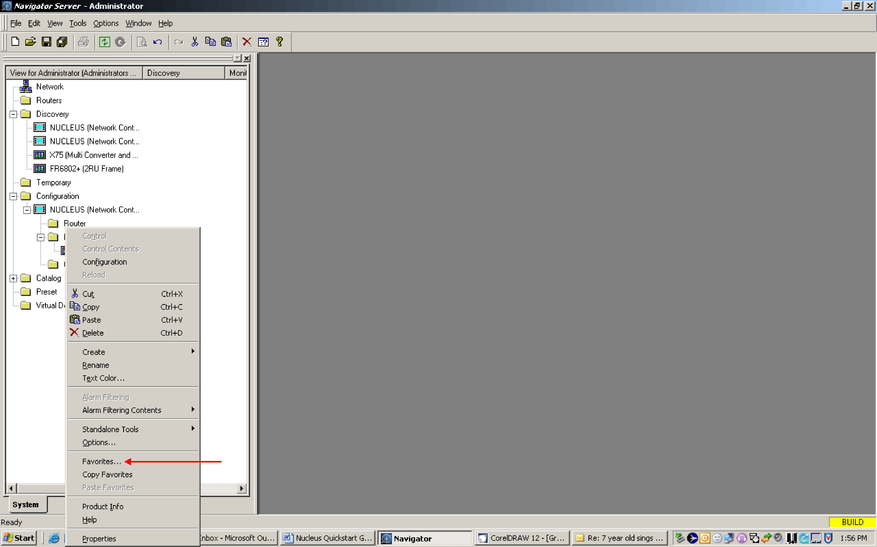

The Favorites menu opens

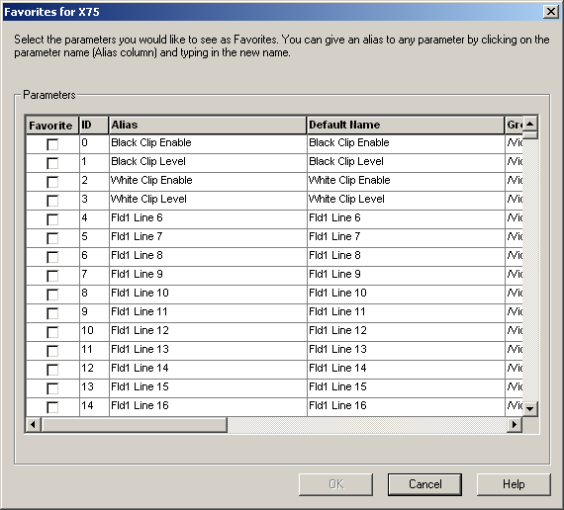

2. Scrolling down through the above Favorites menu for the X75 reveals 2480 parameters. Far more than are actually required for the day to day operation of the X75

3. Scroll down through the list of parameters to number 157, and select the check box in the Favorite column.

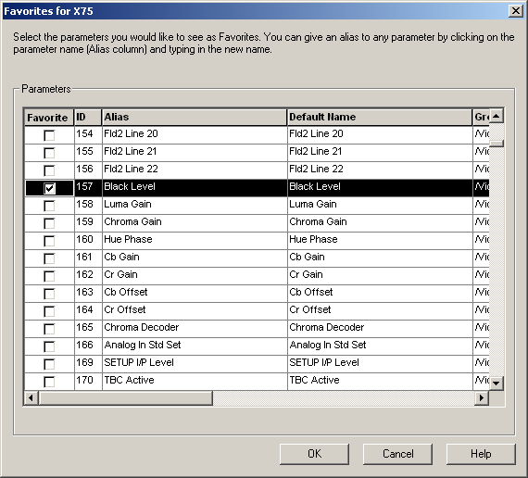

As the instructions at the top of this window suggest, the name of this parameter can be changed by clicking on its name in the Alias column then typing in a new name.

4. Select parameters 157 – 160, then retype their names to “Black”, “Luma”, “Chroma” and “Hue” respectively.

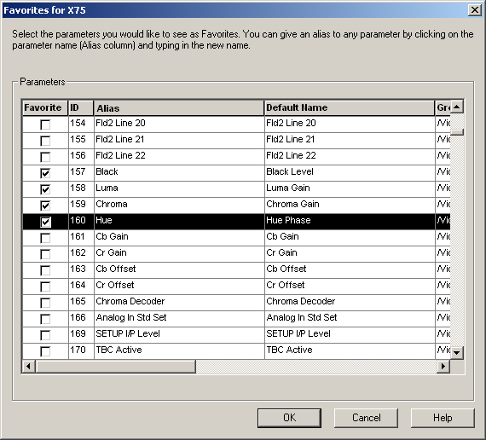

The parameters selected in this example are used to adjust the X75’s Analog Proc amp.
During this process it’s a good idea to make note of the Favorites chosen in order to categorize them later. In this case, the category would be “Analog Proc”
In this example we’ll create four more groups of parameters: “SD1 Proc”, “SD2 Proc”, “ARC” (Aspect Ratio Control) and “Audio Gain”. These can be found at parameter numbers: SD1 Proc – 215-217, SD2 Proc - 257-260, ARC – 371-380 and Gain 577-584.
Select the Favorites check box for each of the parameters listed above.

- Making a First Configuration

1. Double click on the NUCLEUS icon in the Configuration folder or right - click the NUCLEUS icon, then select “Configuration”.

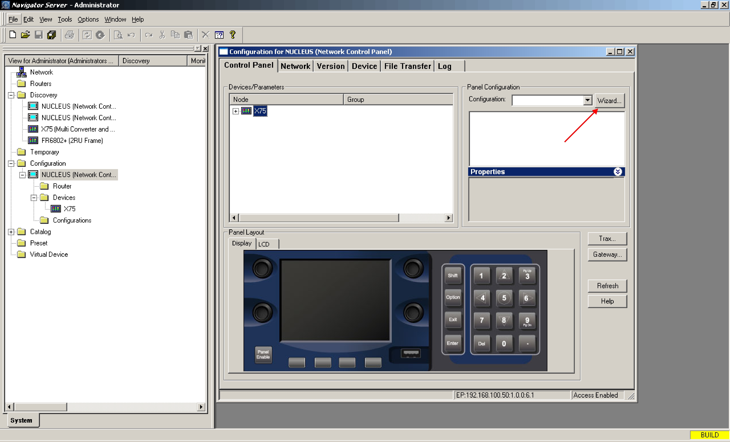

If you are not automatically prompted to do so, click the “Wizard” button in the Configuration for NUCLEUS dialog box.

2. Give a name to the new configuration (for example “test”)

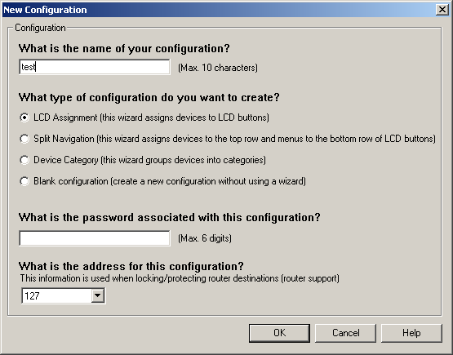

You can now select the type of configuration you want to create
There are four possible choices:

* LCD Assignment:
Used for simple configurations where sixteen or less devices are required

* Split Navigation:
This splits the LCD panel into two rows of eight buttons each. The top row becomes devices and the bottom row becomes device menus.
This type of configuration is useful where very quick switching between multiple devices is required such as in a Newsroom environment or a mobile truck.

* Device Category:
The most common selection, it is used to divide many devices into logical groups

* Blank Configuration:
This is only recommended for advanced users and almost never used for initial configuration.

3. In this case there, is only one device to configure so the best selection is “LCD Assignment” Select LCD Assignment and then OK.
4. In the next window, select Create Device Menu(s) and then click OK.

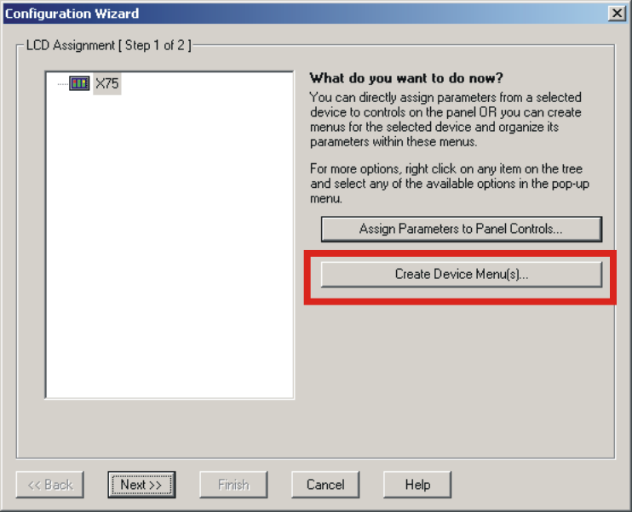

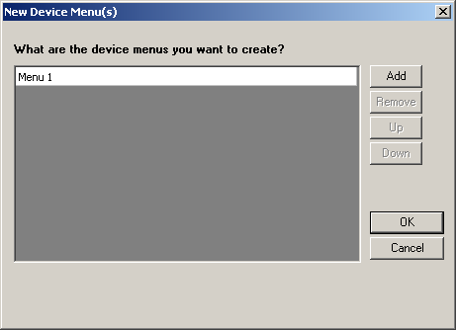

5. Previously parameters were selected using Favorites for device categories Analog Proc, SD1 Proc, SD2 Proc, ARC and Audio Gain.
Click the Add key five times to create Menus 1 through 5.
6. Click on each Menu line and change their names to Analog Proc, SD1 Proc, SD2 Proc, ARC and Audio Gain. Click OK

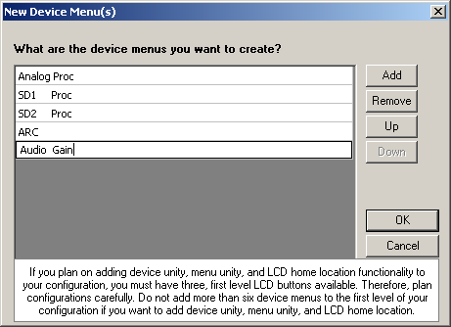

NOTE: Eventually the names used for these menus will be transferred to an LCD button on the NUCLEUS panel. Each line of these LCD button contains seven characters. If more than seven characters per line are used they will automatically wrap around to the next line. In order to prevent this from happening in the middle of a word, use blank spaces to make each word or group of words exactly seven characters. In the example above, the menu SD1 Proc is actually SD1 Proc. There are four blank spaces after SDI which forces the NUCLEUS panel to wrap the word Proc to the next line.
In any circumstance where a name is going to end up on an LCD button, this rule must be adhered to.

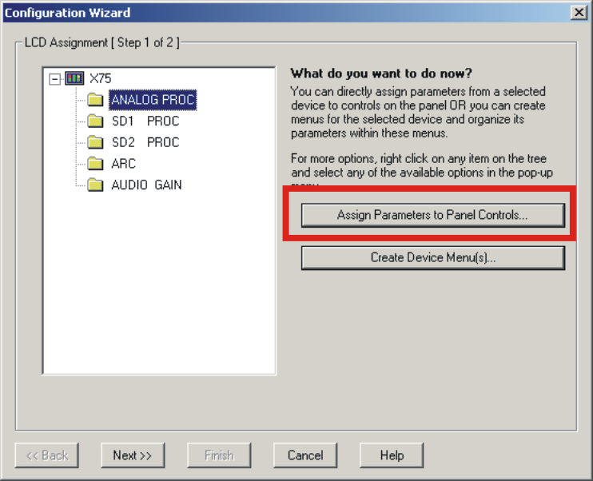

7. Select the first Device Menu (Analog Proc), and then click Assign Parameters to Panel Controls.
.

The next step is to drag and drop the parameters which were previously selected using Favorites onto actual controls. As soon as the mouse button is released the name of the selected parameter will appear on the control.

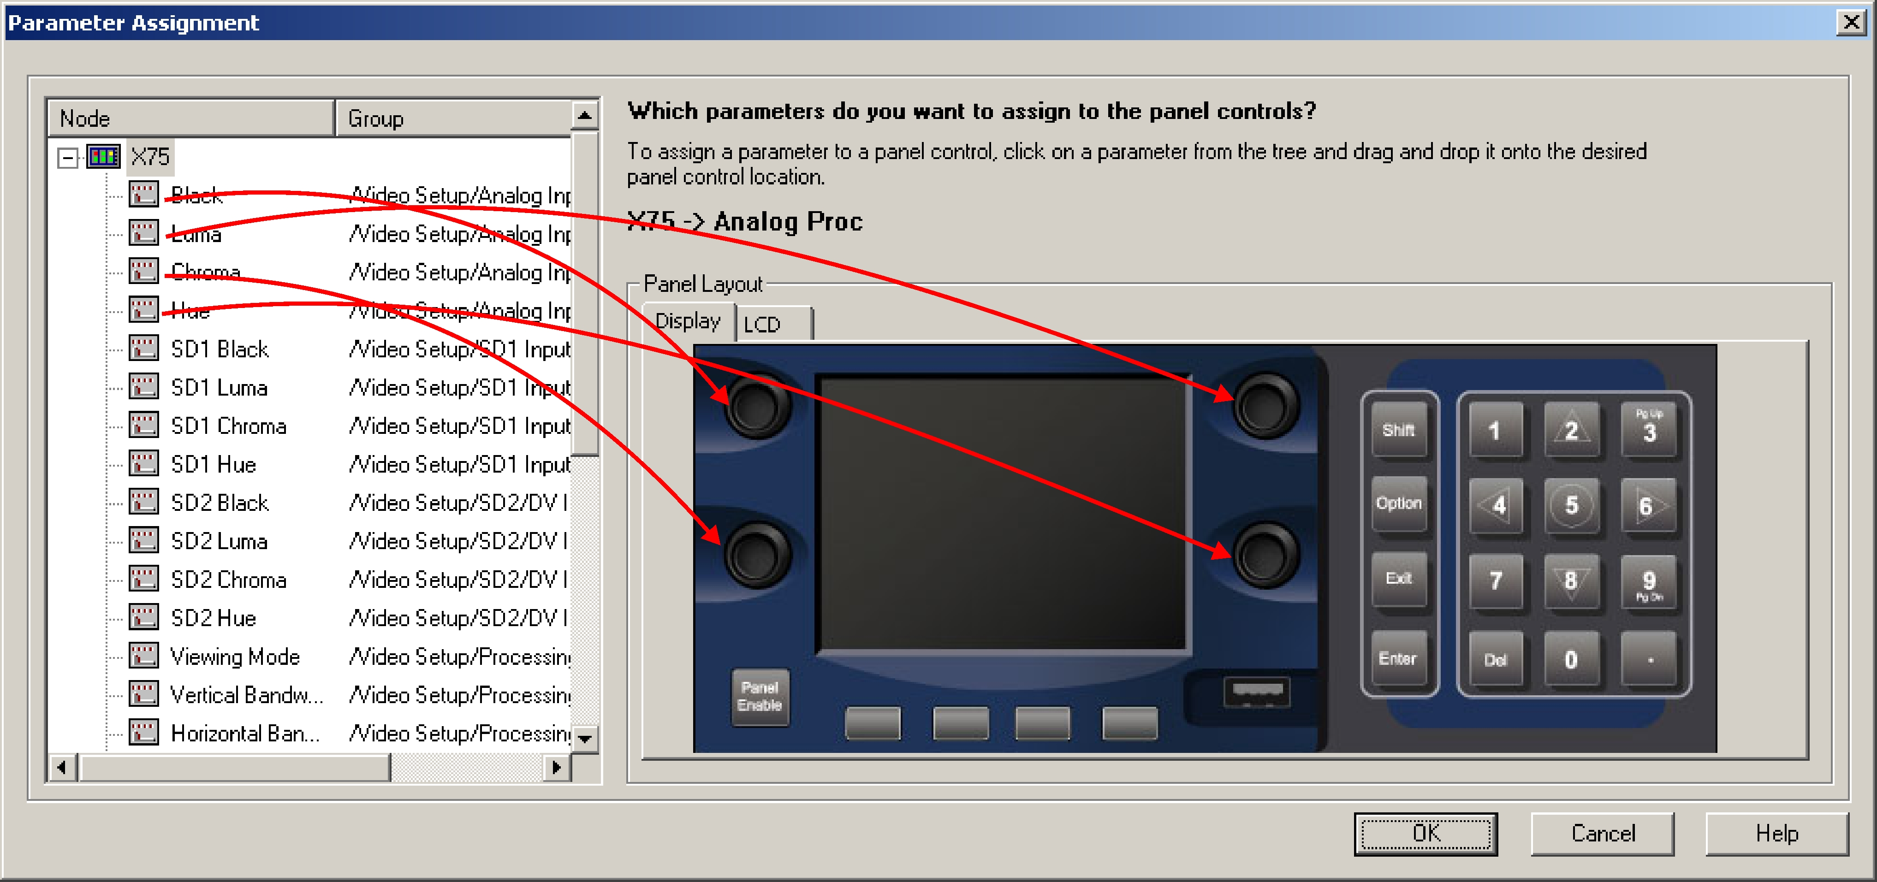

NOTE: Any parameter can be placed on a knob or a button. If the control of a parameter is better suited to a knob but placed on a button, the NUCLEUS panel will allow adjustment from any knob as soon as the button is selected.

Up to eight parameters can be controlled in each Device Menu. In this case, it makes sense to only place the four parameters which relate to Analog Proc control (Black, Luma, Chroma and Hue) onto the control knobs.
Click OK.

8. Select “SD1 Proc”, and then Assign Parameters to Panel Controls.
Repeat the previous procedure to drag and drop parameters to the control knobs, except this time, use the parameters that apply to SD1 Proc.

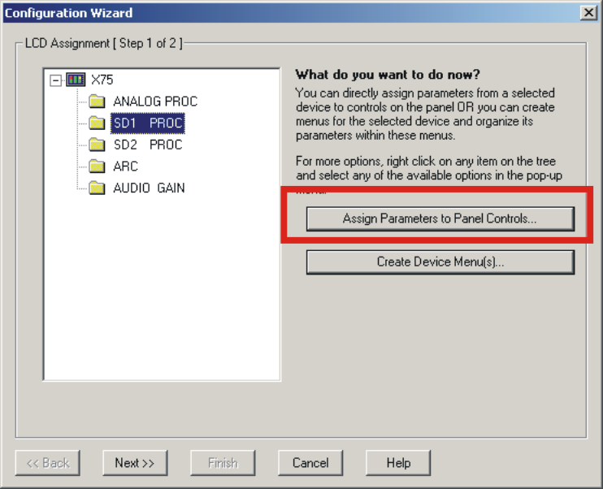

Repeat the procedure for SD2, ARC and Audio Gain.

Once all the Device menus have control assignments click Next.

9. You can now assign Home, Menu Unity and Device Unity functions to the LCD buttons. Select all three check boxes.

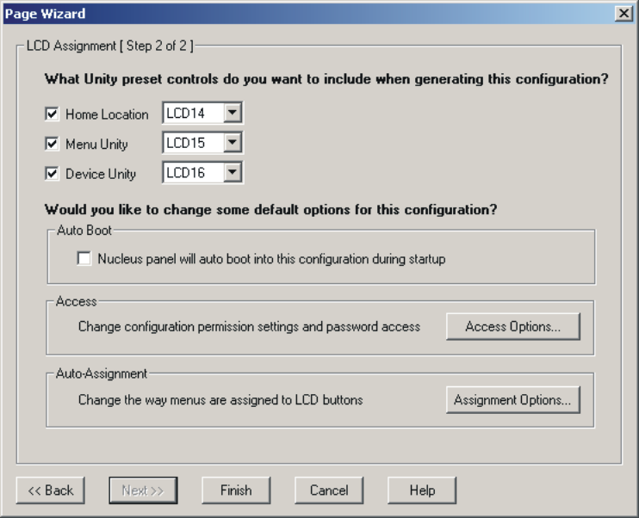

Normally, the NUCLEUS will boot up to the root configuration menu. Selecting Auto Boot causes the NUCLEUS panel to select and load this configuration on boot up.

10. Click Finish to return to the “Configuration for NUCLEUS” screen.

- Transferring Configurations to the Nucleus Panel

1. Now that the configuration is complete the next step, is to transfer it to the NUCLEUS panel

From the Nucleus configuration window, click Transfer.

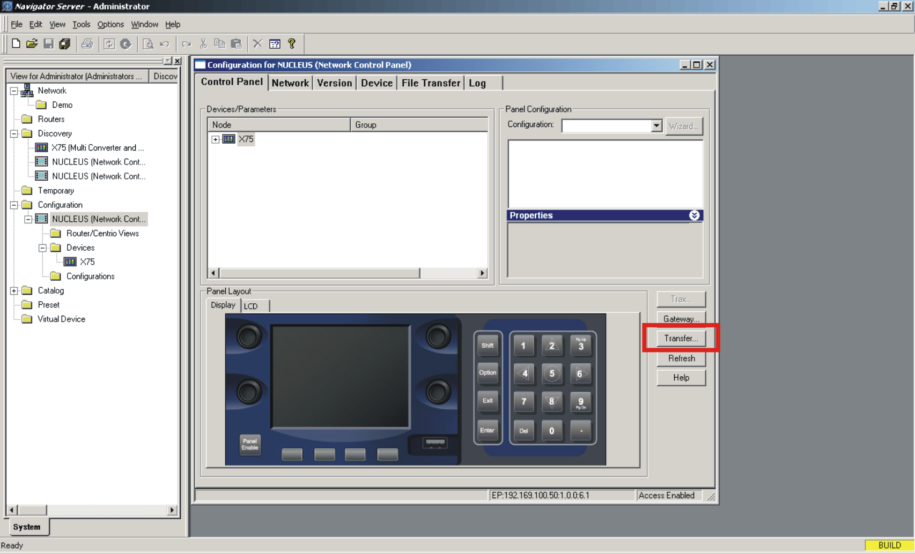

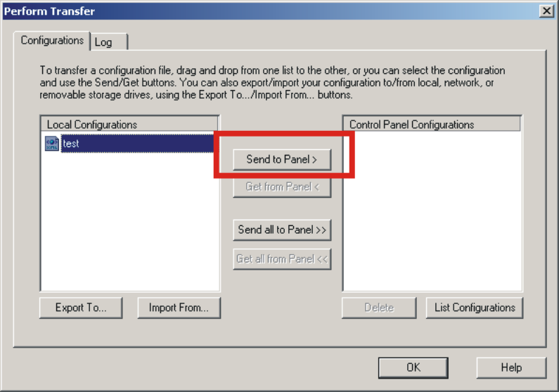

2. Highlight the configuration in the Local Configurations pane, then click Send to Panel>.
After several seconds, the system will complete sending the file to the Nucleus panel.
It’s wise to just leave it transferring for about 30 seconds just to insure the process is complete.

After the transfer process is complete, hold down the Shift, Enter and Delete keys all at the same time. This will cause the Nucleus to reboot.

After rebooting select the “test” configuration from the first window and the Nucleus is ready to go!

