NUCLEUS Router Control Quickstart Guide

- Before You Start ( Hierarchy, Connectivity and IP Settings)
- Discovering Devices
- Importing A Data Base
- Transferring To The Configuration Folder
- Creating A Router Panel

- Before You Start (Hierarchy, Connectivity and IP Settings)

For sake of simplicity, this quickstart guide will assume that the devices to be configured are 1 – Router and 1 – NUCLEUS panel.

The first step in configuring NUCLEUS panels is to insure all the devices you wish to configure are connected to a common network switch and are all on the same IP subnet.
If you don’t understand this statement it’s time to ask for help from your IT person.

Once again, for sake of simplicity, this guide will assume the following IP addresses:

NUCLEUS – 192.168.100.50
Router – 192.168.100.70

NOTE: This guide will also assume that all devices are connected to the same switch.

- Discovering Devices

1. Start the Navigator software application

2. On start up, the application should look similar to the image below.

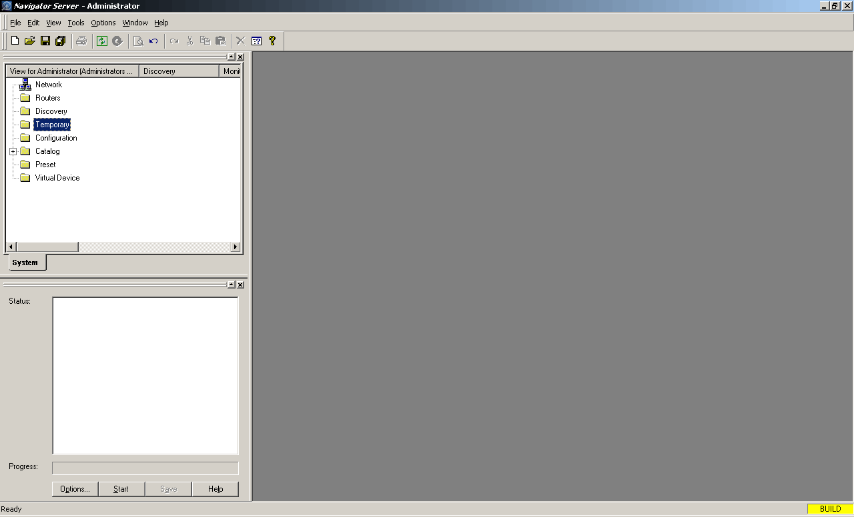

3. However, if the Navigation and Discovery screens to the left are not open, click on the Tools menu at the top of the screen to open them.

4. Click the Options button in the Discovery window.
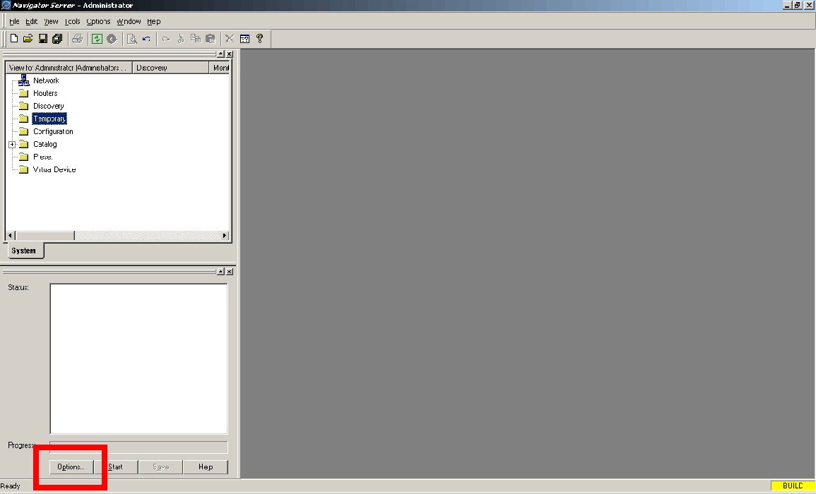

5. The Discovery Options window opens
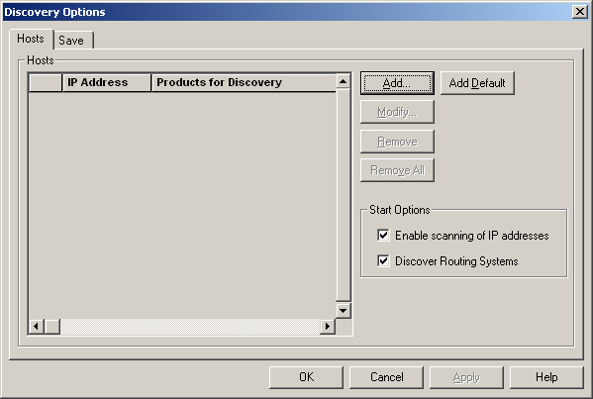

6. Click the Add button

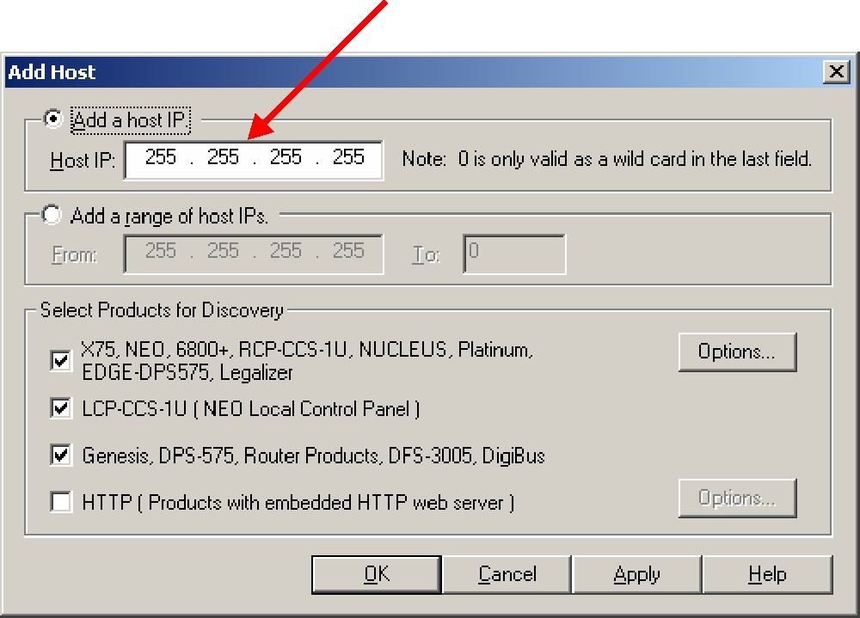
If you want to discover only a single device, type its IP address in the Host IP field.

7. For multiple device discovery, type in a range of IP addresses by using the Add a range of host IP’s fields

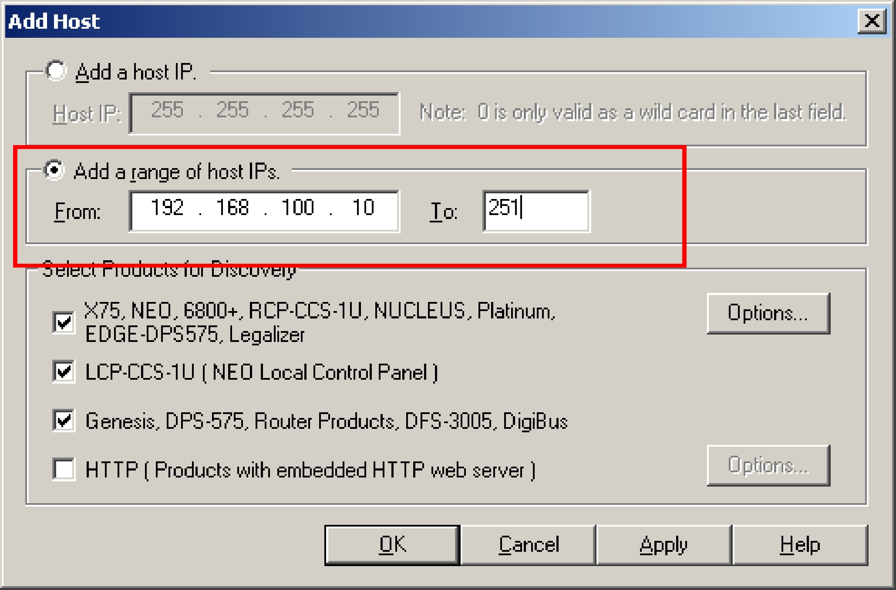

8. The IP addresses you added are displayed under IP Addresses

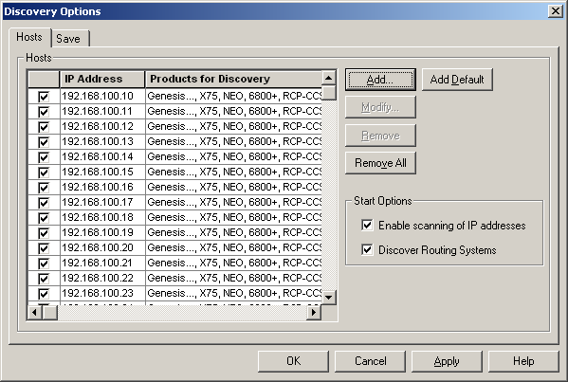

9. Click on OK

10. Click the Start button in the Discovery window

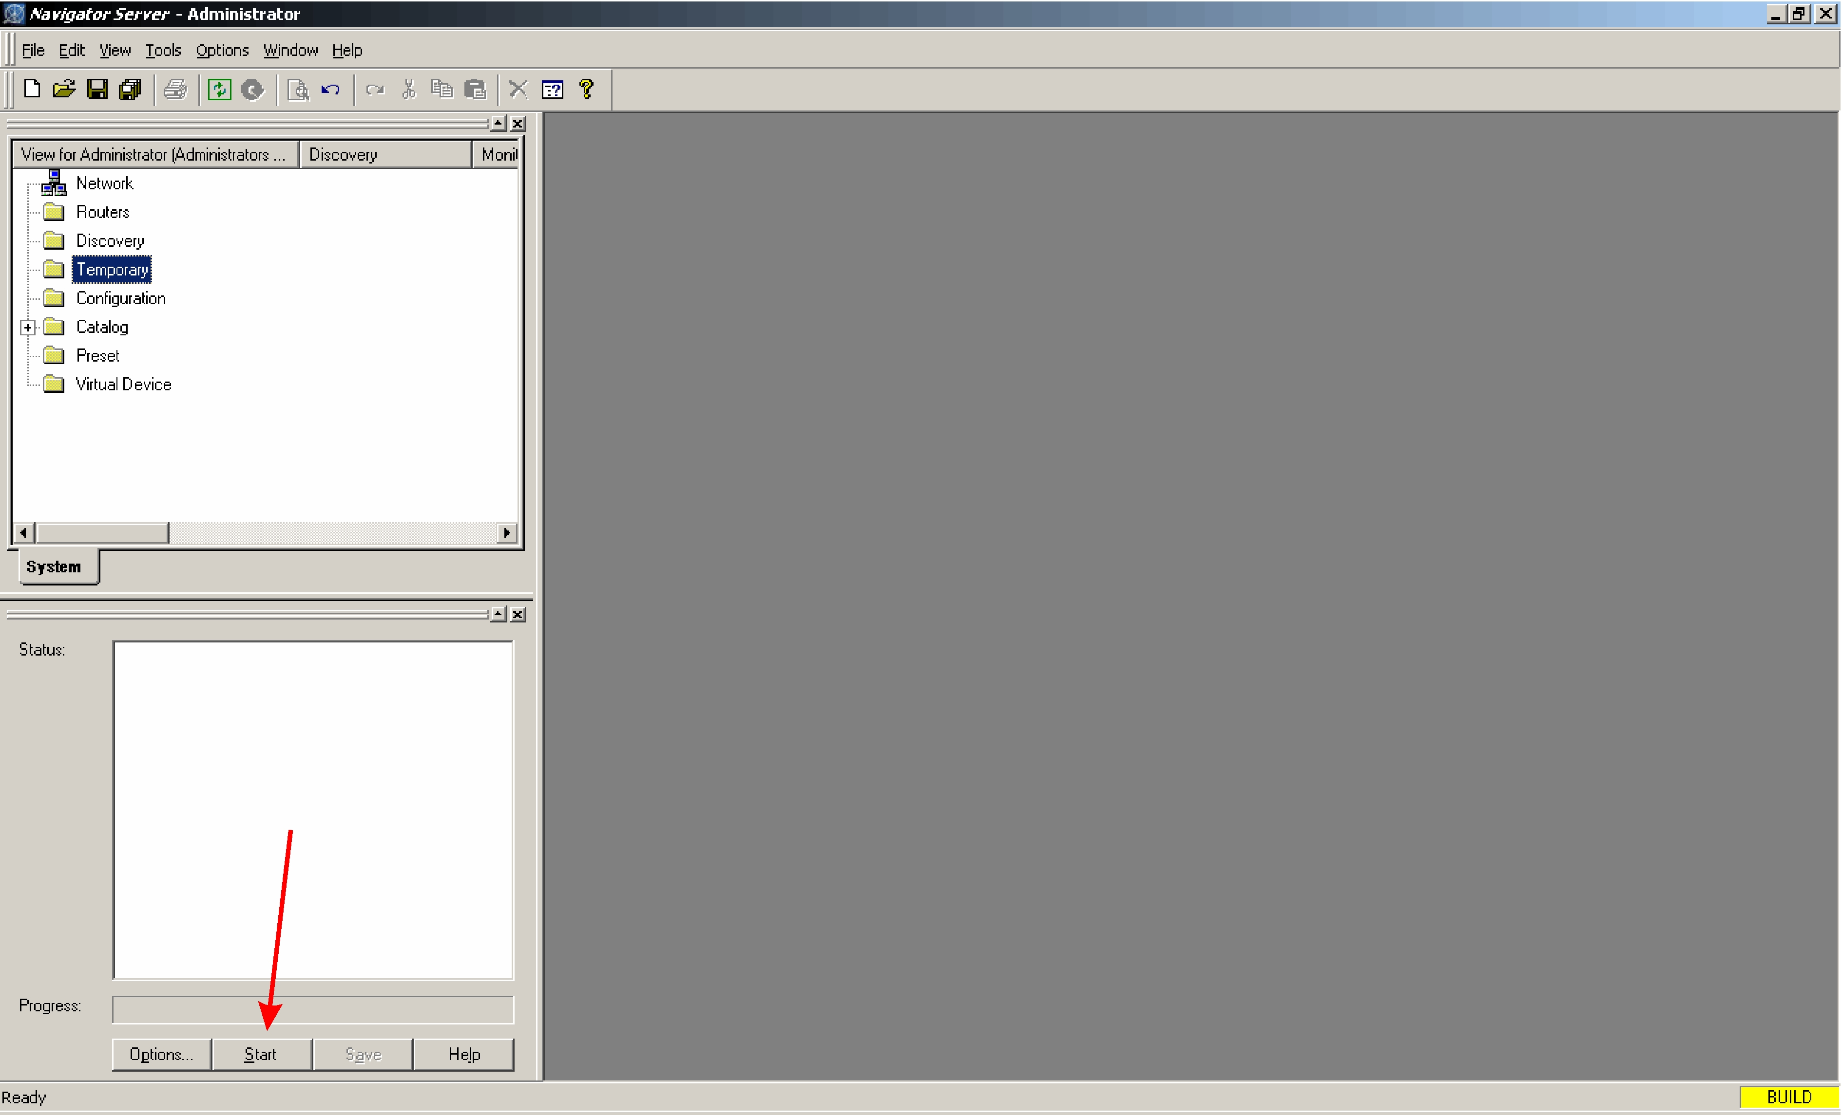

11. When the discovery process is complete, click Save in the Discovery window. Click Yes when the conformation window appeals.

12. Close the Discovery window by clicking on the x in the upper right corner of the window. This allows for more useable screen area.

- Importing A Database

Right click on the Routers folder in the Navigation window

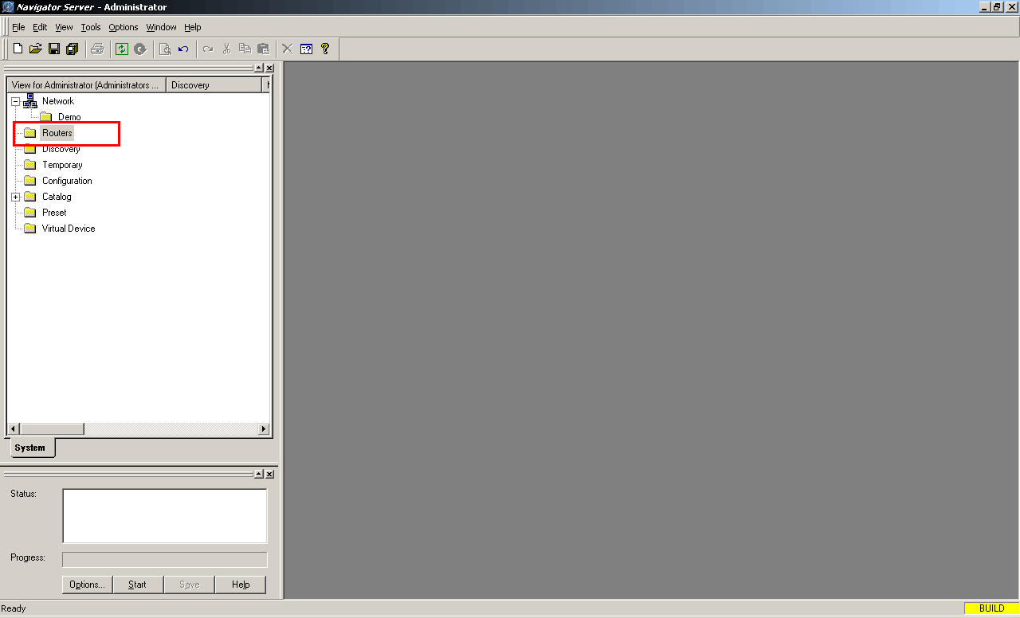

Highlight Create then click Routing System

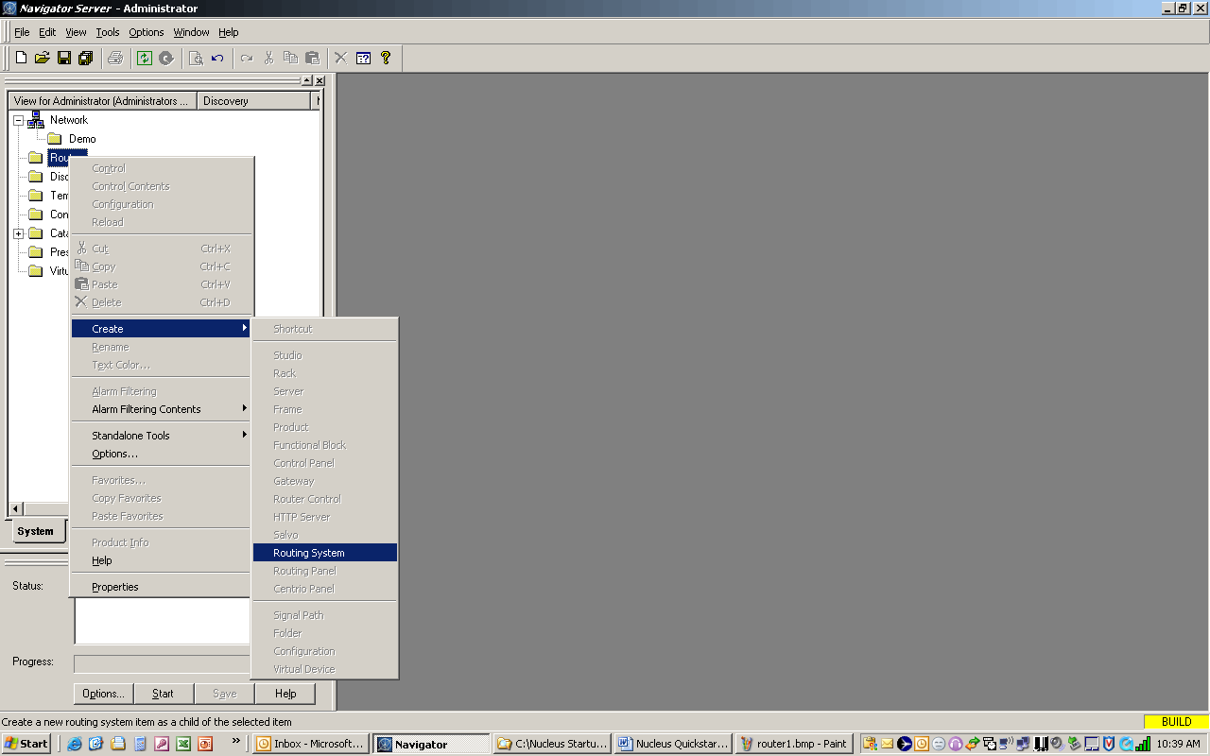

The Create Routing System pane opens

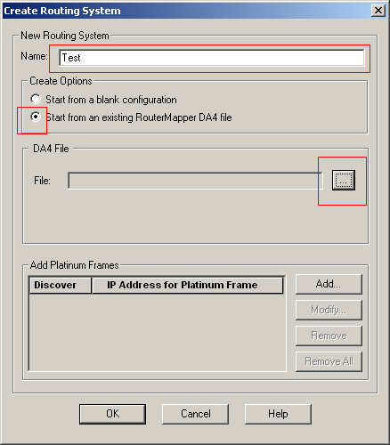

1.In the Name area type in a name for this Router
2. Select Start from an existing Router Mapper DA4 file
3. Click the Browse button (…)
4. Select the DA4 file you wish to import

Click OK

The system will now open Router Mapper and import the database. This may take some time to complete.

The new router database is now in the Navigation window in the Routers directory

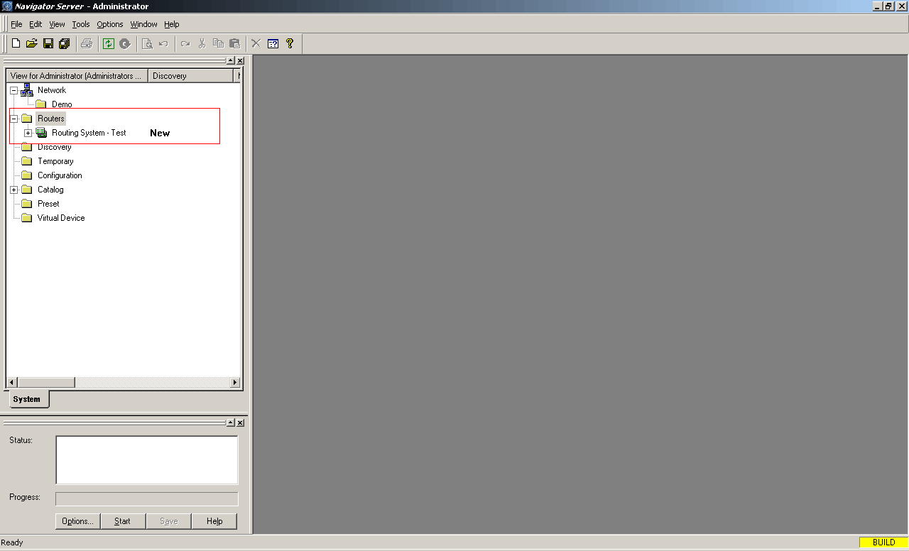

- Transferring To The Configuration Folder

Before starting a configuration, the NUCLEUS panel to be configured and the devices it will control must be copied and transferred to the configuration folder.
There are two methods for doing this. The first is to “Click and Drag”.
To do this, first select a NUCLEUS panel from the Discovery folder. Hold down the left mouse button and drag the NUCLEUS icon into the Configuration folder.

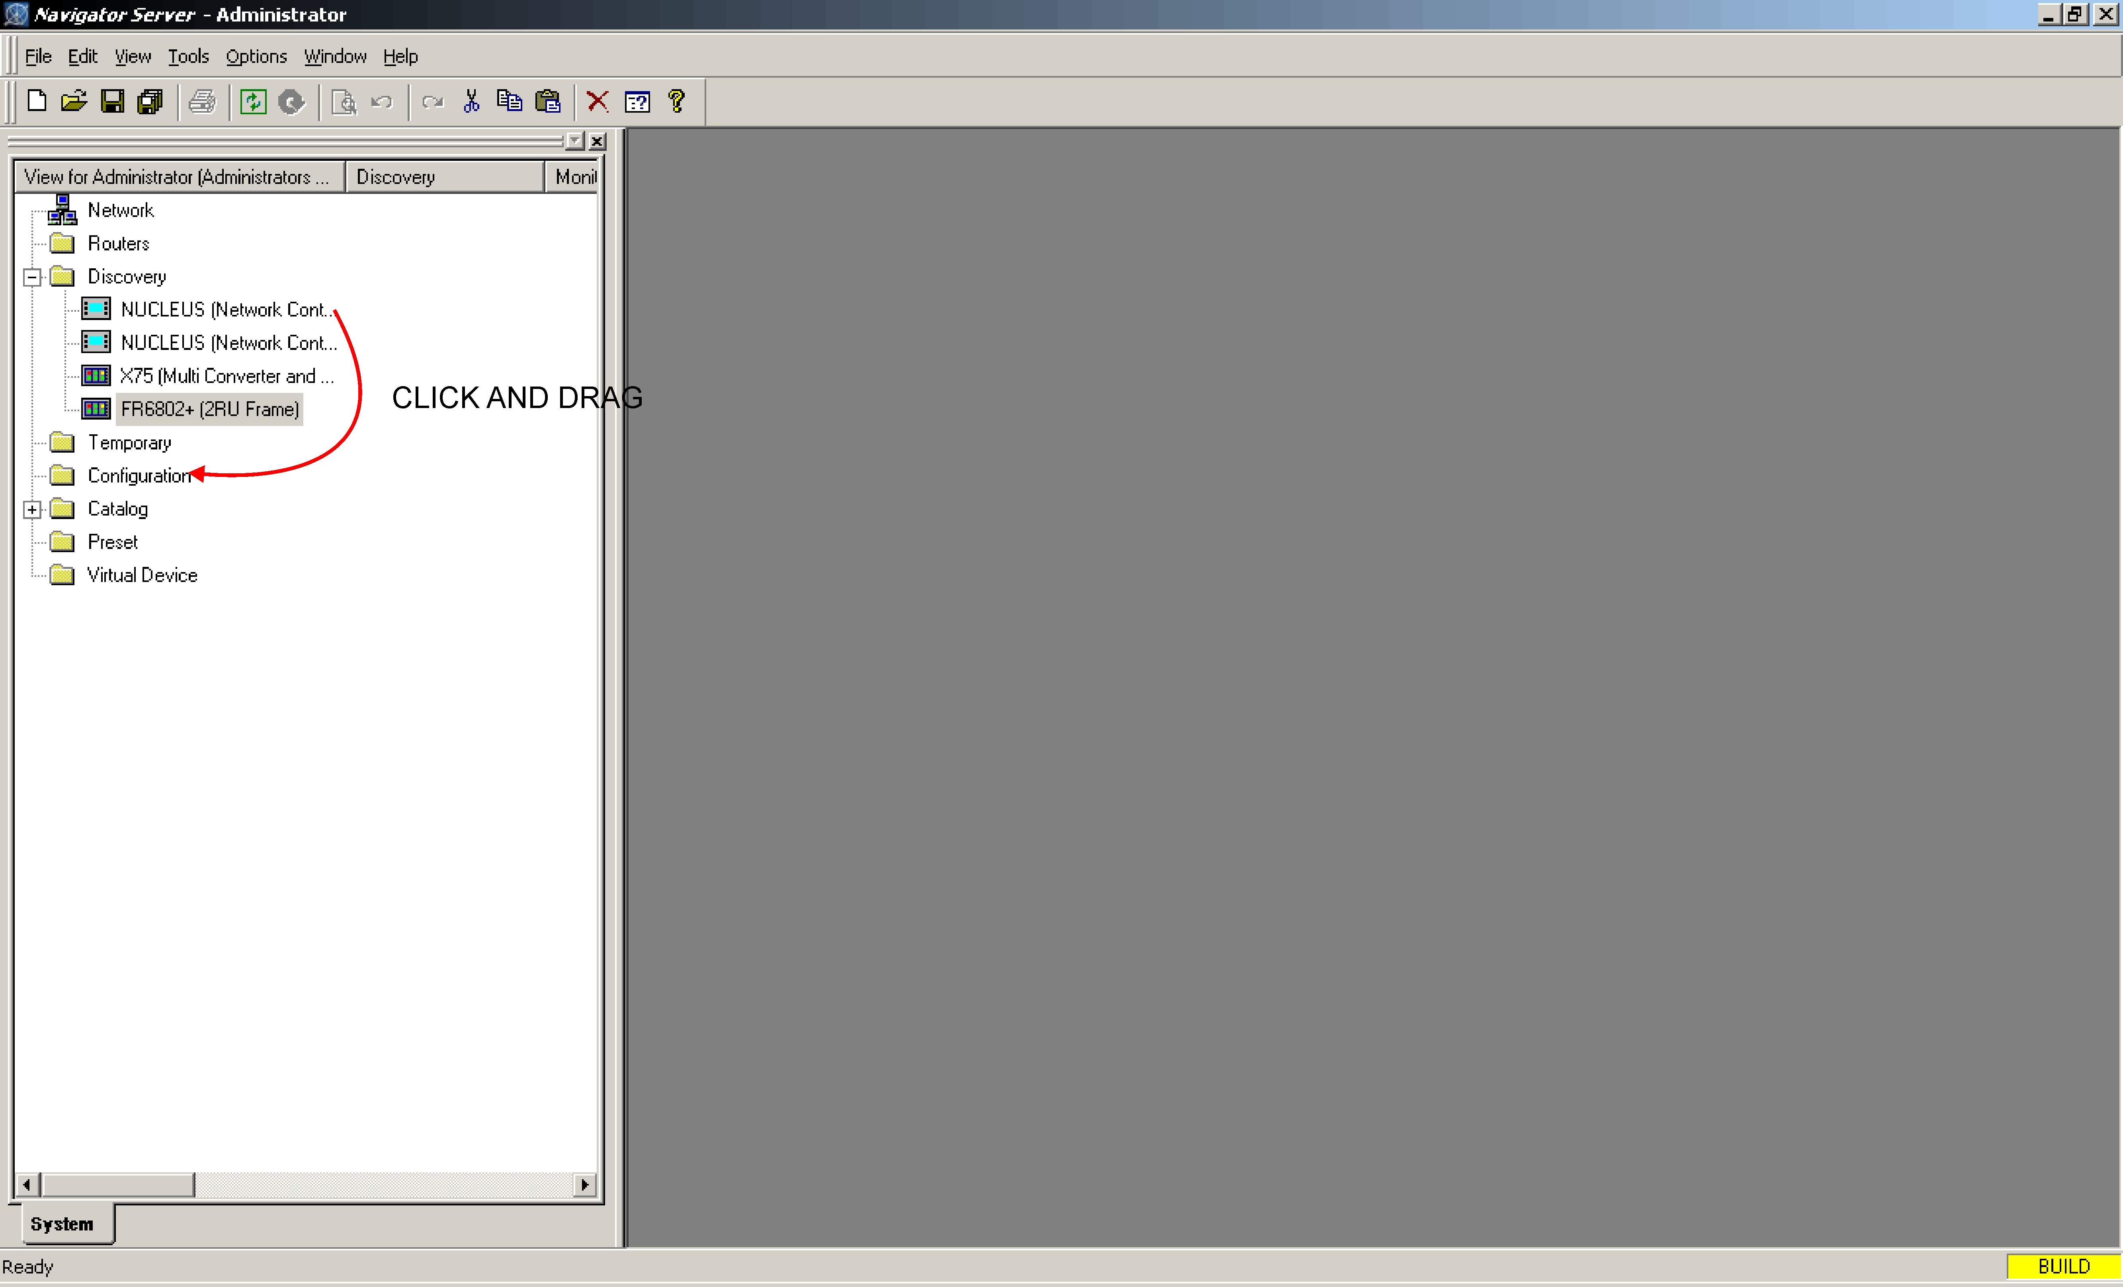

The second method is to copy a device from the Discovery folder and paste it into the Configuration folder. The fastest way to do this is to highlight the desired device in the Discovery folder, then hold down the “Ctrl” key on the keyboard and press “c”.
Next, click on the Configuration folder, hold down the “Ctrl” key and press “v”.

After the NUCLEUS panel is in the Configuration folder, click on it to reveal the following sub folders: Router, Devices and Configurations.
Expand the Routers folder to expose the subfolders Routing System, Control Views, Salvos and Routers.

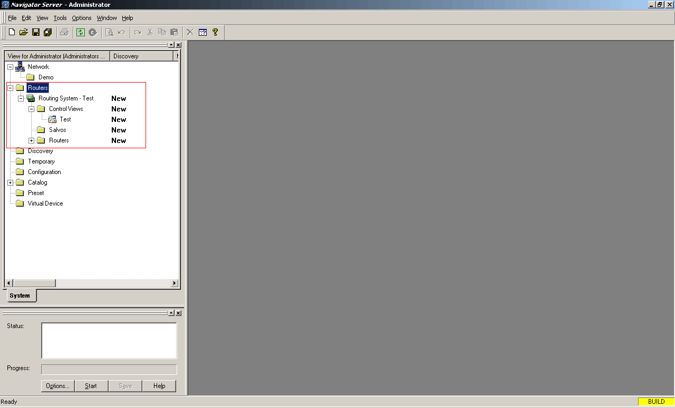

Expand the Control Views folder

Using either the drag and drop or copy paste methods described above, transfer the control view from the Control Views menu to the Routers sub-menu of the NUCLEUS panel in the Configuration folder.

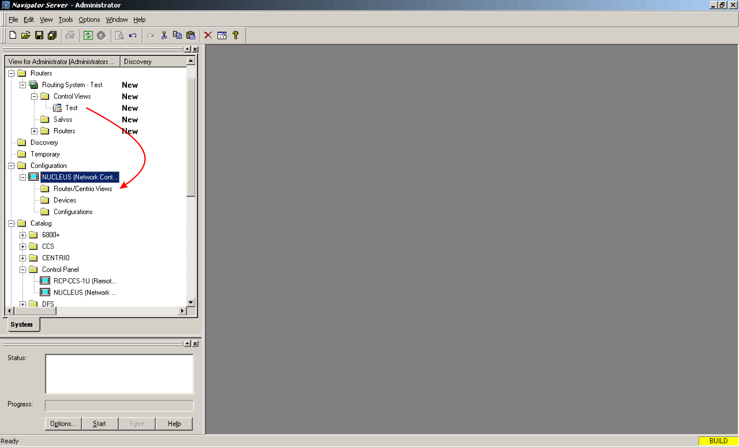

- Creating A Routing Panel

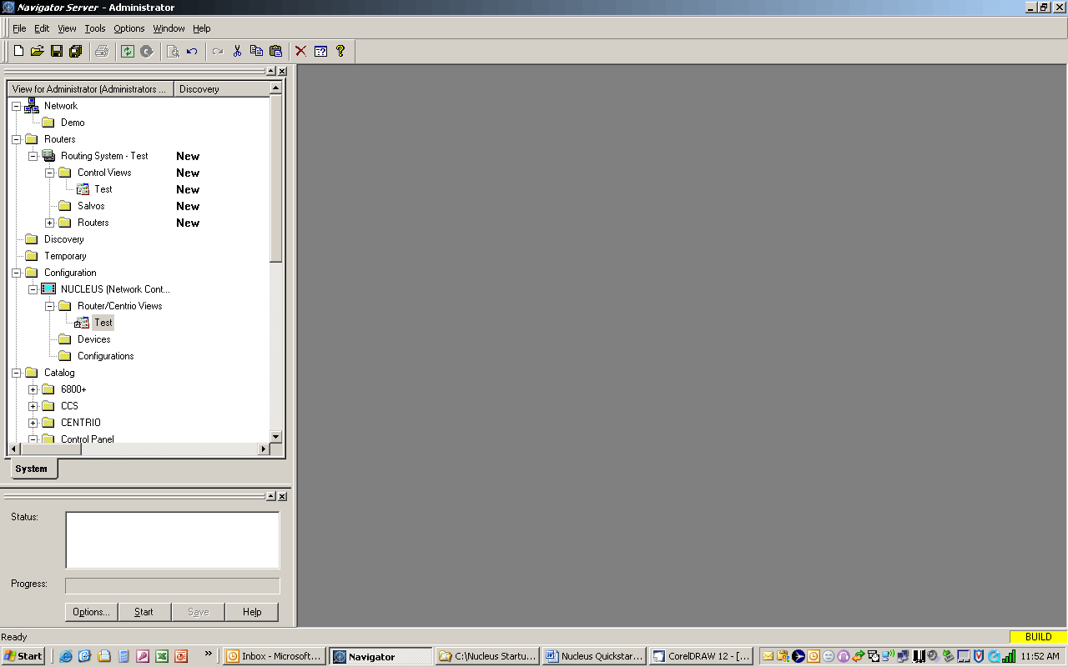

Expand the NUCLEUS in the configuration folder to reveal the Router / Centrio Views subfolder.
Expand the Router / Centrio subfolder and right click on the database (Test in this case)

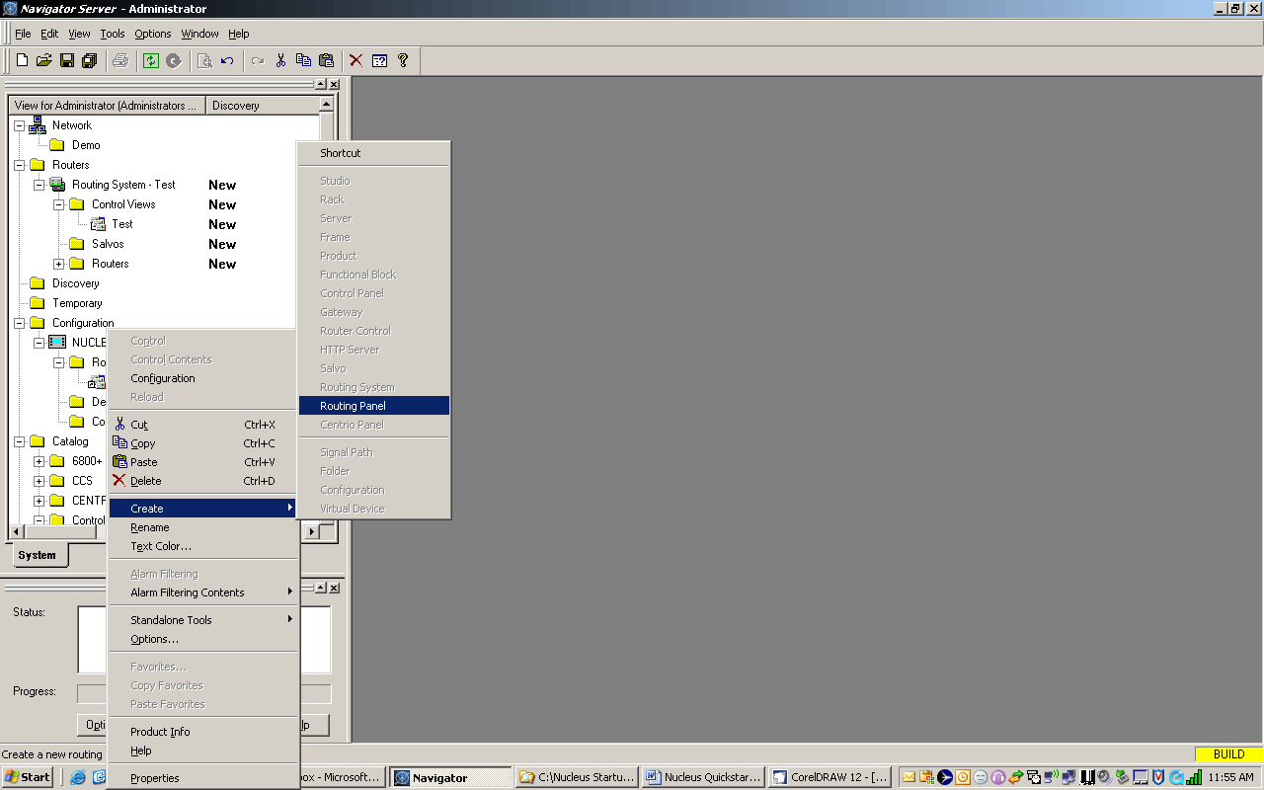
Right click on the database then click Create and Routing Panel

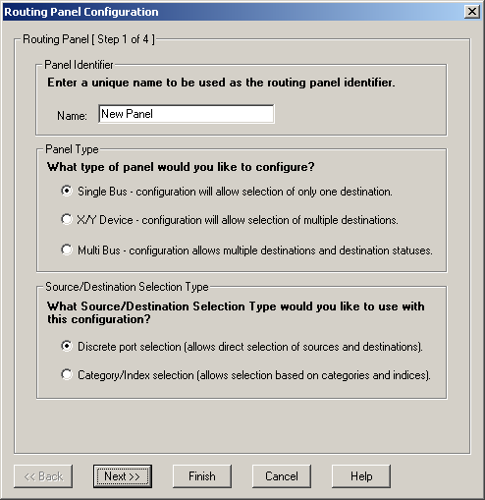

The Routing Panel Configuration window opens.

Under Panel Identifier enter a name for this configuration.
Under Panel Type select either Single Buss, XY or Multibuss.
Under Source / Destination Selection Type select either Discreet Port Selection or Category / Index Selection.

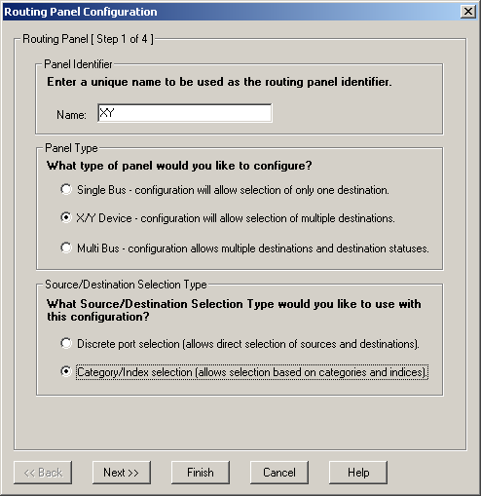

Click Next

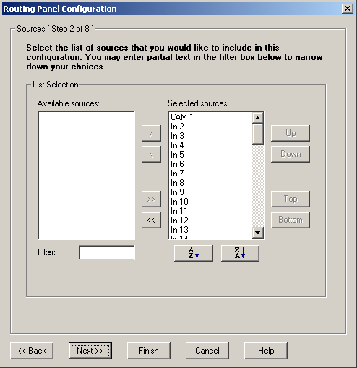

This window lets you select which sources will be available on this router panel.
Sources to the right hand side under Selected sources will appear on the panel.
Sources to the left hand side under Available sources will be excluded.
Sources can be moved from one column to the other using the >, <, >> and << buttons.

Click Next

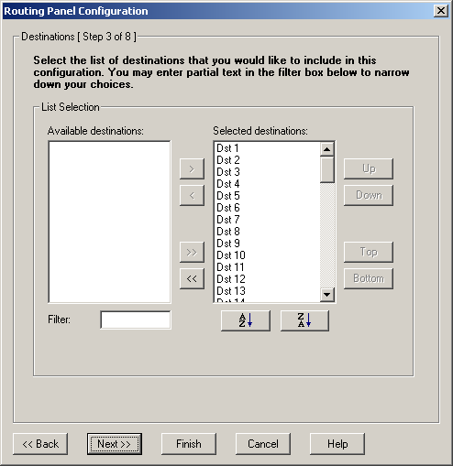

The next step is exactly the same as the previous one except now you are selecting the destinations that you want to appear on the panel.

Click Next

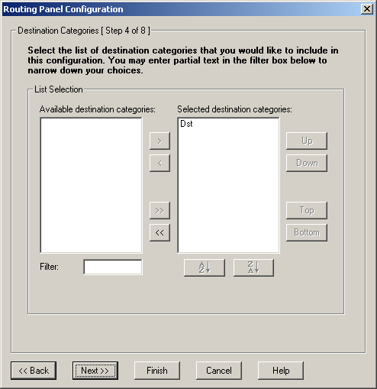

This step is identical to the two previous ones except here you can select which Destination Categories you want.

Click Next

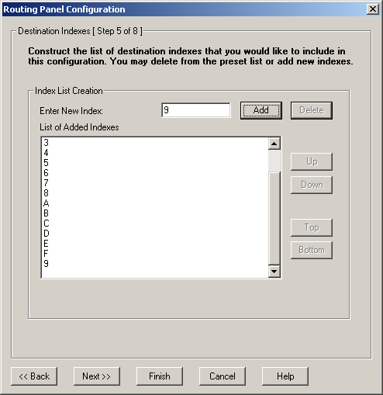

In this window you can select which Destination Indexes you want
NOTE: The maximum number if indexes available is 16

Click Next

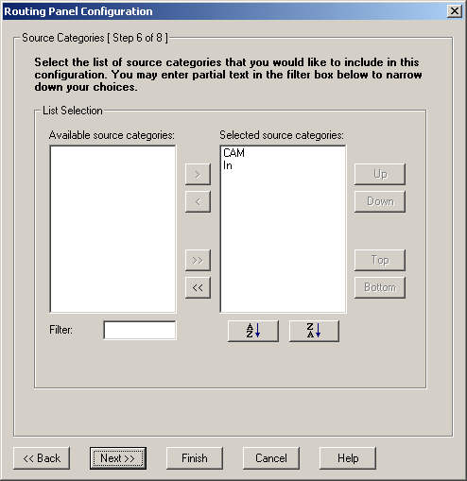

In this window you can select the Source Categories you want

Click Next

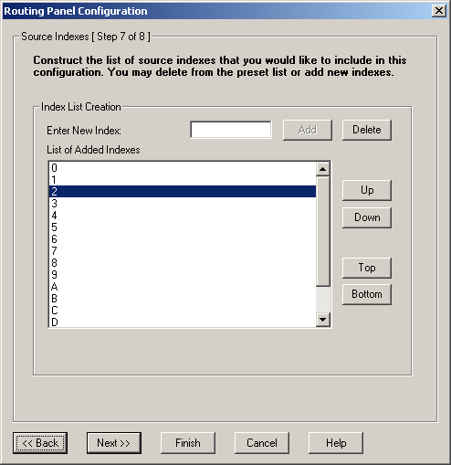

In this window you can select which Source Indexes you want
NOTE: The maximum number if indexes available is 16

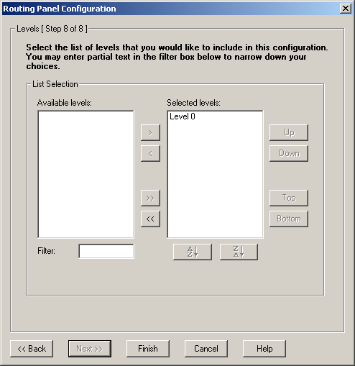

In this last Routing Panel Configuration window you can select what levels of the router you want this panel to switch.

Click Finish

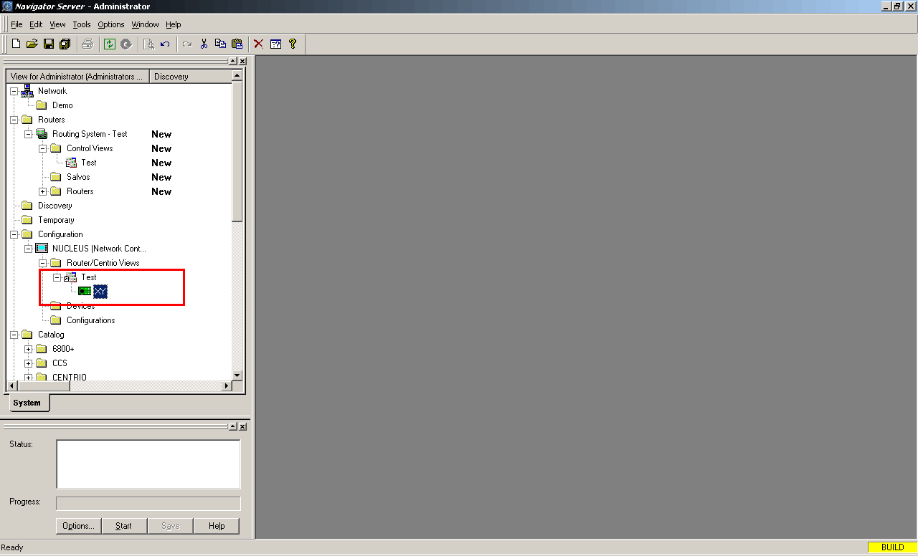

There will now be a new router panel symbol under the database icon in the Router / Centrio view folder of the NUCLEUS panel.

The new router panel can now be transferred to the NUCLEUS panel.
For information on this procedure please refer to the NUCLEUS Quickstart Guide

