LV7800-01 Remote Controller Version Update Procedure
- Save the “EthernetLoader.exe” application software and the ROM data “1083117.bin”in the PC.
- Connect the PC to the remote controller via Ethernet cable (straight or crossover cable).
- Set the PC IP address as:
IP: 192.168.0.5
Subnet Mask: 255.255.255.0
Default Gateway:0.0.0.0

- The default IP address of the remote controller is 192.168.0.2
If you wish to change the IP address, please refer to the “Changing the remote controller IP address procedure” at below.

- Open the EthernetLoader.exe application software to update the remote controller software version.
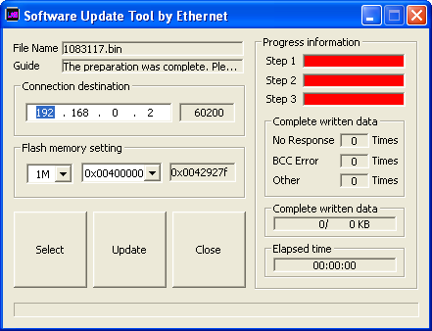

- Click on “Select” button and choose the “1083117.bin”file.
- Type in the IP address of the remote controller at the Connection Destination column. (192.168.0.2 in this case).
- Select flash memory as「1M」and「0x00400000」. You can set the flash memory size and start address by clicking on the setting column and change by UP or DOWN arrow keys.

- Click Update
- After a while, it will display a message “Rewriting the firmware ended” in the Guide column.

Changing the Remote Controller IP Address and destination IP address from a PC
- Connect the PC to the remote controller using a USB cable
- Open the IpAddressWriter.exe application software
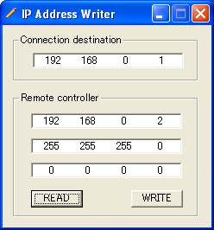

- Type in the mainframe (LV5800 or LV7800) IP address that you want to control at the Connection destination column.

- Type in the Remote Controller IP address as:
IP: 192.168.0.2
Subnet Mask: 255.255.255.0
Default Gateway:0.0.0.0

- Click on WRITE button.

- Click on READ button to verify if the IP address is set correctly.
Switching IP address of the controlling devices from the mainframe (LV5800/LV7800) without a PC

- At the LV7800-01 IP address setting menu, turn the Remote Controller and the connection destination to “ON”.
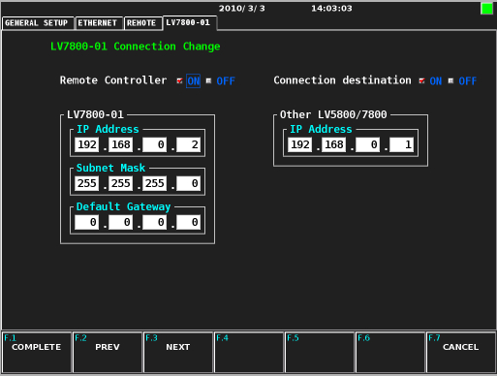
- Set the LV7800-01 IP address and Subnet Mask. Then set the IP address of the unit (LV5800/LV7800) that you want to switch.
- Press COMPLETE

