eRoute Quick Help File

Pages referenced are from eRoute manual rev F

1. The eRoute is a 10 base T only device. If you have routers set for 100Mbs only, then the eRoute will not pass through. (p.8) if you do not properly configure the eRoute through the netconfig utility that runs the first time it’s powered up then just login to the eRoute and type
netconfig
Hit enter
This should start the process over again.

2. To change Com1 from RS232 to RS422 remove IC U8 a 24 pin MAX232 (Maxim). Install two 8 pin ICs marked 75ALS176 (Pesa part # 81901606880). Install jumper J10 (between U3 and U4) to connect pins 1 and 2 (Pesa part # 81902903350). (p.28)

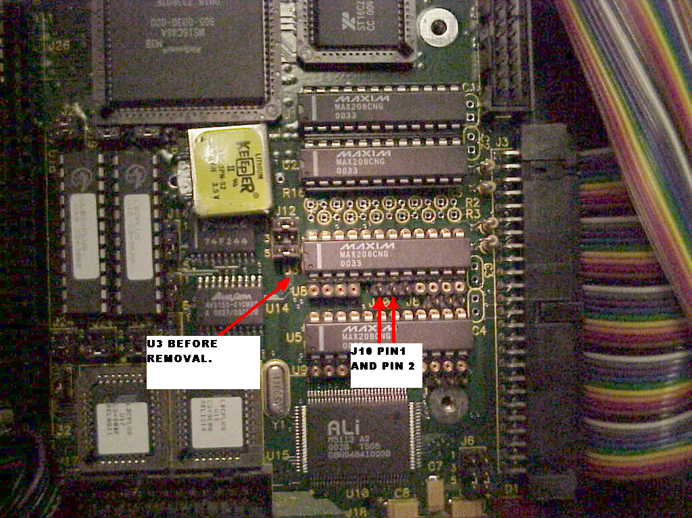

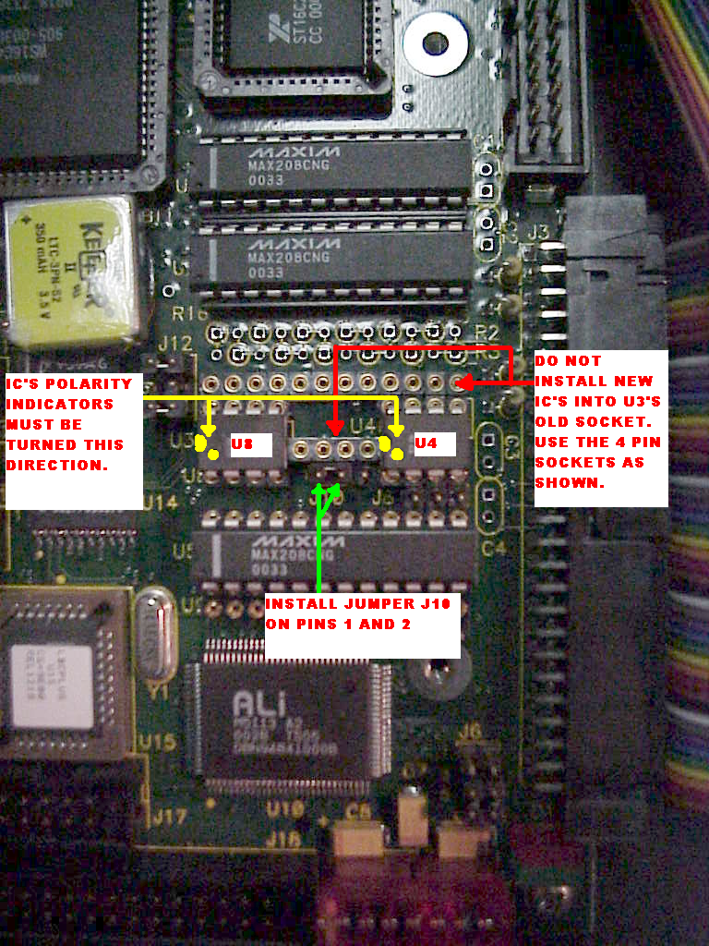

3. To login to the eRoute a keyboard and monitor must be plugged into the front and power must be cycled. Once the computer is booted you will type the login
root
(case sensitive). Hit enter.
Password is
eRoute
(case sensitive). Hit enter. (p.39)

4. To change the configuration of the COM ports to mach the 3500 controller settings that you have (speed, data set and which is the main port) the device.dat and eRoute.cfg file must be edited. (p.40) the 3500PRO and LE are shipped default at 38400 baud, earlier controllers are default to 9600 baud. Do not attempt to make changes to any file without reading the manual pages listed. In the eRoute directory type
emacs eRoute.cfg
The space is necessary. You will then enter the file with the emacs file editor. Once you have made the changed you require type.
CTL+x
Or the control button and x at the same time. This closes the file.
Then type
CTL+s
Or the control button and s at the same time. This saves the file.
Then type again.
CTL+x
Or the control button and x at the same time. This closes the editor.
Then type.
CTL+c
Or the control button and c at the same time. This takes you out of the editor.
Changes will not take effect till the eRoute is restarted.
Type
/root/stop
This statement stops the eRoute service.
/root/start
This statement starts the eRoute service.

5. The eRoute V2.1 and later is able to pull the configuration directly from the 3500plus controller. The device.dat file must be configured for 3300/3500/3500Plus in the first line of the file and you must have a V3.1 3500Plus or higher controller. The Ocelot, Bobcat, 2400, 6600 do not have a configuration that can be transferred to the eRoute and you will need to use the eRoute configuration utility to tell the eRoute what configuration you have on them.

6. For information on the eRoute configuration utility that run’s on the client computers go to (p.42) in the manual. This is where you will set up your passwords and users.

7. If your eRoute was working for a while and now you cannot talk to it. Check with your IT department to see if the IP address that you assigned to it has expired. IP information can be checked on (p.33) Remember a static IP address doesn’t change but many of the DHCP/BOOTP automatic IPs do change or may expire over a period of time. It is best to talk with the “Network Guru” and let him tell you how the network is set up. The “Network Guru” will usually be able to see why you’re having problems and give you advice on how to configure the eRoute. Because the eRoute is a network appliance they should also be notified so that they do not make changes that interfere with the everyday working order of the device without notifying the engineering staff.

8. The client computers use java to talk to the eRoute. So an appropriate version of java must be installed on the clients. There is one included on the eRoute CD for most operating systems. Internet Explorer 5.0 or better should work fine for most people. If you are using a Macintosh then you will need to use the OPERA web browser. All you have to do is type in the IP address in the browser hit enter and your computer will load the java interface from the eRoute. Then you will click on e-Route Server and load the application. The eRoute will prompt you for a login and password.

9. The eRoute uses TCP port 4000 and continues to open ports for each user online so there must be a window opened up in the network to pass these ports. If your network is setup to block these ports from other parts of the network then it will not work. Again this may be something that your “Network Guru” will have to set up on the routers on the LAN.
