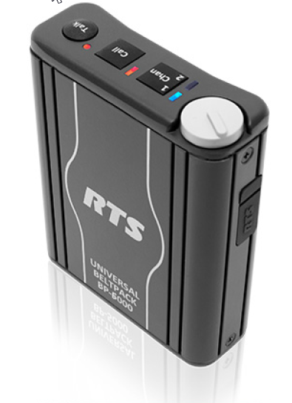 | 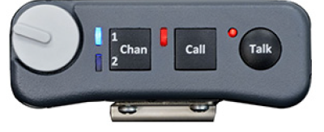
Figure 1. BP-6000
ABOUT BP-6000
BP-6000 is a portable user station compatible with Audiocom and Clear-Com party line systems. It is available in a 2-channel version only. BP-6000 is equipped with a mode-sensing system configuration meaning it determines the system into which it is installed, and configures itself accordingly. The headset connector is 4-pin male XLR with auto-sensing headset inputs, dynamic and electret microphones are supported. The line and loop connectors are 6-pin Switchcraft connectors.
Multiple programming options are available. To simplify programming, voice prompts guide the user through menus. Available in black only.
Part number | CTN | Description | MSRP  EUR | MSRP  USD | Shipping wt  kg | Shipping wt  lb
F.01U.327.757 | BP6000 A4M | BP6000 Beltpack 4 pin Male hdst | 380 | 436 | 0.5 | 1.1

Three adapters are being made available for the BP-6000.
Part number | CTN | Description | MSRP  EUR | MSRP  USD | Shipping wt  kg | Shipping wt  lb
F.01U.350.727 | CA 6MSC-6FNT | Cable 6pin M SWC to 6pin F NTX | 65 | 75 | 0.2 | 0.5
F.01U.350.728 | CA 6FSC-6MNT | Cable 6pin F SWC to 6pin M NTX | 65 | 75 | 0.2 | 0.5
F.01U.350.729 | CA-23-16S | Cable adaptor 6pin SWC M to two 3pin F | 90 | 110 | 0.3 | 0.75

AVAILABILITY
QG3 (when system allows orders to be placed) occurred on April 16, 2018. QG4 (units are available in CDCs) is anticipated to be May 11, 2018.

