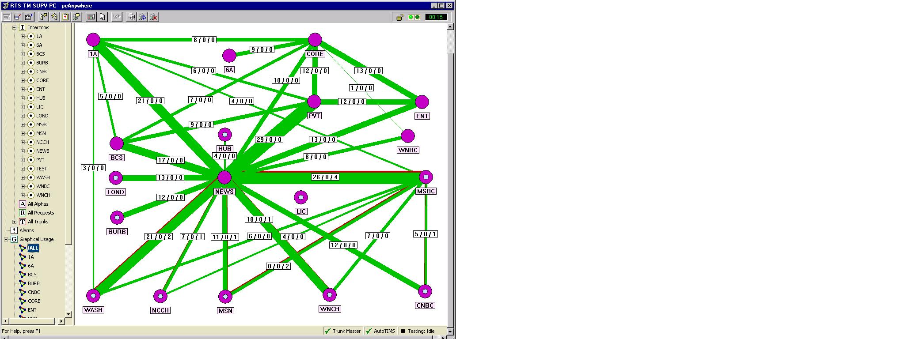
Trunks
Available
Alloc, Not
In Use
Trunks In Use or
In Mtce Mode
8/0/2
Available Trunks
Trunks In Use
Allocated Trunks
= 9600 baud
= Connected
Normally 38,400 Kbd
= Disconnected
Sum of all 3 # equal total # of trunks defined.

