Installing the licence on the ODIN takes some action.

First request the correct mac address.

If you scroll with encoder 1 on the front of the ODIN and on the left of the display to Control. You see the MAC address.

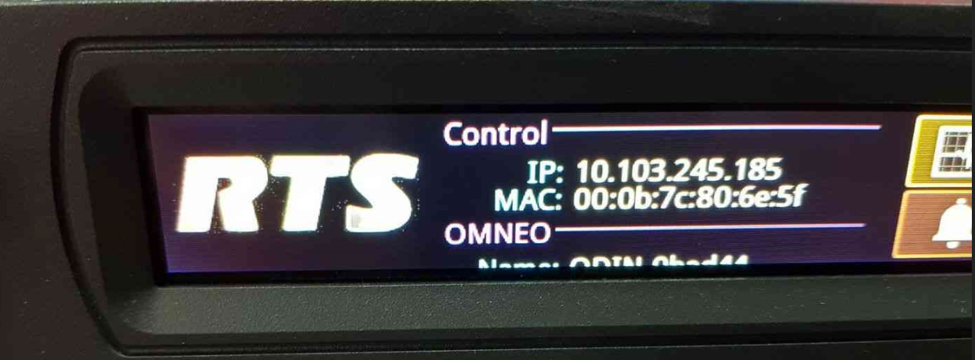

It’s best to make a photo and send that to us by email.

Send it to:

Basic Sabina (BT/LOP11-EU) [Sabina.Basic@de.bosch.com](mailto:Sabina.Basic@de.bosch.com)

After you received the license from us its easy through AZEdit to install that license

How to install Odin license

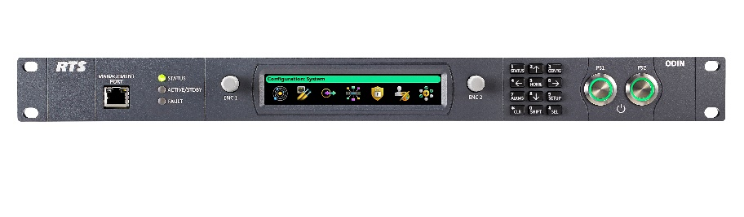

In order to update the licensing of the ODIN follow:

*Step-1*  Connect to the ODIN with Azedit > Go to STATUS > SOFTWARE VERSION > MASTER CONTROLLER

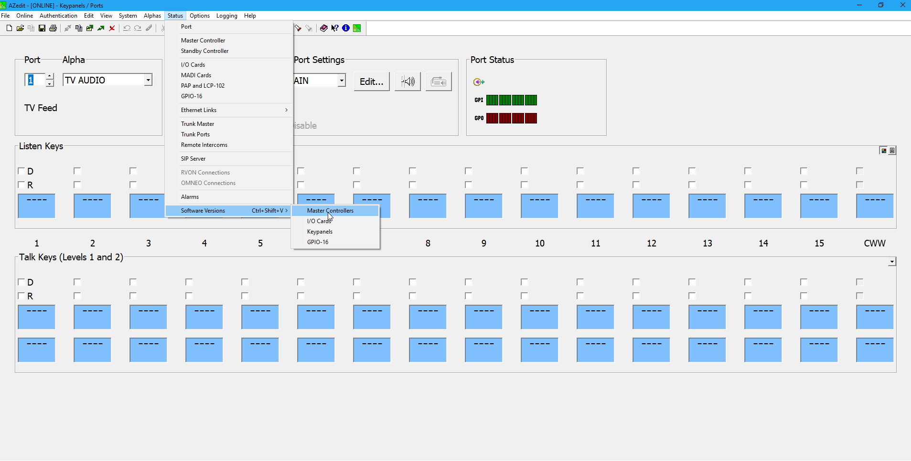

*Step-2* you are going to see your Master Controller > Right Click with the mouse >select DOWNLOAD LICENSE > browse to the location you have stored the license file ending with .lic

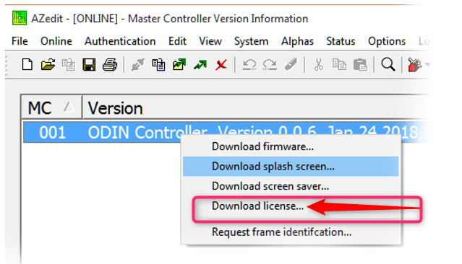

If you see this

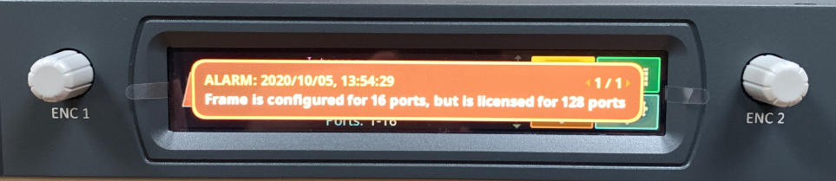

You need to allocate in AZedit the ports.

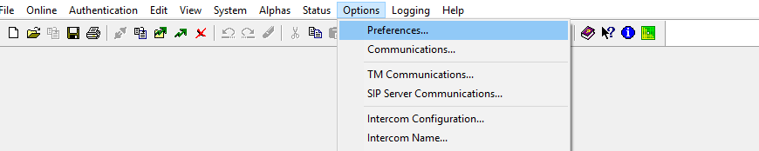

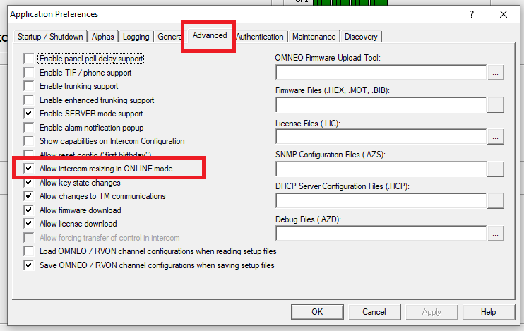

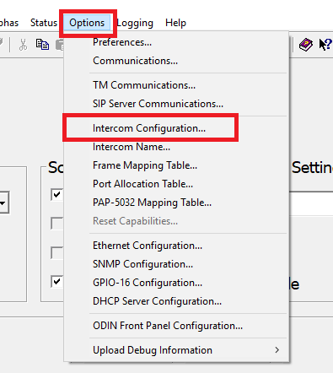

Select intercom and next

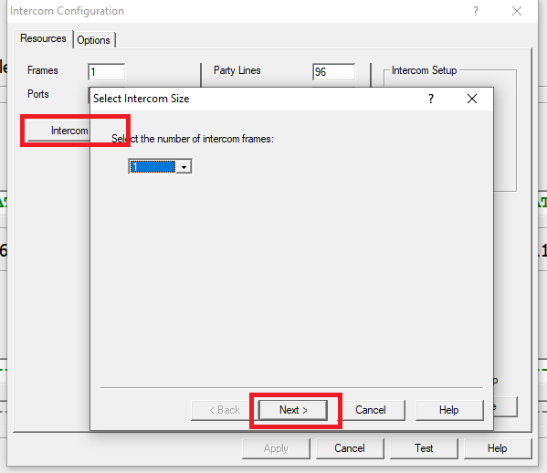

Select up to 128

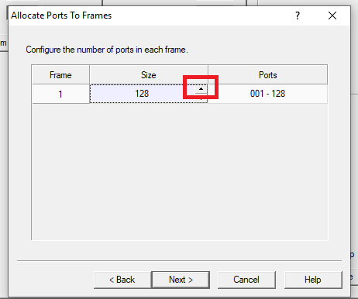

Test and OK

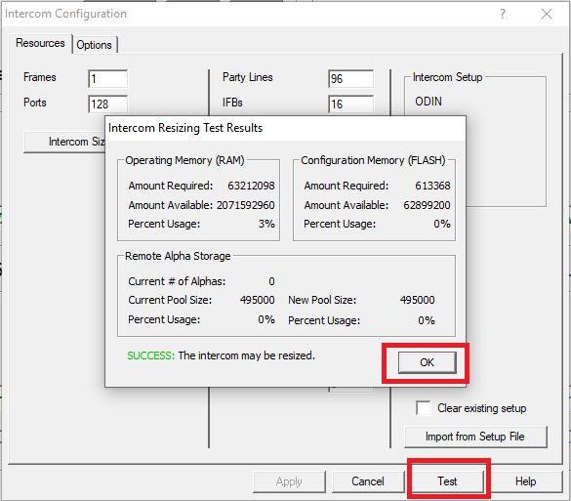

Done. All fine

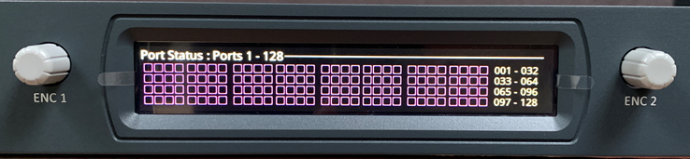

Greetings:

Nico Lewis