**OMNEO Network Setup Recommendation**

The network recommendation in this document is intended to be used for new installation with dedicated OMNEO switch network only.

**OMNEO Network Constraints:**

**•** Single subnet must have 128 OMNEO devices or less.

**•** Maximum point-to-point latency should be less than 1ms

**•** Daisy chains of devices must be limited to 20.

**Installation**

For installation in existing network, consult your Network Administrator to verify all OMNEO requirements are met.

**Other Considerations**

Other considerations when OMNEO is being installed into an existing network are:

**•** All OMNEO and Dante-enabled devices use the IEEE 1588 Precision Time Protocol (PTP) across the network to synchronize their local clocks to a master clock. All PTP messages are sent using multicast packets. Verify that this is allowed by your network administrator.

**•** All OMNEO devices have internal Ethernet switches running RSTP (Rapid Spanning Tree Protocol) for fast network convergence. For security reasons, some networks do not allow connected devices to run spanning tree protocol. In that case, a **none-RSTP firmware version is available with new version 5.2.x platform.** Again, consult with your IT department about which version is best for your network.

**•** Maximum amount of traffic should not exceed 70% of bandwidth of weakest link

**•** Bandwidth of other traffic should also be known/estimated.

**•** Using a separate VLAN for the OMNEO system can at least ensure there is no other traffic.

**Network Redundancy**

For redundancy, each OMNEO device comes with two RJ45 ports and one fiber port. The picture below provides example on how to create a full redundant network.

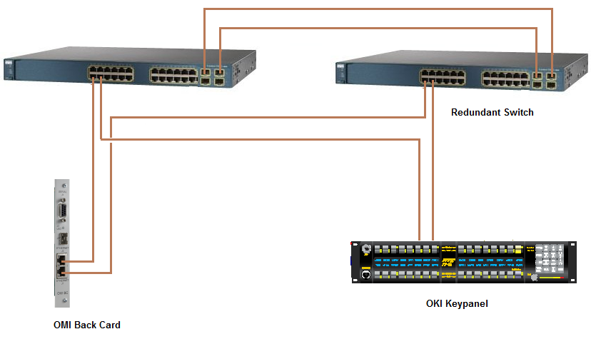

**RSTP Setup**

RSTP improves the system startup time and converges faster than classic STP when a change occurs in the network. Unless you specifically choose to download the firmware with no RSTP version (available only with V5.2.x release), RTS OMNEO devices have RSTP running automatically. Use the following parameters on all switches:

**•** Hello Time: 9 seconds

**•** Maximum Age: 22 seconds

**•** Forward Delay: 30 seconds

**•** Priority value ranges from 0 to 61440 in multiple of 4096. Providing all the ports are Gigabit Ethernet, the device with smallest priority value is selected as a root bridge or switch. The default value on all switches is usually 32768. Each OMNEO device has the priority value of 61440. So, it will never become a root bridge when connected to a switch.

**QoS Setup**

The switches must be configured to prioritize the traffics based on Differentiated Service Code Point (DSCP) values. The OMNEO device automatically inserts the DSCP value into its packet header. The DSCP value of 56 is used for Clock synchronization (PTP) packets. The DSCP value of 46 is used for audio packets.

**IMPORTANT:** OMNEO version 5.2.x does not allow Dante Controller to assign IP Address to OMI card. This is to prevent the card from going into the unrecoverable mode where the audio device and the controller IP Addresses are no longer in synch.