Adam 2.1V specs.

The voltage change you are seeing adjusting the power supplies occurs because of the change in steering diode forward voltage between the signal power supply operation and the shared, dual power supply operation. The voltage difference is a function of the steering diode forward current change between single and current sharing operation. The specification for the part we are using is shown below;
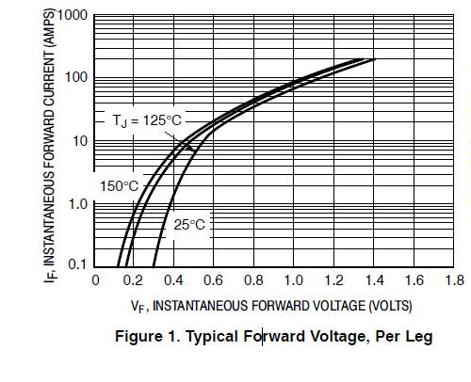

The forward current will change from about 2.5A in single power supply operation to about 1.25A in current share operation which extrapolates to about 0.44v to 0.39v. Since the shared condition results in lower voltage across steering diode, a higher voltage will be seen at the backplane. The analysis above assumes 50% sharing; this is not the typical case due to variations in the pn junctions of the two steering diodes and individual power supply adjustment.
Finally, the current path from the power supply to the backplane has a finite resistance attributed from two spade connectors, a wire, and an H15 connector. This should also be considered for this analysis. Applying the difference you are seeing in voltage between the single and dual supplies of about 0.2v and a current of 2.5A, a calculated value of about 0.08 ohms results for a total resistance. This resistance is not completely accurate since the power supply will drift slightly due to the current change but serves to convey the affect.

Thus, adjusting the single power supplies to 2.25v could result in a dual power supply voltage of 2.45v.

