Engineering Service Bulletin
November 13, 2007

Subject: Control Bus clock noise

Problem exhibited: The system will exhibit issues with high AIO-16 card errors recorded and occasional resetting of the AIO card. Additional symptom are when an RVON-8 card is installed in a frame it cause AIO-16 to reset and send high error counts.

Source of Problem: The issue is a property of a raised noise floor on the control bus clock on the TDM back plane. This higher noise level is misread by the FGA state machine and causes a miss timing in when a message is read from the bus. This miss read message caused data corruptions which eventually cause a reset the card.

Fix for the problem: The problem can be resolved by adding a pull down resistor (600 to 620K ohm) to ground on the control bus clock line of a card. The cards that the resistors are to be installed on are the controller cards and the DBX cards (multi frame). There is only one resistor needed on the bus; but due to the fact that the card are hot swappable and due to varying configurations it was decided to add these to both the controller cards and DBX cards. The reason for this is to insure that there is always a resistor in place rather the system is single frame or multi frame.

The placement of the resistor for each card is as follows.

MCIIE controller card:
Install a 600K to 620K ohm resistor from TG09 to the left side of RG01, this is located just to the right of the memory module on the controller card see attached picture.

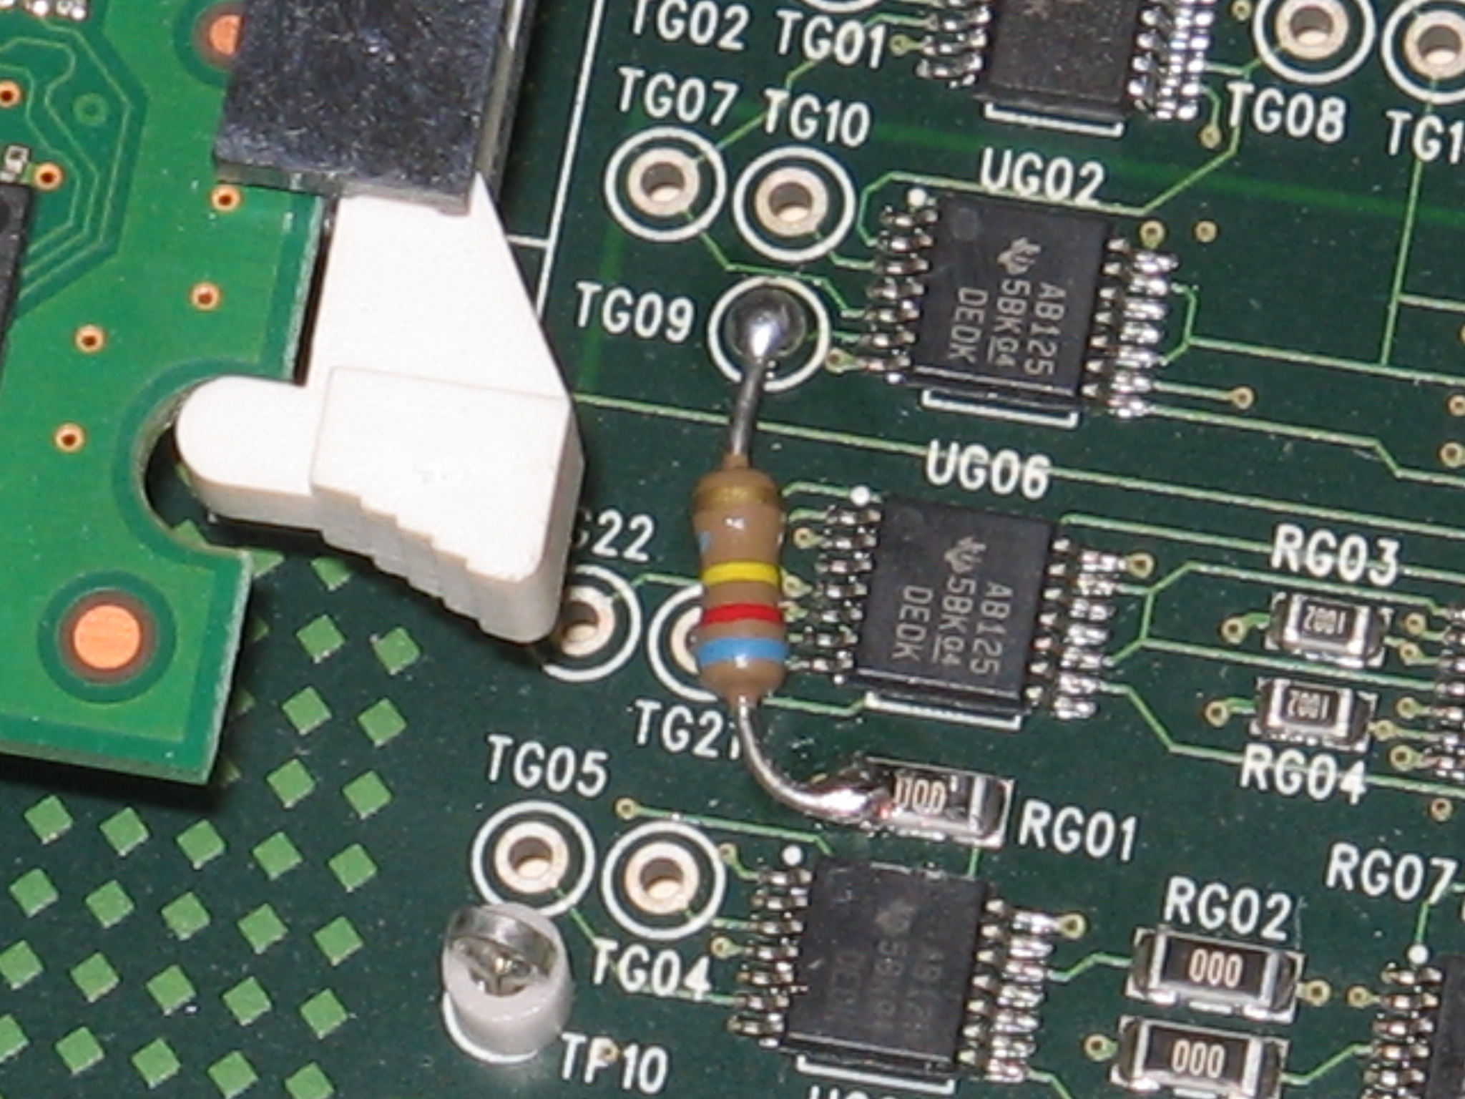

DBX Expansion card:
Install a 600K to 620K ohm resistor from T210 to a GND test point this is located next to the upper J1 connector toward the rear of the card. Please see attached picture.
It is recommended to use insulated tubing to prevent shorting to other components.” Not show on picture to increase detail of connections.

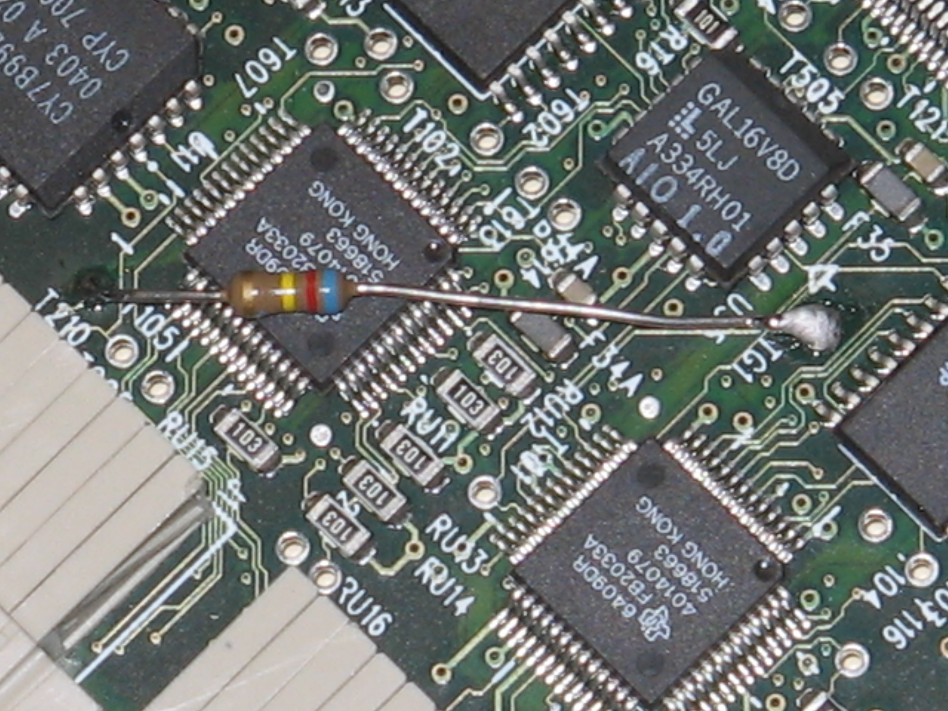

Yours sincerely,

Telex Communications, Inc.
12000 Portland Ave S.
Burnsville, MN 55337
Toll-free: 1.xxx.xxx.xxxx
Tel: +1.xxx.xxx.xxxx
Fax: +1.xxx.xxx.xxxx
firstname.lastname@us.telex.com
www.boschcommunications.com
Shawn Anderson
Tech Support Manager

