Cronus MC bootloader issues.

Subject: RE: Hi, need information on your RTS Cronus frame--NYC
Hi, Calvin

I tried it here. I downloaded Cronus MC v1.3.0 to our Cronus frame, then downloaded v2.0.0 – no problem.

I then tried it in the boot loader. I restarted the MC in the boot loader, connected to it serially, and downloaded v2.0.0 – no problem.

However, I have a suspicion of what the problem is.

The Cronus firmware consists of two parts: the boot loader and what we call the “client code”. (The client code implements the full intercom functionality. The boot loader implements just enough functionality to be able to communicate with AZedit and download new firmware.) When we release Cronus firmware, we include two separate files. From the release notes:

- cronus.hex can be downloaded via AZedit

- eprom_img.hex can be used to reprogram the code flash with a BDM
programmer

The difference between these is that the eprom_img.hex file includes
the boot downloader.

The eprom_img.hex file can also be downloaded via AZedit; however,
depending on the firmware versions, there may not be enough RAM for
the download to succeed. In that case, you can either download the
cronus.hex file, or restart Cronus in the boot downloader and download
the eprom_img.hex file.

I tried it here. When the Cronus MC is restarted in boot loader mode, it is possible to download either “cronus.hex” or “eprom_img.hex”. If the Cronus MC is running the client code, I can download “cronus.hex” successfully. However, if it is running the client code, and I try to download “eprom_img.hex”, there is not enough RAM available for the code image. AZedit gets to about 90% and then displays the following error message:

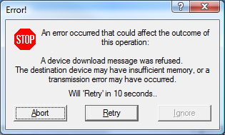

When you hit Abort, it then displays the following:

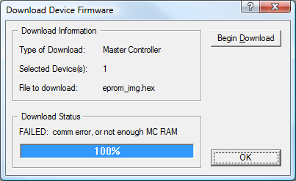

Could that be the problem?

If not, I will have to talk to Somvay Boualouang (CCS Engineering, in Burnsville) about what revisions of Cronus MC hardware are out there.

You told me that eventually 2 new MC cards got shipped to TBN, with v2.0.0 already installed. What happened to the old cards? If they are still around, they could get sent to CCS Engineering (probably Jing Zhang), to do some testing to see if there are any issues trying to download firmware to them.

-- James

____________________________
James H. Puttick

