How to Use RVONFILE.EXE with the RVON 1

To use the rvonfile.exe program first create a folder on the C drive call “rvon_tools”
Copy the file named rvonfile.exe to this folder. Next copy the proper .bib file to be downloaded into this folder also.

From a MS DOS prompt window, Change directories to C:\rvontool

For the RVON I/O type the following command string from the DOS prompt

rvonfile rvon-1 192.168.0.1 –ap rvon1.bib, then press “enter ”
Note: If you are upgrading from Rvon–1 version 1.0.0 to 1.1.0 use flag –ap instead of –a.

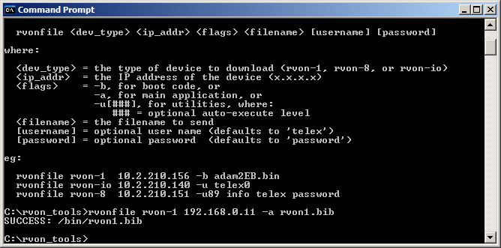

After the download is completed the unit should respond back with
SUCCESS: /bin/rvon1.bib

Then close the DOS prompt window
You can now proceed with reprogramming the RVON-1 channel configuration information as needed.

