# KP32 OKI 2nd Audio Channel.

By C. Roberts 2_11_2014 Rev 1.

To use the 2nd Dante channel on the Omneo Keypanel card for the KP32 you will need to do the following modifications.

1st: If the card is already installed you will need to remove it from the KP-32. You will have to open the top of the KP32 and the 2 screws on the back panel. Pull the card straight up and out of the top of the KP.

2: Turn over the OKI card and identify the J3 connector. (See picture 1)

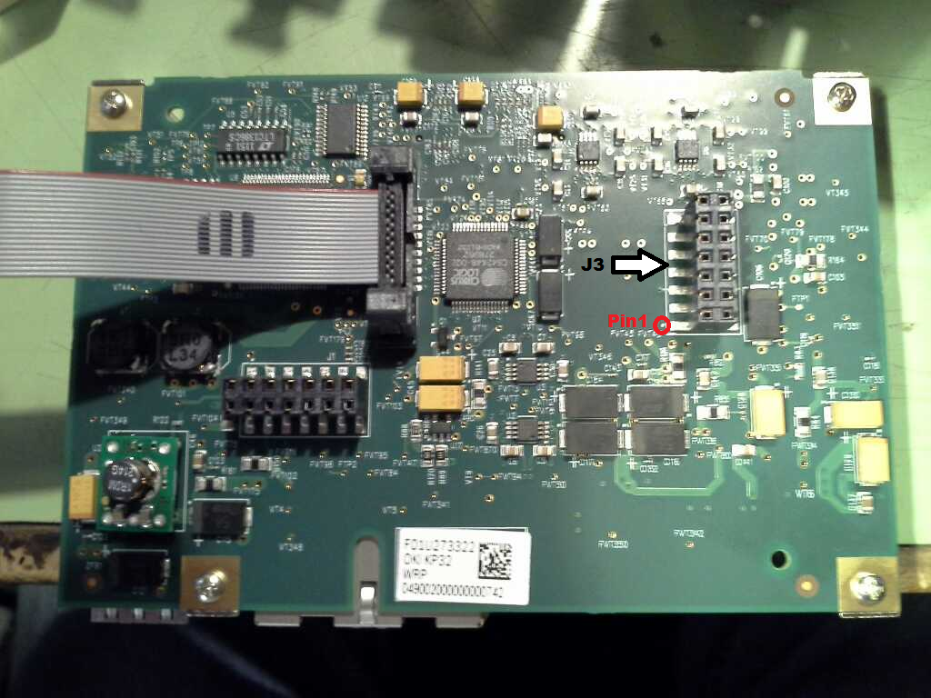

Picture 1.

3: you will need to soldier leads to the following contact on J3.

Pin1 is identified by the white dot in the red circle on the picture.

Aux channel input is

J3.pin7 = **FROM_AUX_AUD_L** J3.pin13 = **FROM_AUX_AUD_H**

Aux channel output is

J3.pin9 = **TO_AUX_AUD_L** J3.pin11 = **TO_AUX_AUD_H**

**Schematic for J3 Pins.**

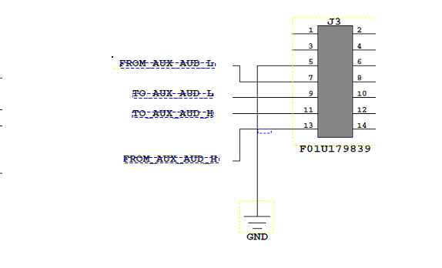

Connections to the AUX IN XLR connectors.

You will have to remove the rear connector kit from the KP32 to connect to the OKI card. (See Picture 2).

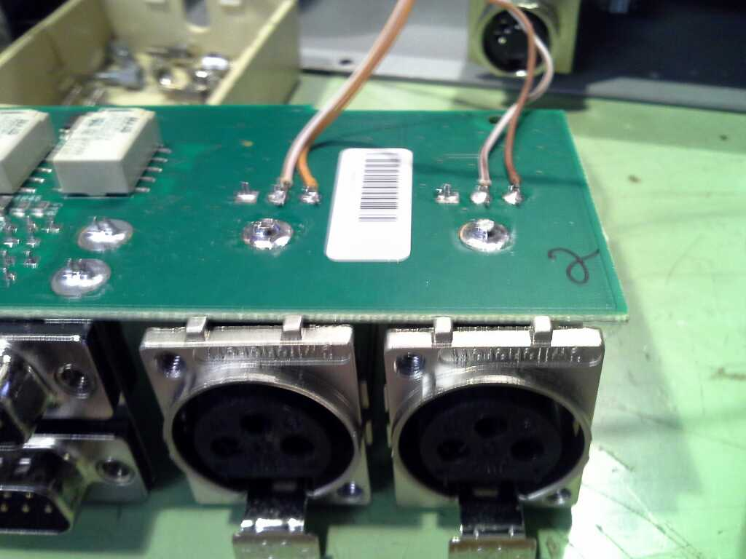

If you do not have a rear connector kit. Then you will have to add 2 XLR to rear of KP-32.

You can now reassemble the KP and the 2nd Omneo channel will be accessible.