By Charles Roberts August 25, 2014
RJ-45 USOC to 586B

RTS / Standard RJ-45 is USOC (See Below)
IT Network cable standard is 568B
If you use a standard Cat 5 / 6e premade cable the problem you may have is a limited distance that the data (RS485) will travel because they are not on the same twisted pair.
The Data will show up on pins 2 & 7 in the USOC diagram. To use standard IT 568B wiring you will need to make a cross over adapter that connects the brown pair of wire in the 568B (pins 7&8) on the matrix end to pins 2 & 7. This will then keep the data on the same pair of wire and allow 485 data to travel up to 1500 feet.

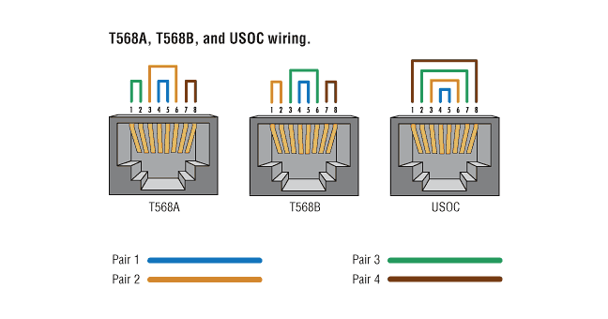
RJ45 to DB-9 (Male) to keypanel 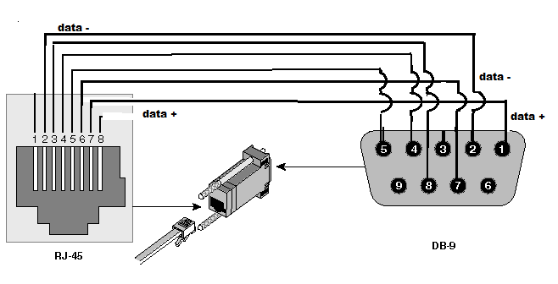
Pins 1,8 of RJ not used.
Pins 2, 7 Rj-45 to Pins 2,1 DB-9 Pins 3 ,6 Rj-45 Pins 8,7 DB-9
Pins 4,5 Rj-45 to Pins 4,5 DB-9

