9/30/09

Restoring RVON-I/O
Charles Roberts. System Support

Hardware Required:
Serial Null cable DB-9M to DB-9F
Pin connections:
- - 3
- - 2
- - 5
Ethernet connection:
Ether a cross over cable or two standard Cat 5 an 1 Ethernet switch.
Computer with Serial 232 port & Ethernet port.
Note: Serial port can be USB device RS232 connection.

Firmware needed:
FTP server program. Suggested, Cerberus FTP Server.

http://www.cerberusftp.com/download.html

SEAD1 dos program, available by request from system support.
RVON_I/O folder with the following files:
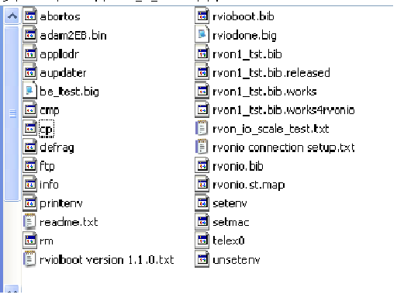
The RVON.BIB should be the current released I/O version.
The SEAD1.exe and the RVON-I/O files need to put in a folder named FTP and moved to the C:\ directory. ( C:\ftp).
You need to do this before installing & setting up the FTP Server.

Installation & setup of FTP server.
Download and install the Cerberus FTP Server, then launch program.
The first screen in the setup wizard will ask if you are a for profit or personal user.
Select personal.
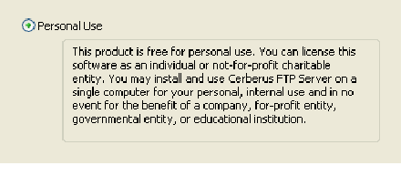
Hit “Next”
This will bring you to a user setup screen:
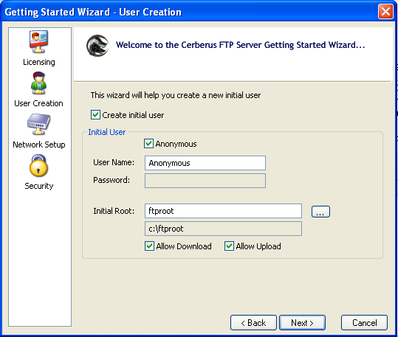
Un check Anonymous, replace user name with “telex” enter a password.
Suggest “password” Then hit NEXT.

Your will now see this message:
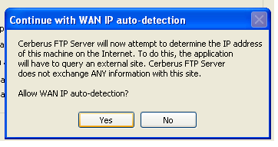
Click Yes. Then Next & finished for the next 2 screens.
You will now need to configure the telex User.
Go to the menu bar and select USER Manager.
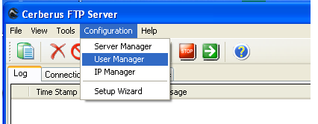
In the screen below select telex: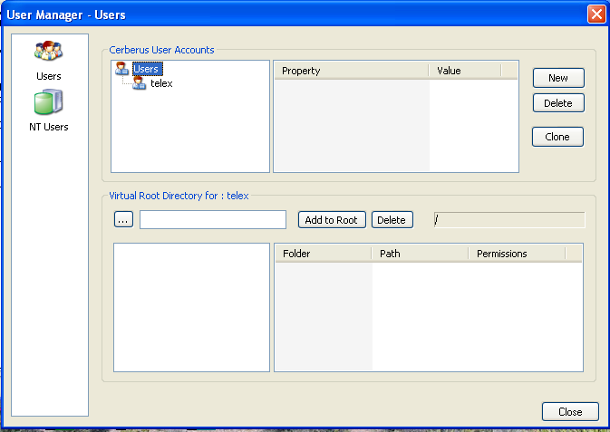

Next go to the Virtual Root Directory selection box;
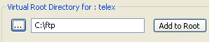
Click on box with the dots, select “My Computer”,Volume C, select the directory “FTP”.
As shown on next page.
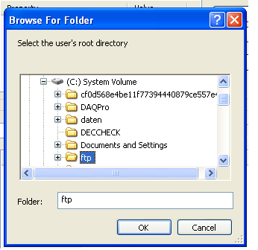

Click OK, then “Add to Root”You should see: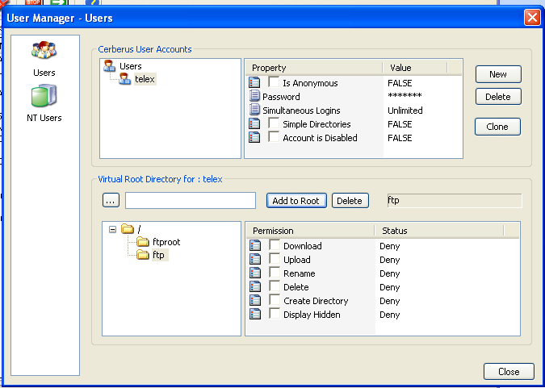

Put a check mark in “Download”
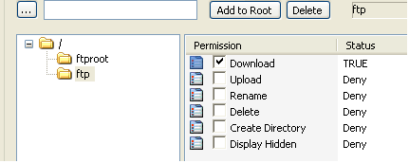

Then hit close.

Your FTP Server should now be ready to connect to the RVON-I/O.
In the main screen of the FTP server you should see an interface box with the IP address of the Network Card in you computer, only have the network connection you are using for the RVON checked, if you only have one network connection it should show it.

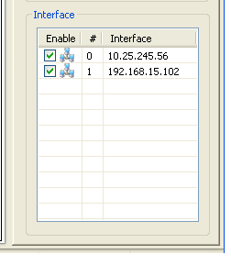
Do not be concerned with the IP address shown here, it is only for an example.
You will need to have one interface with ip 192.168.1.3

Leave the FTP program running but you can reduce it
Running the SEAD1 program.
First make sure your network connection port IP address is set to : 192.168.1.3

Go to Program / Run and type CMD. Once the dos box opens type CD C:\FTP (enter)
The line should show C:\ftp>
Type : SEAD1 –f (enter)
NOTE: if you are not using COM PORT 1. Type SEAD1 –f –p space (com port number) (enter)
You should see :
Adam Local Terminal Ver 0.01
RVONIO >

After the RVONIO> Type: c:\ftp\rvonio\be_test.big (enter)
You should see the following: On Next page….

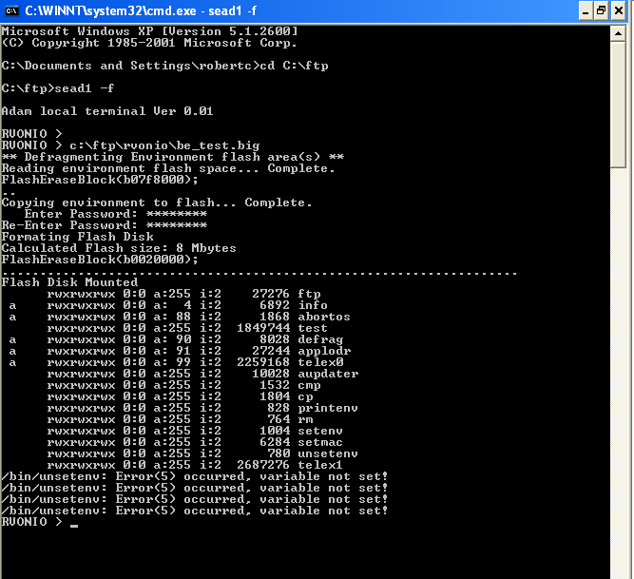

The download will stop at “Enter Password” you will enter the password you setup in the FTP setup. Of course twice.

Once you see RVONIO > again , Push the soft reset button on the RVON IO.

You should see the following in the Dos window:

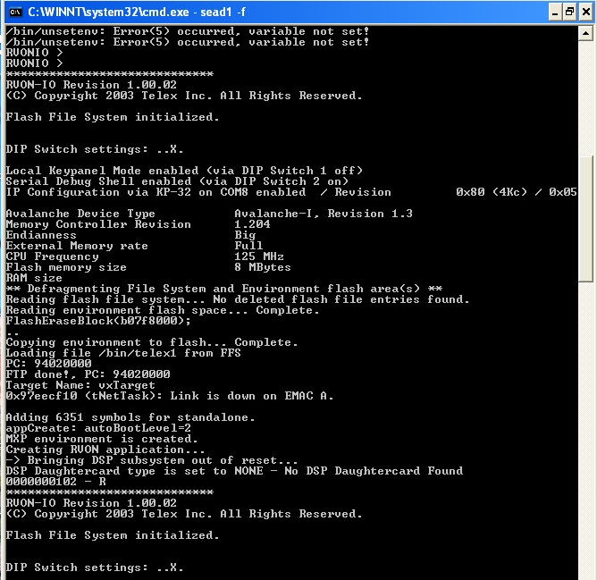

To confirm the RVON IO is fixed you should be able to type: DBGCMD (enter)
The reply will be “entering MXP command shell”
MXP> Type “Show RVON”
You should see the rvon configuration.

NOTE: I have had to reset the RVON IO and restart SEAD1 in some cases. So do not be concerned if you have to do that.

