**NEREUS SONY PBUS LANCE CONTROL SETUP**

Connect the lance Pbus serial output to the first Remote input on the Switcher chassis. This is DCU1_Port 3_1. (of course you also have to connect the remote ports from the Lance to the remote control ports of the Spotbox (usually 4 of them). Also connect the lance control (TDC100) to the control port of the Lance mainframe.

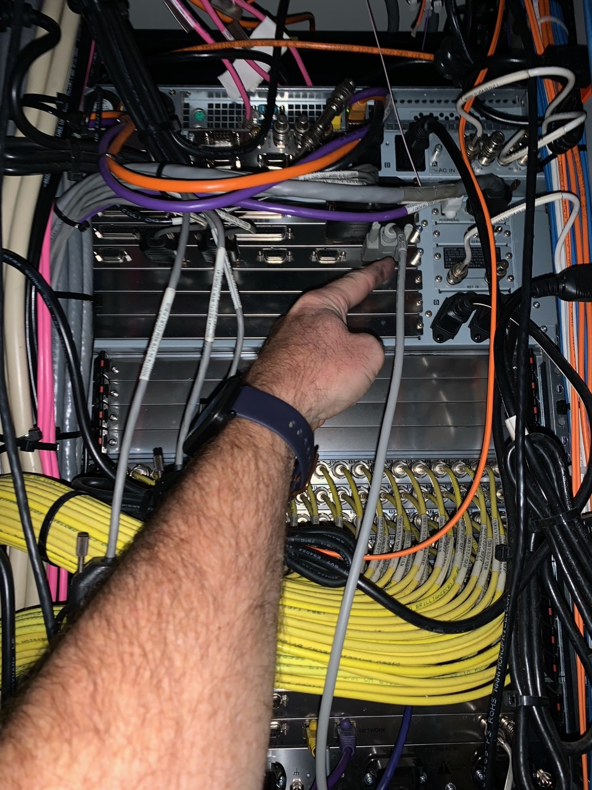

Check the DCU Serial Port assign in the Sony Switcher. It should say P-Bus for DCU1_PORT3_1 and VTR on the next 4 ports (for 4 channel control). If it doesn’t; see below

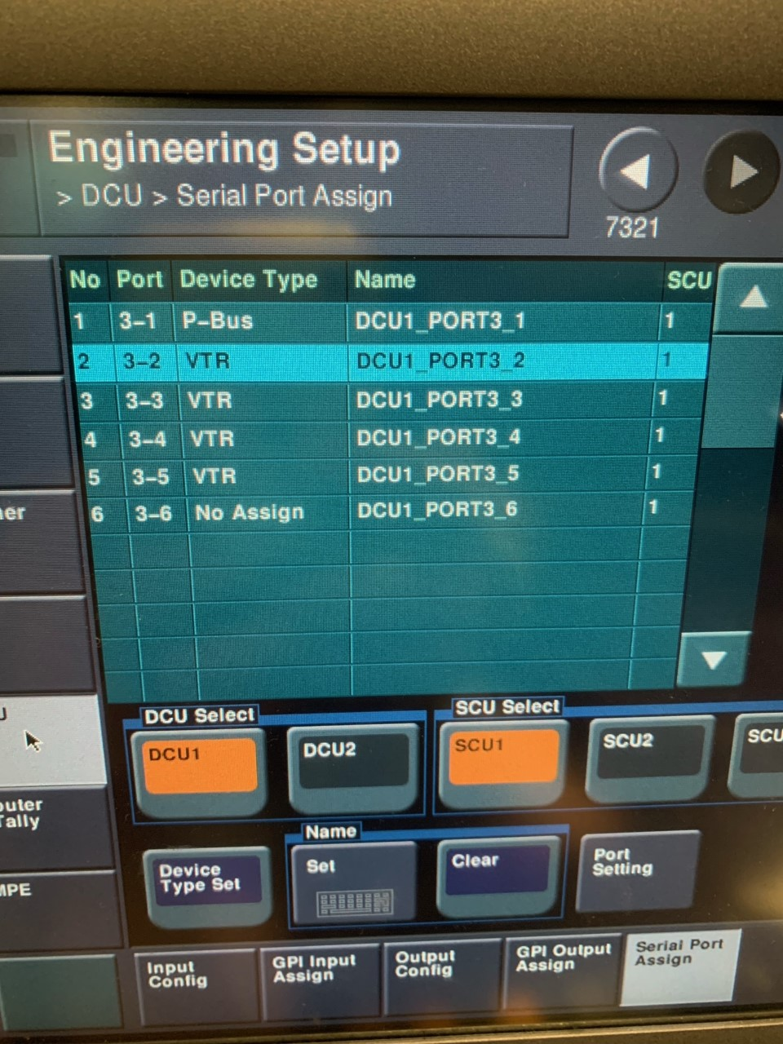

Navigate to ENG Setup / PANEL / DEVICE INTERFACE and make sure PBus control is on “Timeline” and not “trigger”. Enter the next Menu needed by pressing the DCU Serial Port/MPE Assign.

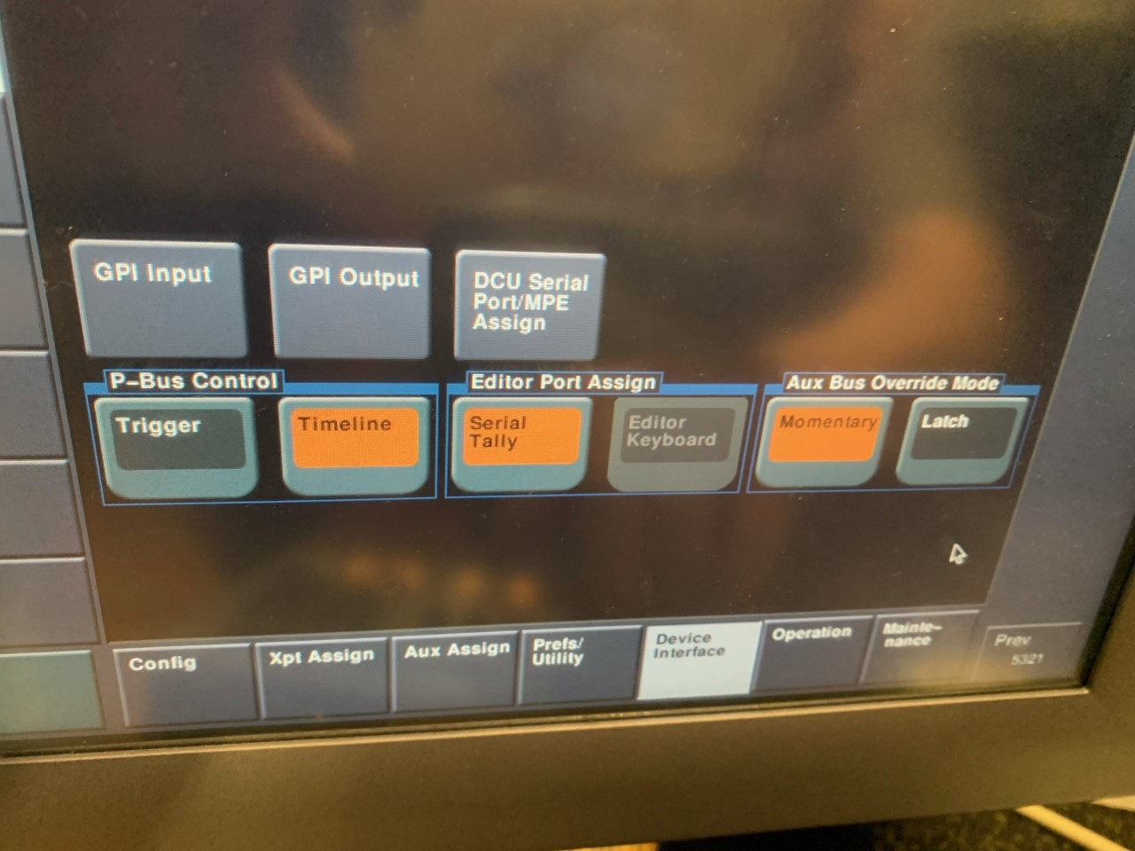

Use Menu 7325.4 (located from the above notes) to assign the Serial Port/MPE. Assign PBus to port 3_1 and then DEV 1-4 to the VTR positions.

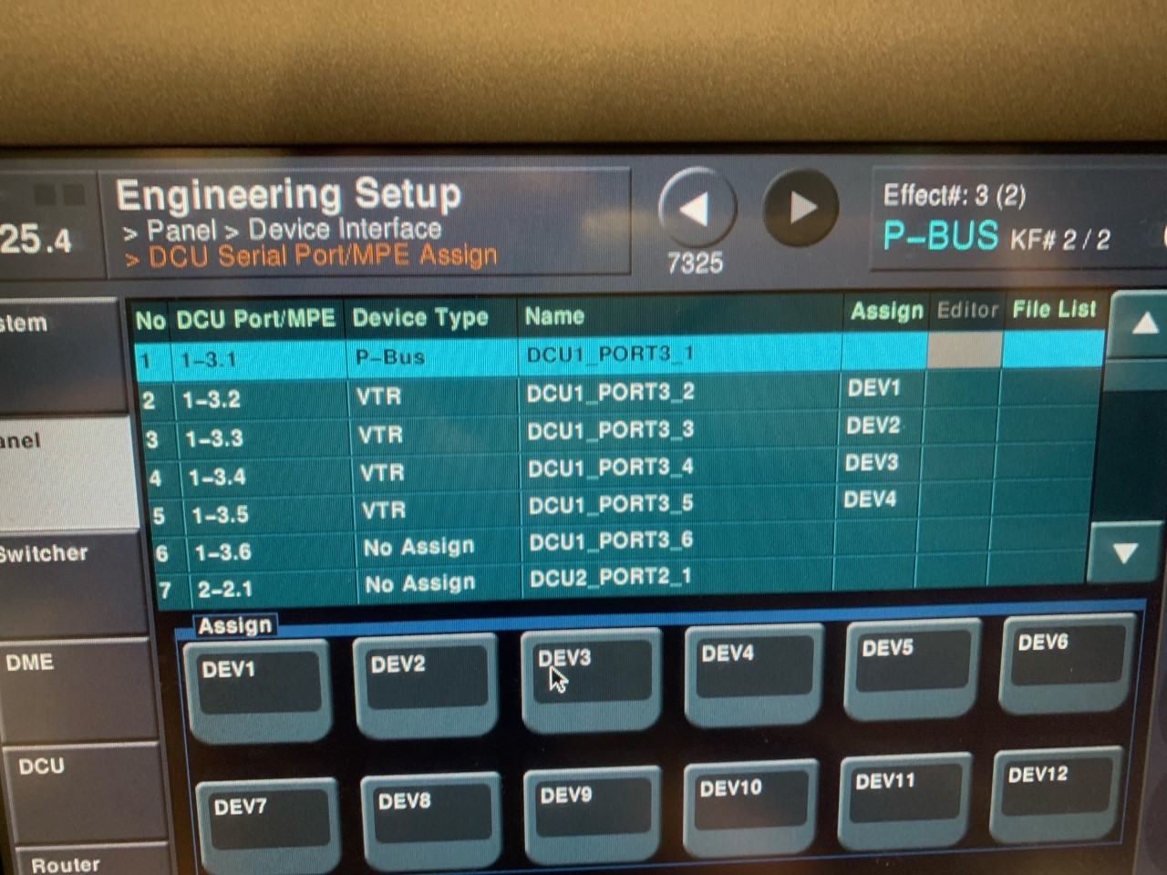

*SPOTBOX CONTROL SHOULD BE ODETICS 1-4

