TelePort 3G™

CWDM Multiplexer/Manager
& Transport System

Instruction Manual

Telecast Fiber Systems, Inc.
102 Grove Street
Worcester, MA 01605
Tel: 508-754-4858
Fax: 508-752-1520
www.telecast-fiber.com

TP3-130228jh1

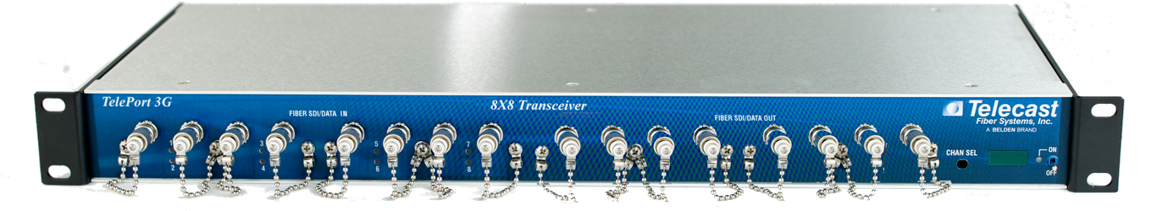

TelePort, front and rear views

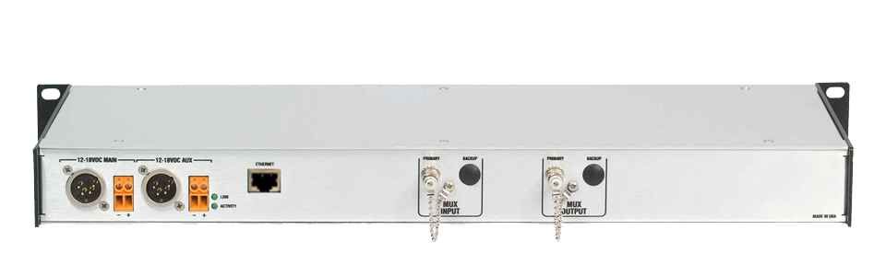

Software Version:
Download a copy of this manual at:
http://www.telecast-fiber.com/manuals.tport.pdf

Table of Contents

Laser Safety 4
Introduction 5
Setup 6
Attaching the Rack Ears 6
Line Power 6
Rear Panel Connections 7
Front Panel Connection/Indicators 8
Fiber Optic Cable Runs 9
Making the Fiber Connection 9
Optical Transmitter Losses 9
Powering Up 10
Operation 10
System Examples 12
Maintenance 13
Repair 13
Accessory List 13
Troubleshooting 13
Specifications 14
Warranty 15

Laser Safety

WARNING! Class 1 laser. Do not look into a fiber port or connector.

Laser Radiation

This TX units contains CDRH Class 1 laser devices. Always avoid looking directly at, or staring into, the laser light located on an optical connector or on the end of a fiber.

Infrared radiation is produced at the fiber connection port on the rear of the TX units and at the end of any un-terminated optical fibers that are attached to this port. Avoid any direct exposure to the light that comes from these sources.

Do not power up the unit when no fiber is attached to the fiber port.

There are no user adjustments inside the TelePort 3G. Do not attempt any type of service to this instrument other than any as instructed this manual. Refer all servicing to Telecast Fiber Systems, Inc.

FCC Part A Manual Notice

This equipment has been tested and found to comply with the limits for a Class A digital device, pursuant to part 15 of the FCC rules. These limits are designed to provide reasonable protection against harmful interference when the equipment is operated in a commercial environment. This equipment generates, uses and can radiate radio frequency (RF) energy and, if not installed and used in accordance with this instruction manual, may cause harmful interference to radio communications.

Operation of this equipment in a residential area is likely to cause harmful interference in which case the user will be required to correct such interference at their own expense.

WARNING CE

This is a Class A product. In a domestic environment this product may cause radio interference.

Introduction

The Telecast TelePort™ is, in the simplest sense, a CWDM multiplexer. It takes in optical signals within the 1310nm and/or 1550mn optical “windows”, receives those signals, does an O/E(optical to electrical) conversion and then re-transmits them (E/O) onto the proper wavelengths to be muxed onto a CWDM optical multiplexer and outputted onto one fiber. This results in 8 signals per fiber within the 1300 optical window. Another path, in the same or opposite direction, can have another 8 signals on one fiber.

The optical signal that you supply to the TelePort must be digital and must be 2.5 Gb/sec or less. There is no requirement that this optical signal originate from a Telecast product. Any optical digital signal, as long as it is digital and less then 2.5gb/sec, can be used.

The result is more efficient use of your fiber and the ability to take advantage of optical multiplexing without having individual wavelength-specific modules. This is a critical consideration when thinking about what kind of spare modules to keep in your inventory.

TelePorts are housed in a standard 19-inch electronics rack and are 1 RU high.

This manual covers the following representative part numbers:

Model Number | Description
TP3-MR-W8 | TR, 4 channels each way, 2 fiber, 1310
TP3-MNPP-W8W8 | TR, 8 channels each way, 2 fiber, 1310
TP3-MN-W8 | TX, 8 channels one way, 1 fiber, 1300
TP3-MNPP-W6* | TR, 8 channels each way, 1 fiber, 1310
TP3-QUPP-W6* | TR, 8 channels each way, 2 fiber, 1550
(*these make a pair)
Table 1: TelePort 3G Varieties

In addition, if you are doing strictly one-way signal transport, a TelePort will be required only on the transmit side of the system. A completely passive, and less expensive, CWDM unit such as the Telecast MCW-8D-13 can be used on the receive end to distribute each optical signal to its appropriate receiver.

Setup

The TelePort system consists of:
• Two TelePort Transceivers
• External power supplies (AC/DC adapters)

After unpacking, inspect the units for mechanical damage, and all electrical and optical connectors for damage. Report any issues to the carrier and to Telecast Fiber Systems, Inc.

Leave the protective caps on the optical connectors until it is time to attach the fiber to the units. Replace the caps whenever the fiber is disconnected.

Place each unit in its intended location before attaching any cables or fibers to prevent accidental damage to the cables or their connectors.

Line Power

Any power supply used with the TelePort must provide a minimum of 2 amps, continuous, at 12 to 24 VDC. Two 4-pin DC power inputs are provided for redundancy.

There is no internal backup battery of any sort in the TelePort.

Power input is through 4-pin XLR’s connector located on the left side of the rear panel; see Table 2 for pin-out and Figure 2 for location. Be sure that AC outlets are within reach of their 6-foot power cords.

PIN | SIGNAL | 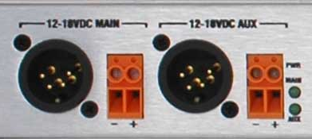
1 | Ground
2 | No Connection
3 | No Connection
4 | +12 to +24 VDC
Table 2: Power XLR Pin-out Figure 1: DC Power Inputs

Rear Panel Connections

Figure 2: Rear Panel Connections

Fiber I/O Connections

The optical connectors for the TelePort combined outputs and inputs are on the rear panel. An INPUT ST connector would be the optical signals being received INTO that unit. The OUTPUT ST connector is for the optical signals being transmitted FROM that unit.

Front Panel Connections/Indicators

The front panels of the RX and TX are shown on the next page in Figure 3. The front panel will have 16 ST type optical connectors that will accept an optical digital signal of not more than 3Gb/sec.

Figure 3: Front Panel Connections/Indicators

Front Panel Primary Indicators

Power An LED for each power input which illuminates GREEN when 12 to 24 VDC of external power is supplied to the unit.

Eth/Link For future implementation. These indicators are UNUSED at this
time.

Individual Channel Indicators

Each ST input and output has a single LED that indicates the following:

On TX Units OUT No Data present
GREEN SDI Data present

On RX Units RED No Optical link
RED/GREEN Flashing indicates good optical link
GREEN SDI Data present

In addition, the RX features a 4-segment LED display and a toggle switch that allows you to see the software revision number on the unit, the received optical power of EACH input and the internal ambient temperature of the frame.

By moving the toggle switch to the right, you may select any received channel.

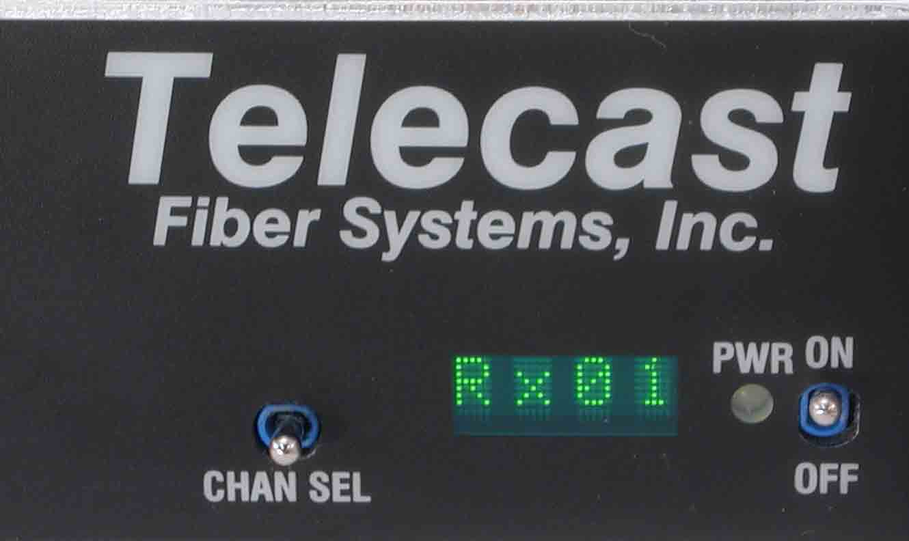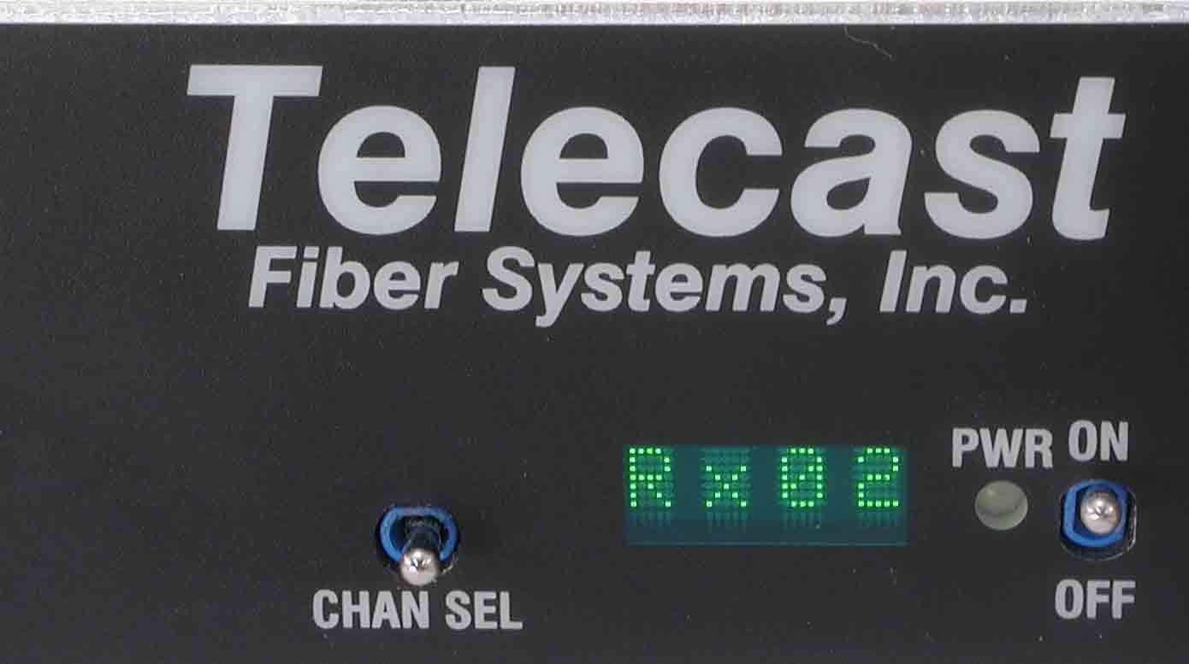

Figure 4: Using the toggle to change channels to be monitored

As you scroll through the channels, you will see one of four conditions:

1. If there is no fiber link for a given channel, n/a will be displayed

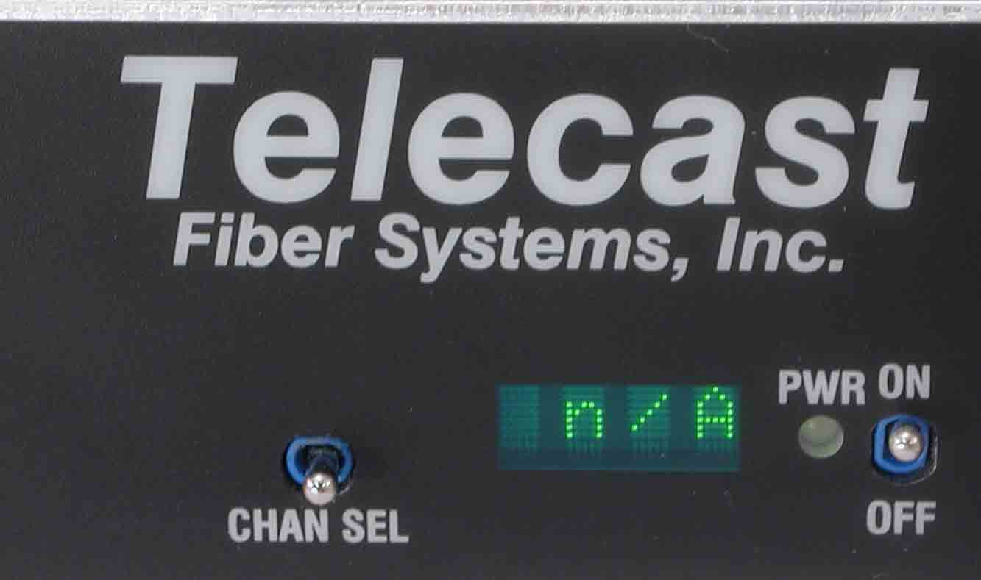

Figure 5: “n/A” indicates no optical link

2. If there is an optical link but no SDI data present, the optical power reading will change between a high and low value, such as -7 and -30. This is because, when there is no data present at the TX, the laser turns on and off until SDI is present. This is also why the individual RX channel LED blinks RED/GREEN.

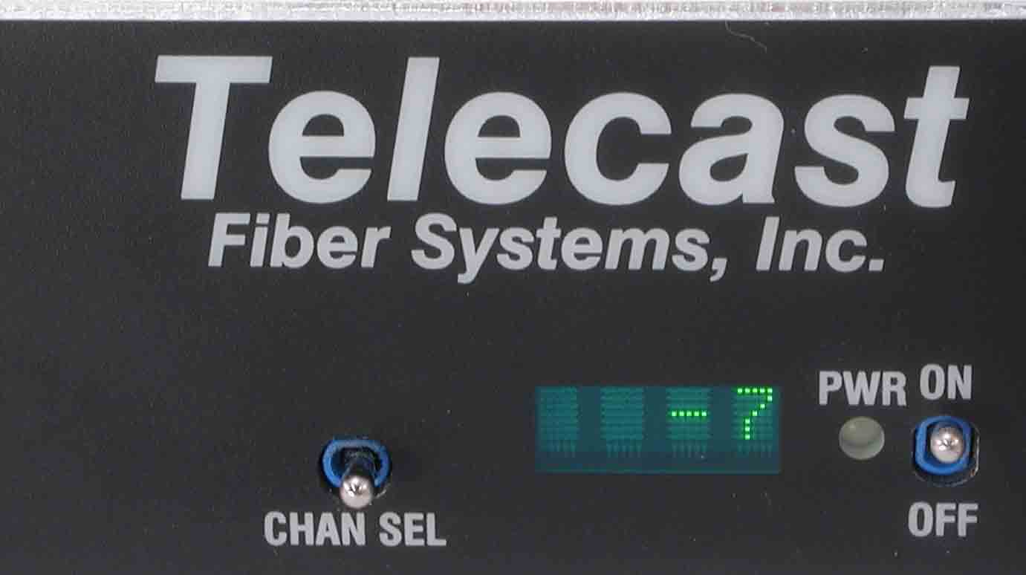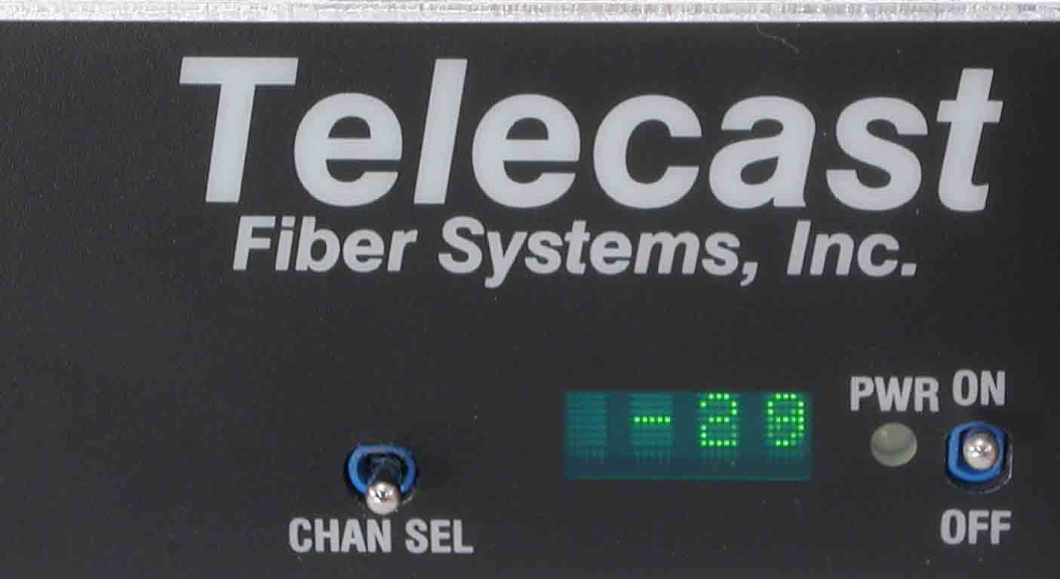

Figure 6 : Variable optical power levels = NO SDI present

3. When the optical link is good AND a valid SDI data stream is present, an optical power level will be indicated. Depending on the loss in the fiber run, this number could range from approximately -5 to -22.

Figure 7: A steady numerical value IS the received
optical power for that channel.

4. After the last channel is displayed, the ambient temperature inside the frame will be indicated in degrees Celsius.

Fiber Optic Cable Runs

The optical output from each transmitter is generated by an infrared laser diode that is coupled to a CWDM and onto the fiber. User connections are made at the bulkhead ST type connectors on the front and rear panels; refer to Figure 2 on page 7. Operation is intended for use on single mode fiber. Since the CWDM output of the TelePort is the aggregate output of all 8 or 16 optical transmitters inside the frame, the optical power output will be in the +4 to +8 dBm range. Standard conventions of NEVER looking directly into a fiber should be followed at all times.

The inputs at the RX uses an InGaAs pin diode and amplifier to convert the optical signal back into an electrical signal.

Making the Fiber Connections

Inspect the fiber ends and clean them with with Kim-Wipes and pure isopropyl alcohol. Fingerprints or other dirt on the optical connector end surfaces will reduce the received optical signal level.

Connect the fibers to their matching ports on both the TX and RX units.

Optical Transmitter Losses

The maximum fiber distance is defined by the optical loss margin. The RX signal must be - 22 dBm or better. Losses on single mode fiber are approximately 0.5 dB/km or less. CWDM’s account for about 5dBm of loss per pair and must be considered when computing your link loss budget.

The integrated optical power meter will show the received optical power for each receiver but note that this figure is POST CWDM.

Powering Up

Power is applied to the units as soon as DC voltage is plugged into on of the rear panel power inputs. There is no on/off switch.

16 Channel TX/RX Operation

In the 16-channel unit with the band-splitter option installed, all 16 signals are carried on one fiber. The first 8 channels are in the 1300nm optical window and the second 8 channels are in the 1550nm optical window. The band coupler combines the aggregate output of each CWDM and couples that onto a single fiber.

System Examples:

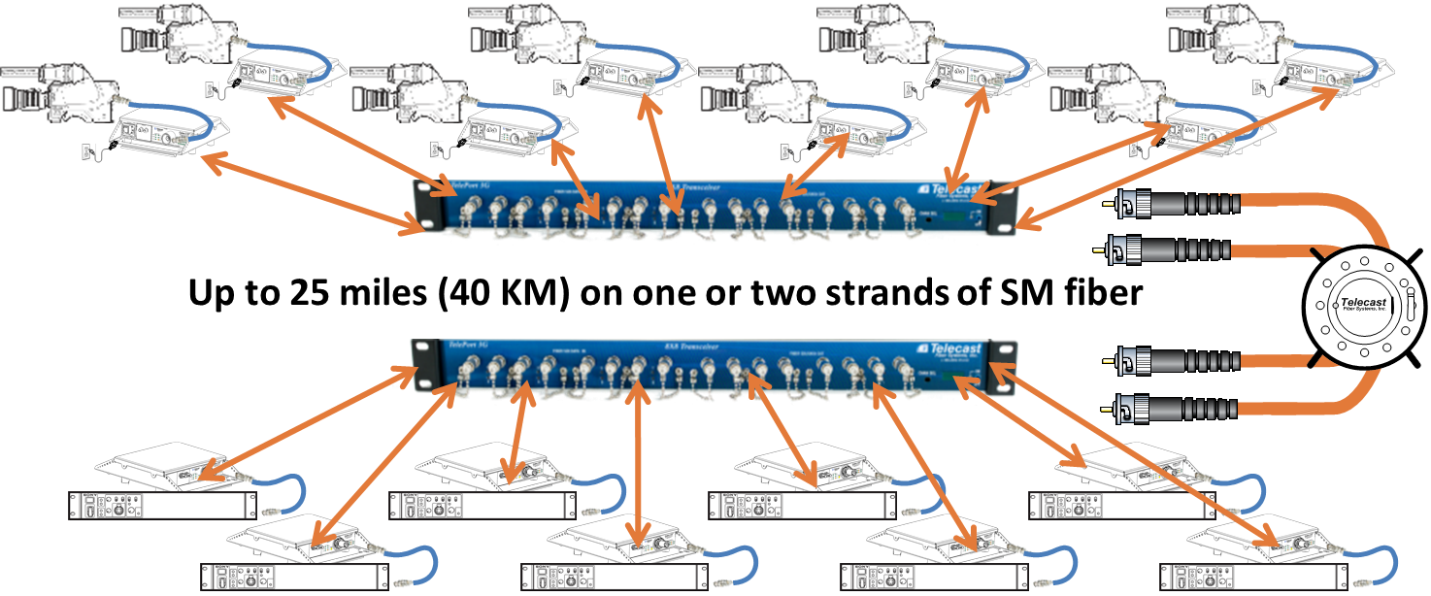

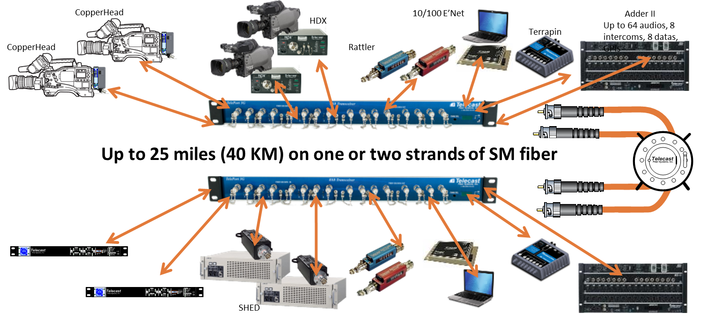

System Maintenance

Repair

For assistance with your TelePort system, contact Telecast Fiber Systems, Inc. at 508-754-4858. To return a unit for repair, you must obtain a return material authorization (RMA) number from Telecast service.

Accessory List

The following accessories are available from Telecast:
• Cable repair kit
• Loop-back cable to localize signals during installation test
• Prefabricated cables built to custom lengths

Troubleshooting

Symptoms | Possible Cause | Corrective Action
No operation, all indicators are off. | Check DC power inputs | Verify that the external power supply is delivering12-24 VDC.
TX LED RED | Bad SDI signal | Confirm presence of SDI signal at the end of the coax or reduce coax cable length at input
TX LED GREEN  RX LED RED | Bad fiber link or fiber mis-patched | Reconfirm fiber link and ensure that fibers are patched properly on multi fiber units
TX LED GREEN  RX LED flashing RED/GREEN | Fiber link is good | RX unit malfunction. Contact Telecast  For RMA number.
LEDs correct  Bad video | Too much fiber loss  Optical Link is marginal | • Clean connectors  • Minimize connection points  • Search for tight bends in fiber run

Table 3: Troubleshooting guide

Operating Characteristics

Optical
Wavelength: 1271 to 1611 CWDM wavelengths
1300-M Module 1271, 1291, 1311, 1331nm
1300-N Module 1351, 1371, 1411, 1431nm
1550-Q Module 1471, 1491, 1511, 1531nm
1550-U Module 1551, 1571, 1591, 1611nm
Fiber: Single mode
Input Optical Power -7 to -15dBm
Optical Data Rate: Up to 3 Gb/s per channel
Optical Source DFB (0 to -3 dBm) CWDM laser
Optical Detector PIN
Link margin: 22 db for HD rates, 30 db for 270 rates
Distance
@1310nm up to 20 km max
@1550nm DFB up to 40 km max

Power Requirements
Voltage: 12 to 24 VDC
Current: < 2 Amps
Power: < 25 watts

Mechanical/Environmental
Dimensions (L x W x H) 16.7” x 10.5” x 1.75”
Weight, each unit 3 lbs
Connectors Singlemode ST Type
Indicators Power On, data present, Display
Temperature Range - 20C to + 55C
Humidity Range 0 to 95%, non-condensing

WARRANTY

LIMITED WARRANTY STATEMENT
Telecast Fiber Systems, Inc. (“Telecast”) expressly warrants to Buyer that the Products supplied shall be free from defects in materials and workmanship for a period of 12 months following the date the Products are delivered to Buyer (the “Warranty Period”). Telecast's liability under this limited warranty shall be limited, at its option, to providing refund of purchase price for Products, or replacing or repairing Products shown to be defective either in materials or workmanship. Buyer's sole and exclusive remedy for breach of warranty shall be such refund, replacement or repair.
A claim of defect in materials or workmanship in any Product shall be allowed only when it is submitted in writing to Telecast Fiber Systems, Inc. within seven days after discovery of the defect, and in any event within the Warranty Period. No claim shall be allowed in respect of any Product which has been altered, neglected, damaged or stored in any manner which adversely affects it. In order to obtain service under the terms of this warranty, Distributor’s customer or Distributor must notify Telecast of the defect prior to the expiration of the applicable warranty period and obtain a Return Authorization Number from Telecast. In no event may products be returned to Telecast or to Distributor for warranty service without having obtained from Telecast a Return Authorization Number.

This limited warranty applies only to new and unused Products delivered to Buyers located within the United States of America, or to international Buyers if sold through an authorized Distributor organization, and shall not extend to any equipment not manufactured by Telecast Fiber Systems, Inc., even though such equipment may be sold or operated with the Products. In addition, this limited warranty shall be void and of no further force or effect whatsoever if the Product is repaired or modified by any person other than an authorized representative of Telecast Fiber Systems, Inc. without the consent of Telecast Fiber Systems, Inc. This warranty shall not apply to any defect, failure or damage caused by improper use or inadequate maintenance and care. Nor shall this warranty apply to any damage caused in whole or in part by attempts by personnel other than Telecast’s personnel, as approved in advance in accordance with the foregoing provisions, to open, install, repair, or service the Product; nor to damage resulting from improper connection with incompatible equipment; nor to damage to a unit which has been modified by personnel other than Telecast personnel.

Products returned to Telecast for warranty service shall be shipped, freight prepaid to Telecast. Telecast will return the repaired product or ship a replacement, freight prepaid, to either Distributor or Distributor’s customer, as requested by Distributor’s customer, at a location within the United States or, at Telecast’s option, to Distributor’s location in the case of international sales.
This limited warranty shall also apply to Products that replace defective Products and Products that have been repaired by authorized representatives of Telecast Fiber Systems, Inc., but only for the original Warranty Period. The Warranty Period shall not be extended by reason of defect, or any period of time during which the Product is not available to Buyer because of defects or repairs, without the express written consent of Telecast Fiber Systems, Inc.

EXCEPT FOR THE EXPRESS LIMITED WARRANTY AGAINST DEFECTS IN MATERIALS AND WORKMANSHIP CONTAINED HEREIN, TELECAST FIBER SYSTEMS, INC. MAKES NO WARRANTY OF ANY KIND WHATSOEVER, EXPRESS OR IMPLIED, AND ALL WARRANTIES OF MERCHANTABILITY, FITNESS FOR A PARTICULAR PURPOSE, AND OTHER WARRANTIES OF WHATEVER KIND ARE HEREBY DISCLAIMED BY TELECAST FIBER SYSTEMS, INC. THIS LIMITED WARRANTY SETS FORTH EXCLUSIVELY ALL OF TELECAST FIBER SYSTEMS, INC.'S LIABILITY IN CONTRACT OR OTHERWISE IN THE EVENT OF A DEFECTIVE PRODUCT.
WITHOUT LIMITATION ON THE FOREGOING, TELECAST FIBER SYSTEMS, INC. EXPRESSLY DISCLAIMS ANY LIABILITY WHATSOEVER FOR ANY DAMAGES INCURRED DIRECTLY OR INDIRECTLY IN CONNECTION WITH THE SALE OR USE OF, OR OTHERWISE IN CONNECTION WITH, THE PRODUCT, INCLUDING WITHOUT LIMITATION, LOSS OF PROFITS AND SPECIAL, INCIDENTAL OR CONSEQUENTIAL DAMAGES, WHETHER CAUSED BY NEGLIGENCE OR OTHERWISE, REGARDLESS WHETHER TELECAST HAS BEEN GIVEN ADVANCE NOTICE OF THE POSSIBILITY THEREOF.
THIS WARRANTY IS GIVEN BY TELECAST IN LIEU OF ANY OTHER WARRANTY EXPRESSED OR IMPLIED.

