Upgrading 121293-1 video FPGA with Xilinx (14.7)

1. Scope
   1. This will briefly describe programming the original VO-Embedder card.
   2. We find it is easier to use an external 48V power brick instead of the router to power the cards for programming (though either way will work). This procedure will reflect using the external power brick.
2. Requirements
   1. -48V power source (48V @ 1A+ power brick) with hooks instead of a plug.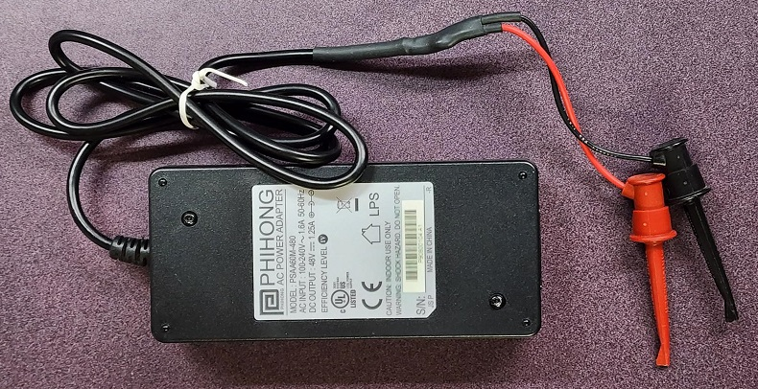
   2. Xilinx software and programming pod.Text

      Description automatically generated with medium confidence
   3. Xilinx project files
3. Hardware Setup
   1. The 121293-1 card has three locations to focus on for connections and changes.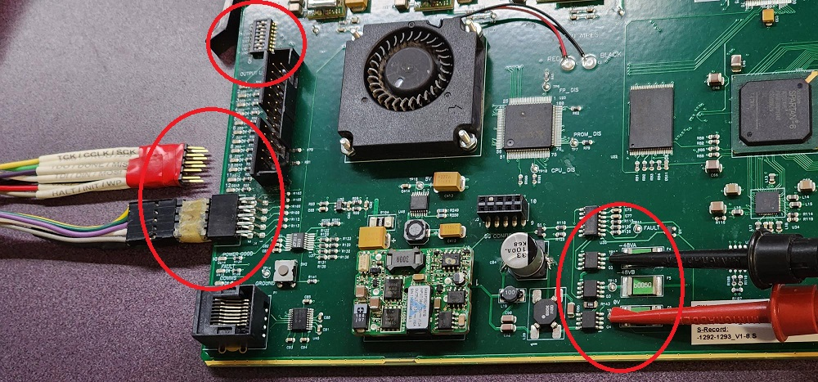
   2. Connect the Xilinx programmer to the front port. Take note that pin 4 is not present on the programmer cable and where it is located on the card connector.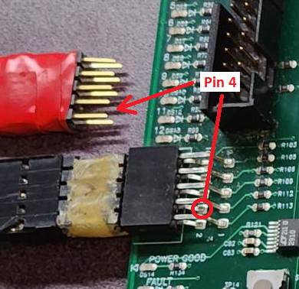 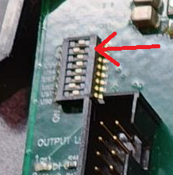
   3. Flip the Bypass (BPS) switch (dip-7) to the ON position (as seen above).
   4. Connect **(unpowered)** cables to the card. Make sure the positive (red) is connected to 0V test point and the negative (black or ground) is connected to the -48V test point.A close-up of a circuit board

      Description automatically generated with medium confidence
4. Software Setup
   1. This may be the tricky part. Sometimes it is hard to get the software and PC to properly identify the programming pod.
   2. Copy the project directory to the PC. I created a “Projects” folder in the Xilinx folder to store various card projects. Extract the project here.

* 1. After launching the iMPACT software, click File and Open and browse to that location. Open the project file (121293-1 ver_1.10.ipf).

* 1. Power on the card by plugging in the power brick. I use a power strip with an ON/OFF switch to make this easier.
  2. To verify communication, right-click on the third chip (shown green above) and select *Verify* from the menu. You should see a progress bar and a “Verify Succeeded” message if everything is functioning. *This quick test works well because the audio code in that chip hasn’t changed since 2012.*

1. Upgrading the Embedder firmware
   1. The firmware upgrade is for the video quad-embedder FGPA. This is the second chip in the chain. If you try the *Verify* on this chip, it should fail (since the code in the chip won’t match the new code in the project file).
   2. Right-click on the second chip and select *Erase*. Give it some time, and when it is complete, you can do a *Blank Check* if desired.
   3. Right-click on the second chip again and select *Program*. This takes the longest but should also be completed successfully.
   4. Power down the card, unplug the programmer from the card, disconnect the power jumpers, and remember to flip dip-7 back to the OFF position.

Programming is complete for this card, and it can now be tested.

For additional cards, repeat step 3, power on the card, and then step 5b through 5d.