Objective:

This provides a back-up method of accessing the status of a unit in the event of an unexpected failure, such as a display failure. This also documents how to log the debugging information available from the unit’s console port.

Required Materials:

1) Fully functioning AMP1-16V or AMP2-16V.

2) 9-Pin RS-232 cable wired straight through (pin 1 to pin 1, etc.).

3) Windows PC with a serial port (a dedicated port or a USB to serial converter) and a terminal program installed. Almost any terminal program may be used, but MTTTY is used for demonstration in this document. Other terminal programs will have similar settings, but in different menus.

Procedure:

- Set the terminal settings to 115200 baud, no parity, 8 data bits, and one stop bit. No hardware or software flow control is used. The COM port number selected should match that of the serial port on the computer you're using.

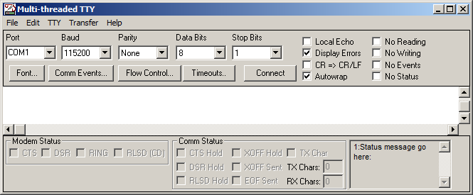

- Connect the RS-232 cable between the serial port of your PC and the "Console" or "Serial" 9-pin port on the back of the unit.

- Press "Connect" on your terminal program (if necessary).

- Select Transfer/Log To File, and specify a log file name and path.

- Apply power to the AMPx-16V. If all the connections are correct, you will see a large amount of diagnostic information on your terminal screen as the unit boots.

- When the unit finishes booting, click “Close Capture” in the lower left corner of the window.

- Send the text file to Wohler if requested.

<<<<<<<< END OF PROCEDURE >>>>>>>>

