1. On “PPCBOOT” prompt, user can use recovery image to load 7800/7801FC image manually. You need to put the jumper to “UPGRADE” first.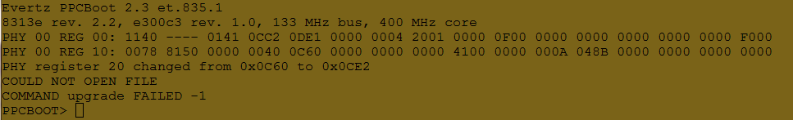

2. Type “upgrade” on PPCBOOT prompt



2. Use XMODEM to send recovery image to FC via serial port

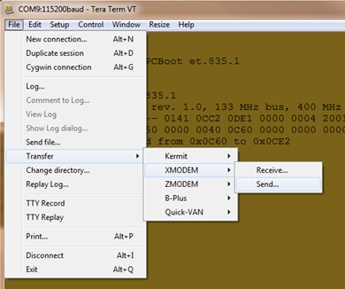

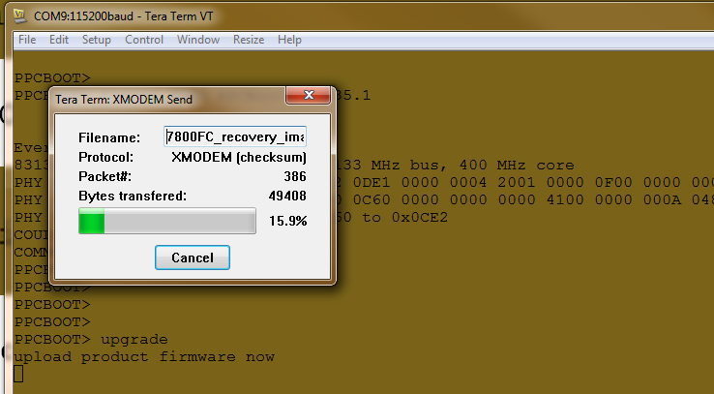

3. On loading recovery image successfully, type “boot” to boot up recovery image. You will see the “CLI” prompt. The default IP address is 192.168.192.100



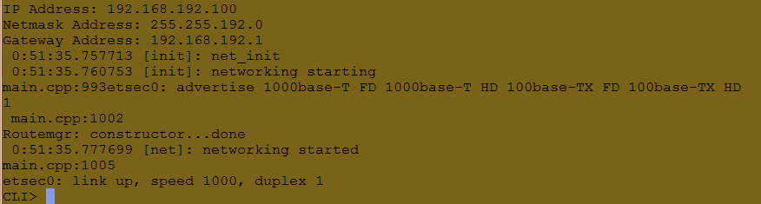

4. Run windows command dialog. Use FTP to log in FC. (User and Password is empty)

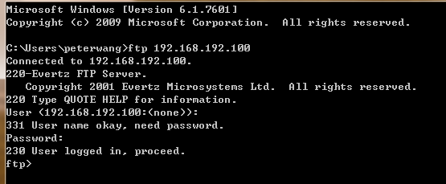

5. Make user you are using binary mode for ftp transmission.



6. Load FC image by typing “put image_name.bin”



7. You will see “Transfer complete” message at the end of upgrade. Then FC will reboot automatically.

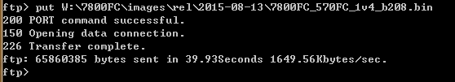

8. Put the jumper back to “RUN” so that FC can boot up automatically.