**FW 876-01P02-192**

This file includes a Virtual Image of the COMPACT FLASH master disc generated from the Jenkins build system. This is the application code of the RCP-200 which will be copied to the COMPACT FLASH.

This method requires opening the RCP-200 box so it’s only used in production at the factory. Never used in the field.

**FW 876-01P03-192**

This file consists of an UPDATE that can be applied to the COMPACT FLASH By USB key. This file only works with units that already contain one (See component P02). This file can be used to update of units already in finished products.

This method is used in field.

**2.5.1 Upgrading the Compact Flash**

After you have obtained the Updater file from Miranda, copy it onto a USB key.

• Create a folder **\RCP200\UPDATE** on the key.

• Copy the updater file you received (**rcp200-update.os**) into the above folder.

• If the file was delivered to you with a different name, e.g. **rcp200-update-buildxxx.os**, rename the file as **rcp200-update.os**

Note – not all USB keys can be used for this purpose. Grass Valley advises that you should use a key that conforms to these requirements:

• The key should be FAT or FAT32 formatted.

• The key should NOT have “U3 Smart Drive” installed

• The key should have a capacity between 1 GB and 8 GB; larger keys do not work

• At least 600 MB of free space is required

Insert the key into one of the USB connectors found on the front and rear panels of the RCP-200.

• An *Update* screen will appear on the left-hand LCD

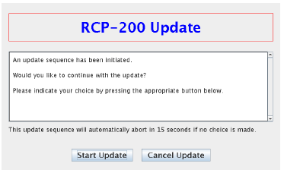

• If no action is taken within 30 seconds, the update will be automatically cancelled. A countdown is shown on the screen. Remove the key from the USB port and reinsert it if you wish to continue with the update.

• Touch “Start Upgrade” to start the process, or “Cancel” to abandon it.

• If the update window does not appear in the left-hand screen within 10 seconds or so, there is a problem with either the file or the key. See the troubleshooting suggestions in section 2.6 on page 11.

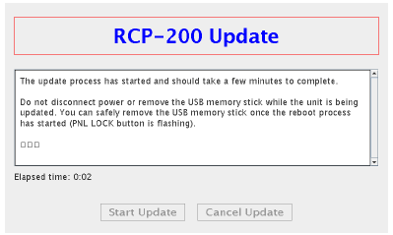

Installation takes a few minutes, and then the unit will automatically reboot. You can safely remove the USB memory stick while the RCP-200 reboots (the PNL LOCK button will be flashing during the reboot).

Once the unit has rebooted, check the system status (see *Checking the system status* on page 9) to verify that the system has been updated correctly. In particular, verify the Compact Flash build number.