To upgrade your Kaleido-X, XFR4,7 or 14 or KMV

1. Copy the update files from the Miranda FTP link that Support will sent you
On to the PC’s hard drive,create a folder Miranda on your desktop.

2. Insert a USB flash drive in to one of the PC’s USB ports.

3. Locate and double-click on the Kaleido-X Upgrade Manager application
(It has a filename of the form “XUpdate7.exe’):

4. When the Welcome screen appears, click on the type of kaleido that you would like to upgrade (Kaleido-X in your case)
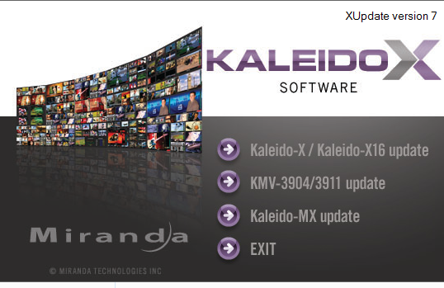

5. When prompted to select a type of update, click Smart Update or Force Update
Note: If you click Forced Update (no confirm), then the update procedure, once initiated, cannot be aborted.
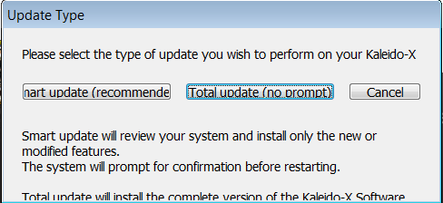

6. When prompted to select an update file, Browse to the Miranda folder that you have created on the desktop in step1 locate and double-click on the Kaleido-X operating system file
(of the form “kxos-7_01_BUILD_5213.os”):

7. The .os file will be copied to the USB drive. This may take a few minutes:

8. When the copying process is finished, a confirmation message appears. Click OK:

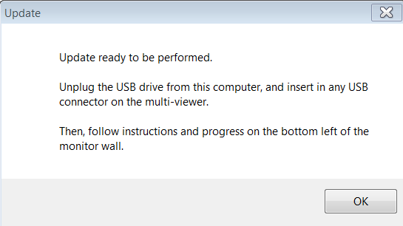
9. Click Exit on the Welcome screen.

10.Connect the USB key to one of the available USB Connector on one of your KXO card in your multiviewer and Follow the instructions and Progress at the bottom left corner of your monitor wall.

