a) COMPACT FLASH REGHOSTING PROCEDURE FOR A KALEIDO-X

1. Download the image file and the Cf_ghoster software from the FTP site that was sent to you from TechSupport.

**IMPORTANT: Make sure if you use the express link to copy and paste the link in Windows Explorer and DO NOT USE Internet Explorer.

1. Unzip the .zip image file
2. Insert the CF or SD into the card reader -  if Windows asks you to format it again,  click Cancel/NO →

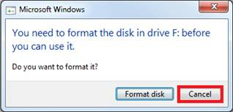

1. Start the CompactFlash Ghoster (also works for SD cards) application and then click on Browse →

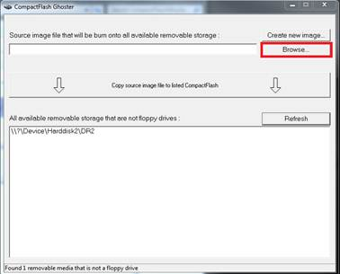

1. Select the image file you just unzipped and Click Open →

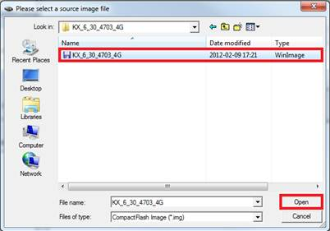

1. Click on Copy source image file to listed CompactFlash/SD →

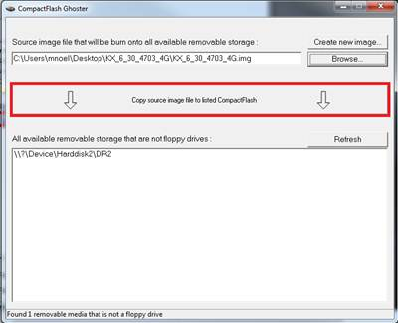

1. The flash card re-imaging is in progress so  you should see the card  reader flashing and the following message at the bottom of the software →

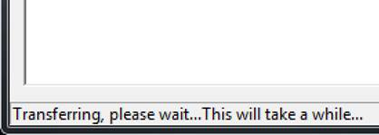

1. You should get this message when the compact flash/SD is rebuilt successfully →

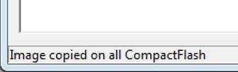

*Note: It’s possible that the non X16 units such as 4RU & 7RU revert back to the default IP address 10.0.3.70