# Automatic LED Reset Tool

## SW Installation

1. Install python 2.7.5 first onto a host PC that is going to be used to reset the module. The Kayenne or Karrerra Menu can be used as well.
2. For 32-bit systems use **python-2.7.5.msi**
3. For 64bit systems use **python-2.7.5.amd64.msi**
4. Install WxPython3.0 onto the host PC. Again, a Kayenne or Karrerra Menu can be used.
5. For 32-bit systems use **wxPython3.0-win32-3.0.1.0.b20140104-py27.exe**
6. For 64-bit systems use **wxPython3.0-win64-3.0.1.0.b20140104-py27.exe**
7. Install pyserial-2.7 onto the host PC. Again, a Kayenne or Karrerra menu can be used.
   1. For 32-bit systems use **pyserial-2.7.win32.exe**
   2. For 64-bit systems use **pyserial-2.7.win-amd64-py2.7.exe**
8. Set the menu to factory default address 192.168.0.175.
9. Set the panel to factory default address 192.168.0.173 and restart panel. Wait until it is finished booting.
10. Copy the calibration tool folder **LEDPresetTool** to the desktop of the hostPC (or Menu)

## Execute Tool

1. Open **LEDPresetTool** and double click on **GVPanelCal.pay**
2. A GUI window titled ***GV Panel Calibration Tools***will appear.
3. Select **Kayenne or Karrera** radio button and per panel. The Telnet radio button is set by default
4. Click the **Scan button** once to scan all the connected Kayenne or Karrera modules to **GV Panel Calibration Tools.**
5. Wait for the panel to restart into diagnostic mode and all connected modules in **Module Section** drop down list appear. Running ### will appear in the blue progress bar until it states “**Operation Complete**” in green.
6. Select the Module to **calibrate** in **Module Section** drop down list. Note the port # and connector # is correct. An example is shown below. The top M/E is Port 1, second to the top Port2, and so on. The name of the module is displayed in the drop-down.

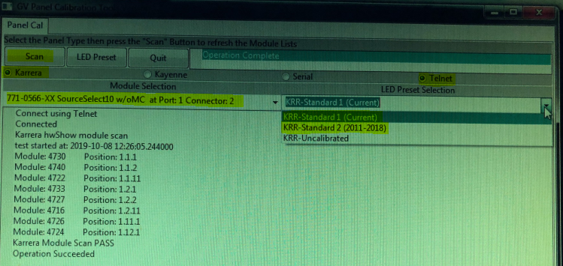

1. Select correct option under **LED Preset Section:**

* **KAYENNE:**
* **KAYN-Standard1 (Current) –** For calibrate switches from 2013 to Current
* **KAYN-Standard2 (2009-2013) –** For calibrate switches from 2009 to 2013
* **KAYN-Uncalibrated –** For un-calibration if needed

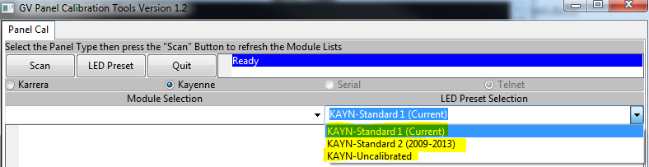

* **KARRERA:**
* **KRR-Standard1 (Current) –** For calibrate switches from Jun 2018 to Current
* **KRR-Standard2 (2011-2018) –** For calibrate switches from 2011 to Jun 2018
* **KRR-Uncalibrated –** For un-calibration if needed

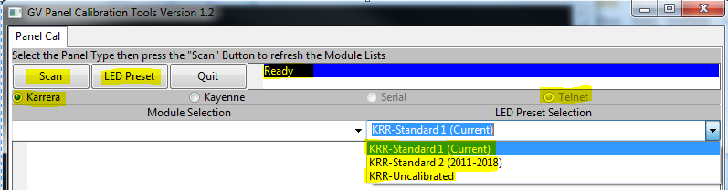

1. Click on **LED Preset** button once to begin the automatic calibration and wait up to 10 seconds. The tool will return PASS if automatic calibration was successful.
2. After automatic calibration press the two Red Test Mode buttons until the **RGB LED Test** is enabled (make note of the 2 red buttons as they will match all other buttons)
3. Push any button to change color to **white high.**
4. Power cycle the panel and wait for it to restart into normal operation to verify button intensity.