KayakDD™ DPM Digital Effects Library

What is it? How do I use it? 1
Configuration notes for DPM 1
How to load the effects to your switcher 2
Catalog of Effects 5
C1fx – for Channel 1 only. 5
C4fx for KayakDD™ system with 4 DPM channels per M/E and advanced effects option (a.k.a “TE” option) 7
Notes: 9
Use of GLOBAL Channel 9
Format 9
Standard 9

What is it? How do I use it?

This DPM effect library is provided to give users examples of the capabilities of the internal DPM as well as a starting point to create own effects.

The library is in 2 sections; C1fx is the section which uses only DPM channel 1 on P-P and ME1. This section uses 3D-planar transformations and can be easily used by owners of systems which do not have 4 DPM channels per M/E. C4fx is the section which uses up to 4 DPM channels per effect and uses the SpecFX: Kurl™ and Splits/Mirrors effects. This section will only show results for owners of fully loaded KayakDD™ switchers.

Each effect is built in 2 parts; 1 to introduce a picture and the 2nd to remove the picture. This enables users to work live with the DPM recall area of the KayakDD™ and also to integrate effects easily into E-MEM™ timelines.

All effects were built using V664.2 software. The effects will not replay correctly, if at all, using earlier software versions.

The effects were built for 4:3 aspect ratio.

The effects can be used in 625/50 and 525/60 standard.

Configuration notes for DPM

In the CONFIG/Ebox- DPM settings area of your switcher are very important settings which affect the edges of pictures in DPM channels. If you use sources which have been digitally sourced you should ensure that the production crop settings for 4:3 are set to Top = 3.05, Left = -4.16, Right = 4.16, Bottom = -3.05. These figures will ensure the correct viewing of the effects in this package.

Note to Tech Pubs: insert a screen shot of the menu here.

How to load the effects to your switcher

Use the memory stick for your system to make a copy of your working application.

- Insert your stick in USB slot 2 or 4.
- Go to the CONFIG menu. It will open in Application Control window
- Press SAVE – your application will be saved to the stick
- Press SAVE AS and give your application a new name, this could include the letters FX.
- You now have 2 copies of your working application. The first is a working backup, the second will become your copy with an effects library

Use your PC to add the effects library to your 2nd application copy.

- Connect your USB memory stick to your PC
- Using windows explorer to navigate to the folder on your computer that contains the effects libraries. There are 2 folders; 1 is called C1fx, the other is called C4fx. In these are folders named te_eff0 and te_eff1. Highlight 1 of these folders and press the “copy to” button in the windows tool bar.
“copy to” button
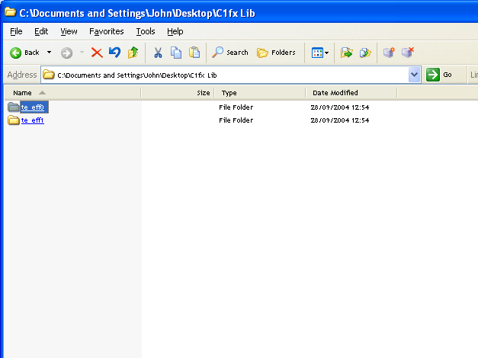

- In the window that opens navigate to your memory stick and open the “appli” folder. In this navigate to the folder named as you named your copy of the active application on your KayakDD™ and then to the MF1 folder. With this folder highlighted press OK. Windows will ask you to confirm that the existing te_eff0 or te_eff1 folder may be overwritten as all data within it will be replaced with the library effects. If you are happy that you have highlighted the correct application answer “yes”.

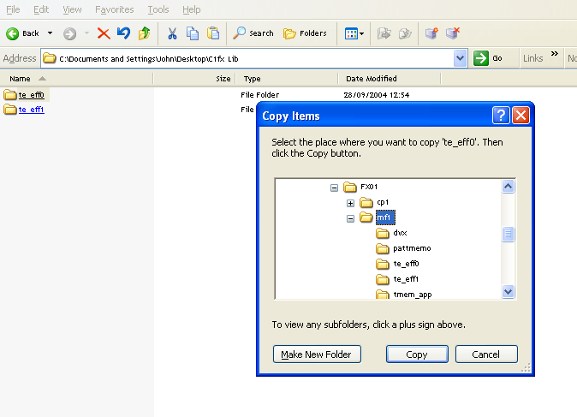

You do not have to copy both te_eff0 and te_eff1 to a 2 M/E KayakDD™ unless you want both mix effect banks to have access to the effect library.

You do not have to copy the same library (C1fx or C4fx), so you could use C1fx from te_eff0 and C4fx from te_eff1.

If you have a KayakDD™ 1 M/E unit the te_eff1 folder exists, but this is a folder made for compatibility only. If you save effects to this folder it will be emptied when the KayakDD™ saves the application.

In the package of software you will find a folder named “ramrecStills”. This folder contains 4 files which are full frame graphics that you can use to name the 4 keyers on an M/E using RamRecorder. You will have to use a PC running the sidepanel program to transfer these pictures to your KayakDD™ and full instructions on how to use the ram recorder transfer system are in the KayakDD™ user manual.

To replay and use an effect refer to the catalogue of effects.

Catalog of Effects

C1fx – for Channel 1 only.

Naming: sl = slide
ps = perspective slide
lb = linear motion bounce
spir = spiral
bnc = multi position bounce
sw = swoop
bri = barrel roll in
bro = barrel roll out

Positions in or out of frame: T = Top Centre
B = Bottom Centre
L = Left Centre
R = Right Centre
TL = Top Left corner
TR = Top Right corner
BL = Bottom Left corner
BR = Bottom Right corner
C = Fully centred

Channel names: C1, C2, C3, C4 = Channel numbers.

All effects in the C1fx section may be used with either full frame pictures or keyed elements.

Bank 00 Slide and zoom with shadows. Effects are 1:00 seconds in duration.

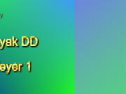
- Zoom OUT
- C1sl-LC
- C1sl-RC
- C1sl-TC
- C1sl-BC
- C1sl-CL
- C1sl-CR
- C1sl-CT
- C1sl-CB

Bank01 Corner slides and spin zooms with shadows. Effects are 1.00

- SpinZoom Out
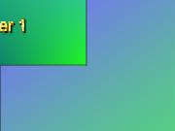
- C1sl-TLC
- C1sl-TRC
- C1sl-BLC
- C1sl-BRC
- SpinZoom IN
- C1sl-CTL
- C1sl-CTR
- C1sl-CBL
- C1sl-CBR

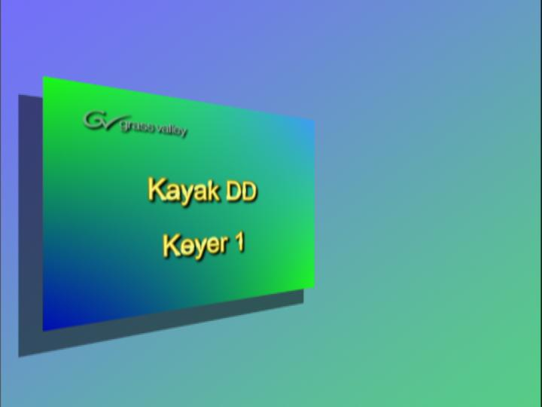
Bank02 Perspective slides and spiral zooms

- C1spir-OUT
- C1ps-LC
- C1ps-RC
- C1ps-TC
- C1ps-BC
- C1spir-IN
- C1ps-CL
- C1ps-CR
- C1ps-CT
- C1ps-CB

Bank03 Linear Bounce

- C1bncOUT
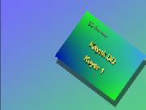
- C1lb-LC
- C1lb-RC
- C1lb-TC
- C1lb-BC
- C1bncIN
- C1lb-CL
- C1lb-CR
- C1lb-CT
- C1lb-CB

Bank04 Swoop IN/OUT

- C1sw-OUT
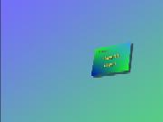
- C1sw-TLC
- C1sw-TRC
- C1sw-BLC
- C1sw-BRC
- C1sw-IN
- C1sw-CTL
- C1sw-CTR
- C1sw-CBT
- C1sw-CBR

Bank05 Barrel Rolls

- C1-OUT
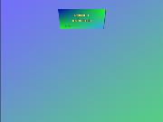
- C1bri-L
- C1bri-R
- C1bri-T
- C1bri-B
- C1-IN
- C1bro-L
- C1bro-R
- C1bro-T
- C1bro-B

C4fx for KayakDD™ system with 4 DPM channels per M/E and advanced effects option (a.k.a “TE” option)

Bank00 Push on/off

- QUAD-ON Brings all 4 channels in from corners
- C12sl-LR Slides C1 off screen, slides C2 on screen
- C12sl-RL Slides C1 off screen, slides C2 on screen
- C12sl-TB Slides C1 off screen, slides C2 on screen
- C12sl-BT Slides C1 off screen, slides C2 on screen
- QUAD-OFF Removes all 4 channels to corners
- C21sl-LR Slides C2 off screen, slides C1 on screen
- C21sl-RL Slides C2 off screen, slides C1 on screen
- C21sl-TB Slides C2 off screen, slides C1 on screen
- C21sl-BT Slides C2 off screen, slides C1 on screen

Bank10 Reduced size effects (over shoulder position)

- Wipe12sq Square wipe reveals 2 over 1
- Wipe21sq Square wipe removes 2 from 1
- Wipe21LR Wipes 1 from 1
- Wipe12LR Wipes 2 over 2
- pgt12 Page turn adds 2
- pgt21 Page turn removes 2
- pgr12 Page roll adds 2
- pgr21 Page roll removes 2

Bank20 Page Turns full size

- K12pg-ON Double sided page turn 2sec.
- C1pgt-ON
- C2pgt-ON
- C3pgt-ON
- C4pgt-ON
- C1pgt-OFF
- C2pgt-OFF
- C3pgt-OFF
- C4pgt-OFF
- K12pg-OFF

Bank30 Page Rolls full size

- C1pgr-ON
- C2pgr-ON
- C3pgr-ON
- C4pgr-ON
- C1pgr-OFF
- C2pgr-OFF
- C3pgr-OFF
- C4pgr-OFF

Bank40 Double sided page turns and page rolls

All effects are 2 seconds

Key 1 is front, K2 back
Key 3 is front, K4 back.

May be used with keyable sources. Make K1 and K2 the same or K3 and K4 the same.
- C12pgt-ON
- C34pgt-ON
- C12pgt-OFF
- C34pgt-OFF
- C12pgr-ON
- C34pgr-ON
- C12pgr-OFF
- C34pgt-OFF

Bank50 Cubes and Slabs

- smlcub Small cube, centre screen rotates 3 times. 8s.
- smlslb Small slab, centre screen rotates 3 times. 8s.
- CUB-R12 Full size cube. C2 replaces C1- rotate to see C3 top
- CUB-R21 Full size cube. C1 replaces C2- rotate to see C3 top
- SLB-TLC 6 sided slab fly
- SLB-TRC
- SLB-CTL
- SLB-CTR
- SLB-IN 6 sided slab fly/rotate from centre
- SLB-OUT reverse

Bank60 Tiles and modulation

- C1twinH
- C1twinV
- C1quad
- C12twin
- C1mod
- C1expld
- C1slitsON
- C1slitsOFF

Notes:

Use of GLOBAL Channel

Although GLOBAL channel is supported, certain aspects may behave unintuitive.
Most of the effects in these libraries do not use GLOBAL, but cubes and push/pull effects do. You may find that when you first load the effects library some effects are not running as intended. Before running any effects go to the DPM, Misc, Reset to Defaults menu and reset ALL PARAMS.

If some effects still run incorrect, be confident that there will be a software update shortly. It may be that another version of effects library will be required at that time.

Format
All effects in this library are built for 4:3 aspect ratio.

Standard
The effects in this library are built in 625/50 standard. The effects durations are stored internally in a format that allows the system to recalculate the duration for 525/60 standard. Effectively that means that effects do not need to be re-built for use in 525/60 standard.

