The 3500Pro software is a three tiered architecture based on Microsoft technology. The database layer is implemented using the Microsoft MSDE database engine. The middleware layer is a set of customer DLL’s and OCX’s generated by PESA. For this release, these files are installed in the chosen installation directory and are not loaded into the Windows directory.
To run the 3500Pro status and diagnostics software, you need a 3500Plus controller that has been flashed with the latest 3500Pro software. (NOTE: you can run the configuration tool without the controller being present.)
(These instructions are for Win2000/WINXP only.)

Loading the 3500Pro Tools on Win2000/WinXP
- Load “3500Pro Config Beta Install.EXE” program
  - This may require a couple of resets as the MSDE and MDAC components may need to be installed.
  - Select the components of the suite that you wish to run.
- Load the SQL Server Service Pack 3 to update the database engine
  - Execute the sql70sp3i.exe program from the install CD directory. This loads the service pack on to your PC.
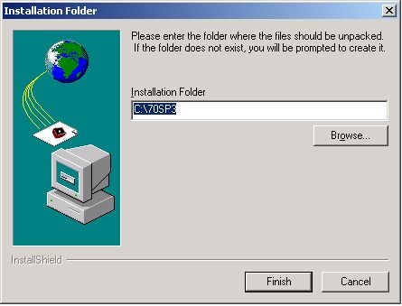
  - Run SETUP from the directory where you loaded the service pack.
  - Use the SQL SERVER 7 Admin login. (Has a blank password)
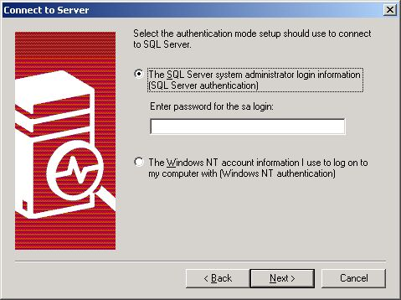
  - When prompted (toward the end of the process) , add the user to “sa” with the password to "sa". (Use the mixed mode option)
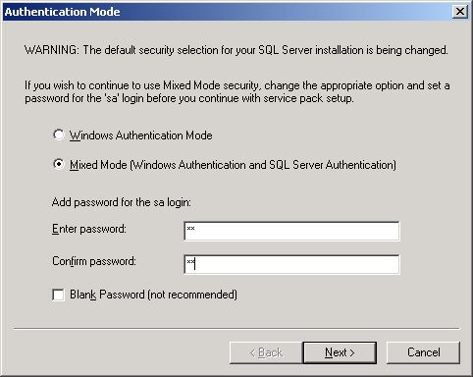

- Create the initial empty databases by running “Initialize Databases” under the “PESA 3500Pro” menu.

Reflashing the 3500Plus controller to 3500Pro
- Load “3500Pro Controller upgrade V1.0.EXE” program which installs the reFLASH software for the controller.
- Run the “3500Pro User V1.0 icon under the 3500Pro Field Upgrade menu.
- When it queries for a license key, enter the key 504553123456789. This will allow you to install the software.
- IF this fails, run the “3500Pro Flash Interactive”
  - Run “Interrupt->Are you There” command. (You should get a Command Acknowledged response.)
  - Run the “loader->License Key” command and enter the license as listed above.
  - Run “loader->Address Range”. Insure that address range is 0 and 60000
  - Run “Loader->Download Data”. Select the file <install Directory>\SRC\3500Pro.abs where <install directory is where you loaded the flash program
  - After Program has been downloaded, run “Loader->Commit Program To FLASH”. Select the USER option.

