**ROAMEO Baseline (7.8.0)**

Contents

[**Release Notes** 2](#_Toc489536247)

[**Introduction** 4](#_Toc489536248)

[**Version Identification** 5](#_Toc489536249)

[Beltpack 5](#_Toc489536250)

[Access Point 5](#_Toc489536251)

[**Initial Setup & Configuration** 6](#_Toc489536252)

[1. Access Point Configuration (via IPedit) 6](#_Toc489536253)

[a. Add OMNEO Access Point (OAP) device and login as “admin” to make DECT changes. 6](#_Toc489536254)

[b. Enter a valid “System ID” for the AP. 6](#_Toc489536255)

[c. Enter a valid “AP ID” for the AP. 6](#_Toc489536256)

[d. Setup the “Sync Master” 6](#_Toc489536257)

[e. Enter a “PIN” code. 6](#_Toc489536258)

[f. Select the desired “Zone”. 6](#_Toc489536259)

[g. Select the desired “Codec”. 6](#_Toc489536260)

[h. Set “DECT Zone Selection” for each beltpack. 6](#_Toc489536261)

[2. Matrix Channel Assignment 8](#_Toc489536262)

[a. Assign OAP OMNEO channels to OMI OMNEO channels. 8](#_Toc489536263)

[b. Assign each beltpack to a particular Intercom Alpha. 10](#_Toc489536264)

[c. Send all IPedit changes to the devices. 10](#_Toc489536265)

[3. Beltpack Subscription 11](#_Toc489536266)

[a. Initiate System Setup. 11](#_Toc489536267)

[b. Enter the “System ID”. 11](#_Toc489536268)

[c. Enter the “PIN” code 11](#_Toc489536269)

[4. Verification 11](#_Toc489536270)

[**System Power-On (after subscribed)** 12](#_Toc489536271)

[**Beltpack Firmware Update** 13](#_Toc489536272)

[**Access Point Firmware Update** 14](#_Toc489536273)

# **Release Notes**

**Bug Fixes:**

* BP – Fix disappearing alpha colors on page change & BP alpha centering on Home Screen.
* BP – Disappearing Key Alphas.
* BP – added key alpha text colors.
* BP – #6343 – Maximum Volume setting does not work.
* BP – #6535 – Aux DIM level remains DIM after Pt to Pt call to a beltpack.
* BP – #6504 – When assigning keys BP should assign both Talk and AF when Talk + AF is selected.
* BP – #6400 – Support for Trunking complete.
* BP – #5837 - Beltpack now sends disconnect message to AP during orderly shut-down.
* BP – #5837 – Beltpack now displays "\*\*\*\*" when matrix disconnected and recovers when reconnected.
* BP – #6209 – Added code to prevent bp from sending ETP packets if call state is active.
* BP – Fixed scroll lists > 256 (max allowed = 250) not handled properly.
* BP – Fixed one source of multiple PUP2 packet requests.
* BP – #6534 – CWW should time out if caller is already defined as a key alpha.
* BP – #6563 – AZedit Restrict box honored but displayed incorrectly.
* BP – #6576 – Adjacent Talk/Listen LEDs sometimes flash when Talk/Listen buttons pushed.
* AP – #6213 – Handling for failed DECT firmware update.
* AP – #6442 – Adjust time for reporting badcut to Matrix after BP disconnected.
* AP – #5943 – Update Home-AP OMNEO status from ST.
* AP – #6160 – DECT timeout exception handling.
* AP – #6496 – Improve simultaneous PUP request handling.
* AP – #6554 – Modify clear link payload behavior on call release.
* AP – #6553 – Handling for failed ETP packet reception.
* AP – #6547 – Improve handling for fp crash recovery.
* AP – #6544 – Improve ETP handling on BP disconnect.
* AP – #6570 – ST queue recovery after full.
* AP – #6574 – BP receives incomplete data on startup.

**Baseline Files:**

The following files are included with the baseline (changes from previous baseline are indicated in red):

|  |  |
| --- | --- |
| Bosch Raptor Baseline v7.8.0.docx | Setup instructions and notes. |
| .\firmware\ | Directory for firmware files. |
| BP\_ V\_0\_0\_3900.bin | BP application.  Loaded via USB flash drive. |
| OAP-Firmware\_v7.8.0.capfw | AP complete [FPGA+ST+A8+DECT] applications.  Loaded via FWUT PC application. |
| pp\_app\_rev409.dct | BP DECT application.  Loaded via USB flash drive. |

# **Introduction**

The following instructions show how to setup and configure an access point (AP) and beltpack (BP) to begin communicating with the Matrix over OMNEO.

The following versions are recognized as baseline (changes from previous baseline are indicated in red):

**Beltpack**

|  |  |
| --- | --- |
| App | 0.0.3900 |
| Boot | 0.0.4 |
| DECT | 03.00.0409 |
| Font | 2.1 |

**Access Point**

|  |  |
| --- | --- |
| FPGA | 5.01.4829 |
| ST App (“HP”) | 7.8.0 |
| A8 App (“AP”) | 0.0.58 |
| Boot | 0.0.8 |
| DECT | 03.16.2385 (hex 03.10.0951) |

**Matrix**

|  |  |
| --- | --- |
| OMI | 6.1.10 |
| OKI | 6.1.10 |
| MCII-e | 3.4.0 |

**Tools**

|  |  |
| --- | --- |
| FWUT | 4.40.4085 |
| IPedit | 3.4.0 |
| AZedit | 5.2.2 |

**NOTE:** Matrix components and tool installation instructions are found in “Bosch Raptor Baseline Tools Setup v0.0.4.zip”.

# **Version Identification**

Beltpack

Navigate menu to version G_versions.png icon:

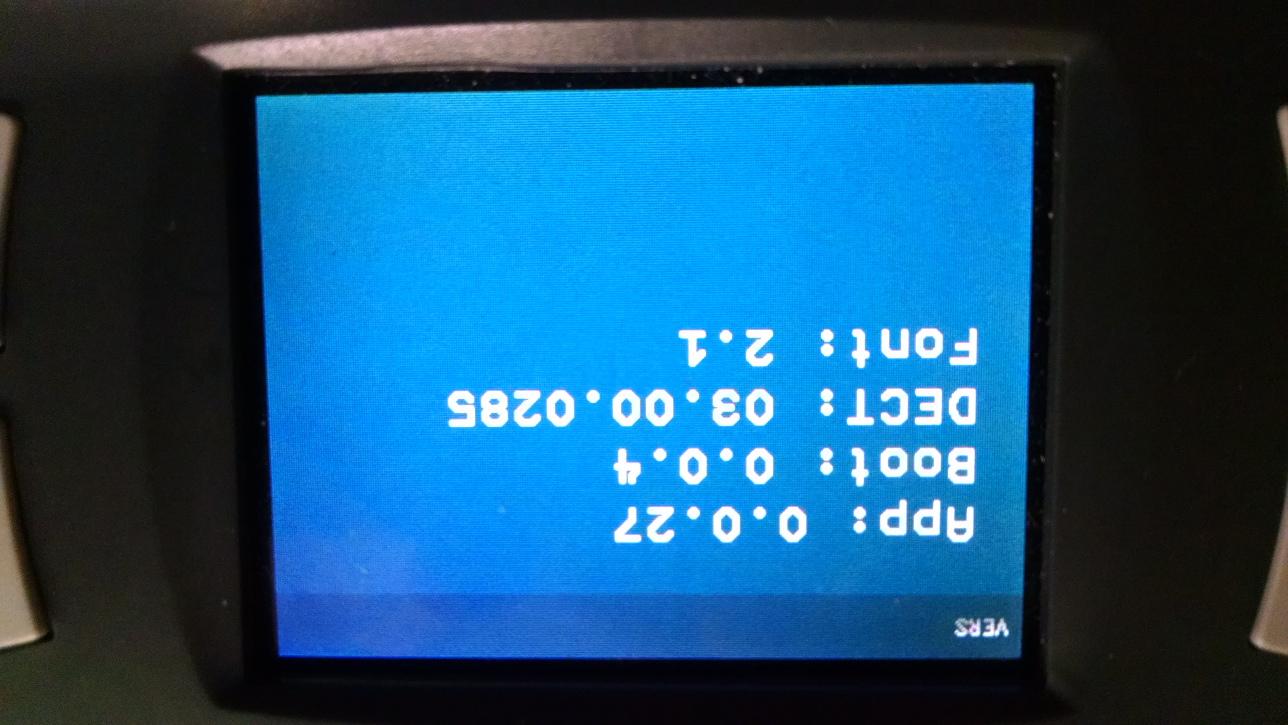

Access Point

In IPedit, **Device Information🡪Version**

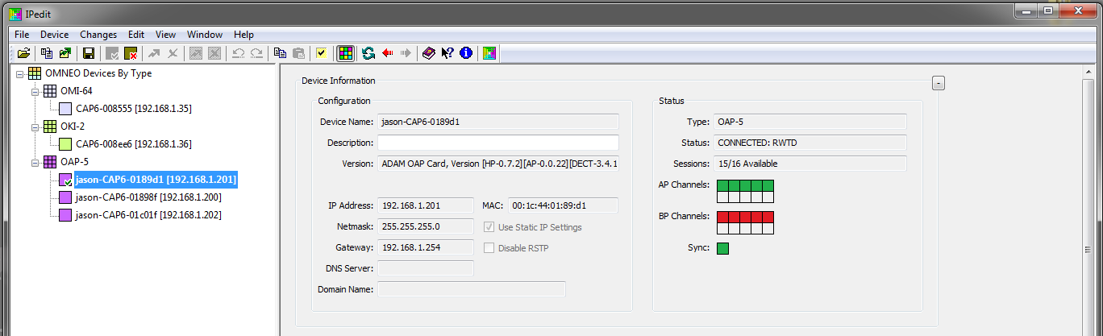

# **Initial Setup & Configuration**

1. Access Point Configuration (via IPedit)

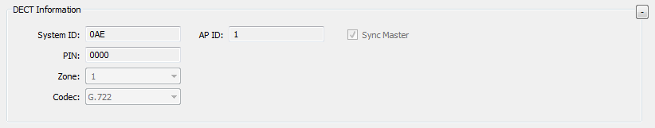

* 1. Add OMNEO Access Point (OAP) device and login as “admin” to make DECT changes.

**Device🡪Change User**, username: **admin**, password: **password**.

* 1. Enter a valid “System ID” for the AP.

The “System ID” is a 3-hex digit entry (e.g., “0AE”).

**NOTE**: All APs within a *roaming system* must have the **same** “System ID”.

* 1. Enter a valid “AP ID” for the AP.

The “AP ID” is a decimal entry (1-255).

**NOTE**: Each AP within a *roaming system* must have a **unique** “AP ID”.

* 1. Setup the “Sync Master”

Check the “Sync Master” box for only one AP within the system.

**NOTE**: **Only one** AP within a *roaming system* must be selected as the “Sync Master”.

* 1. Enter a “PIN” code.

Default “PIN” code is 0000.

* 1. Select the desired “Zone”.

Default “Zone” is 1.

* 1. Select the desired “Codec”.

Default “Codec” is G.722.

* 1. Set “DECT Zone Selection” for each beltpack.

Default Zone Selection is blank (all zones).

* 1. Send all IPedit changes to the devices.  
     Wait until the “Sync” Status box is green (indicating the AP is synchronized and active).

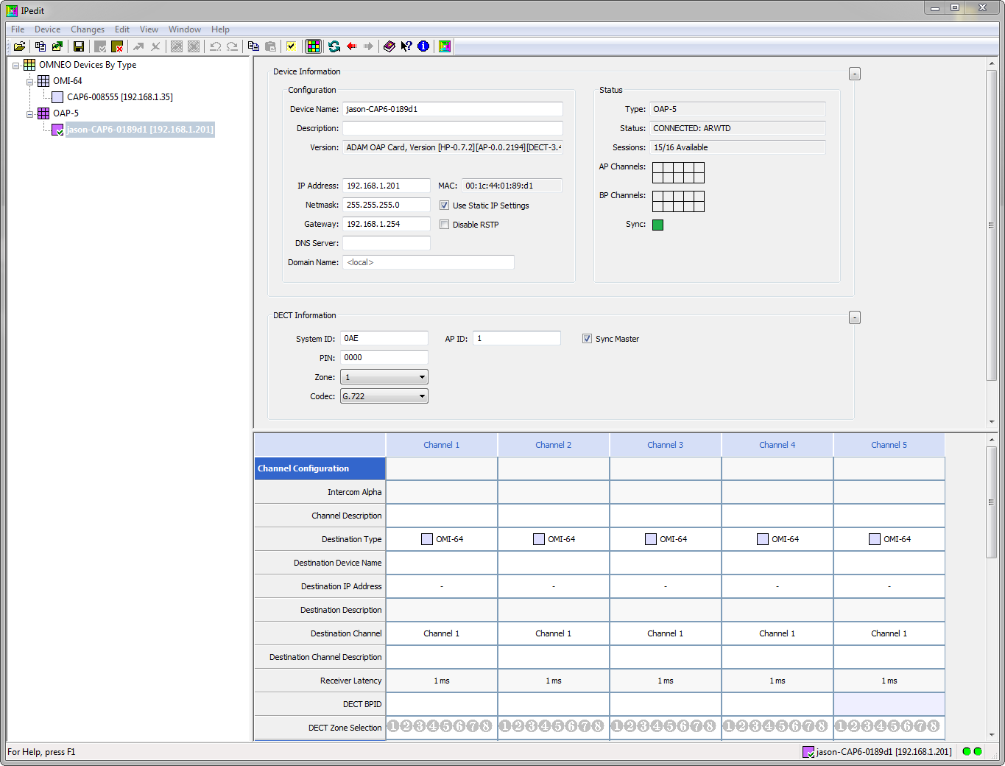

Figure : Configured AP

1. Matrix Channel Assignment

To enable audio and data between the Matrix (OMI) and the AP, OMNEO channels must be mapped between them. An AP has either 5 or 10 OMNEO channels available for assignment (depending on which CODEC is selected).

* 1. Assign OAP OMNEO channels to OMI OMNEO channels.
     1. From the OAP device, select an OMI Destination Device and OMI Destination channel.

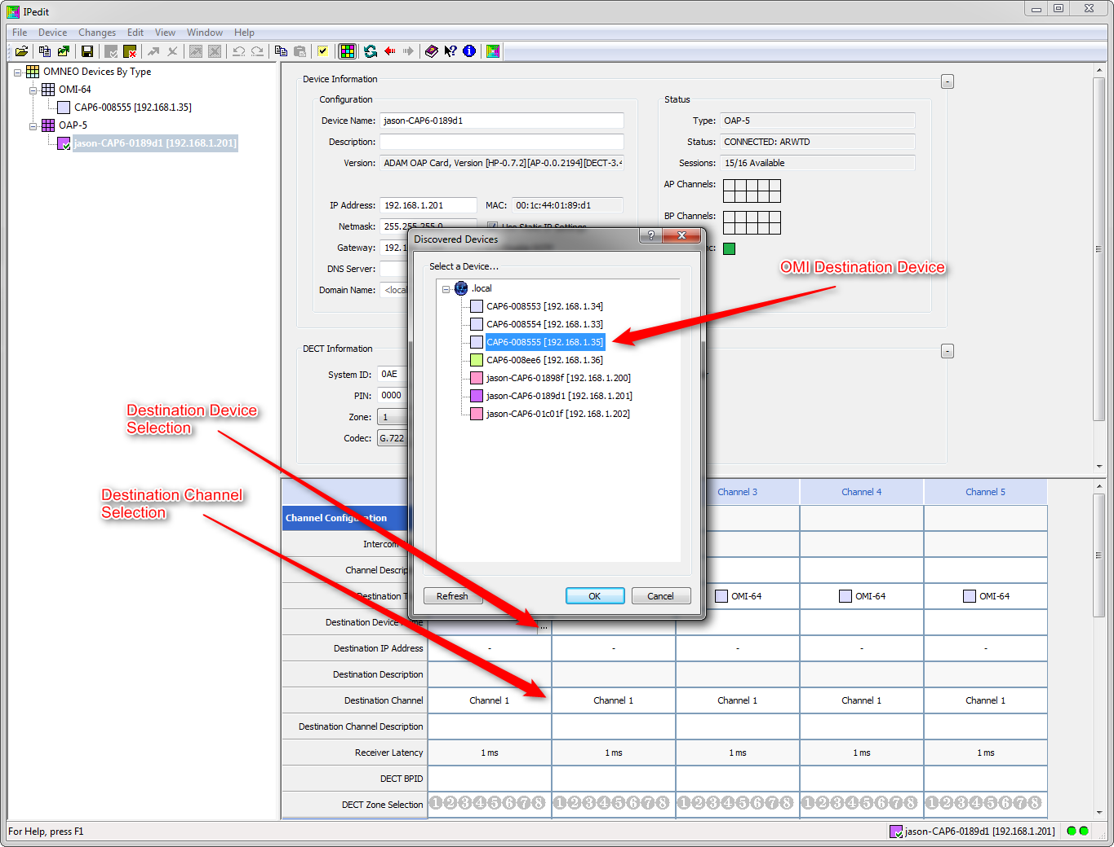

Figure : OMNEO channel mapping

* + 1. In the opposite direction, from the OMI device, select the corresponding OAP Destination Device and OAP Destination channel.
    2. Repeat to setup all desired channels.

The example below shows that AP OMNEO channels 1-5 are mapped to OMI OMNEO channels 1-5. The “AP Channels” status is green boxes indicating that the channels have been mapped successfully.

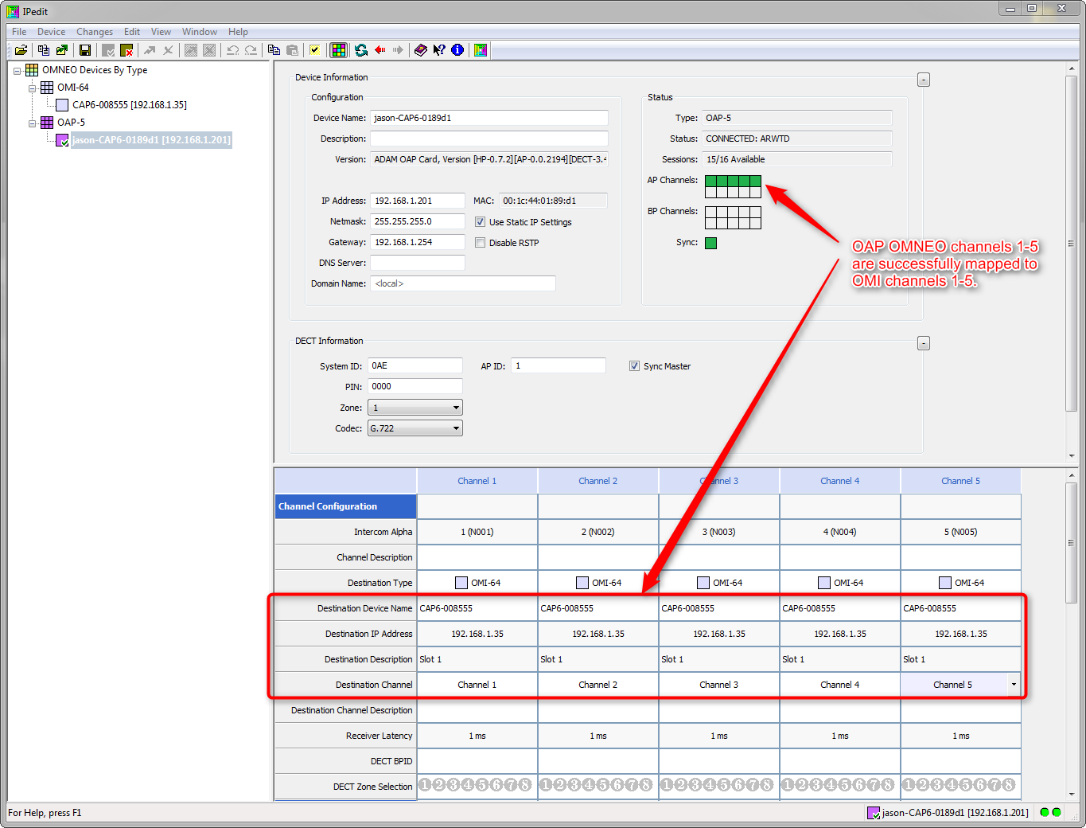

Figure : Example, OAP OMNEO channels 1-5 are successfully mapped to OMI OMNEO channels 1-5

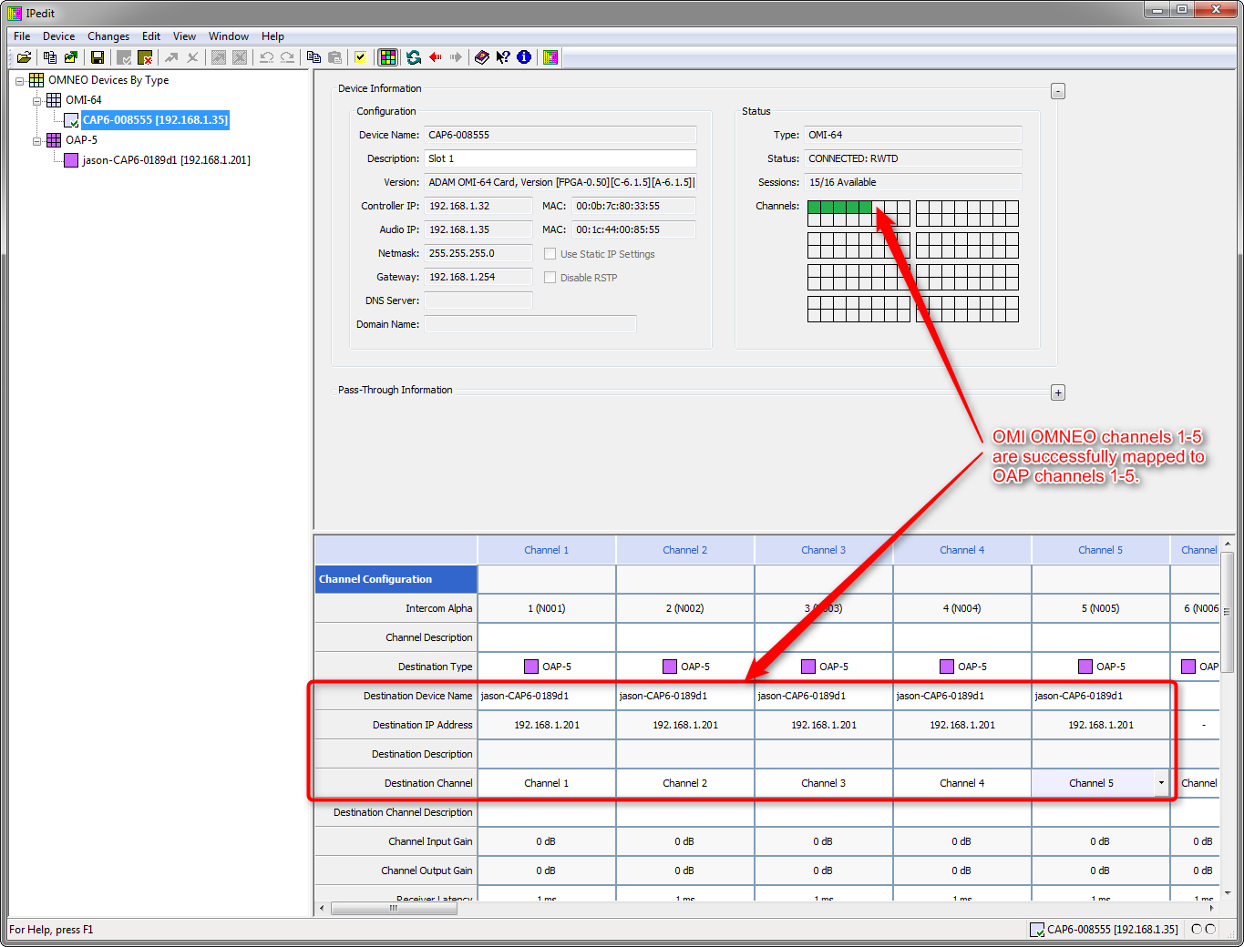

Figure : Example, OMI OMNEO channels 1-5 are successfully mapped to OAP OMNEO channels 1-5

* 1. Assign each beltpack to a particular Intercom Alpha.
     1. Power-on all beltpacks and identify each BPID on the LCD screen.
     2. Assign each beltpack by entering each BPID.  
          
        **NOTE:** This will assign that beltpack to a particular OAP Channel. This beltpack will assume the Matrix identity of the “Intercom Alpha” field.

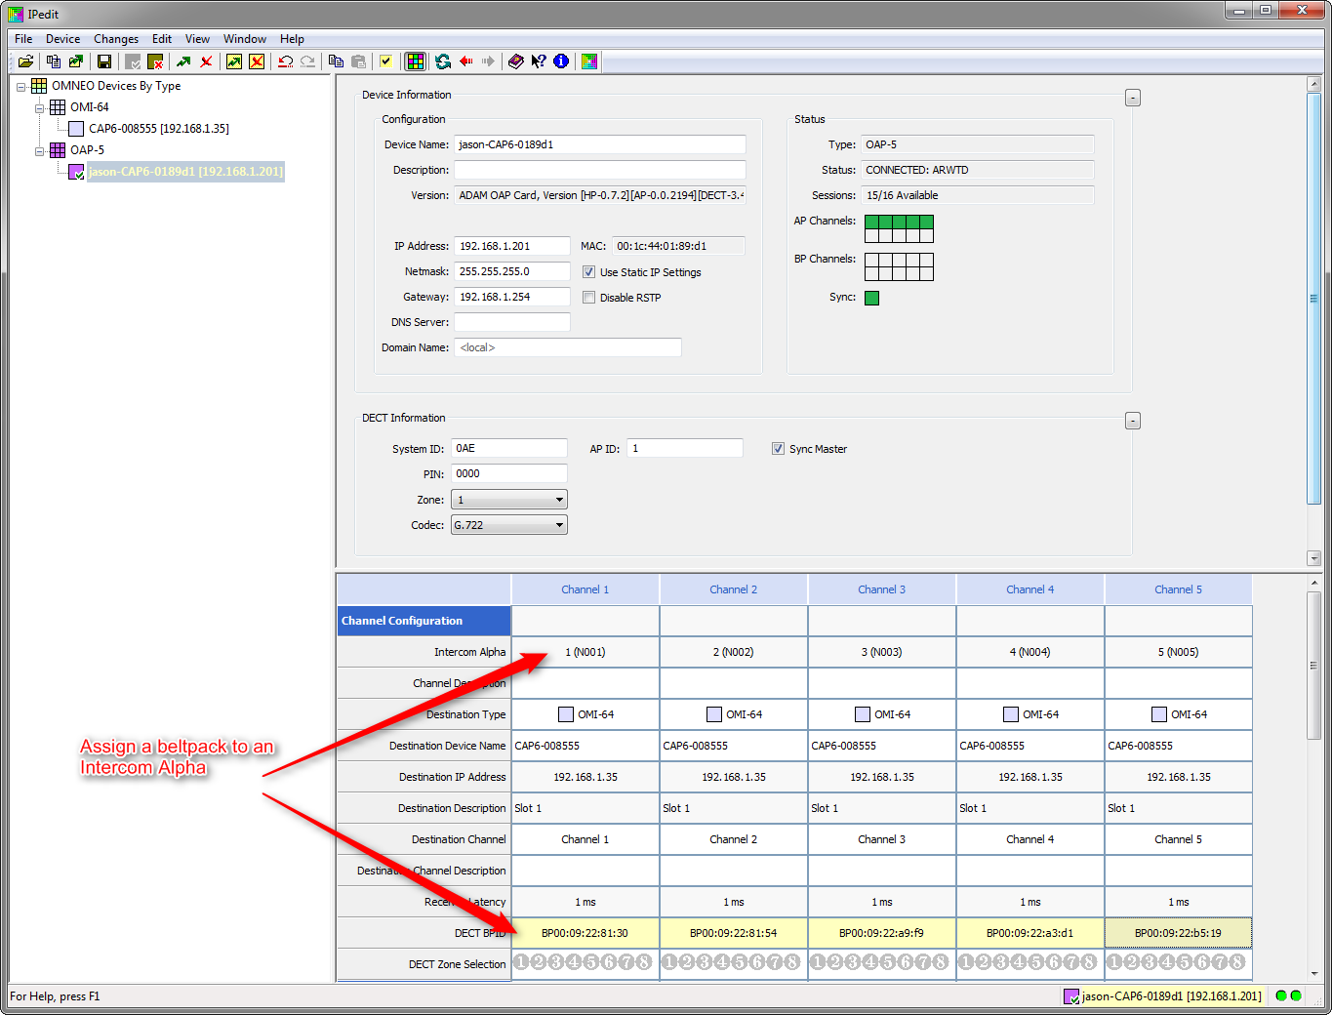

Figure : Assign BPIDs

For example, in the figure above, BPID 00:09:22:81:30 will become port 1 on the Matrix “N001”. BPID 00:09:22:81:54 will become port 2 on the Matrix “N002”.

* 1. Send all IPedit changes to the devices.

1. Beltpack Subscription
   1. Initiate System Setup.

Navigate menu and select the “System Setup” I:\Dept\ENG3\Restricted\Projects\Raptor (75075)\Icons Christoph\Icons & Screens\03_assets_2014-09-30\G_setup.png icon.

* 1. Enter the “System ID”.

**NOTE:** Antennas should be attached to AP during this process.

For example, if the “System ID” (as entered in IPedit) is “0AE”, the “System ID” should also be entered on the BP as “0AE” on the beltpack:

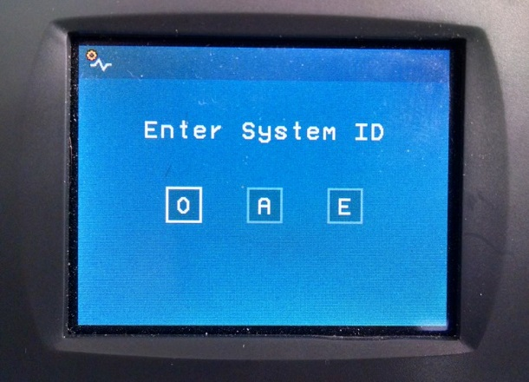

* 1. Enter the “PIN” code

Default pin is “0000”.

1. Verification
   1. After BP is subscribed, a DECT connection is established and the DECT icon A_statusbar_ico_RF-(DECT)-Connection-2.png is displayed.
   2. A Matrix power-up packet is requested and the Matrix icon A_statusbar_ico_Matrix-Connection.png is displayed.
   3. In IPedit, “BP Channel” will turn green indicating a connection, and BP will begin to receive the power up packet data from Matrix.
   4. The beltpack will show key assignments and alpha background colors as assigned in AZedit.
   5. After power-up is received, the beltpack is ready to communicate.

# **System Power-On (after subscribed)**

1. Boot Access Points

Allow APs to boot until the “Sync” status is indicated with a green box in IPedit.

1. Boot Beltpacks

Turn on BP and wait for RF connection A_statusbar_ico_RF-(DECT)-Connection-2.png, Matrix connection A_statusbar_ico_Matrix-Connection.png, and power-up packet is received (BP showing alpha background colors).

After power-up is received, the beltpack is ready to communicate.

# **Beltpack Firmware Update**

Updates to the BP are given in .bin files. These are to be placed on a flash drive that is formatted as FAT.

1. Navigate to firmware update icon G_software_update.png.

1. When prompted, insert the USB stick.
2. Select the desired image to update and press the Select key to start.

# **Access Point Firmware Update**

Updates to the AP are given in the form of a .capfw file. This is a package of one or more .bin files to be sent to the AP for various components. The .capfw file must be placed in the update directory that FWUT looks for.

**NOTE:** For complete updates using FWUT, the AP must have the following versions already installed (or newer):

**[HP-0.7.48][AP-0.0.52][DECT-3.16.2385]**

1. Launch FWUT application.
2. Select desired OAP device and press “Upload”.
3. Select the desired .capfw image to update with and press “Start”.

This will begin the update procedure of all components [FPGA, HP, AP, and DECT] over Ethernet.