Release Title: | 6.1.4
Release Date: | 03-Aug-2016
Version: | 6.1.4

Remarks
This is the release of the OMI, OKI, and OEI-2 which supports OCA. In addition to all the functionality that is available in V5.2.12, this release supports following new features. Please see section 2 for Software Compatibility

Issues fixed in V6.1.4
- Fixing the Phantom Cross-points
- Fixing the issue of removal of the 256th entry in Listen Audio Mixer Map.
- Putting valid range checks when the audio mixer maps were being updated
- Provided Diagnostics to clear and read the ASIC maps

Issues fixed in V6.1.3
- OMI is not able to transmit audio in the Port range of 400 to 500. The OMI was internally using a limit of 500 timeslots. This resulted in the Audio not driven from the backplane by the OMI card. Now it is changed to maximum supported timeslots (880 ports).
- Intercom Alpha names were not displayed correctly for OKI and OEI-2 connected devices.

New Features V6.1.2
- Telnet is disabled by default for all the OMNEO devices. Telnet can be enabled from IPEdit using special keyboard and mouse combination. Right click on the device with Ctrl+Shift down.
- Intercom Port numbers along with the Matrix name and Alpha are shown on the OMI card in IPEdit under channel configuration as shown in the picture below

- The OKI , OEI-2 and KPSeries keypanel will display the Intercom port, matrix name and Alpha to which they are connected as shown in the picture below
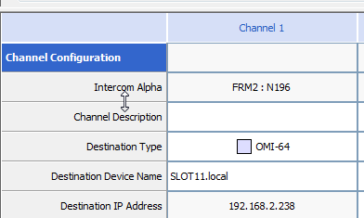

- In AZEdit, the version string for the OMI card will display “Firmware Download in Progress” when the OMI firmware is downloaded using the FWUT. This string will alternate with the regular version string during the Firmware Upgrade process.
- Tear down channel Command has been implemented for OMI, OKI and OEI-2 devices. From IPEdit select a channel and it will show a Teardown channel menu item. Clicking this will temporarily teardown the channel and the connection is re-established automatically.

Issues Fixed
Following issues have been fixed in this release
- The SetupOMNEOXXXFirmware.msi file for NIOS, OEI-2 and OKP did not update the latest files for the firmware upgrade. This has been fixed. The set-up files in this release will remove the old files and install the new files.

Features in V6.1.0:
- New version of the OMNEO (OCA) integrated for OMI/OKI/OEI-2. The new version is 4.40.4085
- Support for switching from RSTP to noRSTP and vice versa is now provided via IPEdit. There is no need to upgrade the firmware. If RSTP needs to be disabled then “Disable RSTP” should be checked. If RSTP needs to be enabled then “Disable RSTP “should be unchecked. The option is shown in picture below
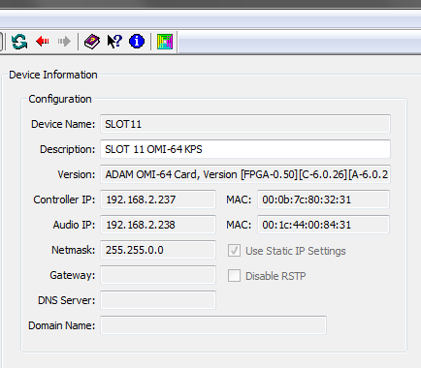

- In earlier version 5.x.x Receiver Latency was always fixed at 1ms, but with 6.x.x onwards the receiver latency can be configured per channel from the OMI. The OKI, OEI-2 and KP-Series will display the set latency value from the OMI when the Audio Routes are established. The Receiver latency values cannot be changed from the OKI, OEI-2 and KP-Series, they are read-only. The default value is still 1 ms. The following Receiver Latency values can be set on per channel basis 1,2,5,10,15 and 20 ms. Refer the picture below for options in IPEdit.

OMI Screen in IPEdit
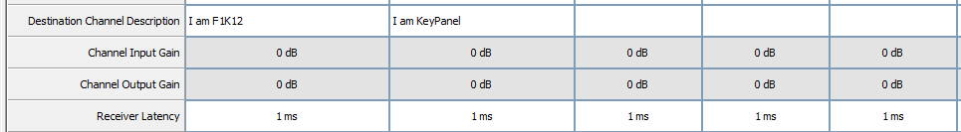

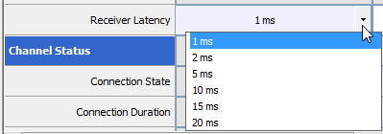

OKI/OEI-2/KP-Series Screen in IPEdit
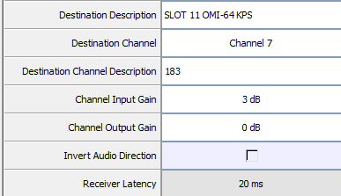

- FWUT /DNS-SD Version 4.40 is released
- ARNI Configuration Tool and Firmware V4.40

.2. Software Compatibility Matrix
The Version 6.x.x firmware requires following version of the software/firmware
- OMI 6.1.0/6.1.2/6.1.3/6.1.4
- OKI 6.1.0/6.1.2/6.1.3
- OEI-2 2.1.0/2.1.3/2.1.4
- KP-Series 2..x.x
- IPEdit 3.3.0 and above releases
- AZEdit 5.2.1 and above releases
- MCIIe 3.0.4 or above releases
- FWUT 4.40
- Bosch DNS-SD 4.40
- SetupOMNEONiosFirmware 4.40
- SetupOMNEOOEI2Firmware 4.40
- SetupOMNEOOKPFirmware 4.40
- K32-CLD V1.6.0 onwards Omneo Support Added
- KP12-CLD V1.3.0 onwards Omneo Support Added
- KP32-Classic V2.4.0 onwards Omneo Support Added.
Requires update to boot loader

Please note:
Version 5.x.x is not compatible with Version 6.x.x or vice versa. For eg: OMI V5.x.x will not connect to OKI version 6.x.x or OEI-2 version 2.x.x or KP-Series version 2.x.x. The OMI needs to be updated to V6.x.x. Similarly OMI version 6.x.x will not connect to OKI version 5.x.x or OEI-2 version 1.4.x or KP-series version 1.2.x. These need to be updated to V6.x.x or 2.x.x

Firmware Versions

From this release onwards it is possible to update the OMI card with the single firmware file (capfw). The following constraints still exist
- If the OMI card version is 4.0.0, then separate capfw files are required to update the OMI card to Ver 6.x.x. The OMI-Controller should be updated first
  - OMI-Controller. capfw
  - OMI-Audio-Device.capfw
- For OMI card with version 4.02 and above single capfw file is required. It will update both the controller and audio device on the OMI.
The following table gives firmware version

Component | Version | Comment
The following firmware file contains images for the both the OMI controller and Audio Device and should be used for upgrading OMI card with Versions 4.02 and above.
OMI-Firmware_RSTP_V6.x.x.capfw  OMI-Firmware_noRSTP_V6.x.x.capfw | 6.1.2 | This file has to be used for upgrading OMI cards with version 4.02 and above. Please read the FWUT instructions
OMI-FPGA_Firmware_V0.50.capfw | 0.50 | This updates only the NIOS FPGA
Component | Version | Comment
The following firmware file contains images for the both the OMI controller and Audio Device and should be used for upgrading OMI card with Versions 4.0.0 and above

OMI-Firmware_Controller_V6.x.x.capfw | 6.1.2 | This file is used for upgrading the OMI board set with the above versions using FWUT. This only updates the NIOS processor
OMI-Firmware_AudioDevice_RSTP_V6.x.x.capfw  OMIFirmware_AudioDevice_noRSTP_V6.x.x.capfw | 6.1.2 | This file is used for upgrading the OMI board set with the above versions using FWUT

LED Diagnostic Information
Following are description of the LED’s on OMI Front card that can be used for diagnostic purposes. This section mentions the changes and additions with respect to the LED’s.

Red LED | # | Green Led
 | 23
ON- Config from MCIIe  OFF- Config form card  Indicates Dip Switch 4 status | 22
ON - Static Mode  OFF- DHCP Mode | 21
ON- NO RSTP Mode  OFF- RSTP Mode | 20
ON- Device Name Mismatch  OFF- Device Name in Sync | 19
 | 18 | ON - IP Address in Sync  OFF - IP address not in Sync
 | 17
 | 16
 | 15
 | 14
 | 13
 | 12
 | 11
OMI Firmware States. | 10
OMI Firmware States. | 9
OMI Firmware States. | 8
OMI Firmware States. | 7
OMI Firmware States. | 6
OMI Firmware States. | 5
OMI Firmware States. | 4
OMI Firmware States. | 3
OMI Firmware States. | 2
OMI Firmware States. | 1
Blinking – Indicating the OMI is Good | 0

During the Firmware download of the OMI, the LED’s 1 to 9 turn on and off is sequence, indicating the OMI controller download is in progress.
Following is the OMI state when booting up.

Red Led # | Status | Remarks
1 | ON | OMI validating the configuration information
2 | ON | Identifying the OMI-Audio Device
3 | ON | Verifying the Network Configuration
4 | ON | Verifying the Audio Device Name
5 | ON | Establish Connection with Audio Device

