TK-2118/3118 Radios KPG-69D , Software :

- Locate DISK 1 place in (A:\) Floppy Drive, “Start Windows Installation”
- Locate setup.exe Double Click to start Installation.

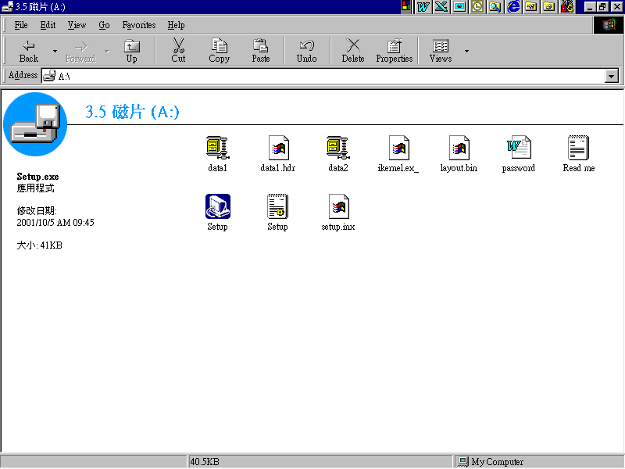

- Setup Initiating .

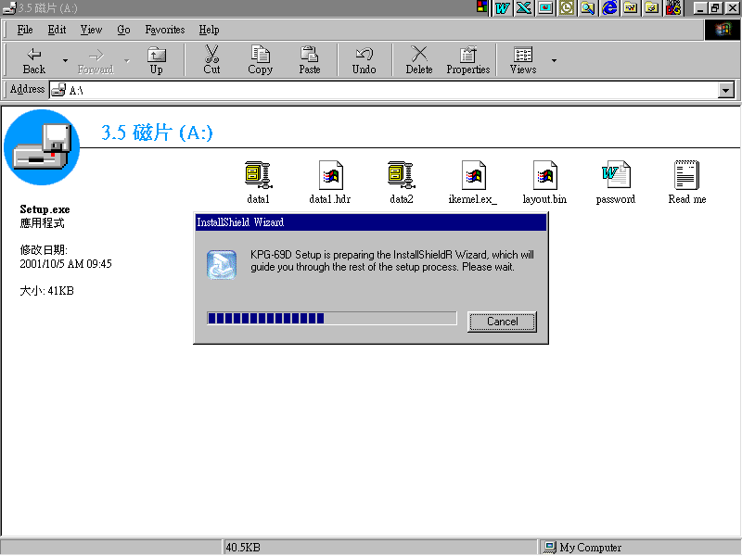

- KPG-69D Installation.

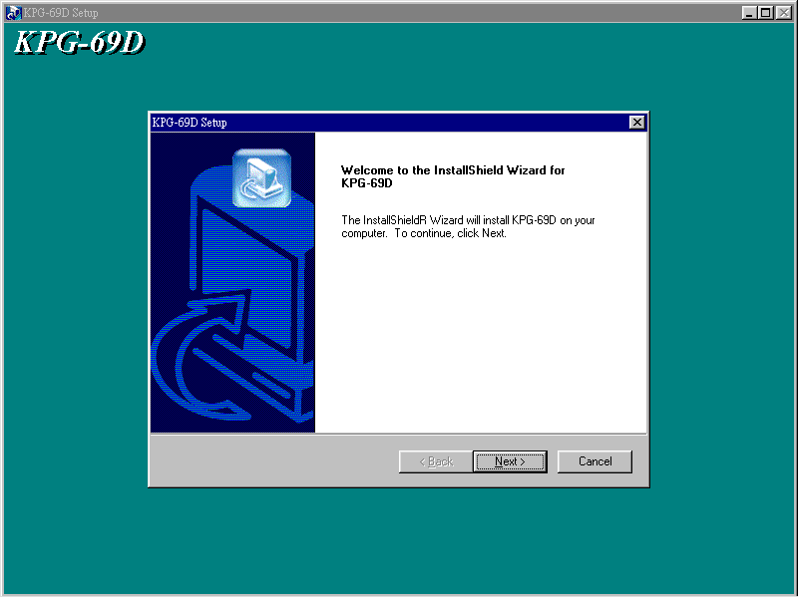

- Click on Next.

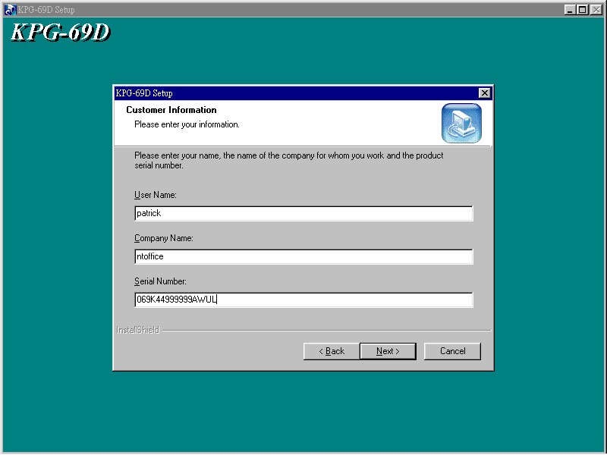

- Enter User Name (user) ,Company Name (company),
Serial Number → 069K44999999AWUL , then click Next .

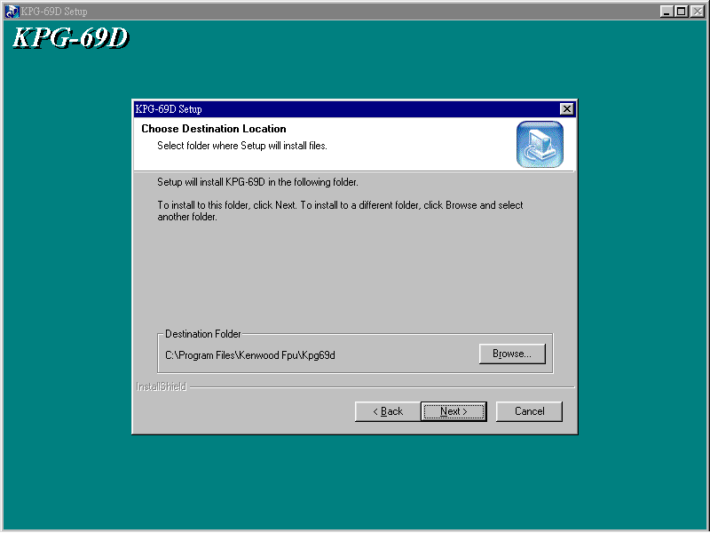

- Install program in Folder, Click Next .

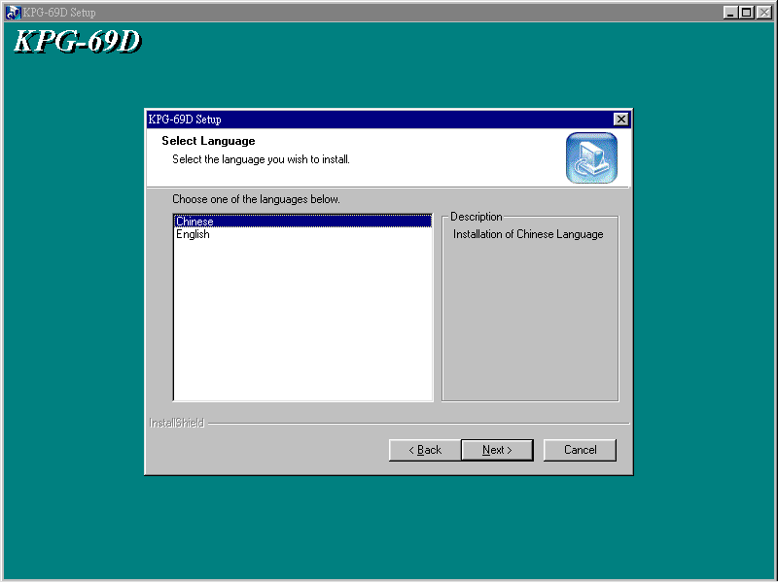

- Choose Language → Chinese or English then Click Next.

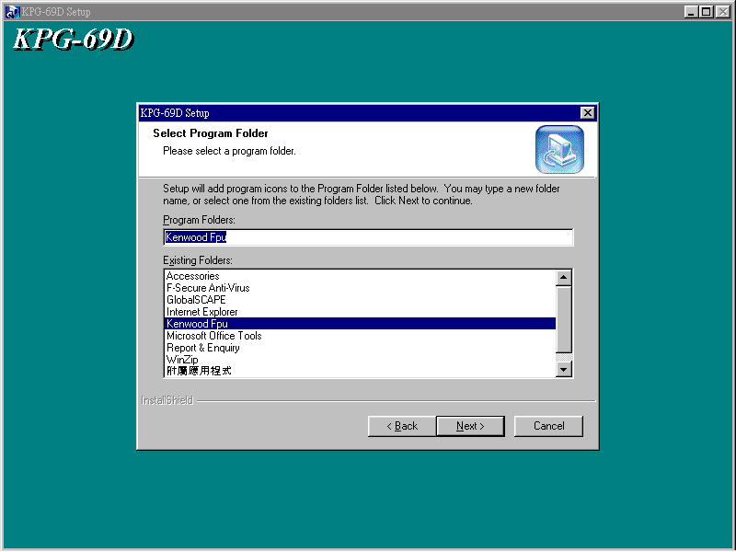

- Click Next.

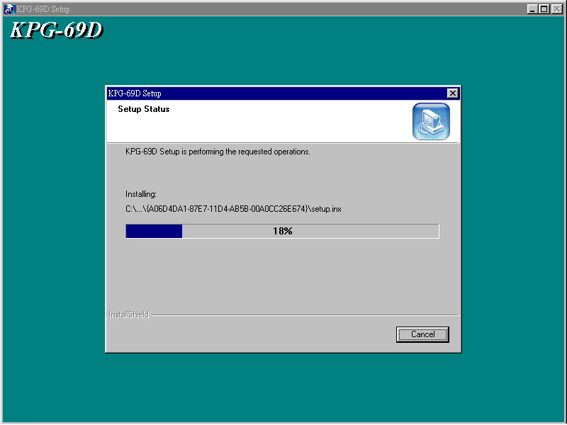

- Installing from DISK 1.

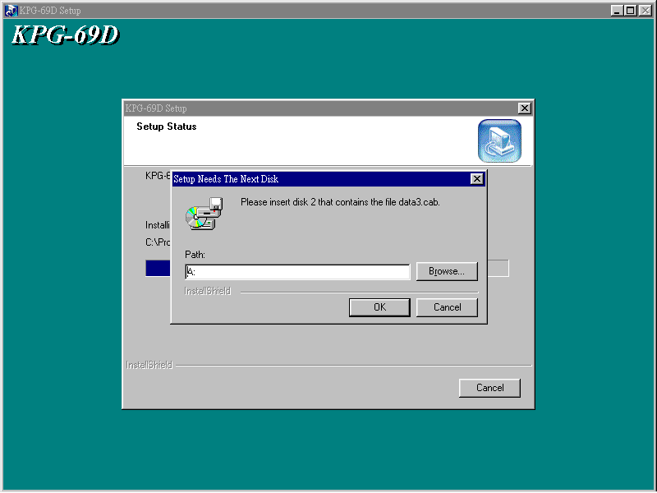

- Setup Disk 2 in A (or where ever file is), Click OK.

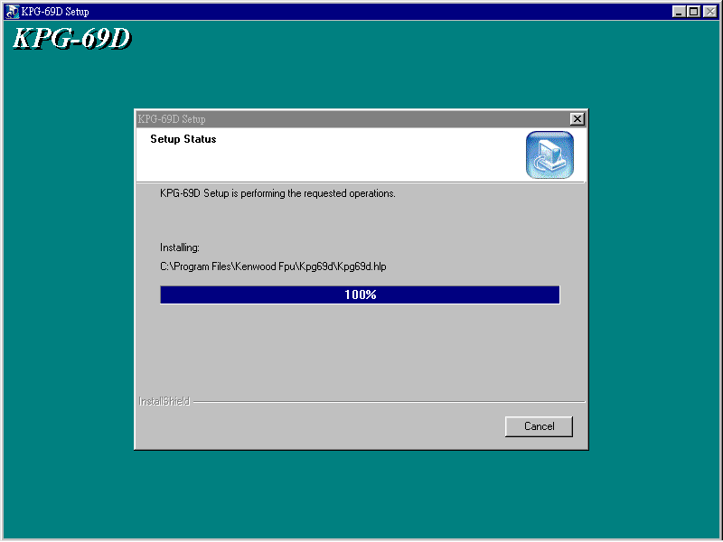

- Installation 100% .

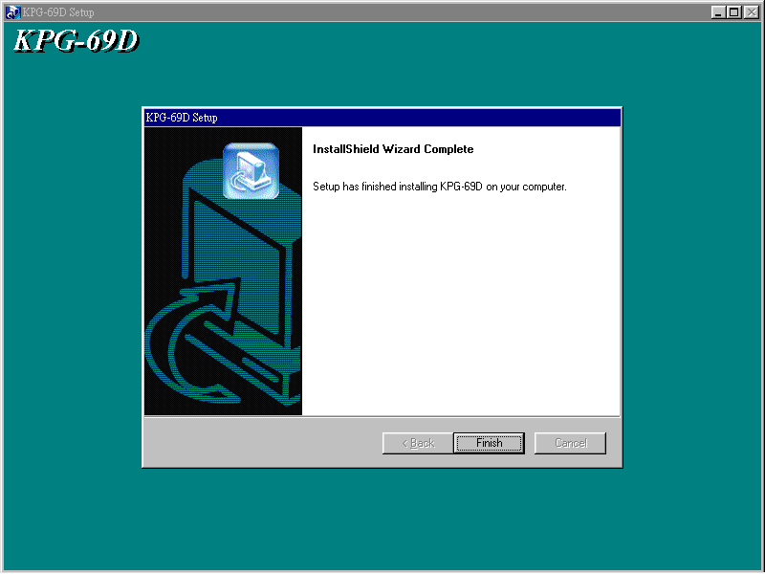

- Installation Complete, Click on Finish

- To access KPG-69D Program.
- Click on Start in the Windows “Click on ALL PROGRAMS” Find the Kenwood Fpu Folder--- Click on KPG-69D

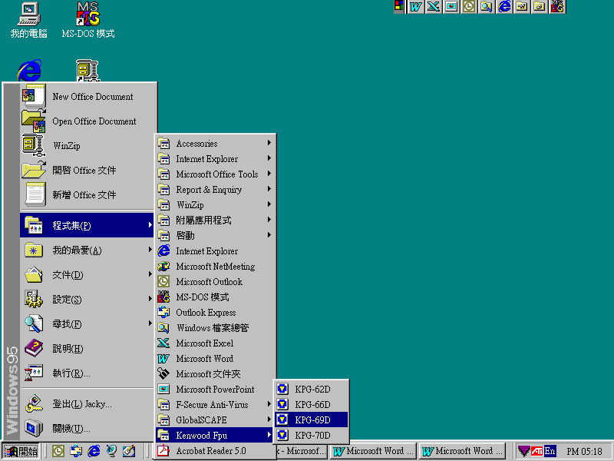

- Now you’re ready to program your TK-2118/3118 Radios.

