TK-7108/8108 Radios KPG-70D , Software :

- Locate DISK 1 place in (A:\) Floppy Drive, “Start Windows Installation”
- Locate setup.exe Double Click to start Installation.

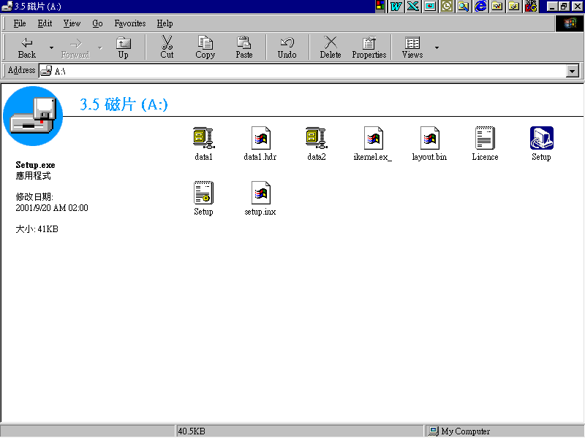

- Setup Initiating .

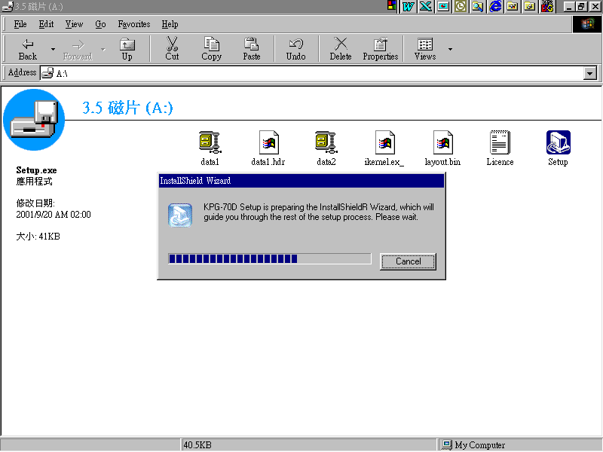

- KPG-70D Installation.

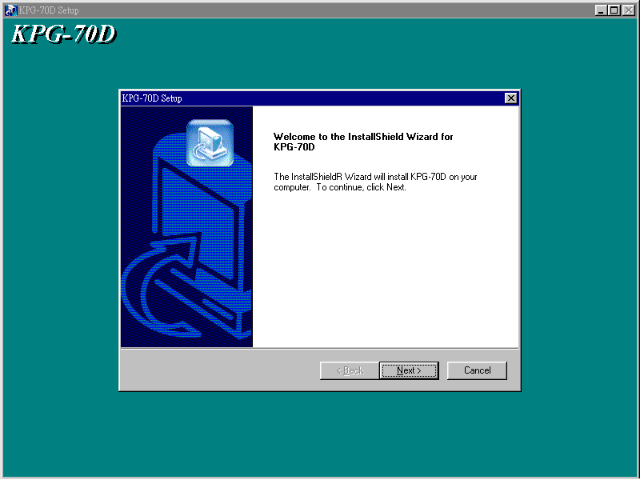

- Click Next.

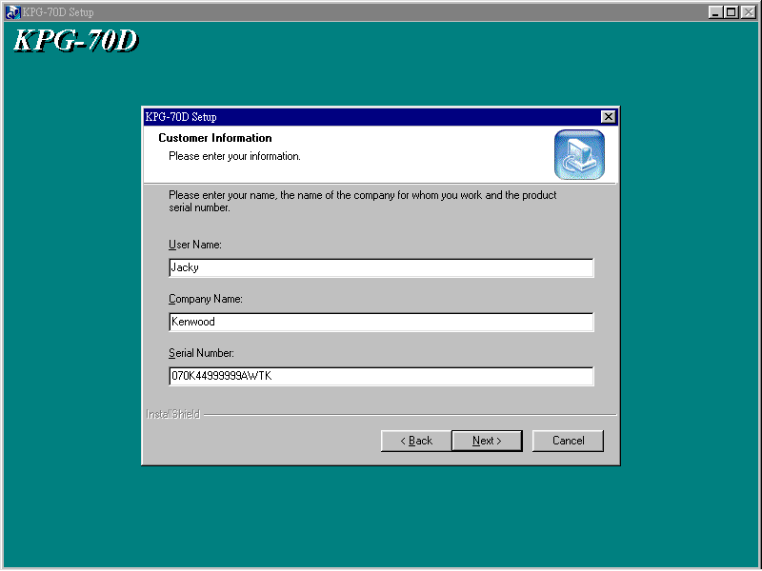

- Enter User Name (user) ,Company Name (company),
Serial Number → 070K44999999AWTK , Click Next .

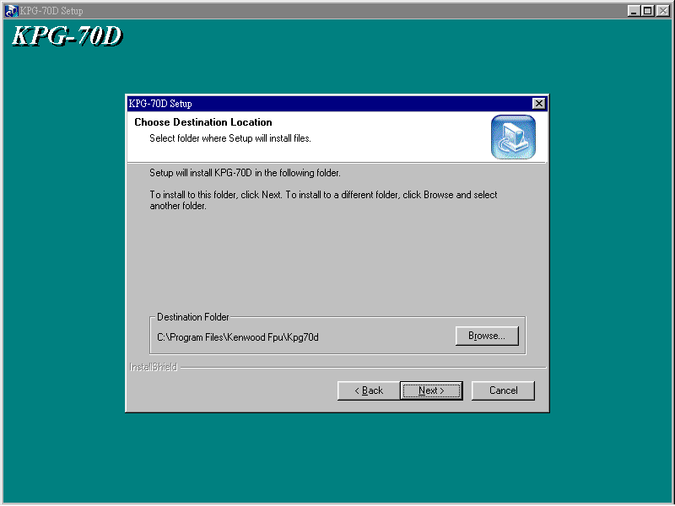

- Click Next .

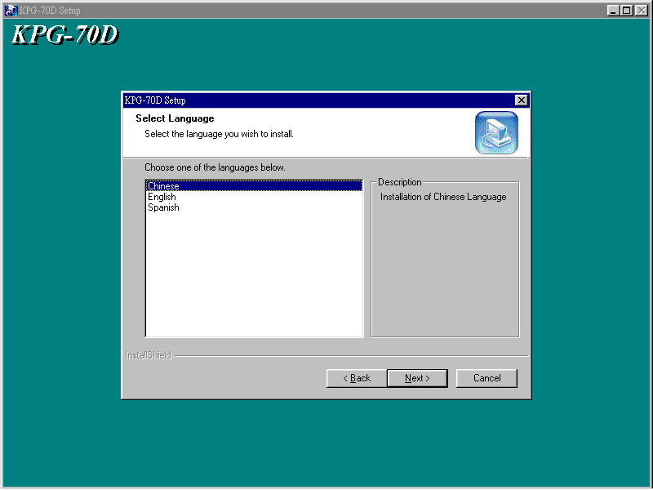

- Choose Language → Chinese, English or Spanish then Click Next.

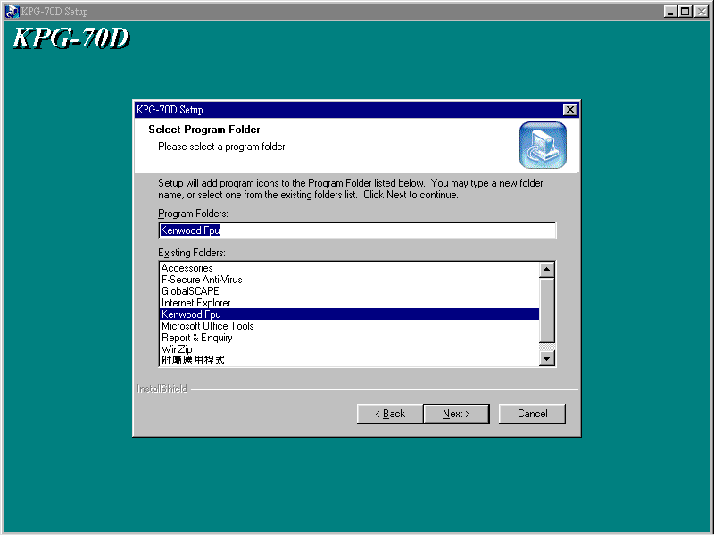

- Click Next.

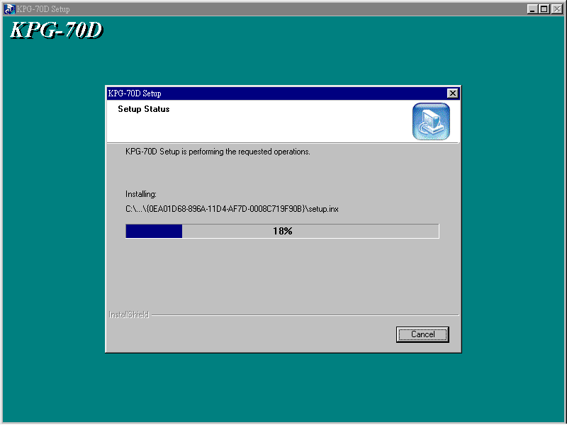

- Installing from DISK 1.

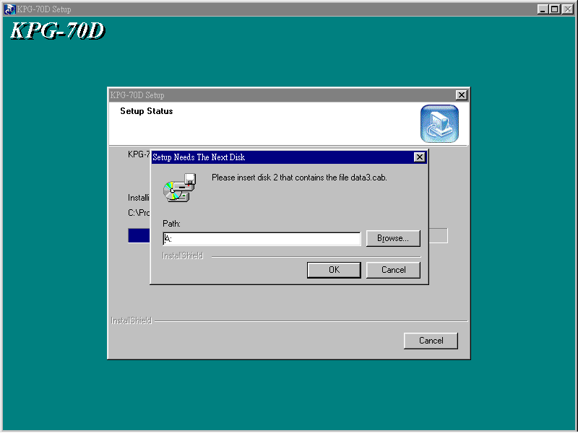

- Setup Disk 2 in A (or where ever file is), Click OK.

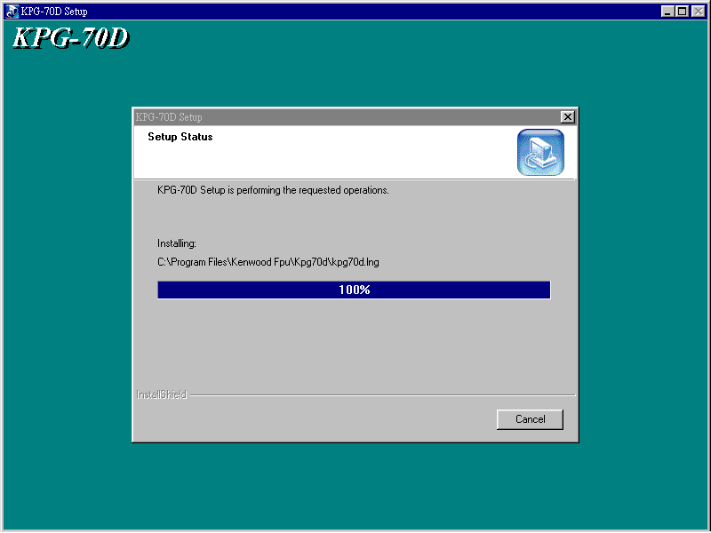

- Installation at 100% .

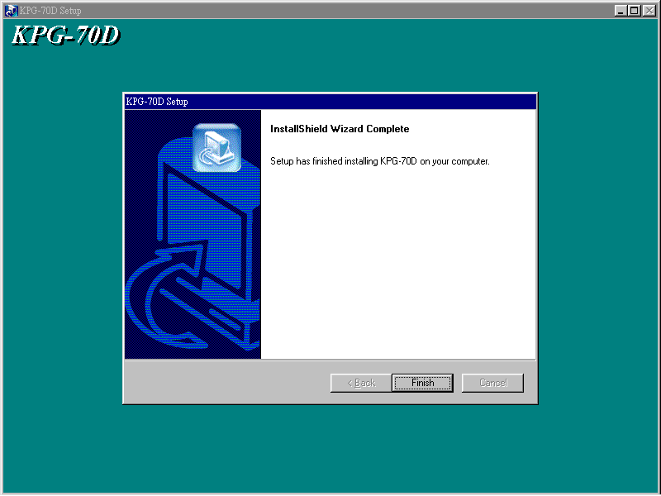

- Click , on Finish.

- To access KPG-70D Program.
- Click on Start in the Windows “Click on ALL PROGRAMS” Find the Kenwood Fpu Folder--- Click on KPG-70D

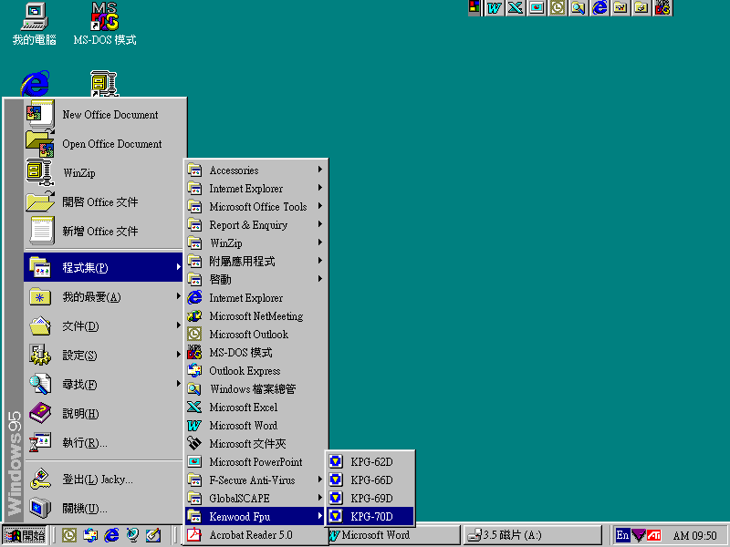

- Now you’re ready to program your TK-7108/8108 Radios

