**[Description]**

The updated version for HDCU3500, HDCU5500 and HDCU5000 software is released. (**V3.20**)

Upgrade the firmware by following the steps below as necessary.

Peripheral devices to be connected are preferred to be upgraded as well, referring the related technical memos.

**[Installable Combinations]**

To apply the modifications in V3.20, update these peripheral devices as below.

- HDC3100, HDC3200, HDC3500, HDC5500, HDC5000, HDC-F5500  
HDC3500V, HDC5500V : V3.41 or later

- HDCE-TX30, HDCE-TX50 : V1.50 or later

- MSU-3000, MSU-3500 : V1.61 or later

- RCP-3500, RCP-3501 : V1.61 or later

- RCP-3100 : V1.60 or later

- MSU-1000, MSU-1500 : V4.10 or later

- RCP-1500, RCP-1501, RCP-1530 : V4.10 or later

- HZC-CSM10 : V1.5.1 or later

- IP Live System Manager (LSM) : V3.0.3 or later

　*NDCP connection to IP Live System Manager (earlier than V3.0.3) will NOT be established.  
　The version of LSM must be V3.0.3 or later.

NDCP connection: Connection that the status of PORT setting in the page of N06<IP LIVE>IP LIVE SYSTEM MANAGER set to “LAN1&LAN2”.

Related technical memos

- HDCM23-039  
　(HDC3100, HDC3170, HDC3200, HDC3500, HDC3500/H, HDC5500, HDC5000, HDC-F5500) [V3.41]

- HDCM23-048 (HDCE-TX30, HDCE-TX50x) [V1.50]

- HDCM23-043 (MSU-3000, MSU-3500) [V1.61]

- HDCM23-044 (RCP-3500, RCP-3501) [V1.61]

- HDCM23-045 (RCP-3100) [V1.60]

- HDCM23-046 (MSU-1000, MSU-1500) [V4.10]

- HDCM23-047 (RCP-1500, RCP-1501, RCP-1530) [V4.10]

- HDCM22-039 (HZC-CSM10) [V1.5.1]

- HDCM22-034   
　(Device Setting Plug-in Software for LSM of HDCU3100/3170/5000/5500/3500, V2.5.0)

- IPTM21-004 (LSM V3.0 License Guide)

- IPTM21-013 (IP Live System Manager) [V3.0.3]

**[Applicable Model]**

|  |  |
| --- | --- |
| Model / Destination | Serial number |
| HDCU3500/L2 | ~12353 Rev.1 |
| HDCU3500/T1 | ~30303 Rev.1 |
| HDCU3500/UL1 | ~102988 Rev.1 |
| HDCU5500/L2 | ~10879 Rev.1 |
| HDCU5500/T1 | ~30461 Rev.1 |
| HDCU5500/UL1 | ~103044 Rev.1 |
| HDCU5000 (CED) | ~40034 Rev.1 |
| HDCU5000 (CNB) | ~50004 Rev.1 |
| HDCU5000 (J2) | ~30198 Rev.1 |
| HDCU5000 (UC5) | ~10081 Rev.1 |

**[Change Points]**

<New Features>

1. Added 3840x2160/59.94P(4x),50P(4x), 3840x2160/59.94P(3x),50P(3x) output when equipped with  
    HKCU-UHF50 (HDCU5000 Option)

*When using the new formats, HDC5500/5000 version must be V3.41 or later.

By connecting HDCU5000 equipped with HKCU-UHF50 to HDC5500 or HDC5000, 4K/4x and 4K/3x SDI signal output is possible. 3840x2160/59.94P(4x),50P(4x), 3840x2160/59.94P(3x),50P(3x) can be selected in CAMERA FORMAT.

1. Added 4K HFR Channel Marker (HDCU5500/HDCU5000)

Added 4K HFR Channel Marker to 3840x2160/59.94P(4x),50P(4x), 3840x2160/59.94P(3x),50P(3x), 3840x2160/59.94P(2x),50P(2x) outputs.

1. Supports a status display of Variable ND Filter Unit

When connected to a camera equipped with Variable ND Filter Unit, the transmittance of the variable filter will be displayed in the status menu.

1. Enabled to use NETWORK TRUNK function when using UHD(4K/HDR) and HD HFR format   
    (When connected to HDC3500)

Be enabled to use NETWORK TRUNK function when using the Camera Format bellow.

- 4K FORMAT  
　UHD/59.94P(4K/HDR), UHD/50P(4K/HDR)  
　UHD/29.97P (4K/HDR), UHD/25P (4K/HDR)  
　UHD/23.98P (4K/HDR), UHD/24P (4K/HDR)

- HD HFR FORMAT  
1080/59.94P(2x), 1080/50P(2x)  
1080/59.94P(3x), 1080/50P(3x)  
1080/59.94P(4x), 1080/50P(4x)

Select “Network + Video” from NETWORK TRUNK section in the page of  
M02<TRUNK/PROMPTER2>.

NETWORK TRUNK transmission line of approximately 30Mbps is added between Camera and CCU in the above Camera Format.

<Improvements>

1. Supports 10km transmission of Single Mode Fiber when HKCU-SM100 is equipped(When connected to HDC3100/3200/3500)

When operating Single Mode Fiber by equipping HKCU-SM100 to the CAMERA FIBER, Single Mode Fiber transmission is supported up to 10km.

*Return CCU EXTENSION ADAPTOR to NONE when HKCU-SM100 is not equipped.

<Specification Change>

V04<DOWNCONVERT> has disappeared from the menu.  
4K-HD DOWNCONVERT FILTER settings are linked to the camera setting, so set them in the camera`s HD DOWNCONVERT FILTER menu.

<Fixed Issues>

1. Fixed an issue that to be “Network is Disconnected” rarely when multiple CCU are connected.
2. Fixed an issue that the output phase is out of sync between 1080/59.94P(6x) IP outputs and 50P(6x) IP outputs. (Applies only HKCU-SFP50 is equipped)
3. Fixed an issue that Multicast Address is changed when CCU File is recalled during 1080/59.94P(6x) or 50P(6x) transmission. (Applies only HKCU-SFP50 is equipped)

**[Preparation]**

<Update File>

From V3.20, two types of firmware update are possible: the conventional firmware update in the Service mode and a firmware update in UUD(UserUpDate) mode.

[Attention]

When update a firmware in UUD mode, the current version must be updated to V3.10 or later.

File Name : **hdcu5000_v3.20.zip**(Package for Service mode)

: **hdcu5000_v3.20.pkg**(Package for UUD mode)

*Available on the website “Software Download”.

\***hdcu5000_v3.20.pkg** contains all software/PLD files.

Unzip **hdcu5000_v3.20.zip** to get the following files.

hdcu5000_app.pkg Software file

hdcu5000_updater.pkg Updater file

hdcu5000_os.pkg OS file

hdcu5000_sy.pkg PLD file

hdcu5000_vif.pkg PLD file

hdcu5000_tx1_high.pkg PLD file

hdcu5000_tx1_ultra.pkg PLD file

hdcu5000_tx1_hfr720.pkg PLD file

hdcu5000_tx2.pkg PLD file

hdcu5000_net1.pkg PLD file

hdcu5000_net2.pkg PLD file

hdcu5000_dpr1.pkg PLD file

hdcu5000_dpr2.pkg PLD file

hdcu5000_enc1_xavc.pkg PLD file

hdcu5000_enc2_rec50.pkg PLD file

hdcu5000_enc2_rec55.pkg PLD file

* The website “Software Download” contains all the latest software/PLD files at the time this technical memo was published.

<Others>

- 1 USB flash drive

**[Installation procedure]**

(1) Service Mode

Refer to MAINTENANCE MANUAL for the conventional firmware update procedure in Service mode.  
*Upgrade in the order of OS => APPLICATION => PLD or the forced upgrade.

(2) UUD Mode

Place the UUD package file in the top directory of the USB flash drive.

[Attention]

Do NOT place multiple version upgrade files in the top directory. If there are multiple files, it is not possible to update the version.

Execute “UPDATE FROM USB” on <FIRMWARE> page of the MAINTENACE MENU and will start update all software and PLD.

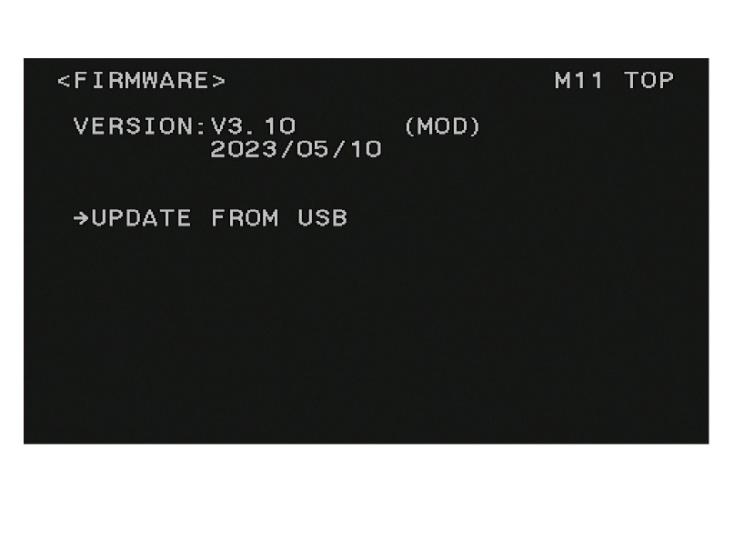

**[Check the version after the upgrade]**

Make sure the device was successfully updated. On each device, see the listed versions of APPLICATION items in the page of D03<VERSION1>.

APPLICATION **V3.20 (updated)**

UPDATER **V3.20 (updated)**

OS **V3.20 (updated)**

SY **V3.21 (updated)**

VIF **V3.21 (updated)**

TX1(HIGH) V3.12

TX1(ULTRA) **V3.20** **(updated)** (HDCU5000/5500 or when HKCU-FB50 is equipped)

TX1(HFR720) V3.12

TX2 **V3.21 (updated)** (HDCU5000/5500 or when HKCU-FB50 is equipped)

NET1 V3.01(When HKCU-SFP50 is equipped)

NET2 V3.00(When HKCU-SFP50 is equipped)

**DPR1 V3.20 (new) (When HKCU-UHF50 is equipped)**

**DPR2 V3.20 (new) (When HKCU-UHF50 is equipped)**

ENC1 V1.13 (When HKCU-REC50/55 is equipped)

ENC2 V2.00 (When HKCU-REC50/55 is equipped)

**[Software History] HDCU3500/HDCU5500/HDCU5000**

|  |  |  |  |  |  |  |  |
| --- | --- | --- | --- | --- | --- | --- | --- |
|  | V1.03  Initial Release | V1.30  HDCM19-054 | V1.31  HDCM19-067 | V1.31  HDCM19-071 | V1.44  HDCM19-212R2 | V1.45  HDCM20-017 | V1.50  HDCM20-027R2 |
| APPLICATION | V1.03 | V1.30 | V1.31 | ← | V1.44 | V1.44 | V1.50 |
| UPDATER | V1.00 | ← | ← | ← | ← | ← | ← |
| OS | V1.00 | ← | ← | V1.05 | V1.10 | ← | V1.20 |
| SY | V1.00 | ← | ← | ← | V1.20 | ← | V1.21 |
| VIF | V1.02 | V1.10 | ← | ← | V1.28 | ← | V1.30 |
| TX1(HIGH) | V1.06 | V1.10 | ← | ← | V1.23 | ← | V1.25 |
| TX1(ULTRA) | V1.06 | V1.10 | ← | ← | V1.22 | ← | V1.25 |
| TX2 | V1.04 | V1.10 | ← | ← | V1.25 | ← | ← |
| NET1 | V2.04 | V2.05 | ← | ← | ← | ← | V2.24 |
| NET2 | V2.04 | V2.05 | ← | ← | ← | ← | V2.26 |
|  |  |  |  |  | V1.01  HDCM20-008 |  |  |
| ENC1(XAVC) | - | - | - | - | V1.01 | ← | ← |
| ENC2(REC55) | - | - | - | - | V1.06 | ← | ← |

|  |  |  |  |  |  |  |  |
| --- | --- | --- | --- | --- | --- | --- | --- |
|  | V1.60  HDCM20-040 | V1.70  HDCM20-051 | V1.71  HDCM21-005 | V1.80  HDCM21-027R2 | V1.82  HDCM21-052R | V1.90  HDCM21-066R | V3.00  HDCM22-025R5 |
| APPLICATION | V1.60 | V1.70 | V1.71 | V1.81 | V1.82 | V1.90 | V3.00 |
| UPDATER | ← | ← | ← | ← | ← | ← | ← |
| OS | ← | ← | ← | V1.80 | V1.81 | V1.90 | ← |
| SY | ← | ← | V1.22 | ← | ← | ← | V3.00 |
| VIF | V1.40 | V1.42 | ← | V1.52 | V1.52 | V1.60 | V3.00 |
| TX1(HIGH) | V1.33 | V1.40 | ← | V1.51 | V1.51 | V1.62 | V1.63 |
| TX1(ULTRA) | V1.33 | ← | ← | V1.51 | V1.51 | V1.62 | V1.63 |
| TX1(HFR720) | - | - | - | V1.51 | V1.51 | V1.60 | V1.63 |
| TX2 | ← | ← | ← | V1.50 | V1.50 | V1.60 | ← |
| NET1 | ← | ← | ← | ← | ← | V2.25 | V2.26 |
| NET2 | ← | ← | ← | V2.27 | V2.27 | V2.29 | ← |
|  |  | V1.12  HDCM20-047 |  |  |  | V1.13  HDCM22-001 |  |
| ENC1(XAVC) | ← | V1.12 | ← | ← | ← | V1.13 | ← |
| ENC2(REC55) | ← | V2.00 | ← | ← | ← | ← | ← |
| ENC2(REC50) | - | V2.00 | ← | ← | ← | ← | ← |

|  |  |  |  |  |  |  |  |
| --- | --- | --- | --- | --- | --- | --- | --- |
|  | V3.02  HDCM22-055R2 | V3.10  HDCM22-019R | **V3.20**  **HDCM23-042** |  |  |  |  |
| APPLICATION | V3.02 | V3.10 | **V3.20** |  |  |  |  |
| UPDATER | ← | ← | **V3.20** |  |  |  |  |
| OS | ← | V3.10 | **V3.20** |  |  |  |  |
| SY | ← | ← | **V3.21** |  |  |  |  |
| VIF | ← | V3.11 | **V3.21** |  |  |  |  |
| TX1(HIGH) | ← | V3.12 | ← |  |  |  |  |
| TX1(ULTRA) | ← | V3.12 | **V3.20** |  |  |  |  |
| TX1(HFR720) | ← | V3.12 | ← |  |  |  |  |
| TX2 | ← | V3.10 | **V3.21** |  |  |  |  |
| NET1 | ← | V3.01 | ← |  |  |  |  |
| NET2 | ← | V3.00 | ← |  |  |  |  |
| **DPR1** | - | - | **V3.20** |  |  |  |  |
| **DPR2** | - | - | **V3.20** |  |  |  |  |
|  |  |  |  |  |  |  |  |
| ENC1(XAVC) | ← | ← | ← |  |  |  |  |
| ENC2(REC55) | ← | ← | ← |  |  |  |  |
| ENC2(REC50) | ← | ← | ← |  |  |  |  |