**[Description]**

Updated version of the software for RCP-1500/1501/1530 is released. (V3.70 => V3.80)

Upgrade it as necessary.

**[Applicable Model]**

|  |  |  |
| --- | --- | --- |
| Model / Destination | Serial Number | Number of Unit |
| RCP-1500 SYM |  |  |
| RCP-1501 SYM |  |  |
| RCP-1530 SYM |  |  |

**[Change Points]**

< New Functions >

1. Added Cinema and S-Gamut3 of OETF / Color Space in Multi Format as an option
2. Support HDR User Gamma

< Detail of new functions >

1. Added Cinema and S-Gamut3 of OETF / Color Space in Multi Format as an option

The following options have been added.

OETF: S-Log3(Cinema)

Color Space: S-Gamut3, S-Gamut3.Cine

1. Support HDR User Gamma

Added HDR User Gamma setting to Paint menu.

The HDR User Gamma function is a function that it is possible to apply the curve created to the HDR output. Set On / Off of the HDR User Gamma function with ON button, and select the curve number to be applied to the HDR output with Rotary Encoder.

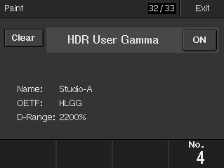

Also added File -> HDR User Gamma -> HDR User Gam Trans menu. It is possible transfer the HDR User Gamma file saved in Memory Stick to the camera. The operating specifications are the same as User Gamma.

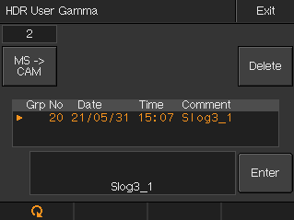

**[Preparation]**

< Memory Stick >

Version upgrade is executed using a Memory Stick Duo or a Memory Stick PRO Duo.

< Software File >

File name:

Upgrade file for MAIN/LOADER BLOCK: RCP15XX.ROM

* Obtain it from Software Download site.

Create a folder having the name shown below in a Memory Stick, and copy the above file in it.

\MSSONY\PRO\CAMERA\RCP15XX

**[Installation Procedure]**

Refer to the section of “Firmware Update” in the Maintenance Manual.

**[Confirmation / Adjustment]**

Confirm if the version of the MAIN is V3.80 and the version of the LOADER is V2.10.

* Refer to the section of “Firmware Update” in the Maintenance Manual for the method of checking the version

number.

**[Software History]**

RCP-1500/1501/1530

MAIN V1.01: Official release of initial version

BOOT V1.00: Official release of initial version

MAIN V1.10: Add or Change the function

BOOT V1.01: Error correction

Technical memo HDCM10-040

MAIN V1.20: Add the function / Error correction

Technical memo HDCM10-058

MAIN V1.21: Change / Error correction

SUBSYS V1.03: Change / Error correction

Technical memo HDCM11-017

MAIN V1.30: Add the function / Error correction

Technical memo HDCM11-022

MAIN V1.40: Add the function

SUBSYS V2.01: Add the function / Error correction

Technical memo HDCM11-027

MAIN V2.00: Add the function / Change the specification

Technical memo HDCM11-037

MAIN V2.11: Add the function / Error correction

LOADER V2.10: Add the function / Error correction

Technical memo HDCM13-004

BOOT V2.00: Change the function

Technical memo HDCM13-058

MAIN V2.12: Add the function

Technical memo HDCM13-063

MAIN V2.20: Add the function

Technical memo HDCM13-073

MAIN V2.30: Add the function

Technical memo HDCM13-080

MAIN V2.40: Add the function / Error correction

Technical Memo HDCM14-031

MAIN V2.42: Add the function / Error correction

Technical Memo HDCM14-047

MAIN V2.50: Add the function

Technical Memo HDCM15-033

MAIN V2.60: Add the function

Technical Memo HDCM15-057

MAIN V2.70: Add the function / Error correction

Technical Memo HDCM16-008

MAIN V2.80: Add the function

SUBSYS V2.02: Error correction

Technical Memo HDCM16-034

MAIN V2.81: Support for new hardware

SUBSYS V2.10: Support for new hardware

Technical Memo HDCM16-056

MAIN V2.91: Add the function / Error correction

Technical Memo HDCM16-078

MAIN V3.00: Add the function / Change the function

Technical Memo HDCM17-021

MAIN V3.10: Add the function / Change the function

Technical Memo HDCM17-067

MAIN V3.20: Add the function / Change the function / Error correction

Technical Memo HDCM17-085

MAIN V3.30: Add the function / Change the function / Error correction

Technical Memo HDCM18-075

MAIN V3.40: Add the function / Change the function / Error correction

Technical Memo HDCM19-026

MAIN V3.51: Add the function / Change the function / Error correction

Technical Memo HDCM19-208

MAIN V3.60: Add the function / Change the function / Error correction

Technical Memo HDCM20-032

MAIN V3.70: Add the function / Change the function / Error correction

Technical Memo HDCM21-023