**HOW TO USE IMPORT/EXPORT SRC/DEST LIST IN UCON 4.7**

1. First, the user needs to export the src/dest list, by selecting the “Export Editable Src / Dest list” button from toolbar.

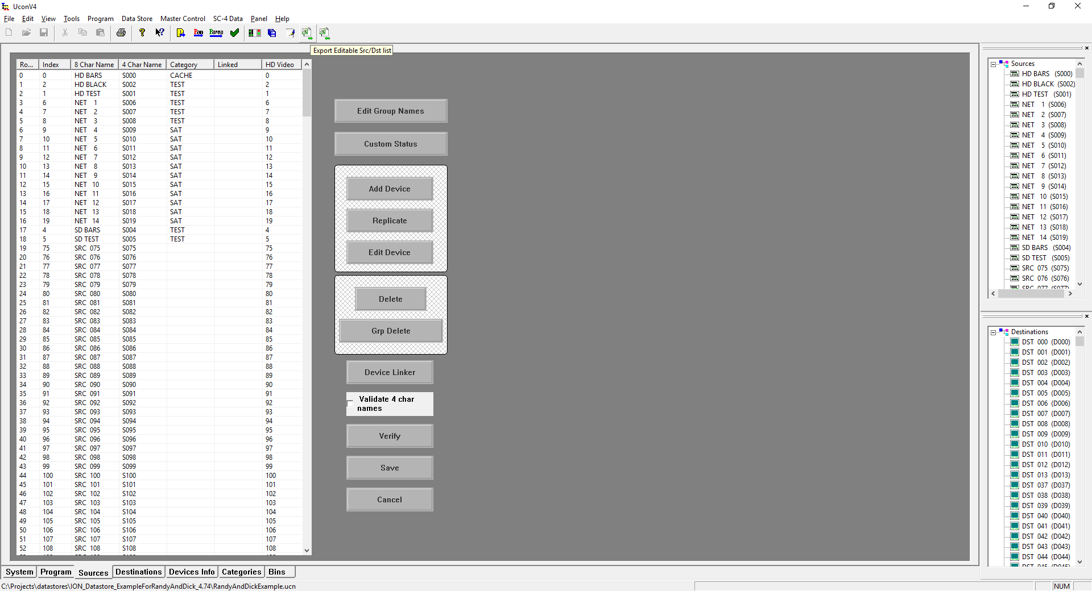

An editable src / dest list file is then created and saved in the export folder

C:\usi\temp\ucondatastore\Export\(Datastore name)_(SRC or DST)_UconExportEditable.txt

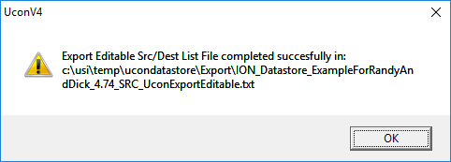

After the file has been created, the user can then make changes to it, like to change names, or copying and pasting, changing levels, etc.

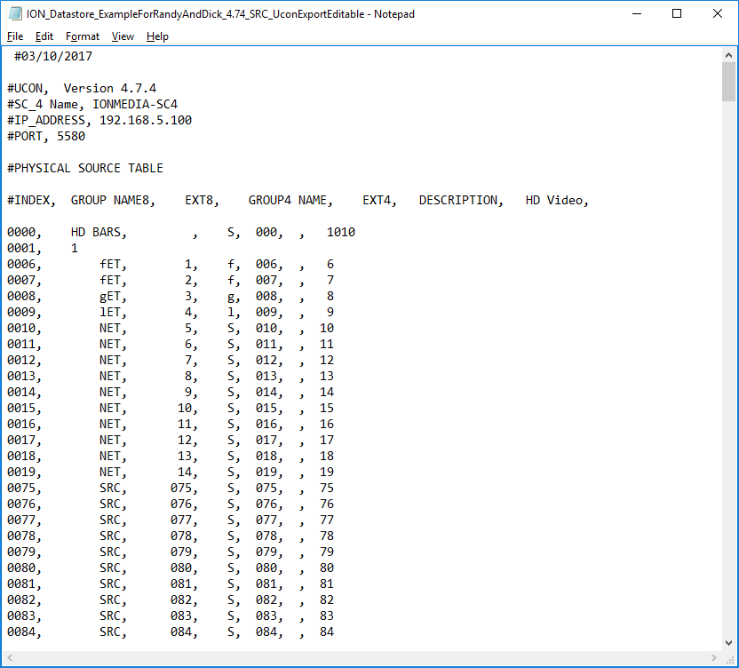

1. When the user is ready to import the edited list, they need to click on the “Import Editable Src / Dest list” button from toolbar.

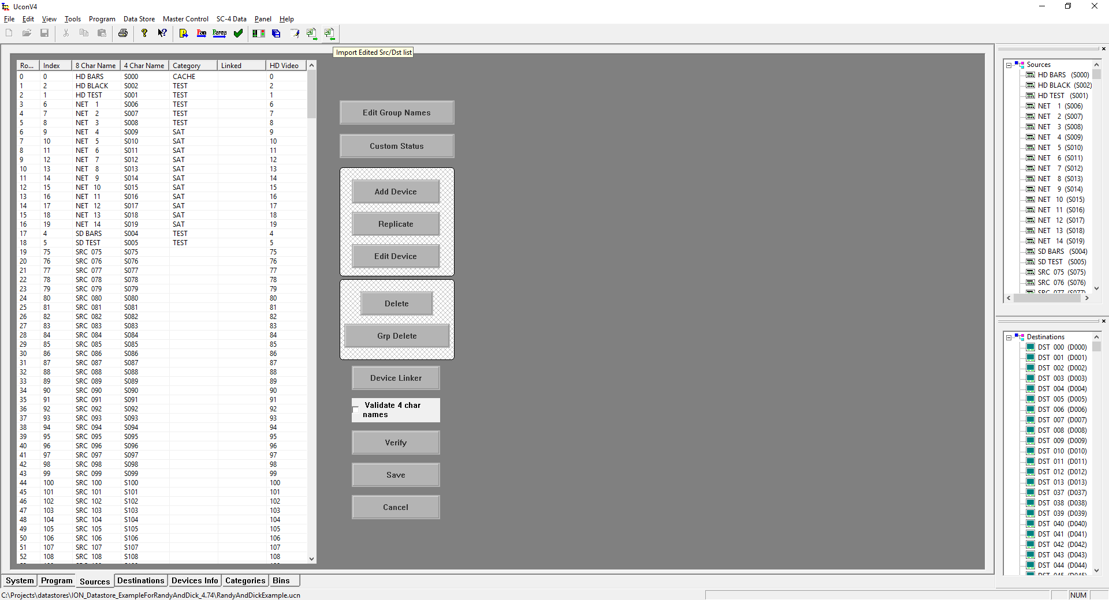

A Dialog box then opens to let the user select which file to import.

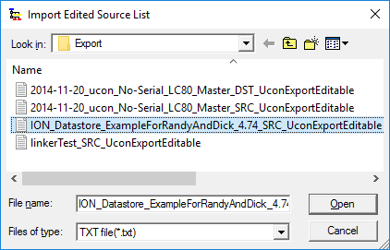

Then, the user needs to agree to replace the current list with the one from the imported file.

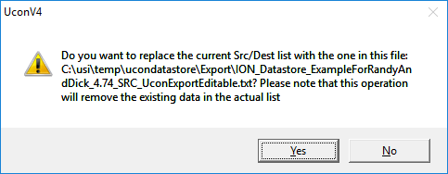

If the file has some lines that are not formatted right, like missing names, level, etc, an error file showing the lines that couldn’t be ingested is created in the same path, following this format:

C:\usi\temp\ucondatastore\Export\(Datastore name)_(SRC or DST)_UconExportEditable_ERROR.txt

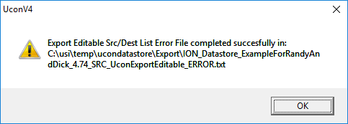

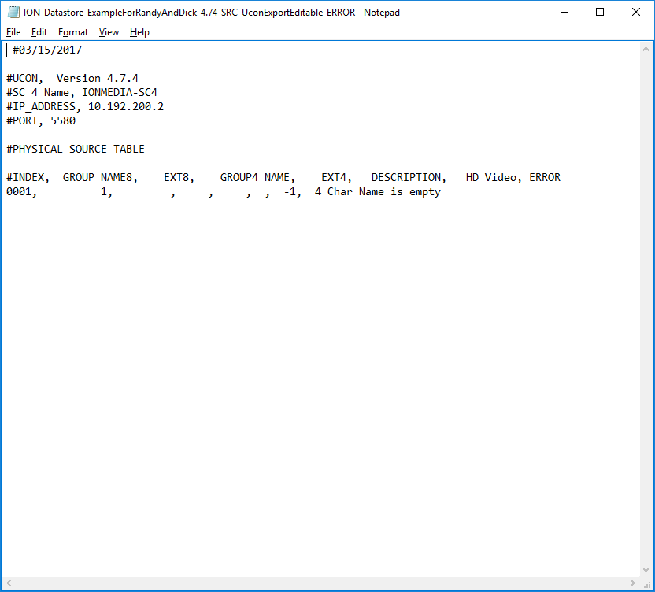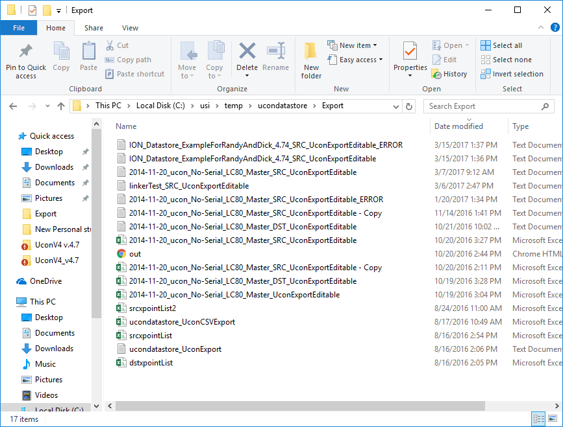

If During the importing a group name needs to be created, because none other matches the new name, the following message will appear if the “Enable new group added message” from the view menu is set. Otherwise the new group is created following the internal logic. (just for the 4 char name, for the 8 char name the Assigning Group Name dialog is shown regardless if the flag is set or not)

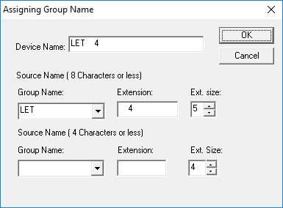

If the importing was successful, the following message appears:

