Utah Scientific Installation Utility Overview

A new Installation Utility is available on USI system software CD’s. It’s called UTSCIInstallUtility.exe

It is a replacement for the install2020.exe program previously released with USI system software CD’s.

UTSCIInstallation Utility provides enhanced features over those provided by install2020. These changes center around the Utilities selection available on the main screen. Selecting this button opens a new window providing an interface for working with USI system devices. Please see the next page for a example of the interface.

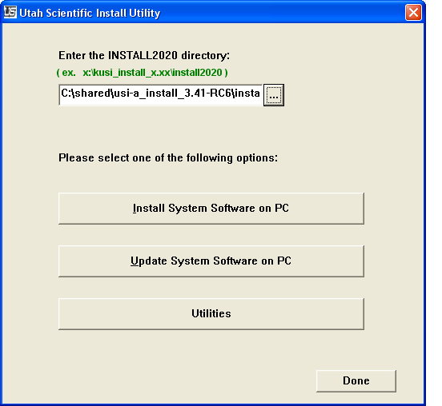

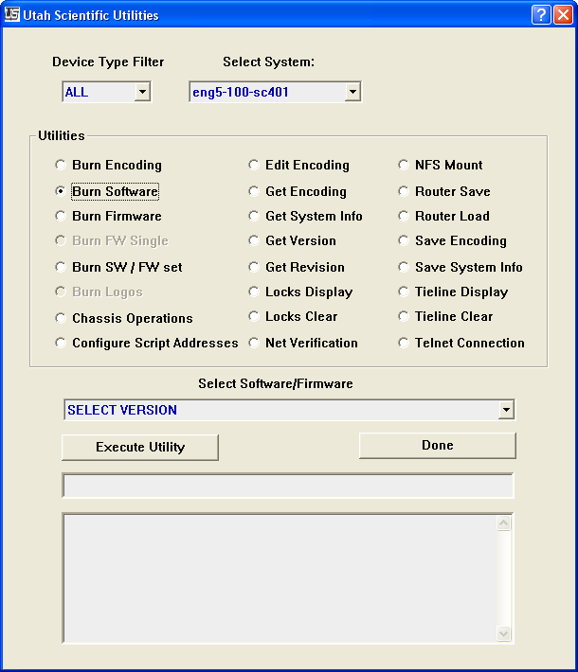

Should you need help using the new utilities interface select the ? mark in the top right of the window then select the option you have a question on. This will display a short description of what the utility will do.

